CHEMISTRY

Form 4

Paper 1

MARKING SCHEME

1. [a] Bolyles law states that volume of a given mass of a gas inversely proportional to its pressure
at constant temperature
[b] P₁V₁=P₂V₂
560 x 850 = V₂
640
V₂=743.75 cm³

2. [a] Magnesium oxide
[b] Mg_{[s]} + N₂O_{[S]} MgO + N₂[g]

3. [a] -Manufacture of fizzy drink
-Used as a refrigerant
[any one correct]
[b] Marble chips [solid calcium carbonate and dilute hydrochloric acid (Any correct 2)

4 [a] Salty condition
Acidic condition
[b] -Addition of minerals to the soil
-decomposition of iron waste

5. 38g 56g of water
? 100g of water
35x 100
56
= 67.85g/100g of water

6. Molten sodium chloride has mobile ions while solid sodium chloride does not have mobile ions

7 [a]
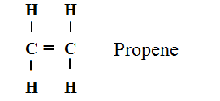
[b] Addition polymerization

[c] [48] n = 25620
48 48
N=533.75 units
8.

[580 X1]+420X4 +[396]1 [446]1 + [420 X5]+[438]1
580+1680 +396 446+2100+438
+ 2656 -2984
+2656 $-$2984
=$-$328kJmol⁻¹

9 [a] Dynamic equilibrium is attained when the rate of the forward reaction is equal to that of the
reverse reaction
[b] [i] The intensity of the yellow colour in the equilibrium mixture increased .
Additional of NaOH reduces the concentration ofH+ ions hence equilibrium shifts to the left
[ii] the intensity of the yellow colour in the equilibrium mixture decreases.
Additional of HCL increased the concentration of H+ ions hence equilibrium shifts to the right

10. [a] Cu^{2+[}aq] + 2e⁻ Cu[s]
[b] Q= It
=1.5x150x60
=13,500C
2moles of electrons are depositing 1 mole of Cu metal
1 mole of electrons=96500C
2 moles of electrons =
193000C deposited 64g of copper
13500
$$\frac{13500 ×64}{193000}$$
4.476g

11. [a] Half life of a radioactive isotope is the time taken for a given or number of nuclides to decay
to half its original mass or number
[b] Alpha particle
Beta particles
[c] the number of half life $\frac{12}{\begin{aligned}3 \\ \end{aligned}}$ =4
[1 /2 ]4x288=18g

12. $E^{θ}$= E _{RHS} $-$ E _{LHS}
$=-$ 1.64 $-$ + 0.44
$=-$2.08V
The reaction will not take place because the e.m.f is negative

13 [a] Ethyne
[b] Calcium carbide and water
[c] Alkynes

14 [a] Rhombic sulphur
Monoclinic sulphur
[b] {i} Red brown gas of fumes were observed
{ii} S_{[s]} + 6HNO_{3[aq]} H₂SO_{4[aq]} +6NO_{2[g]}+2H₂O

15 [a] Acts as a bleaching agent
[b] 2Ca[OH]_{2[aq]}+Cl_{2[g]} CaCl_{2[aq]} +Ca(OCl)_{2{aq}} +2H_{[g]}

16. [a] Ester
[b] propanol and methanoic acid
[C] Concentrated sulphuric {IV}acid catalyst
Warming
17.
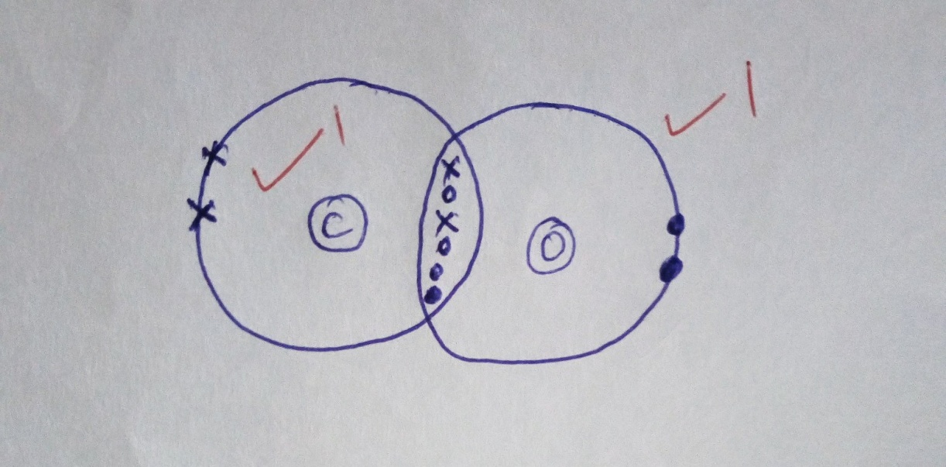
18. Mass of carbon
$=\frac{12}{44}$ x 29.3
Mass of H $=\frac{2}{18}$ x11.7= 7.99
=7.99
Mass of O₂
20 –[7.99+1.3] =10.71
Element C H O
Mass of the element 7.99 1.30 10.71
R.A.M 12 1 16
Divide by R.A.M 7.99 1.30 10.71
12 1 16
Divide by smallest value $\frac{0.6658 }{0.6658} \frac{1.3}{0.6658} \frac{0.6693}{0.6658}$
1 1.95 1.005
Mole ratio 1 2 1
E.F CH₂O

19. [a] White precipitate was formed
[b] Pb_{2[q]} + 2Cl [aq] PbCl2[s]

20 [a] hydrogen
[b] Electrolysis of brine
Cracking of larger alkanes
[c] Finely divided iron
Plantinum catalyst
[d] Manufacture of nitrogen fertilizer
Used as a refrigerant
Softening of water

21 [a] Upward delivery
[b] gas x is denser than gas y
[c] Hydrogen, ammonia,methane
22.x+4 x 36x x +40+4=37.25 x [x + 4]
36x + 160 = 37.25x +149
36x – 37,25x=149 – 160
-1.25x=+11
-1.25 =1.25
X=8.8
23. A liquid is boiled when constant boiling point is maintained the liquid is pure

24.
$\frac{ Time in T}{Time in R}=\frac{\sqrt{Density T}}{\sqrt{Density R}}$
$\frac{ 48 sec}{70 sec}=\frac{\sqrt{0.16}}{\sqrt{Density R}}$
${\left(\frac{ 48 sec}{70 sec}\right)}^{2}={\left(\frac{\sqrt{0.16}}{\sqrt{Density R}}\right)}^{2}$
$\frac{ 2304}{4900}=\frac{0.16}{Density of R}$
$Density of R=0.3402 g/{cm}^{3}$

25. {a}E
{b} A
{c} C

