**ASUMBI GIRLS HIGH SCHOOL**

**TERM 2 – DECEMBER 2021**

**FORM 4**

**CHEMISTRY PAPER 1**

**Name:** …………………………………………………………… **Adm No**: ………………………………

**Class:** …………………………………………………………. **Candidate’s Sign**: …………………….

**Date:** ………………………………………………………….

**233/1**

**CHEMISTRY**

**PAPER 1**

**TIME: 1 HOUR**

*Kenya Certificate of Secondary Education (K.C.S.E.)*

**FORM FOUR**

**Chemistry**

**Paper 1**

**INSTRUCTIONS TO THE CANDIDATES:-**

* Write your **name** and **Admission number** in the spaces provided.
* Answer ***all*** the questions in the spaces provided.
* Mathematical tables and electronic calculators may be used
* All working **MUST** be clearly shown where necessary.

**For Examiner’s Use Only:**

|  |  |  |
| --- | --- | --- |
| **Question** | **Maximum score** | **Candidate’s score** |
| 1-25 | 80 MARKS |  |

1 [a] State Boyle’s law [1mk]

…………………………………………………………………………………………………………………

…………………………………………………………………………………………………………………

[b] At 4000C, 850cm3 of a gas exert a pressure of 560mmHg. What volume of the same gas would exert a pressure of 640mmHg at the same temperature? [3mks]

…………………………………………………………………………………………………………………

…………………………………………………………………………………………………………………

…………………………………………………………………………………………………………………

…………………………………………………………………………………………………………………

2. When burning magnesium is lowered into a gas jar containing nitrogen (I) oxide, it continues to burn forming a white solid

[a] Name the white solid 1mk]

…………………………………………………………………………………………………………………

…………………………………………………………………………………………………………………

[b] Write a chemical equation of the reaction that occurred [1mk]

…………………………………………………………………………………………………………………

…………………………………………………………………………………………………………………

3. Carbon {IV} oxide is one of the gases used in fire extinguishers

[a] State any other possible use of carbon {IV} oxide [1mk]

…………………………………………………………………………………………………………………

…………………………………………………………………………………………………………………

[b] Name any two reagents that can be reacted together ti generate carbon {IV} oxide [2mks]

…………………………………………………………………………………………………………………

…………………………………………………………………………………………………………………

4. Rusting is a process that causes massive destruction of iron structures

[a] State one condition that accelerates rusting [1mk]

…………………………………………………………………………………………………………………

…………………………………………………………………………………………………………………

[b] State one advantage of rusting [1mk]

…………………………………………………………………………………………………………………

…………………………………………………………………………………………………………………

5. At 600C, 38 grams of lead{II} nitrate saturate 56cm3 of water. Determine the solubility of lead {II} nitrate at this temperature [2mks]

…………………………………………………………………………………………………………………

…………………………………………………………………………………………………………………

…………………………………………………………………………………………………………………

6. Explain why molten sodium chloride conducts electricity, but solid sodium chloride does not

[2mks]

…………………………………………………………………………………………………………………

…………………………………………………………………………………………………………………

…………………………………………………………………………………………………………………

7. A polymer can be represented as

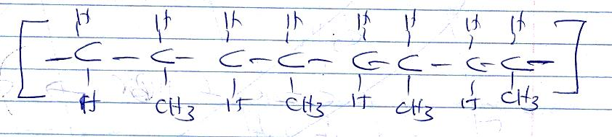

[a] Name and draw the structure of the monomer [2mks]

…………………………………………………………………………………………………………………

…………………………………………………………………………………………………………………

…………………………………………………………………………………………………………………

…………………………………………………………………………………………………………………

…………………………………………………………………………………………………………………

[b] What type of polymerization occurs in the above case? [1mk]

…………………………………………………………………………………………………………………

…………………………………………………………………………………………………………………

[c] Given that the molecular mass of the polymer is 25620, how many units of the monomer make the polymer [2mks]

…………………………………………………………………………………………………………………

…………………………………………………………………………………………………………………

…………………………………………………………………………………………………………………

…………………………………………………………………………………………………………………

8. A reaction can be represented as;

C2H4[g] +HBr[g] C2H5Br[g]

Given the bond energies of C-H, C=C, C-C, C-Br, and H –Br as 20kJ/mol, 580Kj/mole, 446Kj/mole, 438KJ/mole and 396kJ/mole respectively. Determine the heat of formation of C2H5Br [3mks]

…………………………………………………………………………………………………………………

…………………………………………………………………………………………………………………

…………………………………………………………………………………………………………………

…………………………………………………………………………………………………………………

…………………………………………………………………………………………………………………

9 [a] Define the term, dynamic equilibrium [1mks]

…………………………………………………………………………………………………………………

…………………………………………………………………………………………………………………

[b] A reaction at equilibrium can be represented as

2CrO2-4[aq] +2H+[aq] Cr2O7 2[-aq] + H2O{l}

Yellow orange

State and explain the observation made when;

[i] NaOH is added to the equilibrium mixture [2mks]

…………………………………………………………………………………………………………………

…………………………………………………………………………………………………………………

…………………………………………………………………………………………………………………

[ii] HCl is added to the equilibrium mixture [2mks]

…………………………………………………………………………………………………………………

…………………………………………………………………………………………………………………

…………………………………………………………………………………………………………………

10. During the electrolysis of dilute copper {II} chloride using carbon electrodes, a current of 1.5A was passed through the solution for 2 hours and 30 minutes

[a] Write the ionic equation of the reaction that occurred at the cathode [1mk]

…………………………………………………………………………………………………………………

…………………………………………………………………………………………………………………

…………………………………………………………………………………………………………………

[b] Given R.A.M of copper = 64 and 1F = 96500C, calculate the change in mass of the cathode

[3mks]

…………………………………………………………………………………………………………………

…………………………………………………………………………………………………………………

…………………………………………………………………………………………………………………

……………………………………………………………………………………………………………………………………………………………………………………………………………………………………

…………………………………………………………………………………………………………………

11. [a] Define the term half-life [1mk]

…………………………………………………………………………………………………………………

…………………………………………………………………………………………………………………

[b] Name two particles likely to be emitted when a radioactive nuclide undergoes radioactivity

[2mks]

…………………………………………………………………………………………………………………

…………………………………………………………………………………………………………………

[c] The half-life of a radioactive nuclide is 3 hours. Given that its initial mass is 288g, determine the remaining mass after 12 hours. [2mks]

…………………………………………………………………………………………………………………

…………………………………………………………………………………………………………………

…………………………………………………………………………………………………………………

…………………………………………………………………………………………………………………

12. The reduction potentials of elements M and N are;

M2+[aq] +2e- M[s],=+0.44V

N+[aq] e- N[s], = -1.64V

Using the above reduction potentials, predict whether a reaction would occur between

N+[aq] and M[[s]  [3mks]

…………………………………………………………………………………………………………………

…………………………………………………………………………………………………………………

…………………………………………………………………………………………………………………

13. An hydrocarbon can be represented as: C2 H2

[a] Name the hydrocarbon [1mk]

…………………………………………………………………………………………………………………

…………………………………………………………………………………………………………………

[b] State two reagents that can be reacted together to generate the hydrocarbon [2mks]

…………………………………………………………………………………………………………………

…………………………………………………………………………………………………………………

[c] Identify the group of hydrocarbons into which C2H2 belongs to [1mk]

…………………………………………………………………………………………………………………

…………………………………………………………………………………………………………………

14. [a] Name two allotropes of sulphur [2mks]

…………………………………………………………………………………………………………………

…………………………………………………………………………………………………………………

[b] In an experiment to investigate a certain property of sulphur, Maina added few drops of conc HNO3 to sulphur in a test tube and warmed the mixture

[i]State one observation made [1mk]

…………………………………………………………………………………………………………………

…………………………………………………………………………………………………………………

[ii]Write a chemical equation of the reaction that occurred [1mk]

…………………………………………………………………………………………………………………

…………………………………………………………………………………………………………………

15. Chlorine is commonly used in the manufacture of Ca (OCl)2

[i] State one use of the above compound of chlorine [1mk]

…………………………………………………………………………………………………………………

…………………………………………………………………………………………………………………

[ii] Write a chemical equation leading to the production of Ca (OCl)2 [1mk]

…………………………………………………………………………………………………………………

…………………………………………………………………………………………………………………

16. A compound can be represented as

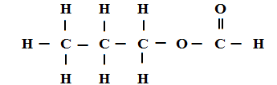

[a] What name is given to the above class of compounds [1mk]

…………………………………………………………………………………………………………………

…………………………………………………………………………………………………………………

[b] Name two reagents that can be reacted together to generate the above compound [2mks]

…………………………………………………………………………………………………………………

…………………………………………………………………………………………………………………

…………………………………………………………………………………………………………………

[c] State two conditions necessary for the reaction leading to formation of the above compound to occur [2mks]

…………………………………………………………………………………………………………………

…………………………………………………………………………………………………………………

…………………………………………………………………………………………………………………

17. Using dots and crosses, show bonding in carbon{II} oxide [2mks]

18. When 20g of a compound containing carbon, hydrogen and oxygen was burnt in the air, 29.3g of carbon{IV} oxide and 11.7g of water were produced. Determine its empirical formulae.

{C=12, H=1 , O=16} [3mks]

…………………………………………………………………………………………………………………

…………………………………………………………………………………………………………………

…………………………………………………………………………………………………………………

19. Few drops of hydrochloric acid were added into a test tube containing lead {II} Nitrate solution

{a} State one observation made [1mk]

…………………………………………………………………………………………………………………

…………………………………………………………………………………………………………………

{b} Write an ionic equation of the reaction that occurred in the test tube [1mk]

…………………………………………………………………………………………………………………

…………………………………………………………………………………………………………………

20. In the industrial manufacture of Ammonia one of the raw materials is nitrogen gas

{a} Name one other raw material [1mk]

…………………………………………………………………………………………………………………

…………………………………………………………………………………………………………………

{b} Name two possible sources of the raw material you have named in {a} above [2mks]

…………………………………………………………………………………………………………………

…………………………………………………………………………………………………………………

…………………………………………………………………………………………………………………

{c} Name two substances that can be used as catalyst in this process [2mks]

…………………………………………………………………………………………………………………

…………………………………………………………………………………………………………………

…………………………………………………………………………………………………………………

{d} State one use of ammonia [1mk]

…………………………………………………………………………………………………………………

…………………………………………………………………………………………………………………

…………………………………………………………………………………………………………………

…………………………………………………………………………………………………………………

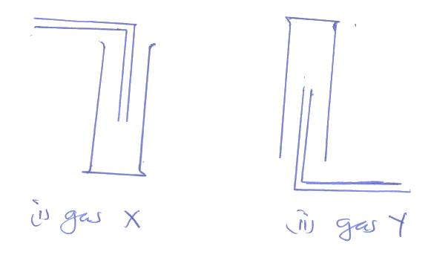21. Gas X and Y can be collected as shown below

[a] Name the method used to collect gas Y [1mk]

…………………………………………………………………………………………………………………

…………………………………………………………………………………………………………………

[b] How do densities of gas X and gas Y compare? [1mk]

…………………………………………………………………………………………………………………

…………………………………………………………………………………………………………………

[a] Give an example of a gas that can be collected using the same method as gas Y [1mk]

…………………………………………………………………………………………………………………

22. Element W has two isotopes W – 36 and W-40 which occur in the ratio x:4. Given that R.A.M of W is 37.25, find the value of x [2mks]

…………………………………………………………………………………………………………………

…………………………………………………………………………………………………………………

…………………………………………………………………………………………………………………

…………………………………………………………………………………………………………………

23. Describe an experiment that can be used to determine whether a given sample of a liquid is pure

[2mks]

…………………………………………………………………………………………………………………

…………………………………………………………………………………………………………………

…………………………………………………………………………………………………………………

…………………………………………………………………………………………………………………

24. A given mass of gas T diffuses through a porous plug in 48 seconds while a similar mass of gas R diffuse in 70 seconds. Given that the density of gas T is 0.6g/cm3, find the density of gas R [2mks]

…………………………………………………………………………………………………………………

…………………………………………………………………………………………………………………

…………………………………………………………………………………………………………………

25. The electron configuration of elements A, B, C, D and E are as given below

|  |  |
| --- | --- |
| **Element** | **Electron configuration** |
| A | 2, 8, 1 |
| B | 2, 8 |
| C | 2, 7 |
| D | 2, 8, 6 |
| E | 2, 8, 3 |

{a} Which element has the highest electrical conductivity [1mk]

…………………………………………………………………………………………………………………

{b} Which letter represents the most reactive metal [1mk]

…………………………………………………………………………………………………………………

{c} Which letter represents the most reactive non-metal [1mk]

…………………………………………………………………………………………………………………

*******