**ASUMBI GIRLS HIGH SCHOOL**

**TERM 2 – DECEMBER 2021**

**FORM 4 - COMPUTER STUDIES PAPER 1**

**MARKING SCHEME**

**SECTION A (40 Marks)**

1. State the technology used in the following computer generations (2mks)
2. 1st generation

Vacuum tubes

1. 2nd generation

Transistors

1. 3rd generation

Integrated circuits (ICS)

1. 4th generation

Very large integrated circuits (VLSI)

1. State **three** ways in which computers have been used to fight the spread of corona virus in Kenya. (3marks)

* Computers have been used to sensitize people on safety measures that help in preventing spread of virus
* For printing posters
* For conducting medical research in KEMRI
* For carrying out statistics for people infected with corona virus in Kenya in Kenya and comparing it with other countries

1. State and explain **two** types of booting in computer. *(2 marks)*

* Cold booting. This is a process of starting up a computer that was initially off by pressing power button on the system unit.
* Warm booting. This is a process restarting a computer that was initially on by pressing CTRL+ALT+DEL keys

1. **Explain the term “log on” as applied in internet (2marks)**

* Process used to get access to an operating system or application, usually in a remote computer system or application, usually in a remote computer. Almost always a logon requires that the user have (1) a user ID and (2) a password

1. **(a)**  What is disk formatting? **(1mark)**

* **Disk formatting is the process of preparing a data storage device such as a hard disk drive, solid-state drive, floppy disk or USB flash drive for initial use**

**(b)** State **two** reasons for disk formatting (2 marks)

**-To prepare a new disk so that files can be stored on it  
-To create sectors & tracks for the storage of data  
-To create/ prepare a new root directory and file allocation tables on the disk  
-To remove/ delete any existing files or information stored on the disk, if it is no -longer needed  
-To determine the effective storage capacity of the disk, i.e. formatting enables the user to know how much data the disk can hold.  
- It can also check for bad sectors on the new disk.**

1. State a stage in system development life cycle where each of the following activities are carried out:
2. identifying the technologies that may be used in a proposed system; (1 mark)

* **Accept any sub stage within system analysis e.g requirement specification, problem definition, information gathering, etc**

1. identifying shortcomings of a system; (1 mark)

* **All stages of system development**

1. Preparing a system for migration plan. (1 mark)

* **Implementation stage**

1. State three reasons why an organisation may opt to develop its own software in-house rather

than buy off-the-shelf software  **(3marks**)

* **Customised to suit business needs of the organisation.**
* **It can be upgraded as needed by the organisation.**
* **The organisation can have a module that the competitors don’t have.**
* **The organisation develops only the modules needed/memory eptimization, or storage/space.**

**8.** A particular computer stores numbers in a single 8-bit word. How would it represent? **0.312510** (3marks)

0.3125 × 2 = 0.625

0.625 × 2 = 1.25

0.25× 2 = 0.5

0.5 × 2 = 1.0

=0.0101 = 0.010100002

1. **(**a) What is a firewall? (1mark)

* It is a program/software that filters out unwanted data and programs/criminals/hackers/malicious persons

**(b)** State the **two** reasons that may have necessitated disabling of the firewall.

* testing the communication link
* when upgrading the firewall
* when there is need to install an application and the firewall is preventing the operation
* when the firewall prevents legitimate communication

1. **Differentiate between absolute and relative cell references.(2 Marks)**

* Absolute cell references do not change when a formula containing the absolute references is copied from one cell to another. E.g. $A$1
* Relative cell references change automatically when a formula containing the relative references is copied from one cell to another e.g. A1

1. Mwanzo Micro finance organization has offices in Kericho and Nairobi connected into a network. The management is convinced that someone is illegally gaining access to the data in their computers. State **three** ways the company can overcome this problem. (3marks**)**

* Encryption
* Firewalls
* User access level/Passwords
* Limit number of log in attempts
* Audit trail
* Log files

1. **The following worksheet represents the number of litres of milk produced by different cows’ species at Kajiado Ranch Ltd.**

|  |  |  |  |  |  |
| --- | --- | --- | --- | --- | --- |
| s/no | A | B | C | D | E |
| **1** | **Month** | **Friesian** | **Ayrshire** | **Guernsey** |  |
| 2 | Jan | 70 | 80 | 65 |  |
| 3 | Feb | 120 | 62 | 75 |  |
| 4 | Mar | 110 | 65 | 45 |  |
| 5 | Apr | 70 | 45 | 60 |  |
| 6 |  |  |  |  |  |

The cost of each litre of milk is **Kshs.30/=.** This amount is typed in cell **B10**

1. Write a function that will calculate the total number of litres of Friesian in all months (2marks)

**=SUM(B2:B5)**

1. Write a formulae that can be typed in cell E2 and then be copied down to obtainmonthly sales of milk. (1mark)

**=(B2+C2+D2)*30 OR =$B$10*(B2+C2+D2)**

1. Identify the data type in cell C1 and cell D3 (1mark)

**C1 – Label**

**D3 – Value**  @1/2 x2mark

1. State **three** main types of looping control structures as used in programming. (3 marks)

* The WHILE loop
* The REPEAT …UNTIL loop
* The FOR loop

1. **Advantages of wireless media to the school**

* The school will find it easy to add or remove nodes on the system
* In case of new building is put up, there will be no need of interfering with communication media
* Users will find it safer to move around as there are no wires around the rooms
* Students will be able to roam as they access the network

1. State the functions of the following keys on the computer keyboard:

(a) Backspace *(1 mark)*

* **This key deletes typed characters or words from right to left on the same line at the cursor position**

(b) Tab key *(1 mark)*

* **Tab key is used to move the cursor at set horizontal interval on the same line such as 0.5 inch, 10 inch etc**

**SECTION B (60MARKS)**

*Answer* ***question 16*** *and any other* ***THREE*** *questions from this section in the spaces provided*

1. **(a) What is meant by each of the following terms (3marks)**
2. **Pseudocode**

Pseudocode describes module design in words using syntax like programming language. It aims at proving programmer with clear and unambiguous process specification

1. **Flowchart**

Diagrammatic or pictorial representation that illustrates the sequence of operations to be performed to get the solution of a problem

1. **Dry run**

The process of manually tracing through a program using a pen and a paper to identify any errors

1. **Outline two disadvantages of low level programming languages (2marks)**

* Difficult and cumbersome to use and learn
* They require highly trained experts to develop and maintain programs
* Removing errors (debugging) is difficult
* Are machine dependent i.e. are not transferrable from one hardware of software platform to another

C) Differentiate between compilers and interpreters as used in programming. (2marks)

* An interpreter translates the source program one statement at a time while a compiler translates the entire source code at once before execution.
* Interpreted programs are slower than compiled program
* Interpreted programs takes less memory compared to compiled program

**b)** A trader bought a car from a manufacturer and later sold the car to another person. Design a pseudocode that will accept the buying price and the selling price of the car, determine whether the trader made a profit /or loss, calculate the profit/loss and display it. (5mks)

**START**

**ENTER “Buying Price( Bp), Selling price (sp)”**

**IF Bp<Sp THEN**

**Profit= Sp-Bp**

**PRINT Profit**

**Else**

**Loss=Bp-Sp**

**PRINT Loss**

**Endif**

**STOP**

Design a flowchart for the above case.

ENTER Buying Price ,(BP) and Selling Price ,(SP)

Is SP >BP ?

Profit= SP-BP

Loss= BP-SP

PRINT profit

PRINT Loss

NO

YES

1. **(a) STATE three limitations of traditional filing methods**

* Unnecessary duplication of data
* Boredom and time wastage when searching records
* Misleading reports due to poor data entry
* Poor update of records

(b) Below are two table structures of files in a database.

**TABLE A** **TABLE B**

|  |  |
| --- | --- |
| **FIELD** | **DATA TYPE** |
| Employee name | Text |
| Employee number | Auto number |
| DOB | Date/time |
| Address | Text |

|  |  |
| --- | --- |
| **FIELD** | **DATA TYPE** |
| Employee no. | Number |
| Date employed | Date/time |
| Department | Text |
| Salary | Currency |

1. **Which of the two tables is likely to be the parent table (1mark)**

* Table A because it has employee information

1. **It is advisable to ‘enforce referential integrity’ when creating a relationships. What do you understand by the term referential integrity? (2marks)**

* To ensure all records entered in the related table exist in the primary table

1. **The field ‘Employee no’ in TABLE B is likely to be the foreign key. What is a foreign key? (2marks)**

* A unique field that identifies each record in the secondary table in a relationship

1. **Which field in both tables is most appropriate for creating relationship? (1mark)**

* Employee number

1. **What would make the relationship between the tables fail to work? (2marks)**

* The data type for the same field in two tables is not similar

1. **In databases the field properties specify finer details related to the fields and the table entries expected. State four field properties. (4marks)**

* Input mark
* Validation rule
* Required
* Indexed
* Field size
* Format
* Decimal
* Caption
* Default value
* Validation text

1. (a) **Characteristics of octal number system**.

* each symbol is represented by 3 bits.
* The number is made of 8 symbols 0, 1, 2, ...............7;
* Maximum value of a single digit is 7 (one less than the value of the base);
* This number system uses base 8.

(Any 2 x 1)

b) i) 111.1012 to decimal (3marks)

**solution**

111 = 1 x 22+1 x 22+ 1 x 20

= 4 + 2 + 1 = 710

1012 = 1 x 2-1 + 0 x 2-2+ 1 x2-3

= 1 x 1/2 + 0 x 1/4 + 1 x 1/8

= 0.5 + 0 + 0.125 = 0.62510

111.1012 = 7.625

ii) 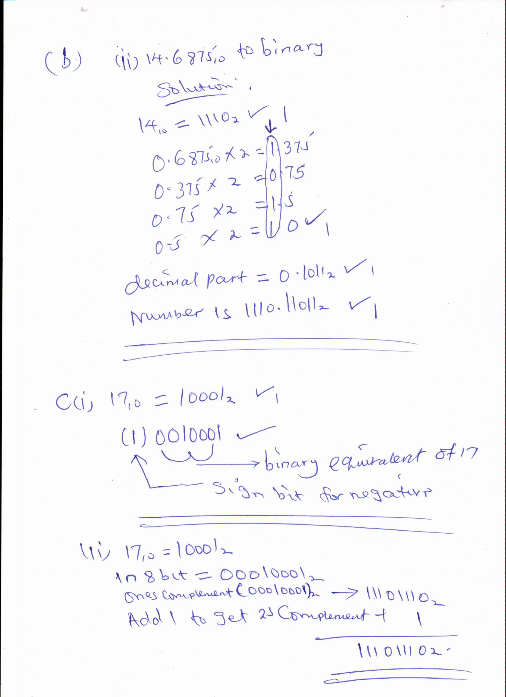

1. (c) State any three reasons why people may resist the introduction of computers at their place of work (3marks)

* Insecurity of replacement
* Hostility towards machines
* Computer illiteracy
* Fear of training

**20** a) State the role of each of the following data communication devices:

(i) **Repeater**

A device used to re-construct data signal during data transmission to its original strength/amplify/boost/regenerate.

(ii) **Router**

- It is a device used to facilitate movement of data or packets between twoor more LANS of different configuration (expansion of networks).

- Delivers a packet/data directly to destination computers.

- Interconnects different networks/provides network services.

(b) (i) The component P is the terminator. 1

(ii) Terminator in a backbone is used to prevent data signal from bouncing back/absorb signals.

(c) **Use of internet in environmental conservation club**

* Source of knowledge on environmental matters;
* Collaboration with peers from other schools or organizations;
* Dissemination of information on what the club is doing;
* Seeking for funding from sponsors. First 3 x 1) 3 marks

(d) (i) **Benefits of linking branch B and C**

* Speed of communication between B and C is increased since the traffic

between the two branches can be re-routed through the link BC;

* If either AC or AB is down, the three branches can still communicate;
* If the HQ systems fail, the two branches B and C can communicate using this link.

(First2x2) 4marks

