ASUMBI GIRLS HIGH SCHOOL

312/2
GEOGRAPHY
PAPER 2
TIME: 2 ¾ HRS

NAME:……………………………………………... ADM NO……………………………..
CLASS:………………..………………… CANDIDATE’S SIGN ………………………..

DATE……………………………

INSTRUCTIONS

- The paper comprises of two sections A & B
- Attempt all the questions in Section A
- In Section B answer question 6 and choose any other TWO questions

SCORE SHEET

SECTION A

QUESTION 6

QUESTION 7

QUESTION 8

QUESTION 9

QUESTION 10

TOTAL

SECTION A

Answer all the questions in this section

1 a) What is human geography? (2 marks)
b) State three ways in which the study of Geography contributes to National development.
(3 marks)

2. a) Apart from coniferous forest, name two other types of natural forests. (2 mks)
b) State three characteristics of coniferous which favour their exploitation. (3 mks)

3. a) Give the characteristics of plantation agriculture in Kenya. (3 marks)
b) State 2 problems facing coffee farming in Kenya. (2 marks)

4 a) Study the map of the Ruhr Industrial region and use it to answer the question below
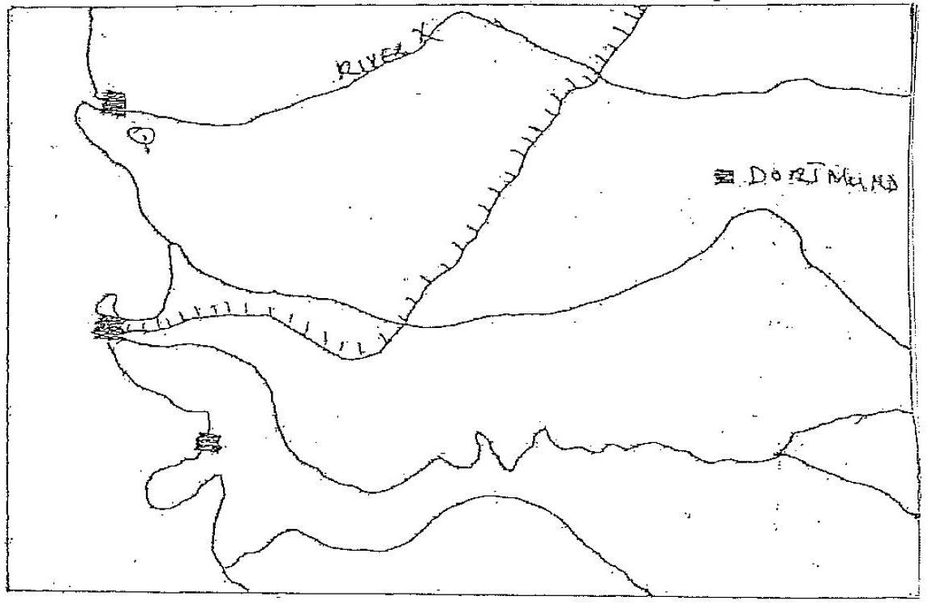

(i) Name
(ii) The town marked Q (1 mark)
(iii) The River marked X (1 mark)

b) Apart from the iron and steel, list 3 other industries in the region. (3 marks)

5. a) State three causes of urban rural migration (3 marks)
b) Give two reasons for rapid population growth. (2 marks)

SECTION B (75 MARKS)

Answer question 6 and any other TWO questions from this section.

6. The table below shows the number of tourists who visited Kenya between 1996 -1999. Use it to answer the questions that follow.

Origin/Year | 1996 | 1997 | 1998 | 1999
Britain | 100,000 | 80,000 | 60,000 | 40,000
N. America | 80,000 | 50,000 | 45,000 | 45,000
Germany | 70,000 | 40,000 | 35,000 | 30,000
S.E Asia | 40,000 | 30,000 | 25,000 | 25,000

(a) Using a scale 1 cm to represent 20,000 people, draw a compound bar graph to present this data. (6 marks)
(b) State possible reasons for the decline in the number of tourists since 1997 (4 marks)
(c) (i) What is eco-tourism (2 marks)
(ii) State two objectives of eco-tourism. (2 marks)
(d) Explain three factors that hinder development of domestic tourism in Kenya. (6 marks)
(e) Identify five steps taken by the Kenya government to promote tourism in the country. (5 marks)

7. Study the sketch map of the great lakes of St. Lawrence
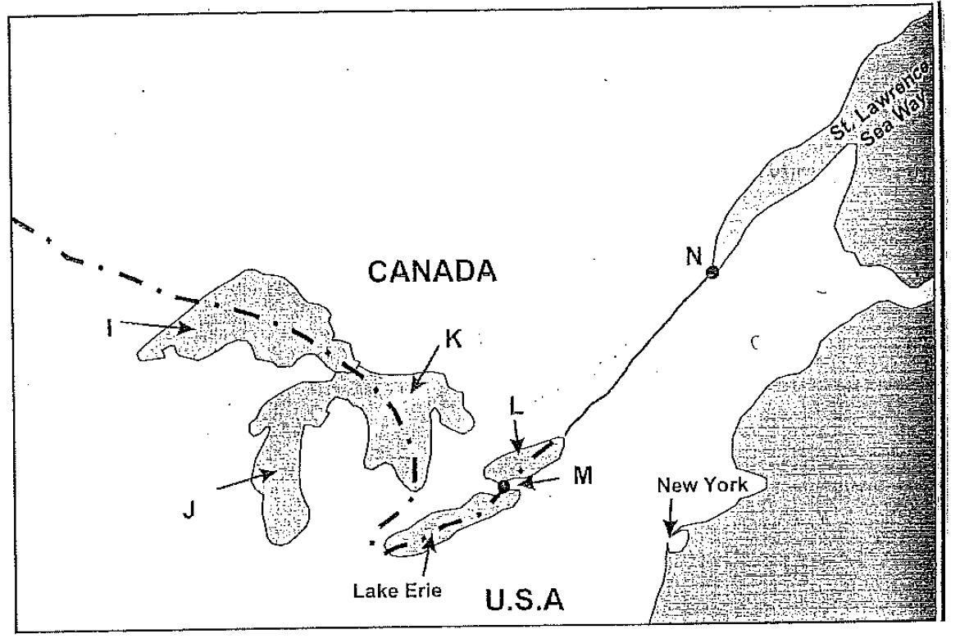
- Name
- The port marked N. (1 mk)
- The waterfall marked M (1 mk)
- The lakes marked I, J, K, L (4 mks)

- Explain five ways in which the great lakes of St. Lawrence sea way has contributed to the economy of Canada and USA. (10 mks)
- i) State three recent developments that have taken place in Kenya to improve communication of information. (3 mks)
ii) Explain three problems facing telephone as a means of communication in Kenya. (6 mks)

8. (a) (i) What is Environmental Hazards. (2 marks)
(ii) Identify three environmental hazards caused by human activities. (3 marks)

(b) (i) State three cause of floods. (3 marks)
(ii) Explain four ways of combating floods in Kenya. (8 marks)

(c) Students from your school carried out a field study on a flood prone area in your country.
(i) State four reasons why the working schedule is very important in their study. (4 marks)
(ii) List two methods of data collection they are likely to use. (3 marks)
(iii) Name two areas in Kenya prone to flooding. (2 mks)

(9) a) (i) Apart from nuclear energy name three other non-renewable sources of energy. (3 marks)
(ii) State three factors that hinder development of nuclear energy in many countries. (3 marks)

(b) (i) Explain the three effects of overdependence of petroleum on the economy of oil importing countries. (6 marks)
(ii) State 3 methods that Kenya can use to conserve her energy. (3 marks)

(c) Give reasons why Kenya has not been fully able to fully exploit her geothermal potential.
(4 marks)

(d) Use the map of Africa to answer the questions that follow
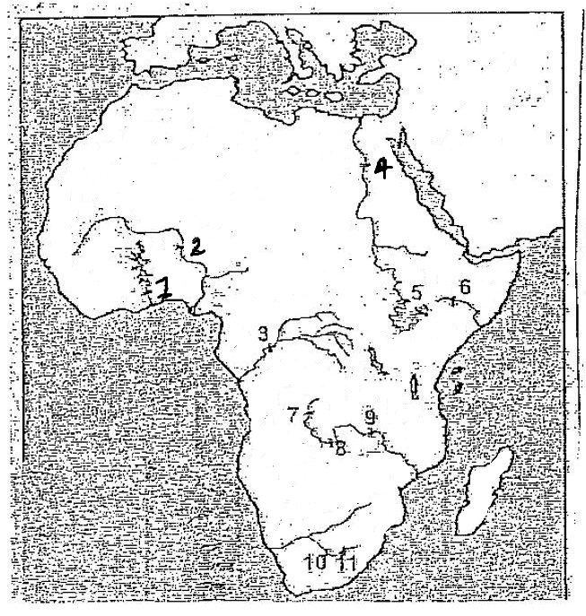

- Name the H.E.P projects that are marked 1,2,5,6. (4 marks)
- Give two reasons why Africa has a high potential of H.E.P ( 2 mks)

10. (a) i) Name four forms of which minerals occur. (4 mks)
ii) State four factors that are necessary for the occurrence of minerals. (4 mks)

b) State three ways in which open cast mining affect the environment. (3 mks)

c) Explain four ways in which mining contribute to the economy of Kenya. (8 mks)

d) Form 4 Geography students carried out field study on mineral found in the Rift Valley
i) State three objectives of their study. (3 mks)

ii) List down three problems they are likely to come across. (3 mks)

