NAME:…………………………………………………INDEX NO:…………………………..
443/1
AGRICULTURE
PAPER I
TIME: 2 HOURS.
DECEMBER 2021

BUTULA SUB COUNTY JOINT EXAMS

INSTRUCTIONS TO CANDIDATES.
- Write your name & index no on the space provided above.
- This paper consists of three sections A, B and C
- Answer all questions in section A and B.
- Answer any two questions in section C.
- All answers should be written in the spaces provided.

FOR EXAMMINERS USE ONLY

SECTION | QUESTIONS | MAXIMUM SCORE | CANDIDATES SCORE
A | 1-21 | 30
B |  | 20
C |  | 20
 |  | 20
TOTAL SCORE |  | 90

SECTION A (30 MARKS)
Answer all the questions in this section in the spaces provided.
- State two benefits of optimum soil temperature in crop production (1mk)
………………………………………………………………………………………………………………………………………………………………………………………………………………………………………………………………………………………………………………………………………………………………………………………………………………………………
- State four reasons for deep ploughing during land preparation (2mks)
………………………………………………………………………………………………………………………………………………………………………………………………………………………………………………………………………………………………………………………………………………………………………………………………………………………………………………………………………………………………………………………………………………………………………………………………………………………………………………
- What is increasing return in crop production (2mks).
………………………………………………………………………………………………………………………………………………………………………………………………………………………………………………………………………………………………………………………………………………………………………………………………………………………………
- Name one physiological disease in tomatoes (½ mark)
………………………………………………………………………………………………………………………………………………………………………………………………………………
- Name FOUR farm records that should be kept by a poultry farmer (2mks).
…………………………………………………………………………………………………………………………………………………………………………………………………………………………………………………………………………………………………………………………………………………………………………………………………………………………………………………………………………………………………………….……………………………………………………………………………………………………………………………

- List three forms in which soil water exists (1½mks)
…………………………………………………………………………………………………………………………………………………………………..…………………………………………………………………………………………………………………………………………………………………………………………………………………………………………………………
- State four sources of capital to a wheat farmer in Kenya (2mks)
………………………………………………………………………………………………………………………………………………………………….………………………………………………………………………………………………………………………………………………………………..………………………………………………………………………………………………………………………………………………………………..……………………………………………………………………………………………………………………………………………………………………………………………………………………………………………
- Sate two ways of increasing light intensity in crops (1mk)
………………………………………………………………………………………………………………………………………………………………………………………………………………………………………………………………………………………………………………………………………………………………………………………………………………………………
- State three methods of preparing planting materials (1 ½ mks)
………………………………………………………………………………………………………………………………………………………………………….………………………………………………………………………………………………………………………………………………………………………..……………………………………………………………………………………………………………………………………………………………………………..
- Name three methods of harvesting trees. (1½ mks)
………………………………………………………………………………………………………………………………………………………………………………………………………………………………………………………………………………………………………………………………………………………………………………………………………………………………………………………………………………………………………………………………………

- Calculate the amount of K₂0 contained in 400Kg of compound fertilizer 25:10:5 (2mks)

- Give four importance of top dressing pastures (2mks).
………………………………………………………………………………………………………………………………………………………………………………………………………………………………………………………………………………………………………………………………………………………………………………………………………………………………………………………………………………………………………………………………………………………………………………………………………………………………………………
- Give THREE reasons for treating water on the farm. (1 ½ mks).
………………………………………………………………………………………………………………………………………………………………………………………………………………………………………………………………………………………………………………………………………………………………………………………………………………………………………………………………………………………………………………………………………
- List three tertiary operations carried out in the farm (1 ½ mks)
………………………………………………………………………………………………………………………………………………………………………………………………………………………………………………………………………………………………………………………………………………………………………………………………………………………………
- Give THREE classifications of farm credit according to the repayment periods. (1½ mks).
………………………………………………………………………………………………………………………………………………………………………………………………………………………………………………………………………………………………………………………………………………………………………………………………………………………………
- Give TWO factors that determine the quality of hay. (1mk)
………………………………………………………………………………………………………………………………………………………………………………………………………………………………………………………………………………………………………………………………………………………………………………………………………………………………
- Give two reasons for training in crop production (1mk)
………………………………………………………………………………………………………………………………………………………………………………………………………………………………………………………………………………………………………………………………………………………………………………………………………………………………
- State two cultural measures taken by farmers to control weeds in the farm (1 mk).
………………………………………………………………………………………………………………………………………………………………………………………………………………………………………………………………………………………………………………………………………………………………………………………………………………………………
- Give one signs shown by crop when they are attacked by nematodes (½ mks)
………………………………………………………………………………………………………………………………………………………………………………………………………………………………………………………………………………………………………………………
- Outline two circumstances when opportunity cost is ZERO ( 1 mk).
………………………………………………………………………………………………………………………………………………………………………………………………………………………………………………………………………………………………………………………………………………………………………………………………………………………………
- Outline three items that a maize farmer can enter into his consumable inventory records. (1 ½ mks)
………………………………………………………………………………………………………………………………………………………………………………………………………………………………………………………………………………………………………………………………………………………………………………………………………………………………………………………………………………………………………………………………………

SECTION B (20 MARKS).
Answer all questions in this section in the spaces provided.

- Study the diagrams below and answer the questions that follows
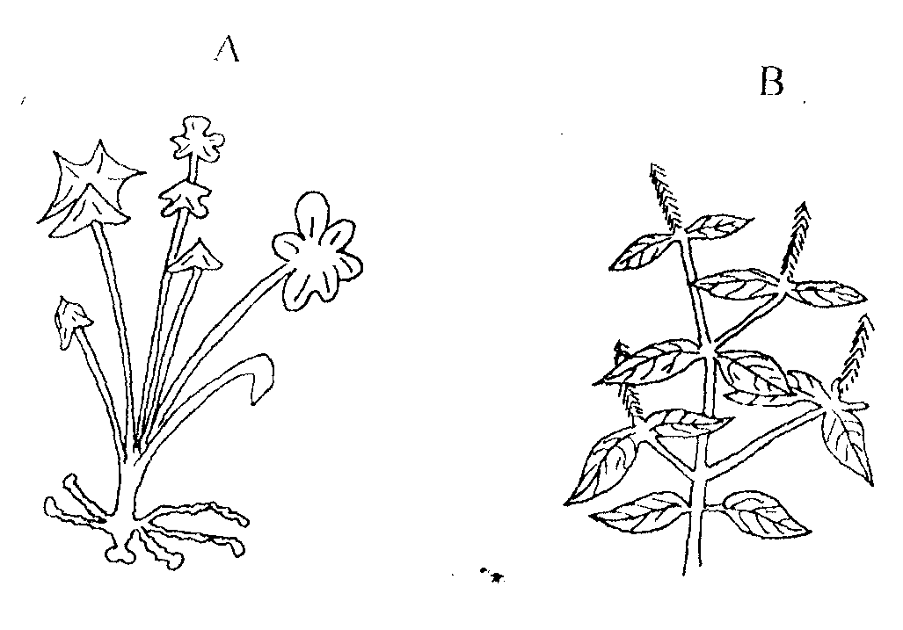

- Identify the weeds A & B A ……………………………………………………………………………………………………………………………… (2mks)
B ………………………………………………………………………………………………………………………………………
b) State one reason why the weed labeled A is difficult to control. (1mk)
………………………………………………………………………………………………………………………………………………………………………………………………………………
c) State TWO economic importance of the weed labeled B in Agriculture. (2mks)
………………………………………………………………………………………………………………………………………………………………………………………………………………………………………………………………………………………………………………………
- The diagram below illustrates materials and a method of vegetative propagation. Study it and answer the questions that follow.
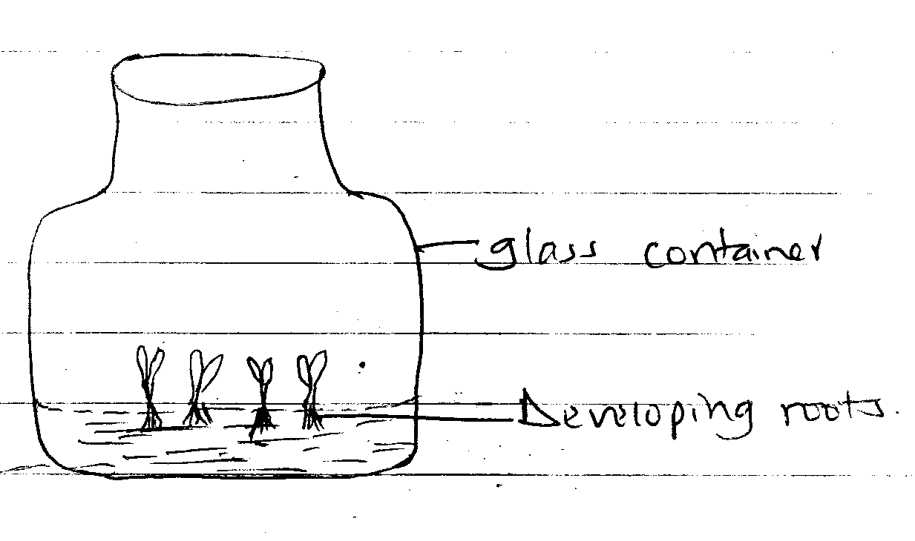
a) Identify the method of crop propagation illustrated above. ( 1mk)
………………………………………………………………………………………………………………………………………………………………………………………………………………
b) Give TWO Advantages associated with the method named (a) above, (2mks)
………………………………………………………………………………………………………………………………………………………………………………………………………………………………………………………………………………………………………………………………………………………………………………………………………………………………
c) State TWO characteristics of certified seeds. (2mks)
………………………………………………………………………………………………………………………………………………………………………………………………………………………………………………………………………………………………………………………………………………………………………………………………………………………………
- Shown below is a layout of a compost heap. Study it carefully and then answer the questions that follow.
4
3
2
1
MAIZE STALKS
Ground Level

- Name the materials in each of the parts labeled 1, 2, 3 and 4 (2 marks)
1………………………………………………….3……………………………………
2………………………………………………….4………………………………………

- State one role of each of the material in the parts labeled 1 and 3. (2 marks)
1…………………………………………………………………………………
2…………………………………………………………………………………

- (i) Give one reason for adding water to a compost heap. (1mark)
……………………………………………………………………………………………………………………………………………………………………………………
(ii) Give one reason for regularly turning the materials in a compost heap
……………………………………………………………………………... (1 mark)

- Illustrated below are crop pests. Study the illustrated above.
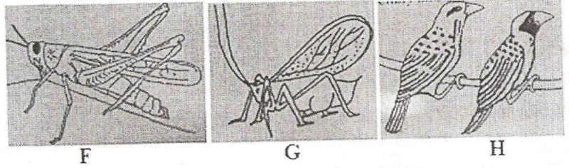

- Identify each of the pests labeled G, G, and H. (3mks)
F……………………………………………………………………………………………

G……………………………………………………………………………………………

H…………………………………………………………………………………………

- State one damage caused by pest G to the crops infested (1 mark)
………………………………………………………………………………………………………
SECTION C (40 MARKS).
Answer any TWO questions in this section in the spaces provided.
- i. Outline FIVE (5) advantages of land consolidation (5mks).
ii. Explain eight factors that can encourage soil erosion (8mks)
iii. Outline 7 importance of drainage as a land reclamation practice (7mks)

- a. Describe field production of dry beans under the following sub headings:
- Land preparation: (4mks)
- Planting (6mks)
b. Explain 5 factors affecting rooting of cuttings in vegetative propagation (10mks)
- (a) The tables below gives information on supply and demand schedules for tomatoes in a local market
Table 1 prices and quantities of tomatoes supplied

Tomatoes (kg) price per kg (Ksh.)
150 16.00
130 14.20
125 13.80
112 13.00
106 12.70
85 11.80
50 10.60
42 10.40
30 10.20
25 10.10
Table 2: prices and quantities of tomatoes demanded

Tomatoes (kg) Prices per Kg (Ksh)
80 18.00
87 16.70
101 15.50
119 14.10
135 13.20
155 12.40
171 11.80
185 11.30
191 11.10
205 10.80
- Using the above data, plot supply and demand curves on the same axes. (8marks)
- Determine the price at which 120kg of tomatoes were supplied on the market. (1mark)
- How many kilograms of tomatoes were bought at a market price of Ksh. 13.00 (1mark)
- What was the equilibrium price for tomatoes on the market (1mark)
- Explain five advantages of mulching in crop production (5marks)
- Outline activities that may be undertaken in organic farming (4marks)

…………………………………………………………………………………………………………………………………………………………………………………………………………………………………………………………………………………………………………………………………………………………………………………………………………………………………………………………………………………………………………………………………………………………………………………………………………………………………………………………………………………………………………………………………………………………………………………………………………………………………………..…………………………………………………………………………………………………………………………………………………………………………………………………………………………………………………………………………………………………………………………………………………………………………………………………………………………………………………………………………………………………………………………………………………………………………………………………………………………………………………………………………………………………………………………………………………………………………………………………………………………………………..…………………………………………………………………………………………………………………………………………………………………………………………………………………………………………………………………………………………………………………………………………………………………………………………………………………………………………………………………………………………………………………………………………………………………………………………………………………………………………………………………………………………………………………………………………………………………………………………………………………………………………..…………………………………………………………………………………………………………………………………………………………………………………………………………………………………………………………………………………………………………………………………………………………………………………………………………………………………………………………………………………………………………………………………………………………………………………………………………………………………………………………………………………………………………………………………………………………………………………………………………………………………………..………………………………………………………………………………………………………………………………………………………………………………………………………………………………………………………………………………………………………………………………………………………………………………………………………………………………………………………………………………………………………………………………………………………………………………………………………………………………………………………………………..…………………………………………………………………………………………………………………………………………………………………………………………………………………………………………………………………………………………………………………………………………………………………………………………………………………………………………………………………………………………………………………………………………………………………………………………………………………………………………………………………………………………………………………………………………………………………………………………………………………………………………..………………………………………………………………………………………………………………………………………………………………………………………………………………………………………………………………………………………………………………………………………………………………………………………………………………………………………………………………………………………………………………………………………………………………………………………………………………………………………………………………………..………………………………………………………………………………………………………………………………………………………………………………………………………………………………………………………………………………………………………………………………………………………………………………………………………………………………………………………………………………………………………………………………………………………………………………………………………………………………………………………………………………………………………………………………………………………………………………………………………………………………………………………………………………………………………………………………………………………………………………………………………………

…………………………………………………………………………………………………………………………………………………………………………………………………………………………………………………………………………………………………………………………………………………………………………………………………………………………………………………………………………………………………………………………………………………………………………………………………………………………………………………………………………………………………………………………………………………………………………………………..………………………………………………………………………………………………………………………………………………………………………………………………………………………………………………………………………………………………………………………………………………………………………………………………………………………………………………………………………………………………………………………………………………………………………………………………………………………………………………………………………..………………………………………………………………………………………………………………………………………………………………………………………………………………………………………………………………………………………………………………………………………………………………………………………………………………………………………………………………………………………………………………………………………………………………………………………………………………………………………………………………………………………………………………………………………………………………………………………………………………………………………………………………………………………………………

