Name: ……………………………………………... Index no …….…......................................

School: ……………………………………………. Candidate’s sign …………………….......

Class………………………………………………… Adm No…………………...……………...

AGRICULTURE 443/2
DECEMBER 2021
TIME: 2 Hours

BUTULA SUB-COUNTY JOINT EXAM
Kenya Certificate of Secondary Education (K.C.S.E.)
Agriculture
Paper 2

INSTRUCTIONS TO CANDIDATES:
- Write your name and index number in the spaces provided above.
- Sign and write the date of examination in the spaces provided above.
- This paper consists of three sections A, B and C.
- Answer all the questions in section A and B.
- Answer any two questions in section C.
- All answers should be written in the spaces provided.

For Examiner’s Use Only:
SECTION | QUESTIONS | MAXIMUM SCORE | CANDIDATES SCORE
A | 1-18 | 30
B | 19-22 | 20
C |  | 20
 |  | 20
 | TOTAL SCORE | 90

SECTION A (30 MARKS)
- Give two reasons why jersey breed of cattle are better suited to arid areas than Friesian cattle (2mks)
------------------------------------------------------------------------------------------------------------------------------------------------------------------------------------------------------------------------------------------------------------------------------------------------------------------------------------
- Give two methods of handling rabbits (1mk)
………………………………………………………………………………………………………………………………………………………………………………………………………………
- Describe four factors to consider when selecting a breeding boar (2mks)
……………………………………………………………………………………………………………………………………………………………………………………………………………………………………………………………………………………………………………………………………………………………………………………………………………………………...
- Name the other tool used together with the following (1mk)
Canular…………………………………………………
elastrator……………………………………………….
- State four characteristics of roughages in livestock nutrition (2mks)
………………………………………………………………………………………………………………………………………………………………………………………………………………………………………………………………………………………………………………………………………………………………………………………………………………………………
- Name four livestock structures used to control livestock parasites on the farm (2mks)
………………………………………………………………………………………………………………………………………………………………………………………………………………………………………………………………………………………………………………………………………………………………………………………………………………………………

- Name a breed of a pig which has the following characteristics (1mk)
- Black body with a white patch on the shoulders ……………………………………………………………
- Erect ears and a broad dished snout …………………………………………………………………………….
- Give two ways in which proper nutrition helps control livestock diseases (1mk)
………………………………………………………………………………………………………………………………………………………………………………………………………………
- List two methods that dairy farmers can use for outbreeding (1mk)
………………………………………………………………………………………………………………………………………………………………………………………………………………
- Give four maintenance practices which are carried out on a wheelbarrow (2mks)
................................................................................................................................................................................................................................................................................................................................................................................................................................................................................................................................................................................................................................................
- State two characteristics that will be observed on chicks when the brooder temperatures are high (2mks)
………………………………………………………………………………………………………………………………………………………………………………………………………………………………………………………………………………………………………………………………………………………………………………………………………………………………
- List two causes of bloat in ruminant animals (1mk)
………………………………………………………………………………………………………………………………………………………………………………………………………………
- List two sources of animal power in the farm (1mk)
………………………………………………………………………………………………………………………………………………………………………………………………………………
- Give two reasons for washing the cow’s udder with warm water before milking (2mks)
………………………………………………………………………………………………………………………………………………………………………………………………………………
- a) Differentiate between cropping and harvesting in fish farming (1mk)
………………………………………………………………………………………………………………………………………………………………………………………………………………………………………………………………………………………………………………………
b) Give four reasons why bees swarm (2mks)
……………………………………………………………………………………………………………………………………………………………………………………………………………………………………………………………………………………………………………………………………………………………………………………………………………………………....
- State four reasons why it is necessary to take weights of animals in the farm (2mks)
………………………………………………………………………………………………………………………………………………………………………………………………………………………………………………………………………………………………………………………………………………………………………………………………………………………………
- Name four systems of a tractor engine (2mks)
………………………………………………………………………………………………………………………………………………………………………………………………………………………………………………………………………………………………………………………………………………………………………………………………………………………………
- Give four characteristics of a good site for a fishpond (2mks)
………………………………………………………………………………………………………………………………………………………………………………………………………………………………………………………………………………………………………………………………………………………………………………………………………………………………

SECTION B (20 MARKS)
- The diagram below shows a reproductive system of a cow, study it carefully and answer the questions that follow.
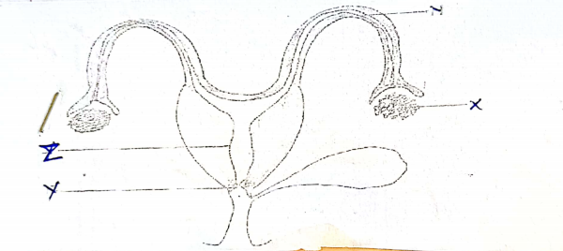

- Name the parts labelled X and Y (2mks)
X
Y
- Give two functions of the part labelled Z (2mks)
…………………………………………………………………………………………………………………………………………………………………………………………………....................
- Name any disease that can be transmitted to the above reproductive system through natural mating (1mk) ………………………………………………………………………………………………………………………………………………………………………………………………

- The diagram below shows a farm structure, use it to answer the questions that follow.
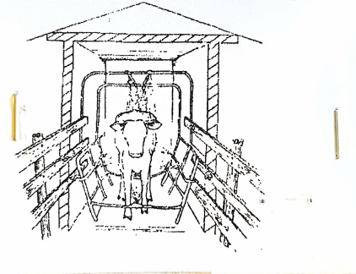
- Identify the practice being carried out (1mk)
............................................................................................................................................................
- Name the structure in which the practice is being carried out (1mk)
………………………………………………………………………………………………………
- Give three advantages of the above structure (3mks)
………………………………………………………………………………………………………………………………………………………………………………………………………………………………………………………………………………………………………………………………………………………………………………………………………………………………

- Study the diagrams below carefully and answer the questions that follow.
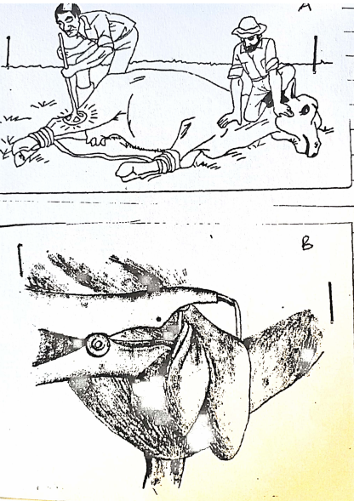
- Identify the livestock management practice taking place in diagram A and B (2mks)
A…………………………………………………………………….
B…………………………………………………………………….

- State two problems associated with practice A in the diagram above (2mks)
………………………………………………………………………………………………………………………………………………………………………………………………………………
- What is the importance of carrying out the management practice illustrated by diagram B? (1mk)
............................................................................................................................................................
- Study the illustration below and answer the questions that follow.
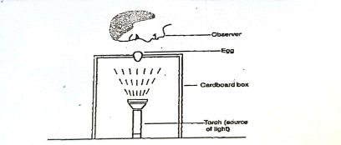
- Identify the practice (1mk)
………………………………………………………………………………………………………
- Why is the practice recommended on the 18th day of incubation? (1mk)
………………………………………………………………………………………………………
- State three defects of an egg that can be detected using this set up (3mks)
………………………………………………………………………………………………………………………………………………………………………………………………………………………………………………………………………………………………………………………………………………………………………………………………………………………………

SECTION C (40 MARKS)
Answer Any Two Questions from This Section
- a) Describe the procedure of erecting wooden post for fencing (10 mks)
b) Describe the process of egg formation in the reproductive system of a hen (6 mks)
c) State four predisposing factors of mastitis in cattle (4 mks)

24. a) Describe seven advantages of artificial insemination (7 mks)
b) State five factors to be considered when formulating a livestock ration (5 mks)
c) Describe the effect of parasite on livestock (8 mks)

25. a) What preparation would a farmer carryout in preparation for arrival a day old chicks
(8 mks)
b) Discuss pneumonia in calves under the following sub-heading (8 mks)
i. Symptoms
ii. Control
c) State four causes of long calving intervals (4 mks)

