NAME: ………………………………………………………… INDEX NO. ………..……………

SCHOOL………………………………………….………………………………………………… CANDIDATE’S SIGN……………………….

DATE……………………

233/1

CHEMISTRY

PAPER I

TIME 2HRS

**BUTULA SUB-COUNTY JOINT EVALUATION EXAM - 2021.**

***Kenya Certificate of Secondary Education (K.C.S.E)***

FORM 4 JOINT EXAMS

DECEMBER 2021

***INSTRUCTIONS TO CANDIDATES.***

* Write your name and Index number in the spaces provided.
* Answer all the questions in the spaces provided below each question.
* All working MUST be clearly shown where necessary.
* Sign and write the date of examination in the spaces provided above.
* Electronic calculators may be used.

For Examiner’s use only.

|  |  |  |
| --- | --- | --- |
| Question | Maximum score | Candidates’ Score |
| 1 – 29 | 80 |  |
| **TOTAL** | |  |

1. (a) Give two reasons why glass apparatus are used for heating in the laboratory. (2marks)

......................................................................................................................................................................................................................................................................................................................................................................................................................................................................................................

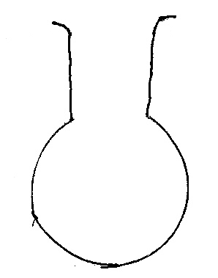(b)The diagram below shows a laboratory apparatus.

1. Name the apparatus (1 mark)

…………………………………………………………………………………………………………….

1. (a) State Graham’s law of gaseous diffusion (1 mark)

................................................................................................................................................................................................................................................................................................................................................ ........................................................................................................................................................................

(b) 60 cm3 of ozone (O3) diffused through a semi permeable membrane in 80 seconds. Calculate the time taken for 90 cm3 of nitrogen (IV) oxide (NO2) to diffuse under the same conditions. (O=16, N=14). (3marks)

................................................................................................................................................................................................................................................................................................................................................ ........................................................................................................................................................................

................................................................................................................................................................................................................................................................................................................................................ ........................................................................................................................................................................

1. The grid below is part of the periodic table. Study it and answer the questions that follow. The letters are not actual symbols of elements.

|  |  |  |  |  |  |  |  |  |
| --- | --- | --- | --- | --- | --- | --- | --- | --- |
|  |  |  |  |  |  |  |  |  |
| A |  |  | D | E |  |  | H | I |
| B | C |  | M |  | F | G |  | J |
|  |  |  |  |  |  |  |  |  |

(a) What is the name given to the chemical family of element **C**? (1 mark)

………………………………………………………………………………………………………......

b) Compare the ionization energies of **B** and **M**. Explain. (2 marks)

................................................................................................................................................................................................................................................................................................................................................ ........................................................................................................................................................................

........................................................................................................................................................................

1. Describe how a sample of Lead (II) chloride can be prepared using the following reagents dilute nitric (V) acid; dilute hydrochloric acid and lead carbonate (3marks)

................................................................................................................................................................................................................................................................................................................................................ ........................................................................................................................................................................

........................................................................................................................................................................ ........................................................................................................................................................................

........................................................................................................................................................................

1. a) Distinguish between nuclear fission and nuclear fusion. (1 mark)

........................................................................................................................................................................

................................................................................................................................................................................................................................................................................................................................................

b) Calculate the values of P and Q in the following nuclear equation.

${}_{92}^{239}U\underset{→}{}{}_{Q}^{p}{Th}$ +2α+2β (2 marks)

................................................................................................................................................................................................................................................................................................................................................

................................................................................................................................................................................................................................................................................................................................................

1. I. When aqueous solution of Iron(II)chloride and potassium thiocyanate are mixed, the equilibrium below was achieved:

Fe3+(aq) + CNS-(aq) Fe(CNS)2+(aq)

(brown) (colourless) (blood red)

State and explain the effect of adding a few drops of potassium hydroxide to the equilibrium mixture. (2marks)

................................................................................................................................................................................................................................................................................................................................................

................................................................................................................................................................................................................................................................................................................................................

II. Given the reaction below

Zn(s) +2HCl(aq) ZnCl2(aq) +H2(g)

State how the following factors affect the rate of reaction giving explanation

(a) Using Zinc powder instead of granules (1mark)

……………………………………………………………………………………………………………………………………………………..………………………………………………………………………..

(b) Heating the reactants (1mark)

………………………………………………………………………………………………………………………………………………………………………………………………………………………………

1. Study the flow chart below and answer the questions that follow.

Ethanol

Ethene

U

L

K

Step 1

Step 2

Polymerization

Step 3. Temp. of 1500C

Nickel catalyst, H2

(a) Identify substances : K, U, L (1 mark)

.....................................................................................................................................

(b) State the conditions for the reaction in step 1 to occur. (1 mark)

………………………………………………………………………………………………………………

1. The following data refer to an element X.

|  |  |  |  |
| --- | --- | --- | --- |
| **Isotope** | **P** | **Q** | **R** |
| Mass | 54 | 56 | 57 |
| %abundance | 6 | 92 | 2 |

Calculate the relative atomic mass of element X (2mks)

........................................................................................................................................................................................................................................................................................................................................................................................................................................................................................................................................................................................................................................................................................

1. a) State Faraday’s law of electrolysis (1 mark)

........................................................................................................................................................................................................................................................................................................................................................................................................................................................................................................................

b) When a current of 2.5 amperes was passed through a cell containing N2+ ions of a metal for 25minutes, the mass of the cathode increased by 0.36g. Determine the relative atomic mass of element N. (*1 Faraday = 96500 coulombs*) (3 marks)

................................................................................................................................................................................................................................................................................................................................................

................................................................................................................................................................................................................................................................................................................................................ ................................................................................................................................................................................................................................................................................................................................................

1. The diagram below represents a set-up used to prepare oxygen gas.

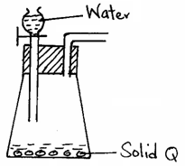

1. Name substance Q. (½ mark)

........................................................................................................................................................................

1. Complete the set-up to show how dry oxygen gas is collected. (1½ marks)

(c) Write the equation for the reaction that occurs when magnesium burns in air (1 mark)

........................................................................................................................................................................

1. In an experiment to investigate the reaction between acids and metal carbonates, a student reacted zinc carbonate with dilute hydrochloric acid, and the resulting gas was bubbled in excess through lime water in a boiling tube.

(a) State and explain the observations made in the boiling tube at the end of the experiment. (2 marks)

................................................................................................................................................................................................................................................................................................................................................

........................................................................................................................................................................

(b) Write an equation for the reaction took place at the end of the experiment. (1 mark).

………………………………………………………………………………………………………………

1. Use the thermo-chemical equations below to answer the questions that follow.

C(s) + O2(g) CO2(g) ΔH = -406KJ mol-1

H2(g) + ½ O2(g) H2O(l)ΔH = -286KJmol-1

C3H8(g) + 5O2(s) 3CO2(g) + 4H2O(l)ΔH = -2209KJmol-1

Draw an energy cycle diagram and use it to calculate the heat of formation of propane. (3 marks)

................................................................................................................................................................................................................................................................................................................................................

................................................................................................................................................................................................................................................................................................................................................

........................................................................................................................................................................................................................................................................................................................................................................................................................................................................................................................

1. A student mixed equal volumes of Ethanol and ethanoic acid. He added a few drops of concentrated Sulphuric (VI) acid and warmed the mixture.

(i) Name and write the formula of the main products (1 mark)

Name…………………………………………………………………..…….

Formula…………………………………………………………………..…..

(ii) Which homologous series does the product named in (i) above belong? (1mark) ………………………………………………………………………………………………………………

1. The apparatus below was set up to show the catalytic oxidation of ammonia. Study the diagram and answer the questions that follow

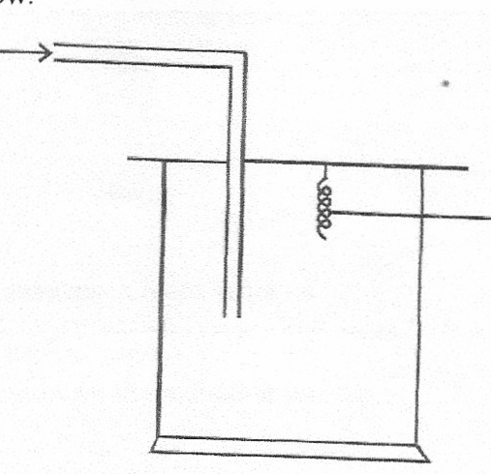

Dry NH3(g)

**Hot nichrome wire**

(i) Write an equation for the reaction that takes place in the gas jar (1mark)

……………………………………………………………………………………………………..………

(ii) What is the role of hot nichrome wire? (1mark)

……………………………………………………………………………………………………..……………………………….……………………………………………………………………………………..

(iii) Write the formula of the complex ion formed when excess ammonia gas is passed through a solution containing Zn2+ ions. (1mark)

……………………………………………………………………………………………………..………

1. a) Define the term allotrope (1mark)

................................................................................................................................................................................................................................................................................................................................................

(b). Name two non-crystalline allotropes of sulphur (1mark)

........................................................................................................................................................................

(c) Diamond and graphite are both allotropes of carbon. Explain why graphite is used as a lubricant whereas diamond is used as an abrasive. (1 mark)

........................................................................................................................................................................

1. The table below shows PH values of some solutions

|  |  |  |  |  |
| --- | --- | --- | --- | --- |
| Solution | A | B | C | D |
| PH values | 13 | 7 | 1 | 6.5 |

(a) What solution reacts vigorously with Magnesium metal? (1mark)

……………………………………………………………………………………………………..………

(b) Industrial Hydrochloric acid (1mark)

……………………………………………………………………………………………………..………

(c) Which solution forms complex ions with zinc (II) oxide? (1mark)

………………………………………………………………………………………………………………

1. Draw the structural formula for each of the following compounds

(a) 4,4-dimethylpent-2-ene (1mark)

................................................................................................................................................................................................................................................................................................................................................ ........................................................................................................................................................................

........................................................................................................................................................................

(b) Give the systematic IUPAC name of the following substances

ii) CH3 CH Br CH Br CH3 (1mark)

……………………………………………………………………………………………………………..

1. A hydrated salt has the following composition by mass. Iron is 20.2%, oxygen is 23.0% sulphur is 11.5%, water 45.3%. Its relative formula mass is 278. Determine the formula of the hydrated salt.

(Fe=56, S=32.0, O=16, H=1) (2marks)

................................................................................................................................................................................................................................................................................................................................................ ........................................................................................................................................................................

........................................................................................................................................................................

........................................................................................................................................................................

1. The diagram shows the apparatus used to separate different dyes in food colouring.

A

B

I Name the parts labeled A & B (1 mark)

A: …………………………………………………………………………………………

B: ……………….…………………………………………………………………………

II Thediagram below shows electrolysis of lead bromide

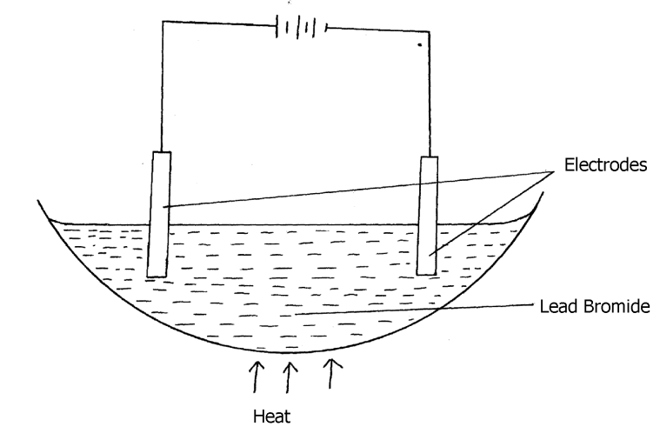

a) Label the anode and cathode (1mark)

b) Write half equations to shows reactions at cathode. (1mark)

……………………………………………………………………………………………………………..

1. The set-up below shows the products formed when solid lead (ii) nitrate is heated.

Heat gas y

-

-

Lead II Nitrate - -

Crystals-

Liquid x ice cold mixture

a) Identify:

(i) Liquid x …………………………………………………………… (½ mark)

(ii) Gas y……………………………………………………………… (½ mark)

(iii) Write an equation for the reaction taking place in the combustion tube. (1 mark)

………………………………………………………………………………………………………………

1. Study the flow chart below and answer the questions that follow.

Iron

Heat Compound T HCl(aq) Gas U +

FeCl2(aq)

Sulphur

(a) Name: (i) Compound T _________________________________________ (½ mark)

(ii) Gas U ______________________________________________ (½ mark)

(b) State a physical property that you could use to identify gas U. (1 mark)

……………………………………………………………………………………………………………….

1. (a) The melting point of phosphorous trichloride is -9180 C and that of sodium chloride is 8010 C. Explain the huge difference in their melting points. (2marks)

........................................................................................................................................................................................................................................................................................................................................................................................................................................................................................................................

1. The electronic arrangement of two stable ions Q2+ and P2- are 2.8.8 and 2.8.8 respectively.

(a) Write the electron arrangement of neutral atoms **Q** and **P**. (1 mark)

**Q**………………………………………………………………………………………....…

**P**………………………………………………………………………………………....…

(b) What is the most likely structure of an oxide element **P**? (1 mark)

………………………………………………………………………………………………………………

1. The structures shown below represents two cleansing agents A and B.

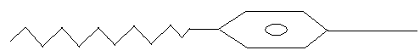

COO-Na+ SO3-Na+

A B

(i) Identify the cleansing agents A and B (1 mark)

**A** ……………………………………………………………………………………………………

**B** …………………………………………………………………………………………………….

(ii) Explain how the cleaning properties of the above cleansing agents can be improved. (1 mark)

........................................................................................................................................................................

……………………………………………………..………………………………………………………..

1. 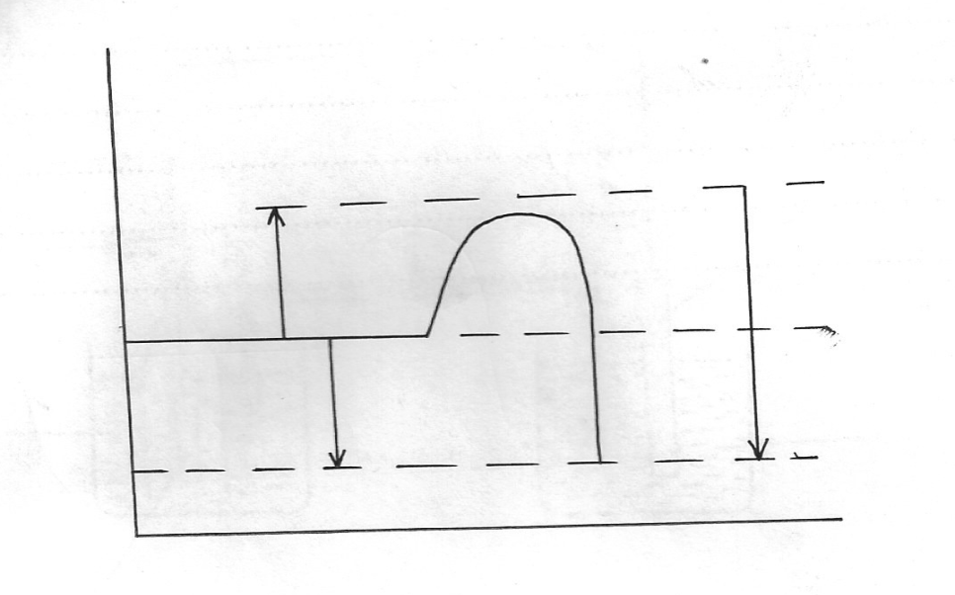Sulphur burns in air to form sulpur (IV) oxide. A simple energy level energy level diagram for the reaction is given below. Study the diagram and answer the questions that follow:

SO2(g)

ΔH2

ΔH3

ΔH1

S(g) + O2(g)

Reaction co-ordinate

**Energy**

(a) On the diagram indicate the activation energy (1 mark)

(b) Write an expression for ΔH3in terms ofΔH1and ΔH2 (1mark)

……………………………………………………………………………………………………………..

1. Study the flow chart below and use it to answer the questions that follow:

**Solution containing Pb2+**

**Step I**

**Na2SO4(aq)**

**Lead metal**

**Solid R**

**Step II**

**Step III**

**Few drops of NaOH(aq)**

**White precipitate**

**Step IV**

**Excess NaOH**

**Colourless solution**

(a) Identify the reagent used in step **I.**  (1mark)

……………………………………………………………………………………………………....…

(b) Name solid **R**. (1mark)

……………………………………………………………………………………………………....…

(c) Explain the observation in step **IV**. (1mark)

........................................................................................................................................................................

........................................................................................................................................................................

1. Study the set- up below and answer questions that follows.

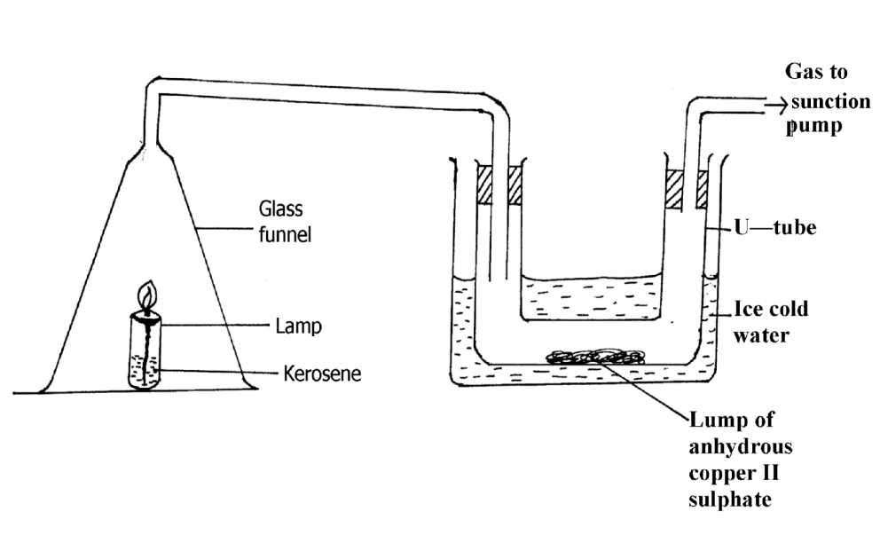

a) State and explain the observation made in the U- tube. (1½ marks)

................................................................................................................................................................................................................................................................................................................................................ ........................................................................................................................................................................

........................................................................................................................................................................

b) Explain what will happen to lamp when the suction pump is turned off. (1½ marks)

................................................................................................................................................................................................................................................................................................................................................

........................................................................................................................................................................

1. Using dot ( •) and crosses ( x) diagram to represent electrons in the outer most energy levels only show bonding in;

(a) Phosphine molecule.PH+4. (P = 15, H = 1) (1 mark)

................................................................................................................................................................................................................................................................................................................................................ ........................................................................................................................................................................

............................................................................................................................................................................................................................................................................................................................

(b) Ammonia (NH3) (1 mark)

................................................................................................................................................................................................................................................................................................................................................ ........................................................................................................................................................................

...............................................................................................................................................................................................................................................................................................................................

1. The set up below was used to prepare dry sample of chlorine gas.

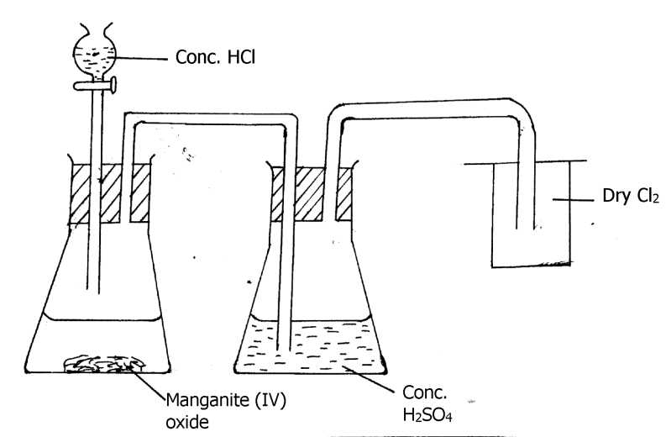

a) What is the function of manganese (IV) oxide in the preparation of chloride (1mark)

................................................................................................................................................................................................................................................................................................................................................

b) Write a chemical equation for the formation of chlorine gas. (1 mark)

........................................................................................................................................................................

c) Explain the observations made when chlorine gas is bubbled through a solution of iron II sulphate. (2marks)

................................................................................................................................................................................................................................................................................................................................................

**THIS IS THE LAST PRINTED PAGE.**