Name……………………………………………………. Index Number ………………………

Candidate’s Signature…………………………………School…………………………………….
Date......................................

312/2
GEOGRAPHY
Paper 2
Nov. 2021
Time: 2hours and 45 minutes

THE KENYA NATIONAL EXAMINATIONS COUNCIL
BUTULA CLUSTER FORM 4 JOINT EVALUATION
Kenya Certificate of Secondary Education (KCSE)
GEOGRAPHY Paper 2
23/4 hours
Instructions to candidates
(a) This paper has two sections: A and B.
(b) Answer all the questions in section A.
(c) Answer question 6 and any other two questions from section B.
(d) All answers must be written in the answer booklet provided.
(e) This paper consists of 6 printed pages.
(f) Candidates should check the question paper to ascertain that all the pages are printed as indicated and that no questions are missing.
(g) Candidates should answer the questions in English.

QUESTION
SECTION A
6
7
8
9
10
TOTAL SCORE

SECTION A
Answer all the questions in this section
- (a) Name two exotic species of trees planted in Kenya ( 2 mks)
(b) State three reasons why it is necessary to carry out afforestation
programs in Kenya ( 3 mks)
2a) Name two water canals found in Africa. (2mks)
b) Give three roles of transport on industry. (3mks)
3. (a) State three measures which the government of Kenya has taken to reduce infant mortality
(3 marks)
(b) Give two negative effects of lowpopulation growth in a country. (2 marks)
4a) Give any two minerals found in the Rhur region of Germany. (2mks)
b) Identify three main types of industries found in Kenya. (3mks)
5a) List two factors influencing trade ( 2 marks)
b) Identify THREE major imports to Kenya. (3 marks)

SECTION B
Answer question 6 and any other two questions from this section

6. 6. Study the photograph below and answer the questions that follow.

a i) Identify the type of photograph above. (1mk)

ii) Give two reasons for your answer above. (2mks)

iii) Draw a rectangle measuring 8cm by 6cm. on it, mark and label the main features.
(4mks)

b i) Name two types of coffee grown in Kenya. (2mks)

ii) Name three counties in Western Kenya where coffee is grown. (3mks)
iii.)Give three conditions favoring coffee growing in Kenya (3marks)

c i) State three problems facing coffee farmers in Kenya. (3mks)

ii) Identify three ways in which the government has attempted to promote coffee farmers in Kenya. (3mks)

d Explain two reasons why coffee production is more developed in Brazil than in Kenya.
(4mks)

7. a) Apart from the sun, name three other sources of energy (3Marks)
ii) State four advantages of using solar energy (4Marks)
b) Give four ways in which Kenya has benefited from hydroelectric power scheme
(4Marks)
c) Explain five factors favouring development of Hydroelectric power projects

(10Marks)
d) Explain two impacts of energy crisis in the society. (4Marks)

8a)i.) Define the term land reclamation. (2mks)

ii) State three ways through which land can be rehabilitated in Kenya.(3mks)

b) A part from Mwea Tebere, identify any three irrigation schemes in Kenya.
(3mks)

ii) Explain three physical factors that influenced the location of Mwea Tebere irrigation scheme. (6mks)
c) Give three problems facing Mwea Tebere irrigation scheme. (3mks)

d) Identify two benefits of Zuyder Zee project in Netherlands (2mks)

- Explain three similarities between land reclamation in Kenya and Netherlands.
(6mks)

9. a) Define the term Mining. (2mks)

ii) List three ways in which minerals occur.(3mks)

b) Identify any three minerals mined within the rift valley of Kenya. (3mks)

ii0 Mention any two problems associated with underground mining.(2mks)

c) Study the diagram below and answer the questions that follow.
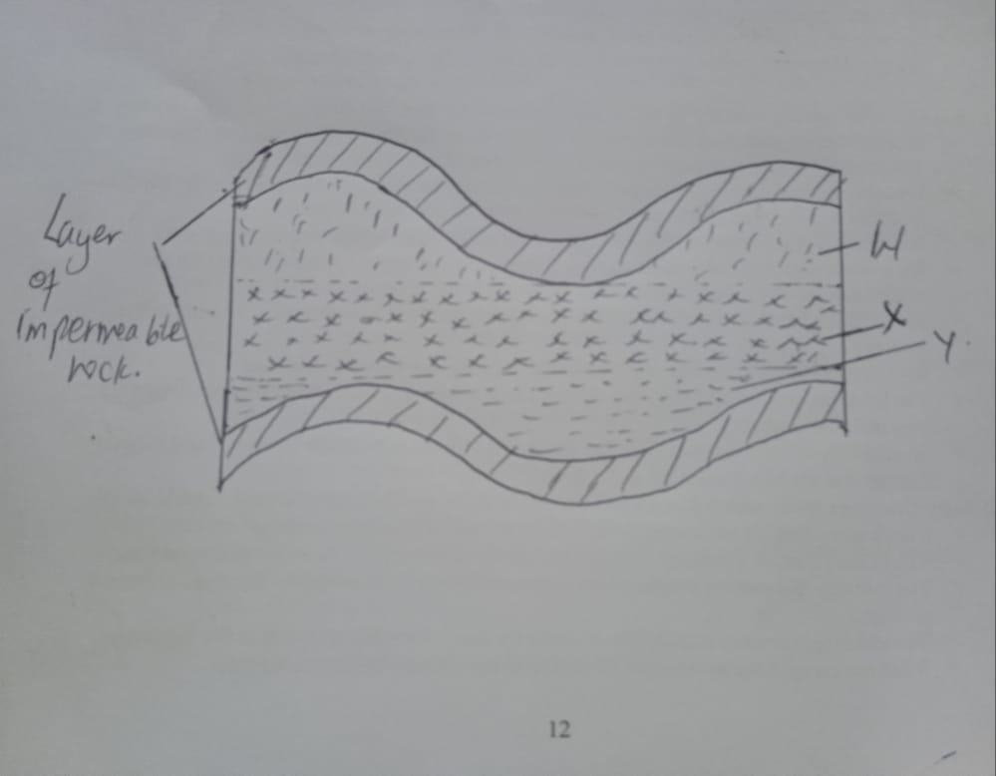

- Name the part labeled WXY (3mks)

- State three conditions that favor the formation of an oil reservoir. (3mks)

d) Students carried out a field study in a mining site.

i) State one objective of the study. (1mk)

ii) Give two methods they used to collect data. (2mks)
iii) Identify the features they may have observed to conclude that the land has been derelicted. (3mks)

iv)A part from land dereliction, give three other effects of mining on the environment. (3mks)

10. a) Define the term environment. (2mks)

ii) State three farming methods that assist in soil conservation. (3mks)

b) State three ways in which people are affected by floods. (3mks)

ii) Explain three methods in which floods can be controlled. (6mks)

c) Give two causes of water pollution. (2mks)

ii) State three effects of water pollution on environment. (3mks)

iii) Explain any three ways in which drought and desertification can be controlled.(6mks)

