**NAME:…………………………………………………INDEX NO:…………………………**

**SCHOOL:………………………………………………DATE:……………………………….**

**SIGN:………………………………..**

**232/2**

**PHYSICS**

**(THEORY)**

**DECEMBER 2021**

**TIME: 2 HOURS**

**BUTULA SUB COUNTY JOINT EVALUATION**

**KENYA CERTIFICATE OF SECONDARY EDUCATION (KCSE)**

**INSTRUCTIONS TO CANDIDATES**

1. Write your name and index number in the spaces provided at the top of this page.

2. Sign and write the date of examination in the spaces provided above.

3. This paper consists of **TWO** sections: A and B

4. Answer **ALL** the questions in the sections A and B in the spaces provided.

5. ALL working **MUST** be clearly shown.

6. Non-programmable silent electronic calculators and **KNEC** mathematical tables may be used.

**FOR EXAMINERS USE ONLY.**

|  |  |  |  |
| --- | --- | --- | --- |
| **SECTION** | **QUESTIONS** | **MAXIMUM SCORE** | **CANDIDATE’S SCORE** |
| A | 1 – 11 | 25 |  |
| B | 12 | 11 |  |
| 13 | 10 |  |
| 14 | 10 |  |
| 15 | 11 |  |
| 16 | 13 |  |
| **Total Score** |  | **80** |  |

*This paper consists of 12 printed pages.*

*Candidates should check the question paper to ensure that all pages are printed as indicated and that no questions are missing.*

***SECTION A (25 marks)***

1.The figure below shows two mirrors inclined at an angle of 80° to each other. A ray of light is incident on Mirror as shown below.



1. Complete the path of the ray as it emerges. (1 mark)
2. Indicate the angle of reflection on each mirror. (2 marks)

2. State the reason why the magnetic field strength of a magnet is greatest at the poles.

(1 mark)

______________________________________________________________________________________________________________________________________________

_________________________________________________________________

3. You are provided with; 1.0 $μ F$, 2.0 $μ F$ and 3.0 $μ F$ capacitors. Arrange the three capacitors with a cell such that the total capacitance is 1.5. (3 marks)

______________________________________________________________________________________________________________________________________________

______________________________________________________________________________________________________________________________________________

4. Fours pins were hang onto two magnets as shown. 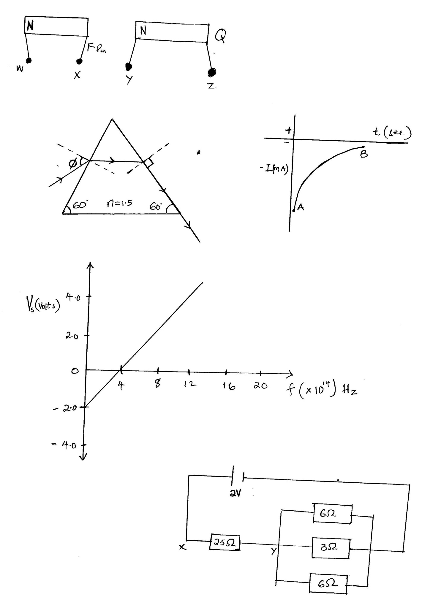

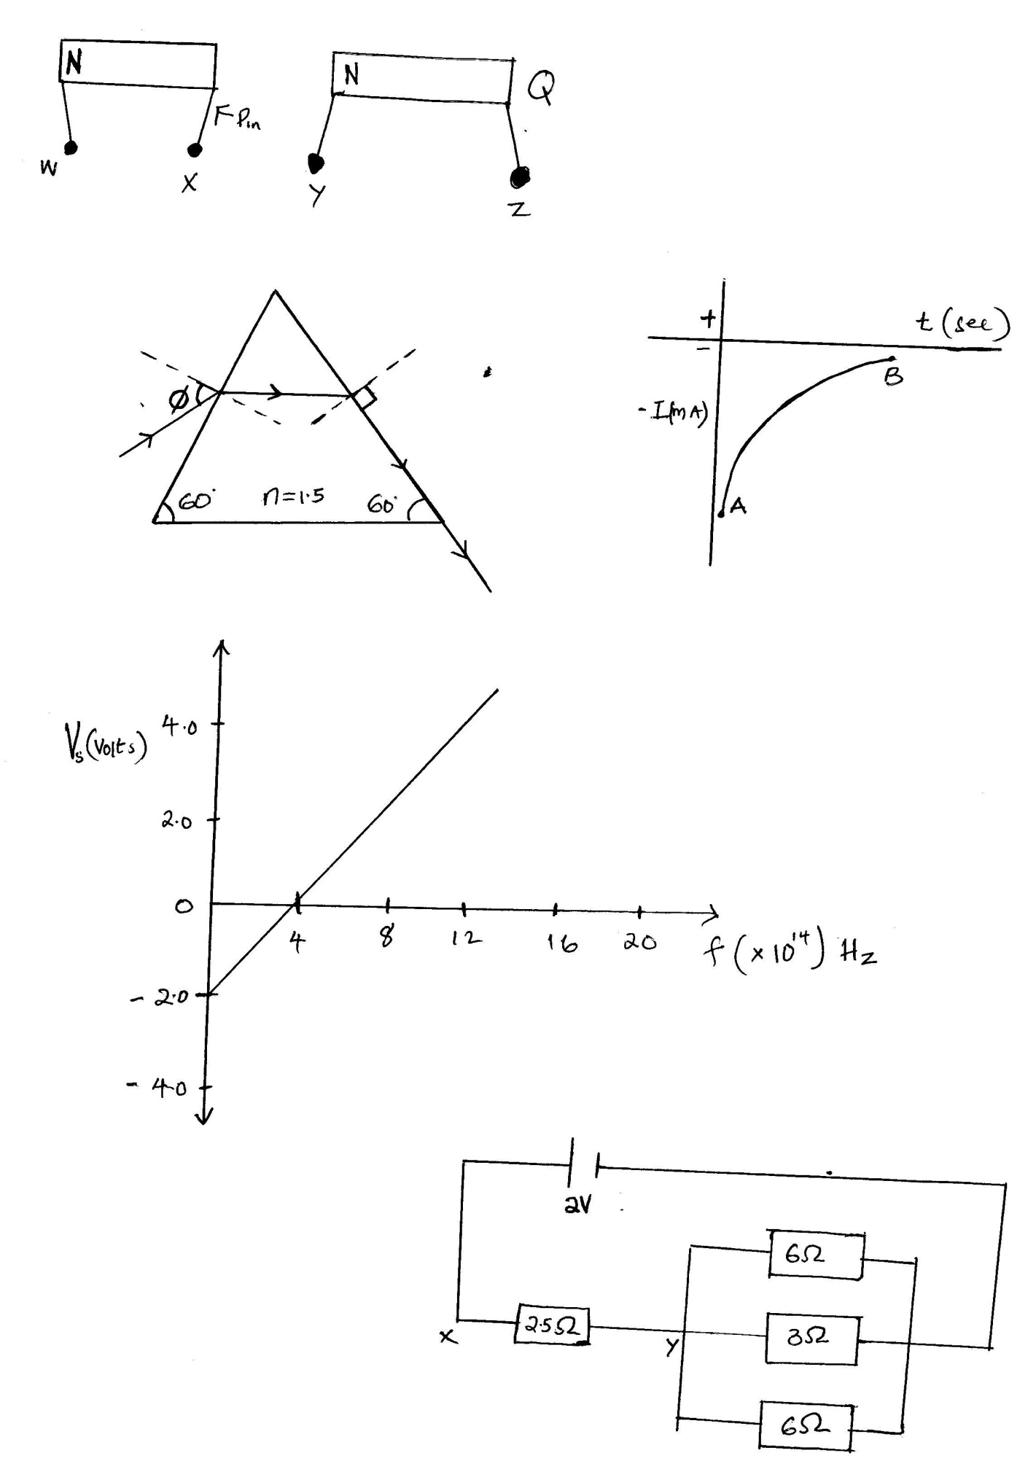

X…………….

Z……………

Q……………..

Identify the polarity on end X, Z, and Q. (3mks)

X: _______________________________________

Z:____________________________________

Q:________________________________

**5. The** Figure shows a cathode ray entering into a region between two charged plates.

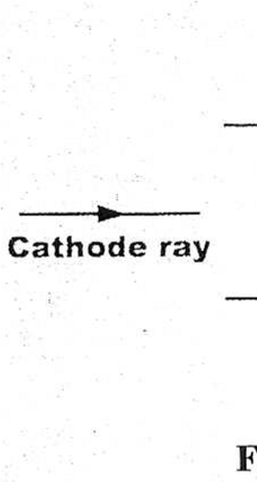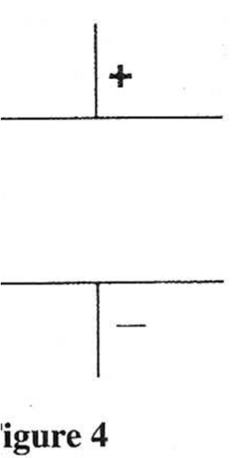

Complete the diagram to show the path of the ray in the field. (1 marks)

**6.** A form two student found the dry cells leaking on removing them from the torch. Name this defect and how is minimized. (2 marks)

______________________________________________________________________________________________________________________________________________________________________________________________________

7. Below is radioactive decay.

$\begin{matrix}232 \\ 90\end{matrix}A$ $\begin{matrix}228 \\ 88\end{matrix}$ B $\begin{matrix}y \\ x\end{matrix}C$

K

$$gamma$$

(i) Identify radiation K. (1 mark)

____________________________________________________________________________________________________________________________________

(ii) Determine the values of x and y. (2 marks)

___________________________________________________________________________________________________________________________________

**8. The figure below** shows a ray of light passing into a glass prism ABC.

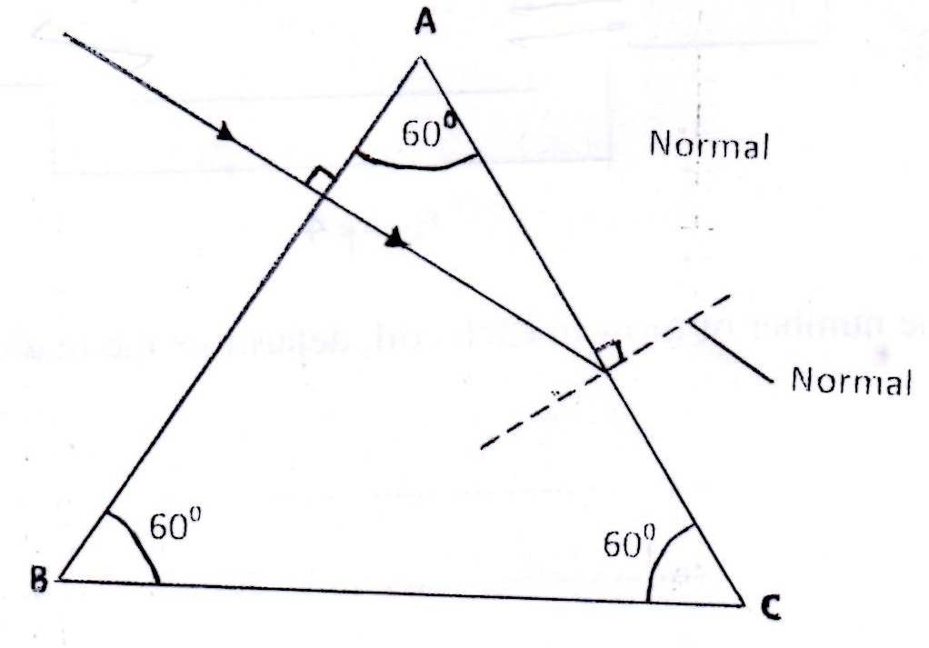

Sketch the path of the ray as it travels from face AC. (*critical angle for glass is 420*)

(2 marks)

_______________________________________________________________________________________________________________________________________________________________________________________________________________________

9. An electric heater is rated 1000W, 240V. Calculate the resistance of this element.

(3 marks)

___________________________________________________________________________________________________________________________________________________________________________________________________

10. The figure below shows electromagnetic spectrum.

|  |  |  |  |  |  |  |
| --- | --- | --- | --- | --- | --- | --- |
| Radio wave | Microwave | A | Visible light | UV | X- ray | Gamma radiation |

a) Identify A. (1 mark)

________________________________________________________________________

b) State how A is detected. (1 mark)

________________________________________________________________________

**11.** Study the figure below and answer the question that follows.



   When switch is closed at x, the lamp lights but when switch is closed at Y, the lamp does not light. Explain this observation. (2 marks)

______________________________________________________________________________________________________________________________________________________________________________________________________

**SECTION B (55 Marks)**

12. a) Distinguish between rarefaction and compression. (1 mark)

____________________________________________________________________________________________________________________________________

b) The **figure** below shows a displacement (cm) time graph for a progressive wave.

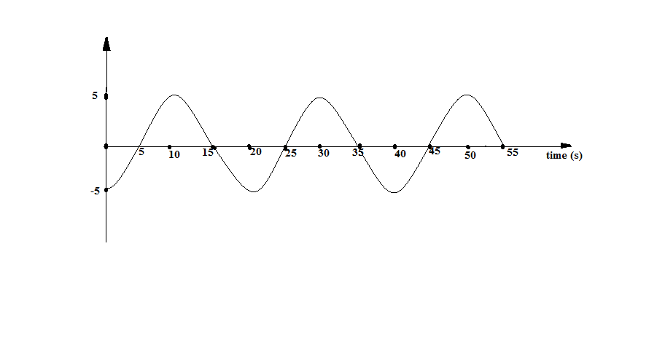

i) State the amplitude of the wave. (1mark)

____________________________________________________________________________________________________________________________________________________________________

ii) Determine the frequency of the wave. (2marks)

____________________________________________________________________________________________________________________________________________________________________

_______________________________________________________

iii) Given that the velocity of the wave is 320cm/s determine its wavelength (3marks)

______________________________________________________

______________________________________________________________________________________________________________

b) A man standing600 away from a wall hangs two pieces of wood together and hears an echo 2.5 seconds later. Determine the speed of sound in air at that place. (3 marks)

________________________________________________________________________________________________________________________________________________________________________________________________________________________________________________________________________

c) State any one use of x- rays in medicine. (1 mark)

____________________________________________________________________________________________________________________________________

13. (a) State two factors that affect photoelectric emission. (2 marks)

________________________________________________________________________________________________________________________________________________________________________________________________________________________

(b) Light of wavelength 4.3 x 10-7m is incident on two different metal surfaces, nickel and potassium.

(*Take speed of light as 3.0 x 108 ms-1and planks constant h, as 6.63 x l0-34Js*).

* + - 1. Determine the energy of the incident radiation. (3 marks) ________________________________________________________________________________________________________________________________________________________________________________________________________________________________________________________________________________________________________________________________________________________________________________________________________
      2. If the work function of nickel is 8.0 x 10-19J and that of potassium is 3.68 x 10-19J, state with a reason from which of the two metals the given light will eject electrons. (2 marks) __________________________________________________________________________________________________________________________________________________________________________________________________________________________________________________________________________________________________________________________________________

(iii) Determine the velocity of the emitted electrons from the metal surface in b(ii). *(Take the mass of an electron as 9.1 x 10-31 kg).*  (3 marks) ________________________________________________________________________________________________________________________________________________________________________________________________________________________________________________________________________________

14. a) Figure below shows an experimental set up consisting of a mounted lens, I, A screens, a metre rule and a candle

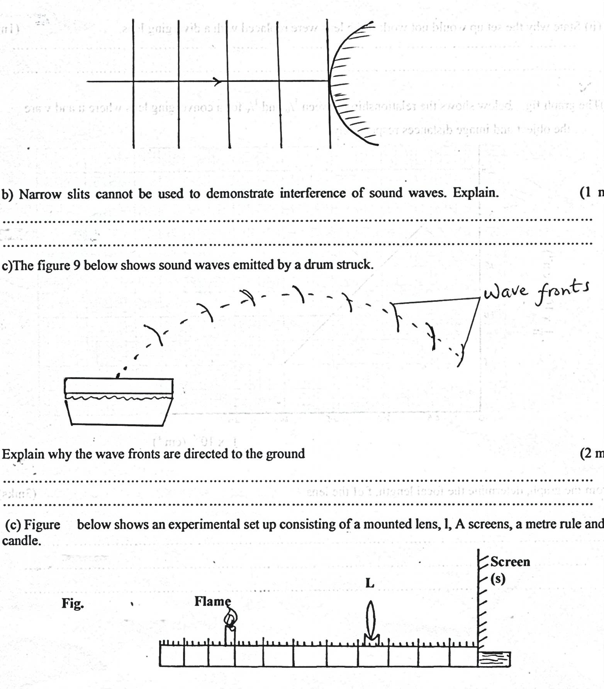

**Flame**

**Screen (S)**

**L**

1. Describe how the set up may be used to determine the focal length f, of the lens. (3 marks)

_________________________________________________________________________________________________________________________________________________________________________________________________________________________________________________________________________________________________________________________________________________________________________________

ii) State why the set up would not work if the lens were replaced with a diverging lens.

(1 mark)

________________________________________________________________________________________________________________________________________________

b) The Figure below shows an object in front of concave mirror and it’s image.

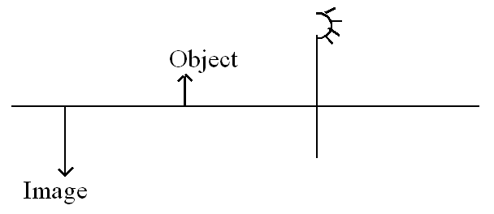

i) Locate position of its principal focus. (3marks)

ii) If the figure is drawn to scale, determine the magnification. (2 marks)

________________________________________________________________________________________________________________________________________________________________________________________________________________________________________________________________________________________________

c) State one reason why a convex mirror is preferred over a plane mirror for use as a driving Mirror. (1 mark)

________________________________________________________________________________________________________________________________________________________________________________________________________________________

15.a) State Lenz’s law. (1 mark)

______________________________________________________________________________________________________________________________________________________________________________________________________

b) The diagram in the figure below shows a bar magnet attached to a spring oscillating through

a coil connected to a galvanometer.

Magnet

Galvanometer

Coil

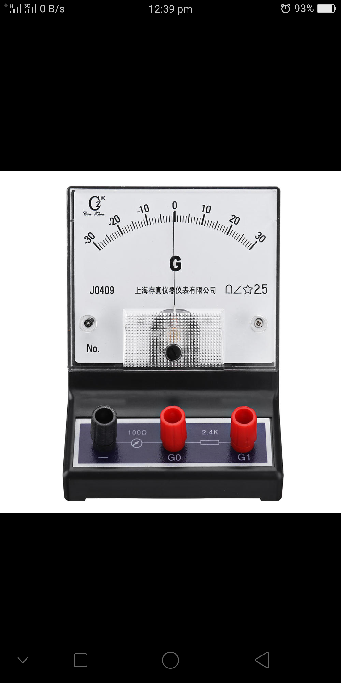

N

1. State and explain the observations made on the pointer of the galvanometer.(2 marks)

____________________________________________________________________________________________________________________________________________________________________________________________________________________________________________________________________________________

ii). Explain why the oscillations dies off very fast. (1 mark)

________________________________________________________________________________________________________________________________________________________________________________________________________________________

c) The primary coil of a transformer has 1200 turns and the secondary coil has 60 turns. The

transformer is connected to a 240V A.C source. Assume there are no energy losses, determine secondary voltage (2 marks)

_____________________________________________________________________________________________________________________________________________________________________________________________________________________________________________________________________________________________

**d)** The following figure shows a coil in a magnetic field. The coil is rotated in the direction shown by the arrow to produce an alternating current.



i) Name the parts labelled X. (1 mark)

____________________________________________________________________________________________________________________________________________

ii) State two factors that influence the magnitude of the induced e.m.f (2 marks)

_______________________________________________________________________________________________________________________________________________

e) State and explain any one ways by which energy losses are minimized in a transformer.

(2 marks)

____________________________________________________________________________________________________________________________________________________________________________________________________________

18. a) Give a reason why power is transmitted at high voltage. (1 mark)

____________________________________________________________________________________________________________________________________

b) The cost of electricity in a region is sh.7.20 per kwh.

I.a 1.5KW water heater for 1 hour per day.

II.a 100W light bulb for 30 days at 12 hours per day and

III. a fan of resistance 24ohms connected to a 240V supply for 30 days at 2 hours per day.

i) What would be the monthly bill for a household using the above appliances? (3 marks)

_______________________________________________________________________________________________________________________________________________________________________________________________________________________________________________________________________

ii) In addition to the energy consumed, the company charges each customer the following.

I.a monthly standing charge of sh.150.00.

II.a fuel cost levy of 50 cents per kwh consumer.

III. a foreign exchange levy of 40cts per kwh.

IV. a value added tax of 16% of the monthly energy consumption

Find the total monthly bill.(2 marks)

________________________________________________________________________________________________________________________________________________________________________________________________________________________

 c) The figure below shows an electric circuit with two bulbs X and Y, which are identical.



Explain what happens to the bulbs when:

1. S1 only is closed. (1 mark)

________________________________________________________________________________________________________________________________

1. S1 and S2 are closed. (1 mark)

________________________________________________________________________________________________________________________________

d) The figure below shows an electric circuit.

Find

(i) the effective resistance. (2 marks)

________________________________________________________________________________________________________________________________________________________________________________________________________________________

  ii)the current supplied by the battery (3 marks)

________________________________________________________________________________________________________________________________________________________________________________________________________________________

________________________________________________________________________