**Name**:………………………………………...……… **Class** ……………………………….

**232/1**; **PHYSICS**   **Candidate’s Signature**:………………

**PAPER 1**

**JUNE/JULY 2021 Date**………………………………..

**TIME: $2\frac{1}{2}$ HRS**

**MOKASA 1 JOINT EXAMINATION**

***Kenya Certificate of Secondary Education (K.C.S.E.)***

**INSTRUCTIONS TO CANDIDATES**

* Write your name and index number in the spaces provided.
* Mathematical tables and non-programmable calculators may be used.
* This paper consists of four questions.
* Attempt all the questions in the spaces provided.
* ALL working MUST be clearly shown.

**For Examiners Use**

|  |  |  |  |
| --- | --- | --- | --- |
| **SECTION** | **QUESTIONS** | **MAXIMUM SCORE** | **CANDIDATE’S SCORE** |
| **A** | 1 – 10 | 25 |  |
| **B** | 11 | 10 |  |
| 12 | 13 |  |
| 13 | 12 |  |
| 14 | 13 |  |
| 15 | 07 |  |
|  | **TOTAL** | **80** |  |

***This paper consists of 11 printed pages. Candidates should check to ascertain that all pages are printed as indicated and that no questions are missing.***

**SECTION A** (25 MARKS)

*Answer* ***all*** *the questions in this section in the spaces provided.*

1. State the meaning of SI unit and give its significance. (2 marks )

……………………………………………………………………………………………… ……………………………………………………………………………………………… ……………………………………………………………………………………………… ………………………………………………………………………………………………

1. The human lung functioning normally can withstand a pressure of up to *5 atmospheres.* How deep in metres can an experienced diver go under water at normal atmospheric pressure?

(*1 atm = 10 metres of water*) (2 marks)

………………………………………………………………………………………………………………………………………………………………………………………………………………………………………………………………………………………………………………………………………………………………………………………………

1. The figure below is a set up used to study the behavior of gases

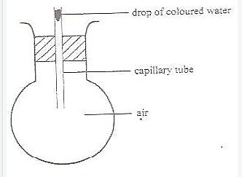

State and explain fully the observations made if the round bottomed flask is immersed in cold water. (2 marks)

……………………………………………………………………………………………… ………………………………………………………………………………………………

1. The diagram below shows a matchstick placed under a Bunsen burner flame

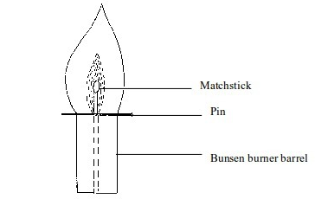

It is observed that the matchstick does not catch flame. Explain this observation. (2 marks)

……………………………………………………………………………………………… ……………………………………………………………………………………………… ……………………………………………………………………………………………… ………………………………………………………………………………………………

1. When an oil drop is placed on a clean water surface, it spreads to form a thin film. Explain why this happens. (1 mark)

……………………………………………………………………………………………… ……………………………………………………………………………………………… ……………………………………………………………………………………………… ………………………………………………………………………………………………

1. A ball of mass 600g falls from a height of 16 m and bounces back to a height of 10 m. Calculate the amount of sound energy produced. (Assume no other energy losses)

(3 marks)

……………………………………………………………………………………………… ……………………………………………………………………………………………… ……………………………………………………………………………………………… ………………………………………………………………………………………………

1. A balloon is filled with air to a volume of 100ml at a temperature of 300C. Determine the volume when the temperature rises to 700C at the same pressure. (2 marks)

……………………………………………………………………………………………… ……………………………………………………………………………………………… ……………………………………………………………………………………………… ………………………………………………………………………………………………

1. a) Explain why steam causes more serious burn than water at same temperature. (1 mark)

……………………………………………………………………………………………… ………………………………………………………………………………………………

b) Steam at 1000C was passed into 100g of cold water at 150C. When the temperature of the mixture reached 500C, its mass was found to be 106.1g. Assuming no heat losses to the surrounding, determine the latent heat of vaporization of water. (Take specific heat capacity of water to be 4200 J/kg/K) (3 marks)

……………………………………………………………………………………………… ……………………………………………………………………………………………… ……………………………………………………………………………………………… ………………………………………………………………………………………………

1. Complete the diagrams below to show the streamlines for a fluid flowing past the stationary object in the direction shown. (2 marks)
2. The diagram below shows the scale of vernier callipers when the jaws are closed

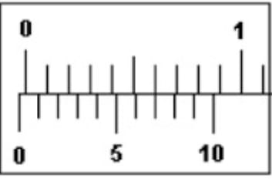

1. State the zero error. ( 1 mark)

………………………………………………………………………………………………

1. A student used the vernier calipers above to measure the length of a cube. If the mass and density of the cube were 6.86g and 2.5g/cm3, calculate the reading shown by the instrument. (4 marks)

……………………………………………………………………………………………… ………………………………………………………………………………………………

**SECTION B** (55 MARKS)

*Answer* ***all*** *the questions in this section in the spaces provided.*

1. The figure below represents a system in equilibrium



Determine the force F needed to maintain the system at equilibrium. (3 marks)

……………………………………………………………………………………………… ……………………………………………………………………………………………… ……………………………………………………………………………………………… ………………………………………………………………………………………………

1. A uniform rod of length 4m and mass of 4kg is pivoted at 3.6m mark. The rod is held horizontal with a vertical rope at the 4m mark, as shown in the figure below.



Calculate the tension, T in the rope (Take g = 10N/kg) (3 marks)

……………………………………………………………………………………………… ……………………………………………………………………………………………… ……………………………………………………………………………………………… ……………………………………………………………………………………………..

1. State two conditions necessary for a body acted upon by a number of parallel forces to remain at equilibrium. (2 marks)

………………………………………………………………………………………………………………………………………………………………………………………………………………………………………………………………………………………………

1. Explain why a bunsen burner has a heavy and wide base . (2 marks)

……………………………………………………………………………………………… ……………………………………………………………………………………………… ………………………………………………………………………………………………

1. (a) (i) State Newton’s second law of motion. (1 mark)

……………………………………………………………………………………………… ……………………………………………………………………………………………… ………………………………………………………………………………………………

(ii) A striker kicks a ball of mass 250g initially at rest with a force of 75N. If the

foot was in contact with the ball for 0.10 s. Calculate the take off velocity of

the ball. (2 marks)

……………………………………………………………………………………………… ……………………………………………………………………………………………… ……………………………………………………………………………………………… ………………………………………………………………………………………………

1. A bullet of mass 20g moving at 400 m/s strikes a block of wood of mass 3.5 kg

initially at rest. The bullet sticks into the block and the two move off together on a horizontal rough surface, with a frictional force of 4N acts between them and the surface.

(i) Determine the initial common velocity of bullet and wooden block. (3 marks)

……………………………………………………………………………………………… ……………………………………………………………………………………………… ……………………………………………………………………………………………… ………………………………………………………………………………………………

(ii) What distance does the block move before coming to rest? (3 marks)

……………………………………………………………………………………………… ……………………………………………………………………………………………… ……………………………………………………………………………………………… ………………………………………………………………………………………………

1. A high jumper usually lands on a thick soft mattress. Explain how the mattress helps in reducing the force of impact. (1 mark)

……………………………………………………………………………………………… ……………………………………………………………………………………………… ………………………………………………………………………………………………

1. The figure below shows a graph of velocity against time for a ball bearing released at the surface of a viscous liquid.

**Velocity (m/s)**

A **B**

O **Time (s)**

Explain the motion of the ball bearing for parts. (i) OA (1 mark)

……………………………………………………………………………………………… ……………………………………………………………………………………………… ………………………………………………………………………………………………

(ii) AB (1 mark)

……………………………………………………………………………………………… ………………………………………………………………………………………………

1. Give a reason why it is important that passengers in vehicles put on safety belts. (1 mark)

……………………………………………………………………………………………… ……………………………………………………………………………………………… …………………………………………………………………………………………….

1. (a) The figure below shows a section of a tape (drawn to scale) after passing through a ticker timer of frequency 100 Hz. The tape is attached to a trolley moving in the direction shown.

. . . . . .

**A B C D**

1. State the type of current that was used to operate the timer. (1 mark)

…………………………………………………………………………………………

1. Determine the initial velocity of the trolley, AB. (2 marks)

……………………………………………………………………………………………… ……………………………………………………………………………………………… ……………………………………………………………………………………………… ………………………………………………………………………………………………

1. Determine the final velocity of the trolley, CD (2 marks)

……………………………………………………………………………………………… ……………………………………………………………………………………………… ……………………………………………………………………………………………… ………………………………………………………………………………………………

1. Determine the acceleration of the trolley. (2 marks)

……………………………………………………………………………………………… ……………………………………………………………………………………………… ……………………………………………………………………………………………

1. A bullet is fired horizontally at a velocity 200 m/s from the roof top of a storey building. If it strikes the ground after 1.5 seconds;
2. What is the name given to the path followed by the bullet. (1 mark)

………………………………………………………………………………………………

1. Calculate the height of the building. (2 marks)

……………………………………………………………………………………………… ……………………………………………………………………………………………… ………………………………………………………………………………………………

1. Calculate the distance from the foot of the building to where the bullet hits the ground. (2 marks)

……………………………………………………………………………………………… ……………………………………………………………………………………………… ………………………………………………………………………………………………

2. i) Define proportionality limit for an elastic material. (1 mark)

……………………………………………………………………………………………… ………………………………………………………………………………………………

ii) Name the property of a spring that enables it to regain its original length when a load is removed. (1 mark)

………………………………………………………………………………………………

1. A pan is attached to the lower end of a hanging spring of natural length 12 cm. When an object of mass 100g is placed in the pan the length of the spring becomes 25 cm. For an object of mass 220g placed in the pan, the length of the spring becomes 30cm. Calculate the mass of the pan. (4 marks)

……………………………………………………………………………………………… ……………………………………………………………………………………………… ……………………………………………………………………………………………… ………………………………………………………………………………………………

1. A spring and several masses were used in an experiment to determine spring constant. Below is a graph of extension against weight plotted from the experimental results.

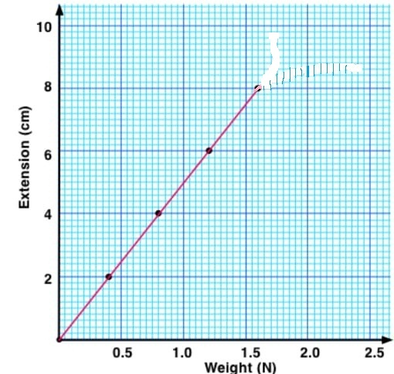

1. Determine the slope of the graph. (2 marks)

………………………………………………………………………………………………………………………………………………………………………………………………………………………………………………………………………………………………………………………………………………………………………………………………

1. Determine the spring constant of the spring used in the experiment. (2 marks)

……………………………………………………………………………………………… ………………………………………………………………………………………………

1. Calculate the elastic potential energy stored in the spring. (2 marks)

……………………………………………………………………………………………… ………………………………………………………………………………………………

1. On the same graph page sketch the expected graph if two such identical springs arranged in parallel were used during the experiment. (1 mark)
2. (a) The figure below shows a circuit diagram for controlling the temperature of a room.

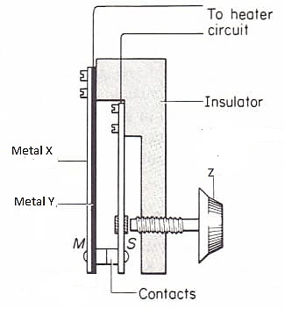

1. State the name of the device. (1 mark)

………………………………………………………………………………………………

1. The bimetallic strip is made of two metals, Copper and Steel. Suggest what metal X is likely to be. (1 mark)

………………………………………………………………………………………………

1. What is the function of part labeled Z? (1 mark)

………………………………………………………………………………………………

………………………………………………………………………………………………

1. Briefly explain how it works. (3 marks)

……………………………………………………………………………………………… ……………………………………………………………………………………………… ……………………………………………………………………………………………… ………………………………………………………………………………………………

1. State the advantage of alcohol in glass thermometer over mercury in glass thermometer. (1 mark)

……………………………………………………………………………………………… ………………………………………………………………………………………………