FORM 4 CHEMISTRY PAPER 233/1
END TERM 2 2021
MARKING SCHEME
1. Chromatography can be used to test for the purity of substances.
Describe one area in everyday life where purity of substances is important (1mark)
2.The diagram shows the apparatus used to separate different dyes in food colouring.
A
B

Name the parts labeled A & B (2marks)
A - Solvent front
B -Baseline
3. Describe how a solid sample of copper (II) carbonate can be prepared starting with copper metal. ( 3 marks)
Heat copper in air to form copper (ii)oxide. Add excess copper (II)oxide to dilute sulphuric acid. Filter excess oxide and add sodium carbonate solution to the filtrate to precipitate copper(ii) carbonate, filter and wash the residue with distilled water. Dry the residue between filter papers.
4. The table below describes the reaction of some metals with water.
METAL | REACTION
Calcium | Reacts rapidly with cold water producing many bubbles of gas.
Magnesium | Reacts very slowly with cold water but reacts rapidly with steam.
Rubidium | Reacts very rapidly with cold water producing many bubbles of gas and will explode.
Zinc | Only reacts with steam when powdered form and heated very strongly.

Arrange these metals in order of their reactivity beginning with the most reactive. (2marks)
Rubidium>Calcium>Magnesium>Zinc

5. A student set up an experiment to demonstrate rusting as shown below. He made observations at the start of the experiment and after two weeks.

Cylinder Iron Wool
Measuring
Air

Water

State and explain the observations made in the measuring cylinder after two weeks. (2marks)
- Iron wool had turned from grey to brown because it had rusted.
- Water level in the measuring cylinder had risen so as to occupy the space initially occupied by Oxygen.
6.. A student wanted to determine the solubility of potassium nitrate at a certain temperature. He
obtained the following results.
Mass of evaporating dish = 12.72g
Mass of evaporating dish + saturated solution = 34.10g
Mass of evaporating dish + salt = 17.00g
Calculate the solubility of potassium nitrate from the results above. (3 marks )
Mass of salt 17.00g – 12.72g = 4.28g
Mass of solvent 34.10g – 17.00g = 17.1g
17.1 g 4.28g
100g ?
100 x 4.28 = 25.03
17.1
Solubility of KNO₃ = 25.03g / 100g of water
7. Chlorine gas was bubbled through water for some time. The green yellow solution formed was poured into along glass tube and placed in the sun as shown in the diagram below .
Gas T
Sun rays
Green yellow solution

- What compounds are in the yellow solution ? (1mk)
Chloric (I) acid and Hydrochloric acid.
- Write an equation to show how gas T is formed (1mk)

2HOCl (aq) 2HCl (aq) + O₂ (g)
- Give one use of chlorine (1mk)

- Manufacture of (i) HCl
- Bleaching agent
- PVC
- Water treatment

8. A gas occupies 4 litres at 250K and 152mmHg pressure. At what pressure will its volume be halved, if the temperature then is 227⁰C? (3 marks)

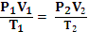  P₁ = 152 mmHg  V₁ = 4 litre  T₁ = 250k | P₂ = ?  T₂ = 227 + 273 = 500k  V₂ = 2 litres | P₂ = 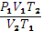  = 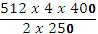  = 608 mmHg

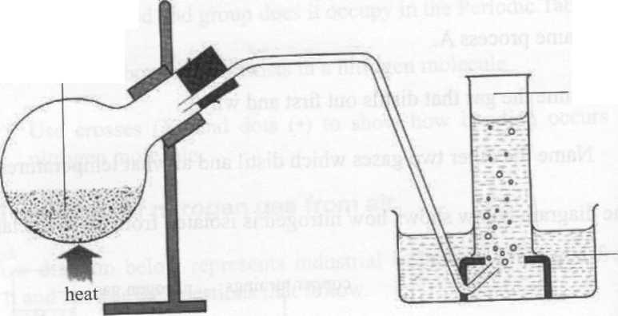
9. The set up below shows the preparation of nitrogen gas in the laboratory. ( 3 marks)
A mixture of ammonium chloride + compound A
nitrogen
water

- Name compound A. ( 1Mk)

Sodium nitrite /NaNO₂

- Write an equation for the reaction above. (1MK)

NaNO₂(aq) + NH₄Cl(aq) NH₄N0₂(s) + NaCl(s) + 2H₂0(1) + N₂(g)

- Why is ammonium nitrite not heated directly to prepare nitrogen gas? (1Mk)

Ammonium nitrite is very explosive,

10.Blue petals were dropped into a gas jar containing sulphur (IV) oxide as show below. ( 4 marks)
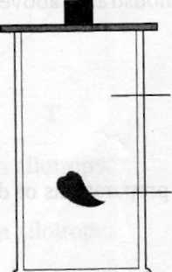
Sulphur(IV) oxide
blue petals

- Which observation was made? (1Mk)
Blue petals turned white

- Which property of sulphur (IV) oxide is exhibited above ?(1Mk)
The bleaching property of S0₂.

- Write the equation for the reaction above.(1Mk)
Dye + H₂S0₃ (aq) (dye - Oxygen) + H₂SO₄
(Blue ) (White)

- Explain the observation above. (1mk)
SO₂ gas has reducing agent ability thus takes oxygen from the dye hence bleaching it

11. (a) State Graham’s law of diffusion. (1mk)

- under the same conditions of temperature and pressure, the rate of
Diffusion of a gas is inversely proportional to the square root of its density.

(b) 60cm³ of oxygen diffused through a porous plate in 20 seconds. How long will it take 120cm³
of carbon (iv) oxide gas to diffuse through the same plate under the same conditions?
(C=12 , O=16) (2mk)

R₁ = M₂
R₂ M₁

60 = 44 √ ½
20
32
120
x

3x = 44
120 32

x = 120 44 √ ½ = 46.9 seconds √ ½
3 32
12.a) State Hess law. 1mk
The energy change in converting reactants to products is the same regardless of the path by which the chemical change occur √ 1mk
b) What happens to the heat energy supplied to a liquid
i) before it starts boiling? 1mk
Heat used to break the intermolecular forces of attraction
ii) when it is boiling Heat used to overcome forces of attraction between particles of a liquid 1mk
13. The following tests were carried out in 3 separate portions of a colourless solutions S.
 | Test | Observation
i | Adding dil HCL acid to solution S | No observable change
ii | Adding Na₂CO_{3(aq)} to the second portion | A white precipitate is formed
iii | Adding aqueous ammonia to the third portion | A white precipitate which dissolves in excess ammonia

a) From the information in test (i) name one cation which is not present in solution S. 1mk
Pb²⁺ or Ag⁺
b) Identify a cation which is likely to be present in solution S. 1mk
Zn²⁺ or Zinc ion
c) Write an ionic equation for the reaction which takes place in test (iii) 1mk
Zn²⁺ _{(aq)} + 4NH_{3(aq)} Zn(NH3)₄²⁺(aq)

14. Zinc metal and hydrochloric acid reacts according to the following equation
Zn_{(s)} + 2HCL_{(aq)} ZnCl_{2(aq)} + H_{2(g)} 2.0g of Zinc metal were reacted with 100cm³ of 0.2M Hydrochloric acid.
a) Determine the reagent that was in excess. (Zn=65.4) 2mks

moles of HCL_{(aq)} = 100 x 0.2 = 0.02 √ ½ mk
1000
Moles of ZN = 0.01 (2:1) √ ½ mk
Mass of Zn = 0.01 x 65.4
= 0.654g √ ½ mk
Hence Zn is in excess √ ½ mk

b) Calculate the total volume of hydrogen gas that was liberated at s.t.p (Zn=65.4, molar gas volume = 22.4 litres at s.t.p. (2mks)

Moles of H_{2 (g)} = 0.01
Volume of H_{2 (g)} = 0.01 x 24 √ ½ mk
= 0.24dm³ √

15. Study the diagram below and answer the questions that follow.
NH₄Cl_{(s)}
Energy
Reaction co-ordinate
ΔH₁
ΔH₂
ΔH₃
NH₄ ⁺_{(g)} + Cl⁻_{(g)}
NH₄ ⁺_{(aq)} + Cl⁻_{(g)}

- What do ∆H₁ and ∆H₂ represent. (2marks)
$∆H_{1}$-lattice energy1
$∆H_{2}$-Hydration energy1

(b) Write an expression to show the relationship between ∆H₁, ∆H₂ and ∆H_{3.} (1mark)
$∆H_{3}=∆H_{1}+∆H_{2}$1

16. Use the information below and answer the questions that follow .The letters are not the actual symbols of the elements.

${ E}_{(aq)}^{2+}$ + 2e
-0.76V

E_{(s)}
$F_{(aq)}^{3+}$ + 3e
-1.66V

F_{(s)}
$G_{(aq)}^{2+}$ + 2e
-0.44V

G_{(s)}

- Calculate the E^{θ} value for the electrochemical cell represented below. (1mark)

F_{(s)}
$$F_{(aq)}^{3+}$$
$$G_{(aq)}^{2+}$$
$$G_{(s)}$$

$$E=E_{red}-E_{ox}$$
$=-0.44++1.66$
= +1.22v 1

- Arrange the elements in order of reactivity starting with the least reactive. (1mark)

G, E, F 1

(c) Explain if it would be advisable to store element G in a solution containing E²⁺ Ions. (1mark)
Yes¹/₂mk- G cannot be displaced the E²⁺ ions because it is less reactive than E. ½ mk
17.a) Iron is obtained from haematite using a blast furnace shown below. Study it and answer the questions that follow.

Raw materials (Haematite)
Hot Air
Molten iron
Hot air
Slag
230⁰ C
470⁰C
Y 1790⁰C Y

- Four raw materials are required for the production of iron. Three of these are haematite, hot air and coke. Give the name of the fourth raw material and its use. (1 mark)
Name) (i) – Limestone (ii)Use – To produce Calcium Oxide which reacts with Silica to form slag

Name another Iron ore other than the one shown in the blast furnace. (1 mark) - Magnetite, Fe₃O₄ Any 1
- Siderite, FeCO₃
- Iron pyrites
Accept both the name and/ or a correct formula

State one physical property of slag other than density that allows it to be separated from molten Iron as shown in the figure. (iii) Slag is immiscible with molten iron (1 mark

17.The graph below shows the amount of calcium carbonate and calcium chloride varying with time in the reaction.
CaCO_{3(s)} + 2HCl_{(aq)} CaCl_{2(aq)} + H₂O + CO_{2(g)}
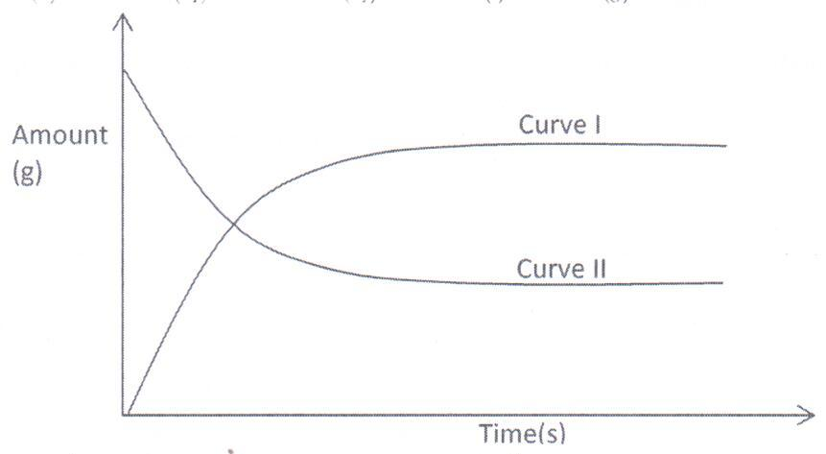

- Which curve shows the amount of calcium chloride varying with time? (1mk)

Curve 1

- Explain why the two curves become horizontal after a given period of time. (1mk)
The reaction will have reached completion and the amount of reactants and products do not change further
- Sketch on the graph, how curve II would appear if the experiment was repeated using a more dilute hydrochloric acid solution.
(1mk)

18.Study the flow chart below and answer the questions that follow.
Ethanol
Ethene
U
L
K

Step 1

Step 2
Polymerization
Step 3. Temp. of 150⁰
Nickel catalyst, H₂

- Identify substances: K, U L (1½ marks)

K – Ethane
U – Polyethene
L – Water

- State the conditions for the reaction in step 1 to occur. (2mks)

- Heat
- Conc. H₂SO₄

- Give one disadvantage of continued use of substances such as U. (½mk)

- Non biodegradable
- Blockage of water sources.

19.In an experiment to study properties of carbon, a small amount of charcoal is placed in a boiling tube. 5.0cm³ of concentrated nitric acid is added. The mixture is then heated.
- What observations are made? (1mk)

Black colour of carbon (charcoal fades)
- A brown gas was formed at the boiling tube.
- Write an equation for the reaction that took place in the boiling tube. (1mk)

C_{(s)} + HNO_{3(aq)} NO_{2(aq)} + CO_{2(g)} + H₂O_{(l)}

- What property of carbon is shown in this reaction? (1mk)
Reducing property.

20.The peaks below show the mass spectrum of element X.

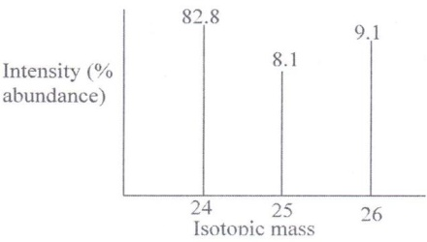

Calculate the relative atomic mass of X. (2mks

82.8 x 24 + 8.1 x 25 + 9.1 x 26
100
2426.3
- RAM =24.26

21.The equation for the reversible reaction of Bismuth (III) chloride in water is
BiCl_{3(s)} + H₂O_{(l)} BiOCl _{(s)} + 2H⁺_{(aq)} + 2Cl⁻_{(aq)}

- State Le chatelier’s principle (1 mark)
When a stres is applied to a system in equillibrium ,the system adjusts in a manner so as to oppose the effect of that stress

- What would be the effect of adding NaOH pellets to the equilibrium mixture. Explain. (2 marks)
Equilibrium will shift to the right /forward reaction is favoured.
OH⁻ reacts with H⁺ ions reducing their concentration hence the system produces more through forward reaction.

22.Thorium${}_{90}^{232}{Th}$ undergoes two consecutive alpha decays followed by two consecutive beta decays to form the nuclide ${}_{y}^{x}R$. Identify the values of $x$and $y$. (2 marks)

X=224 and Y=88

23.The diagram below shows part of Solvay Process.
M
K
N
Brine
with ammonia

Carbon (IV) Oxide

NH₄Cl_{(aq)}

NaHCO₃ _{(s)}

Solid P

Solid llllY

- Name solid P ( 1 Mark)

Calcium oxide//Quickline 1 Mark

- State the process taking place in chamber N. ( 1 mark)
Filtration//Fractional crystallization/crystallisation of NaOH₃ 1

- State two uses of calcium chloride which is a by-product in this process. ( 1 mark)

- In the extraction of sodium metal
- Pickling
- As a drying agent
- Anti microbial agent
- Anti cracking agent
(Any to correct answers award ½ mark each)

24.Substance L, M, N and P have the following properties.
Substance | M.P. | Solubility in water | Electrical conductivity
 |  |  | Solid state | Liquid state
L | Low | Soluble | Does not | Does not
M | High | Soluble | Does not | Conducts
N | High | Soluble | Conducts | Conducts
P | High | Insoluble | Does not | Does not
- Select the letter which represents a substance which is suitable for making kettle handles (1mk)

. P ¹/₂

- Which letter represents a substance which is likely to be sodium chloride? (1mk)
M ¹/₂

- Name the bond structure and bond type likely to be in L. (1mk)
- Bond structure Simple molecular ¹/₂
(ii) Bond type Covalent bonds ¹/₂

25.The table below shows some solutions and their PH values.
Solution | PH value
P | 1.5
Q | 6.0
R | 14.0
S | 8.0
Which of the above solution.
- Is strongly basic. (1 mark)

R

- Reacts with sodium carbonate more vigorously. (1 mark)

P
(c) Is ammonia solution. (1 mark)

S

26.Write the equation for decomposition of:
- Sodium nitrate. (1 mark)
2NaNO_{3(S)} → 2NaNO_{2(S)} + O_{2(g)}

(b) Copper (II) nitrate. (1 mark)
2Cu(NO₃)_{2(S)} → 2CuO_{(S)} + 4NO_{2(g)} + O_{2(g)}

27,The diagram below represents a set-up used to prepare oxygen gas.
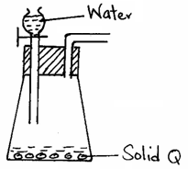
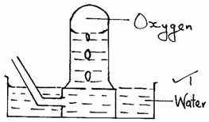

- Name substance Q. (1 mark)
- Sodium peroxide ¹

- Complete the set-up to show how oxygen gas is collected. (1 mark)

(c) Write the equation for the reaction that occur. (1 mark)

- 2Na₂O_{2(S)} + 2H₂O_{(l)} → 4NaOH_{(aq)} + O_{2(g)}

28.When an electric current of 0.5A was passed through a molten chloride of J for 32 minutes and 10 seconds, a mass of 0.44g of J was deposited at the cathode. (IF = 96500C).
(a) Calculate the quantity of electricity used. (1 mark)

Q = 1t
= 0.5 x 1930 sec
= 965C ¹

(b) Determine the value of χ if the ion of metal J is represented as J^{χ+}.
(R.A.M of J = 44). (1 mark)

44g
965C → 0.44g
← 44g
½ = 96500C ½
½
χ = 1
Charge = 1+ ½

29.The grid below is part of the periodic table. Study it and answer the questions that follow. The letters are not actual symbols of elements.

A |  |  | D | E |  |  | H | I
B | C |  | M |  | F | G |  | J

- What is the name given to the chemical family of element C? (1 mark)

Alkaline earth metals. ¹

- Would element B react with J? Explain. (1 mark)
J does not form compounds as it is chemically stable already. ¹

(c) Compare the melting points of B and M. (1 mark)
M has a higher melting point than B as it has a stronger metallic bond. ¹

