312/1
GEOGRAPHY PII
FORM IV
END OF TERM II EXAM (2021)
MARKING SCHEME

SECTION A
Answer all questions in this section
1)a) Name two rivers to the West of the Rift valley that causes flooding (2mks)
- Nyando
- Nzoia
- Kuja
- Yala
b) Give three ways how floods can be controlled (3mks)
- Construction of dams / check dams which help to reduce rivers velocity
- Construction of dykes / artificial levees to restrict river outflow
- Construction of diversion channels / canals to align river meanders
- Planting of vegetation / forests in the river catchment areas to reduce surface runoff
- Widening / dredging / clearing of drainage systems to facilitate easy flow of water
2)a) What is urbanization? (2mks)
- Urbanization is the process whereby an increased proportion of the total population in a country settles in town and changes from primary to secondary and tertiary production
b) Name one functional zone of an ideal urban centre (1mk)
- Central business district
- Industrial zone
- Residential zone
c) State two factors which have led to the development of Mombasa as a major sea port (2mks)
- Has a deep sheltered harbour
- Has fine weather thought the year
- Has a large hinterland
- It is located at strategic position on the East African coast
- It is well linked to the interior by the road / railway / air
3)a) Distinguish between Horticulture and market gardening (2mks)
- Horticulture is the growth of flowers, fruits and vegetable for sale in the international market while market gardening is the growth of fruits and vegetable for sale in the local market
b) Identify three reasons why horticulture is developed in Netherlands (3mks)
- Framers in Netherlands have more access to capital for horticultural development
- Netherland has highly skilled labour for production of horticulture
- Presence of farming related research
- She was a well organized marketing system / co-operatives / auction marts which offers support
- Highly developed transport system
- Presence of a high urban population which offer a ready market for horticultural produce
- Presence of advanced and appropriate technology supporting horticultural industry
4) Study the map below showing the St. Lawrence sea way and the great lakes and answer question a (i), ii, (iii)
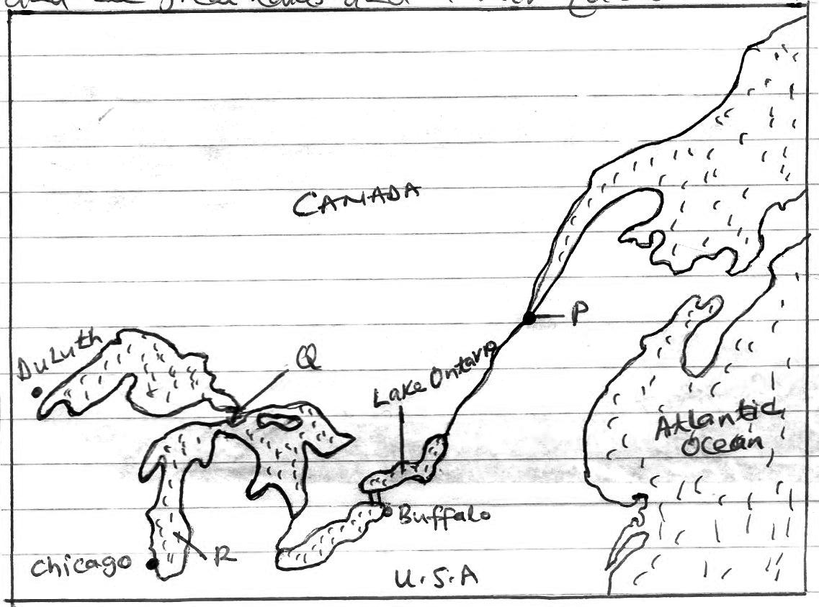

a)i) Name the town marked P (1mk)
- Quebec
ii) Identify the canal located at point Q (1mk)
- Soo canal
iii) Name the lake marked R (1mk)
- Lake Michigan
b) In what ways is Kenya going to benefit from direct air flight with United States of America (3mks)
- There will be increased volume of horticultural produce to U.S.A market
- Will allow more cultural exchange between the two countries
- Increased earning of foreign exchange from increased tourist from U.S.A
- Promote more co-operation between the two countries promoting more understanding
- Promoting the growth of international trade through Agoa
5)a) What is the major difference between a National park and a game reserve (2mks)
- National park are exclusively established for the conservation of wildlife while game reserves can accommodate both wildlife and domestic animals
b) Apart from game reserves and National park, give three ways in which wildlife is conserved in Kenya (3mks)
- Banning of trade in wildlife products
- Encourage wildlife conservation education
- Employing anti-poaching units / forest rangers / game rangers in the park for protection
- Protecting the endangered species in orphanages / sanctuaries
- Translocation / culling / game cropping
- Establishment of bufferzones
- Enhance research on diseases / pests affecting wildlife
- Promoting peaceful co-existence between wildlife and human beings.

SECTION B
Answer questions 6, and any other two questions.
Study the photograph below and answer questions a, b and c
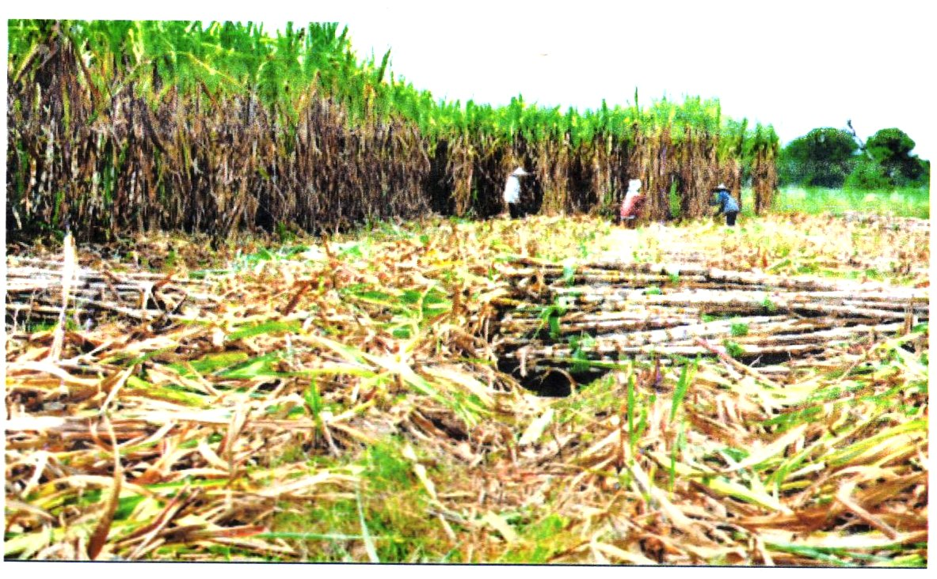

a)i) Identify the type of photograph shown above (1mk)
- Ground general view
ii) List two counties West of the Rift Valley where this crop is grown in Kenya (2mks)
- Kakamega county
- Transzoia county
- Kisumu county
- Uasin Gishu county
- Busia county
- Bungoma county

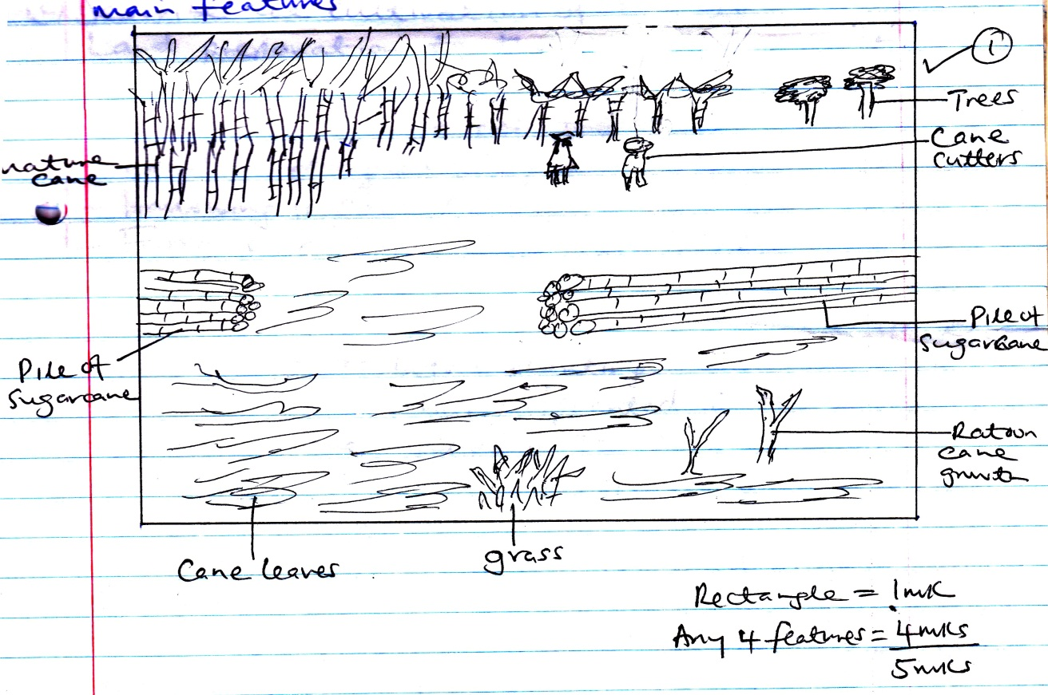
iii) Draw a rectangle measuring 15cm by 10cm (1mk)

On the rectangle sketch and label the main features (4mks)
b) Briefly describe the above photograph (3mks)
- There is a pile of sugarcane in the middle right / middle left ground
- There is presence of grass in the middle foreground
- There are sugar cane waste / leaves in the foreground / middle ground
- There is mature cane in the left middle background
- There are cane farmers in the middle right backgrounf
- There are trees in the right background
c) Describe the cultivation of the above crop from land preparation to the stage shown on the photograph (5mks)
- Land is cleared off the bushes
- Land is ploughed using machines / primary cultivation
- Hallowing is carried out / secondary cultivation
- Farrows are made in the field
- Sugarcane setts are obtained from mature canes
- The sugarcane setts are dipped in insectides to kill the pests before planting
- Buried / planted in the farrows
- Fertilizers are applied in the field severally
- Weeding is done regularly / sprayed with herbicides to kill the weeds
- When mature, the cane is harvested using pangas / machetes
- The cane pilled in heaps in the field ready to be transported to the factory.
(NB: Sequence must be maintained to score)

d)i) Name two dairy breeds reared in Denmark (2mks)
- Danish red
- Anyshire
- Guernsey
- Alderney
- Fresian
- Jersey
ii) State four physical factors that support dairy farming in Denmark (4mks)
- Low lying relatively featland / gentle land scape which makes it ideal for dairy rearing
- Cool to warm climate which facilitates growth of natural pasture
- Presence of builder clay suitable for growing of fodder crops
- Availability of a variety of fodder crops supporting dairy production
- Warm / sunny summers that allows outdoor grazing
- Moderate rainfall suitable for grass / fodder crop growth
iii) What is the role of Kenya government in dairy farming (3mks)
- The government provides extension services through her officers in the field to assist farmers in production
- The government has established research institutes / train personnel to research on pests / diseases to improve milk production
- The government has established demonstration farms which train farmers on dairy rearing
- The government facilitates provision of artificial services to the farmers to improve their breeds
- The government encourages formation of co-operative societies to help farmer pool resources together
7)a)i) What is an industry (2mks)
- An industry is any form of economic activity through which people produce goods and services for consumption.
ii) List two non-agricultural manufacturing industries in Kenya (2mks)
- Cement manufacturing
- Oil refining
- Steel rolling
- Glass manufacturing
- Vehicle assembling
- Clay product manufacturing
- Pharmaceutical manufacturing
b) Give four roles of the Jua Kali Industry to the economic development of Kenya (4mks)
- Has created employment opportunities / self employment to many Kenyans hence promoting their living standards
- Has helped to utilize the locally available raw materials, that would have bee thrown away
- Produces goods for the local market thus saving the country foreign exchange
- Has acted as a substitute to very expensive import products
- Has earned the country foreign exchange when the products are exported to COMESA regions.
c)i) List two major areas where cottage industry is highly developed in India (2mks)
- Bhutan
- Calcuctta
- Bangalore
- Madvas / Chennai
- Moradabad
- Lucknow
- Mumbai
- Bhopal
ii) Give five characteristics of the cottage Industry in India (5mks)
- They require small capital investment
- They use simple tools
- Sue locally available raw materials
- Most of the products aresold locally
- The labour is provided by the individual / family members
- They are owned by family
- It is labour intensive
- The industry requires very little skills
- The industry is found almost everywhere/ ubiquitous
d) Study the map below showing Rul………………industrial region in Germany, and use it to answer question i, and ii below:
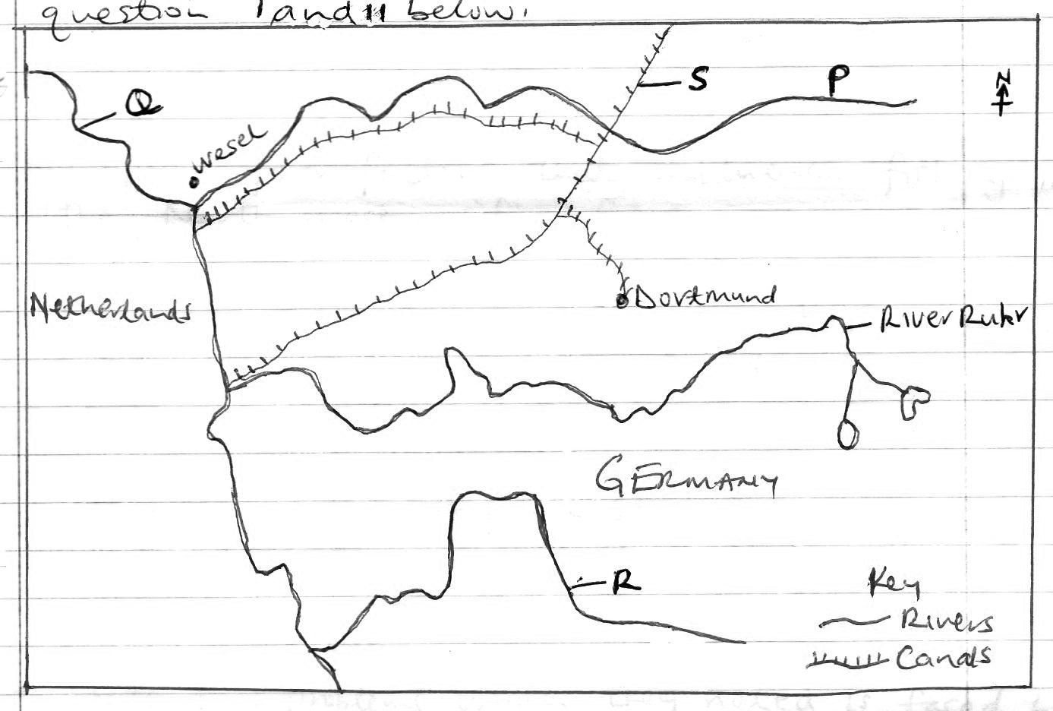

i) Identify the Rivers marked P, Q and R (3mks)
- P – R. Lippe
- Q – R. Rhine
- R – R. Wupper
ii) Name the canal labeled S. (1mk)
- S – Dortmund EMS canal
e) Explain how the following factors have influenced industrial growth in the Ruhr region of Germany
i) Capital (2mks)
- The presence of rich families e.g KMPP family / rich companies e.g Krupp group, Kohle group provided capital to facilitate development of the iron and steel industry
ii) Raw materials (2mks)
- The availability of raw materials e.g iron ore / coal/ limestone offered the necessary support to the growth of iron and steel industry
iii) Market (2mks)
- Presence of an affluent population with Germany / Western Europe provided the needed market for iron and steel industry products
(NB: example must be given to score)
8)a)i) Differentiate between pelagic and demersal fish (2mks)
- Pelagic fish are type of fish that live near the surface/ at shallow depths while demersal fish live at / close to the sea bottom
ii) List two examples of demersal fish (2mks)
- God
- Halibut
- Dogfish
- Haddock
- Hake
- Flounder
- Catfish
b) Outline four reasons why fresh water fishing is more popular in east Africa than marine fishing (4mks)
- Fresh water fishing requires simple euipments which are cheaper to buy
- Presence of many inland fishing grounds in the region
- The East African coastline is regular hindering presence of fish
- East African countries have inadequate / poor technology for deep sea fishing
- There is high demand for fresh water fish than marine fish.

c)i) Name the Ocean current that makes the coastal water of U.S.A ice free during winter (1mk)
- The warm gulf stream current
ii) Explain four factors that influence fishing in the North West pacific fishing ground (8mks)
- The convergence of cold oyasiwo and warm kurosiwo currents results in cool / ice free water ideal for fish breeding / upwelling of water which nutrients close to the surface
- Presence of broad continental shelf favouring the growth of plankton causing accumulation of fish
- The coastline is highly indented hence well shettered which favour fish breeding / for port development
- The adjacent land is highly mountainous which discourage agriculture and hence fishing is alternative economic activity
- Availability of large ready market offered by Asian countries with high population
- Presence of advanced technology for ship building / net making / modern vessels support deep see fishing.
- Modern and efficient transportation facilities which allow movement of fish to the market on time.
d) Form four students from a school in Kisumu carried out a field study on fishing in L. Victoria
i) State one objective that they could have used for the study (1mk)
- To find out the economic benefit of fish to the local community
- To establish the problems faced by fishermen in the lake.
ii) State the reasons why the students needed a route map during the study (2mks)
- To establish the shortest route to follow
- Helps to determine the cost of the journey
- Helps to plan for the days activities
- Helps to estimate the distance
iii) Give three advantages of studying fishing through field work (3mks)
- Learners get firsthand information
- Learners appreciate / interact with the environment
- Breaks the classroom monotony / arouses interest
- Learners acquire skills
- Enhances learners visual memory
iv) State two problems which they noted is faced by fishermen in Lake Victoria (2mks)
- Presence of water hyacinth hindering movement of fishing vessels
- Some strong waves / storms lead to capsizing of their boats
- Frequent harassment by security agents from neighbouring country
- Reduced stock of some fish species

9)a)i) What is a fossil fuel? (2mks)
- Fosil fuels are natural fuels that are formed from the remains of living organisms and are used to provide energy
ii) List two fossil fuels that have recently been discovered in Kenya (2mks)
- Crude oil / petroleum
- Coal
iii) State three formations in which mineral ore occurs (3mks)
- Some minerals occurs as evaporates
- Other occurs as veins c/ lodes
- Some minerals occurs as alluvial / placer deposits
- Some minerals are found in seams / beds
- Some minerals occur as weathering products
b) Explain how the following factors influence mining
i) Value of the mineral (2mks)
- Minerals of high economic value are in high demand and hence will be exploited even at high cost
- Minerals of low / less economic value may be exploited if the cost of their extraction is low if the cost is high they may remain unexpected.
ii) Transport (2mks)
- Efficient transport links allow mineral products to be moved from the mining site to the markets / ports without delay
- Minerals that are bulky / heavy requires water railway / road which are cheap means of transport to reduce the cost.
- Mineral deposits in remote areas / poorly developed transport system are less likely to be exploited
c)i) Describe how solution mining method is carried out (5mks)
- Pipes are sunk into the ground to reach the mineral
- Superheated water is pumped into the ground into the mineral
- The mineral is dissolved in the superheated water
- Pressure builds up underground
- The mineral rises to the surface due to pressure
- The solution is collected and water is evaporated away to be left with the mineral deposits, which is processed in factories
ii) Give three negative effects of mining to the environment (3mks)
- Mining causes pollution of air / water / land
- Causes land develiction
- Mining disrupt / lower the water table
- Mining causes loss of biodiversity / plants and animals.

d)i) Name two areas where gold is mined in South Africa (2mks)
- Wit waters rand
- Orange free state
- Far east rand
- Klerksdorp
ii) Describe how diamond is processed (4mks)
- The ore containing diamond is crushed into small pieces
- The crushed pieces are washed with water to remove dirt
- The wet rock containing diamond is placed on rotating table covered with grease
- Grease repels water, hence wet rock pieces will slide off the table as waste
- Diamond pieces stick on the grease since they do not get wet
- The diamond pieces are removed / sorted frequently by stopping the rotating table
(NB: Sequence must be maintained)
10)a)i) Define the term energy (2mks)
- Energy is the power /fuel needed to run machines or assist human in production
ii) Name two non-renewable sources of energy (2mks)
- Uranium
- Coal
- Crude oil / Petroleum
- Natural gas
b)i) Identify two potential sites in Kenya for wind energy production (2mks)
- Ngong hills
- Marsabit
- Turkana
ii) State three reasons why wind energy is still underdeveloped in Africa (3mks)
- Wind mill equipments for harvesting are very expensive to buy and install
- The equipments are relatively expensive to maintain
- Wind is only available in open areas
- Many wend mills are needed to produce a substancial amount of energy.
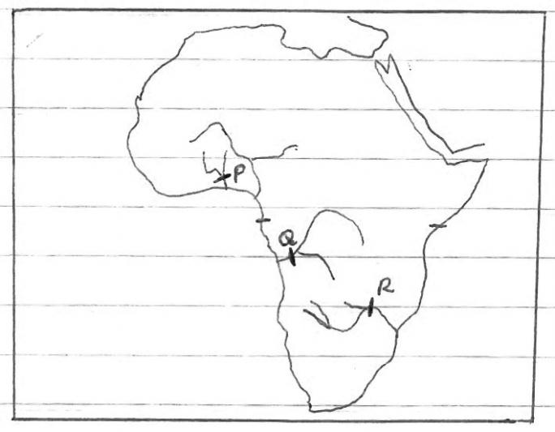
c) Use the map of Africa shown below to answer question c (i)

i) Name the power plant laballed P, Q and R (3mks)
- P – Akosombo dam
- Q – Inga dam
- R – Kariba dam
ii) Explain the problems facing generation of hydro-electric power production (6mks)
- Majority of the African countries have inadequate capital to construct power plants and usually relies on expensive loans from developed nations
- Some potential sites are located in remote areas, away from the market hence remaining unexploited
- Some rivers which have potential sites for power generation have irregular volume of water in sometimes of the year
- African countries have a shortage of skills and relevant technology which forces them to rely on expensive expatriates, making production expensive.
iii) Apart from providing power, state three other benefits of the power dams in Africa (3mks)
- The dams provide a bridge across the river promoting road transport
- The dams / reservoirs are a tourist attraction
- The reservoirs provide water utilized for domestic / industrial use
- The reservoirs are used to provide sources of fish
- The reservoirs provide water utilized for irrigation purposes
(NB: Note the appropriate use of dam)
d) Explain how the following two factors causes energy crisis
i) Artificial shortage (2mks)
- Some oil producing countries U.S.A / Russia depend on oil resources from other countries, while conserving their own which causes scarcity of oil supplies
ii) Oil prices (2mks)
- The oil producing and exporting countries increases oil prices without notifying the consuming countries which affects the supply of oil / consuming countries are unable to cope with the increased prices.

