Name:………………………………………………..Class:……..…AdmNo:…….
FORM 3 CHEMISTRY 2021
END OF TERM 2 EXAMINATION
DECEMBER 2021
2 ½ HOURS
ANSWER ALL QUESTIONS IN THE SPACES PROVIDED
1. State any two differences between luminous and non – luminous flames (2mk)

2. Compound Q is a solid with a giant ionic structure. In what form would the compound conduct an electric current. (2mks)

3. Pentane and ethanol are miscible. Describe how water could be used to separate a mixture of pentane and ethanol. (3mk)

4. Explain why it is not advisable to leave a Jiko with burning charcoal in a closed room where one is sleeping. (2mk)

5. In an experiment, ammonia chloride was heated in a test tube. A moist red litmus paper placed at the mouth of the test tube first changed blue then red. Explain these observations.(3mk)

6. A given volume of ozone, (O₃) diffused from a certain apparatus in 96 seconds. Calculate the time taken by an equal volume of carbon (IV) oxide (CO₂) to diffuse under the same conditions (O = 16.0, C = 12.0) (3mk)

7. How would you obtain a sample of pure iodine from a mixture of iodine and lead sulphate? (2mk)

8. The apparatus shown below was used to investigate the effect of carbon (II) oxide on copper (II) oxide.
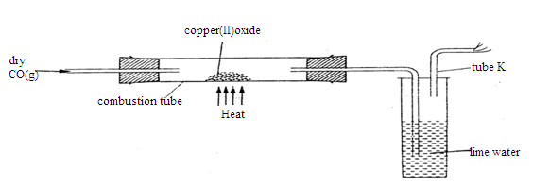

a) State the observation that was made in the combustion tube at the end of the experiment. (1mk)

b) Write an equation for the reaction that took place in the combustion tube. (1mk)

c) Why is it necessary to burn the gas coming out of tube K? (1mk)

9. When potassium nitrate is heated, it produces potassium nitrite and gas C

(a) Identify gas C (1mk)

(b) Name the type of reaction undergone by the potassium nitrate. (1mk)

c) Write a balanced chemical equation for the reaction that takes place. (1mk)

10. Describe how a solid sample of Zinc (II) carbonate can be prepared starting with zinc oxide (3mk)

11. The diagram below is set – up for the laboratory preparation of oxygen gas.

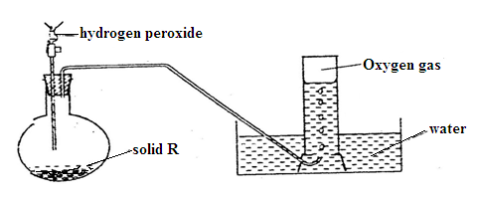

- Name solid R (1mk)

- Write an equation for the reaction that takes place in the flask.(1mk)

(c) Give two commercial uses of oxygen (2mks)

12. (a) Give a reason why concentrated sulphuric(VI) acid is not used to dry ammonia gas. (1mk)

- Name one suitable drying agent for ammonia gas.(1mk)

13. The graph below shows the behaviour of a fixed mass of a gas at constant temperature.
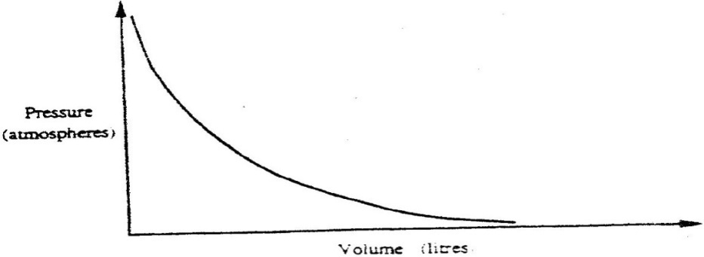

- What is the relationship between the volume and the pressure of the gas? (1mk)

- 3 litres of oxygen gas at one atmosphere pressure were compressed to two
atmospheres at constant temperature. Calculate the volume occupied by the oxygen gas (2mks)

14. When X cm³ of a solution of 0.5M magnesium carbonate was reacted with excess hydrochloric acid 8.4g of carbon (IV) oxide gas was evolved.

- Write the ionic equation for the reaction that took place(1mk)

- Calculate the value of X. (C = 12.0, Mg 24.0; 016.0 (2mks)

15.Using dots (.) and crosses(x) to represent electrons, show bonding in the compounds formed when the following elements react:
a) Sodium and chlorine (2mks)

b) Silicon and chlorine (2mks)

16. Use the information in the table below to answer the questions that follow. (The letters do not represent the actual symbols of the elements)

Element | B | C | D | E | F
Atomic number | 18 | 5 | 3 | 5 | 20
Mass number | 40 | 10 | 7 | 11 | 40

- Which two letters represent the same element? Give a reason. (2marks)

- Give the number of neutrons in an atom of element D (1 mark)

17. When a hydrocarbon was completely burnt in oxygen, 4.2g of carbon (IV) oxide and 1.71 g of water were formed. Determine the empirical formula of the hydrocarbon
(H= 1.0 ; C=12.0 ; 0 = 16.0) (3 mks)

18. (a) What is meant by isomerism? (1mark)

(b) Draw and name two isomers of butane. (2 marks)

19. The table below shows the relative atomic masses and the percentage abundance of the isotopes L1 and L2 of element L. Calculate the relative atomic mass of L. (3mks)

isotopes | L1 | L2
relative atomic mass | 69.09 | 64.93
percentage abundance | 62.93 | 30.91

20. In an experiment, a test-tube full of chlorine water was inverted in chlorine water as shown in the diagram below and the set up left in sunlight for one day.
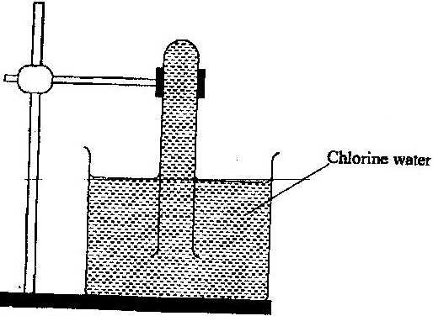

After one day, a gas was found to have collected in the test-tube
a) Identify the gas. (1mk)
b) What will happen to the pH of the solution in the beaker after one day? Give an explanation. (2mks)

21. Study the set- up below and answer the questions that follow

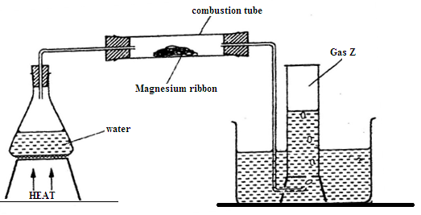

(a)Identify gas Z. (1mk)

(b) Write an equation for the reaction, which take place in the combustion tube. (1mk)

(c) What property of gas Z allows it to be collected as shown in the diagram (1mk)

22. Study the information in the table below and answer the questions that follow. The letters do not represent the actual symbols of the elements)

Element | Electrical conductivity | Ductility | Action of water
A  B  C | Good  Good  Good | Good  Poor  Good | No reaction  No reaction  Reacts
Select an element which
(a) Is likely to be used in group II of the periodic table. (1mk)

(b) Could be used to make electric cables. (1mk)

(c) Likely to be graphite. (1mk)

23. (a) State the Gay Lussac’s law. (1mk)

(b) 10cm3 of a gaseous hydrocarbon C₂H_{x} required 30cm3 of oxygen for complete combustion .If steam and 20cm3 of carbon (IV) oxide were produced, what is the value of x. (2mk)

24. The diagram below shows the bonding between aluminium chloride and ammonia.
H Cl

H N Al Cl

H Cl

(a)Name the types of bonds that exist in the molecule (1mk)

(b)How many electrons are used for bonding in the molecule? (1mk)

25. The table below gives the number of electrons, protons and neutrons in particles.

Particle | Protons | Electrons | Neutrons
A | 6 | 6 | 6
B | 10 | 10 | 12
C | 12 | 10 | 12
D | 6 | 6 | 8
E | 13 | 10 | 14
F | 17 | 17 | 18
G | 8 | 10 | 8

- Which particle is likely to be a halogen? (1mk)

- What is the mass number of E? (1mk)

- Write the formula of the compound formed when E combines with G.(1mk)

- Name the type of bond formed in (iii)above.(1mk)

- How does the radii of C and E compare? Give a reason (2mk)

- Why would particle B not react with particle D? (1mk)

26. a) What is meant by the term binary electrolyte? (1mk)

- In an experiment to investigate the conductivity of substances, a student used the set – up shown below.
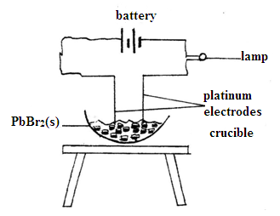

- The Student noted that the bulb did not light .What had been omitted in the set- up?(1mk)

- Explain why the bulb lights when the omission is corrected . ( 2 mks)

- Write the equations for the reactions that take place at the anode and at the cathode when the mistake is rectified. (2mks)

Anode

Cathode

27. When a few drops of aqueous ammonia were added to copper (II) nitrate solution, a light blue precipitate was formed. On addition of more aqueous ammonia, a deep blue solution was formed.
Identify the substance responsible for the:
- Light blue precipitate ( 1mk)

- Deep blue solution ( 1mk)
28. Explain why a high temperature is required for nitrogen to react with oxygen (1mk)

29. a) The set-up below was used to prepare and collect ethene gas. Study it and answer the questions that follow.

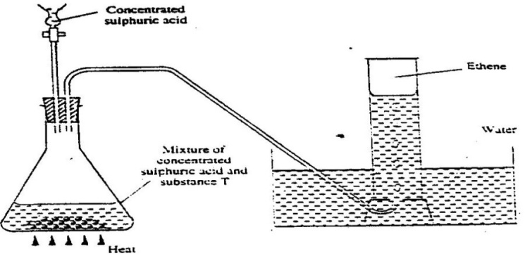

- Name the substance T(1mk)

- Give the property of ethane that allows it to be collected as shown in the set up. (1mk)

b) One of the reactions undergone by ethene is addition polymerization. Give the name of the polymer and one disadvantage of the polymer it forms.(2 marks)
Name the polymer.

Disadvantage of the polymer

30. Oxygen was bubbled into concentrated ammonia solution as shown below.

Oxygen
Conc. Ammonia solution
Hot platinum wire

(a) Explain why the platinum wire remained red-hot even though it was no longer being heated.
(1mk)

(b) Brown fumes were observed in the boiling tube. Using chemical equations, explain this
observation. (2mks)

31. Distinguish between a strong and a weak base. Give an example of each (2mk)

32. The set – up below represents the apparatus that may be used to separate a mixture of two miscible liquids C and D whose boiling points are 80⁰C and 110⁰C.
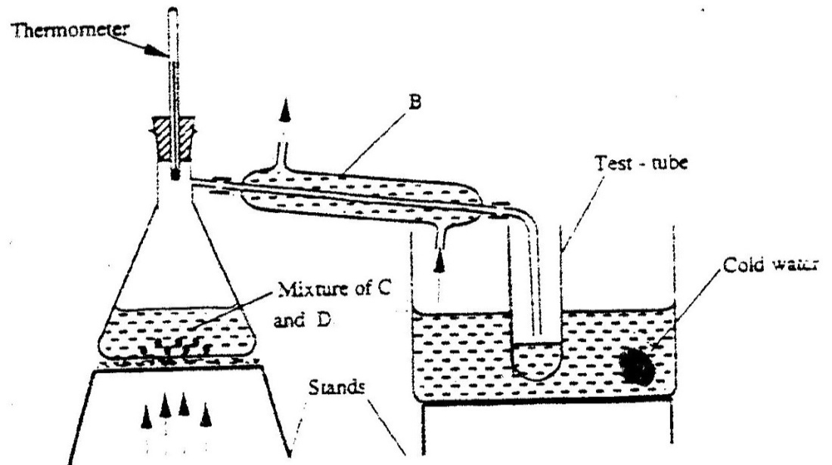

- Name B (1mk)

- What is the purpose of the thermometer ( 1mk)

(b)Which liquid was collected in the test tube? (1mk)

34. Define the following terms as used in organic chemistry (2mks)

- Saturated hydrocarbon

- Catalytic cracking

35. Name two substances that are recycled in the Solvay process. (2mks)

