101/2
FORM 3
ENGLISH
END TERM 2 EXAM 2021

TIME: 2 % HRS
PAPER 2
INSTRUCTIONS TO CANDIDATES
- Answer all the questions in this questions paper.
- All answers must be written in the spaces provided in this question paper.
- Do not leave any question blank
- Any form of irregularity will not be tolerated.
FOR EXMAINER'S USE ONLY
SKILLS | MAXIMUM | SCORE
COIVTPREHENSION | 20
EXCERPT | 20
ORAL LITERATURE | 25
GRAMMAR | 15 | 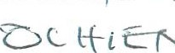
TOTAL SCORE | 80
1. COMPHRENSION ( 20 MARKS)
Read the following passage and answer the questions that follow.
Jechiel Oliver, then a financial expert working in the United States, was getting restless.
He wanted a new challenge whose impact would be felt by a significant portion of the population.
In his search for impact, he travelled to diverse locations, including Afghanistan and read widely.
One of the books that spoke to him in an especially significant way was Banker to the poor: Micro-Lending and the Battle Against World Poverty, the story of Mohammed Yunus.
Yunus set up a bank in Bangladesh to lend tiny sums to the poorest of the poor in the country, those shunned by banks that saw no business case in lending to this segment of society.
By going against the grain, Yunus ended up founding the multinational Grameen Bank, and won a Nobel Peace Prize for his efforts.
Five years ago, Oliver found the perfect way to apply the lessons learned fromYunus.
He focused on Africa's smallholder farmers who struggle to access credit and farm inputs, and have to contend with high labour costs.
In 2014, Oliver launched Hello Tractor, a service similar to the global taxi hailing service Uberexcept that it mainly operates in rural small-holder farms and largely deals with tractors.
In general terms, the service aims to connect smallholder farmers to tractor owners, and then improve access to related services, such as farm inputs, valuable agricultural data and improved credit scores.
Nigeria was the first country to pilot the project, and so far, there are 1,500 tractors on the platform.
The service was launched in Kenya in August 2018, with at least 250 tractors expected to be on the platform by the end of the current planting season.
With the help of Nairobi-based IBM Researcah Lab, Hello Tractor aims to deliver new services for the agriculture value chain.
With the partnership, participants such as farmers, financial institutions, Government agencies and tractor owners can make use of the data collected on tractor maintenance, fleet utilization, operator rankings, farm yield forecasting and microfinancing.
"Tech-based agricultural practices is what will turn local fanners into bankable individuals, as they will have the tools to mitigate against extreme weather conditions, while reducing overhead costs," says Oliver.
to attain this vision the platform addresses the entire farming process including tilling harrowing planting spraying and harvesting
"Sixty per cent of farming in Africa is done using manual labour and is more expensive than using tractors. Paying workers sh600 or sh700 a day for 30 days ends up being more expensive than a tractor that may cost sh6,000 or sh7,000 for a few hours," says Oliver.
"We need to connect available tractors to farmers, who can then maximize their yields by harnessing modern technology"
During the interview with Oliver at IBM's research lab at the Catholic University of East Africa in Karen, scientists took Hustle through several technologies that are driving the agriculture digital wallet. These include artificial Intelligence, block chain, the Internet of Things and cloud-based solutions.
Monitoring devices installed on tractors that are connected to the Hello Tractor cloud can pin point each vehicle's location and how long it's been there. This helps field agents connect farmers to available tractors.
When combined with analytics and block chain, such data can be used to develop a credit score for loans, says Oliver.
In addition, whether data can be used to help smallholder farmers know when to plant, what to plant, quality of farm cultivation, appropriate fertilizer and land topography.
Research shows that 50 per cent of the yield gap is due to a lack of mechanized farming, while the other half is due to lack of farm inputs," says Oliver. "We're developing a system that will make the farmer have a business mind and appeal to lenders. For example, the lender can see current and historical data pertaining to a farmer's cumulative yield or tractor utilization and make immediate credit decisions.'
On the other hand, tractor owners and dealers can manage their current and future fleet, and predict maintenance needs and after-sales services.
The rollout of the services has not been without challenges, however.
Just as Oliver was launching in Nigeria, the country went into a two-year recession.
"We soldiered on and now have an equivalent of 10 per cent of tractors sold on the continent on our platform in that country," he says.
"In Kenya, we hope to build trust in both farmers and tractor owners. The challenge we have here is that there are not that many tractors in the field. Like other countries on the continent, banks hardly lend to farmers due to the many risks associated with farming."
Oliver says African governments can help stem the tide by insuring farmers and their crops. This, he says, will make local farmers compete on the same level with those in developed nations who are heavily subsidized by their governments.
According to IBM, governments can utilize the data available for actionable insights into various options including structuring incentives, enforcing regulations, priotising investments in the sector and long-term policy decisions.
QUESTIONS
1.
Gi
the
passage
a
suitable
title.
(Imk)
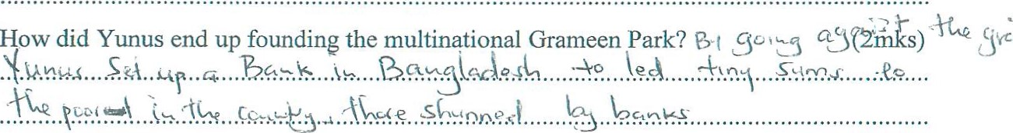
2.

- What are the challenges that Oliver encountered? (4mks)
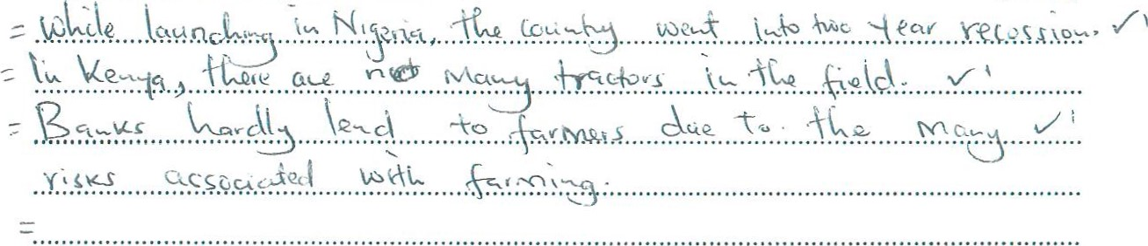
- List the pieces of advice given by the Auth r. (2mks)
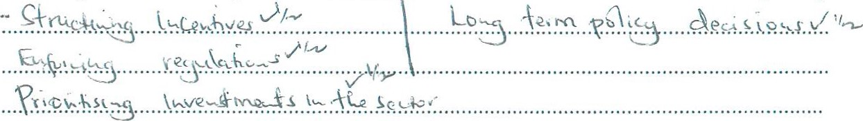
- Punctuate the following sentence,To attain this vision the platform addresses the entire farming proce»including filling, harrowin9plantin spraying and harvesting. (2mks)

- Make notes on what Oliver does beyond farming. (5mks)
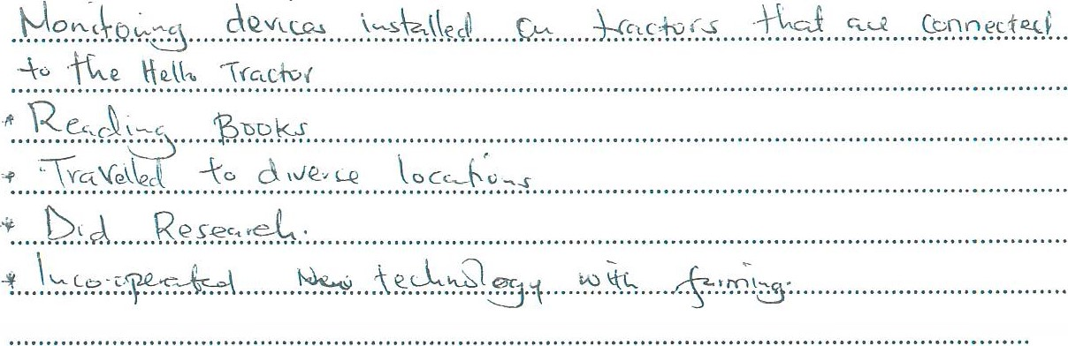
- Explain meaning of the following words/expressions (4mks)
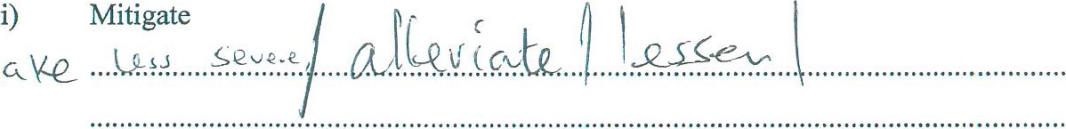

- artificial intelligence
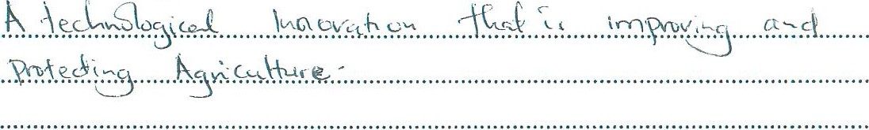
- digital wallet

2. EXCERPT: BLOSSOMS OF SAVANNAH (25 MARKS)
Read the excerpt below and answer the questions that follow
Minik rubbed her hands together nervously as she walked cautiously t%9s the parked vehicles. As she walked, she counted the vehicles and she thought sh She was not sure whether she got the figure right.
When the man in the first vehicle saw Minik approaching, he alighted. Minik, Taiyo and Resian recognized him at once. It was Oloisudori Lonkiyaa!
"How are you, madam?" he greeted Minik as he walked towards her his hands outstretched, "We didn't know you were holding a party!"
"You did not announce your coming, so that we could tell you we were having a party." Minik answered acidly, "Besides, we do not have to inform anybody when we have to hold a party. Anyway, what can I do for you?"
"Since you seem to be rash with me," Oloisudori said in a fit of pique, embarrassed by the way Minik rudely addressed him, I'll come straight to the POInt. I am told you are keeping two of Ole Kaelo's daughters here. For your information, I have a choice to marry any one of the two. Choose the one you want to keep I have come to take one of them. I have already paid dowry enough to cover the two!"
"You will be advised to get out of this place fast." Minik told him in a quiet angry tone, "the two girls are under my charge and none of them, I repeat none of them taken away from me, not even by their father, Ole Kaelo!"
She steeled herself and looked up into his eyes with an unwavering stare. Oloisudori's nostrils flared as he walked briskly toward her with an angry snarl, pointing his finger at her.
"Who are you to talk to me like that?" he bellowed trembling with fury. "Do you know Oloisudori Loonkiyaa? I don't need your permission to pick a wife, do I'? Who are you by the way? You are nothing but a mendacious spinster who has lost a chance to get married and now masquerades as a crusader against the so called FGM. Let us not waste time, call either Taiyo or Resian, then you can go ahead with your miserly party peacefully."
"You are getting none of them," Minik snarled, walking toward him menacingly, "For your own safety and the safety of your expensive machines leave this place this instant." Oloisudori uttered a strangled sound in a wordless growl and his eyes bul ed with fury.
He called out his men pointed at Resian and told them to get hold of er.
The pandemonium that broke was unprecedented Oloisudori must have underrated the loyalty of about four hundred energetic workers who had just eaten to their fill. As the

girls retreated, the men surged forward and in no time Oloisudori's convoy was reduced to smouldering shells and acrid smell of burning tyres.
QUESTIONS
- What leads to,'ffie ev nts in this "rpt (3mks)
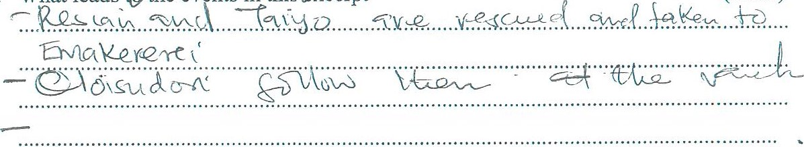
- Describe the general feeling in the excerpt. (2mks)
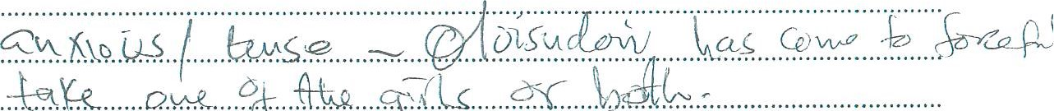
A.*k.... .Q.kk....ff&. .41!".. .s.q..lx..
³
- How are the following characters portrayed In the excerpt
i)
ii)
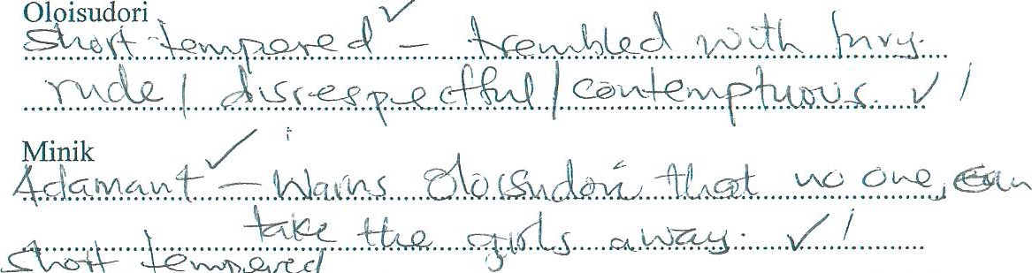
- Identify and explain thÄs71i{t c devices used in the excerpt (6mks)
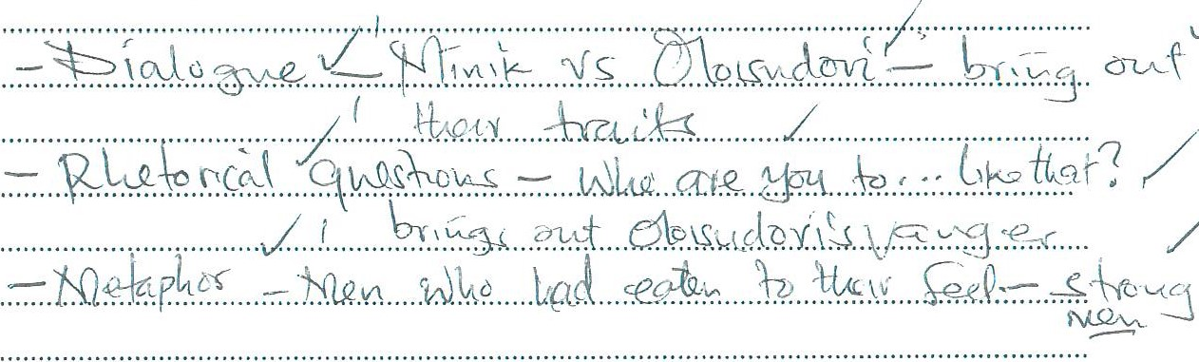

- State and illustrate any two major themes in the excerpt (4mks)
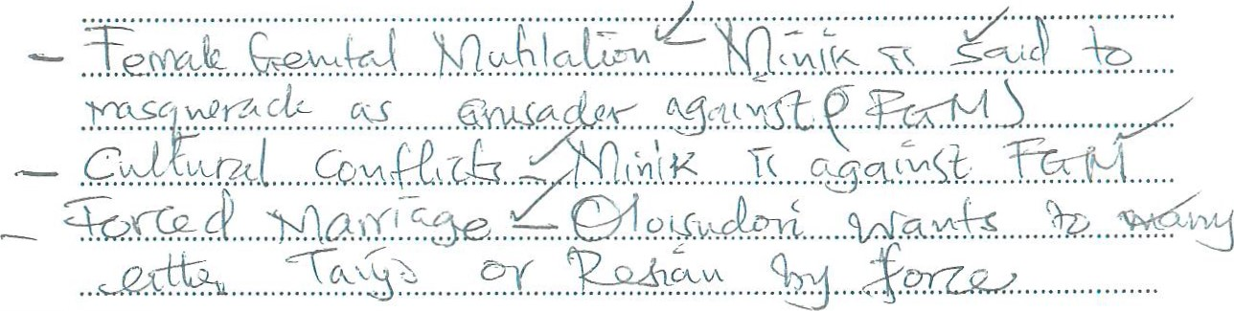
- What happens immediately after the excerpt (3mkSl)
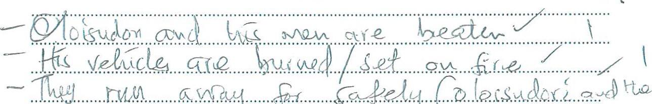run.... c.ufdwj ..$f.. ccQeA3 C.o.
- Rewrite the following sentence in reported speech (Imk)
"You did not announce your coming so that we could tell you we were having a party," Minik answered acidly
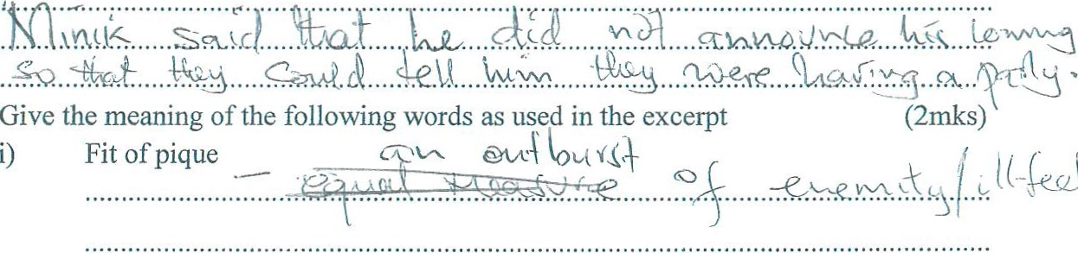
8.

ii) Masquerades

3. ORAL LITERATURE ( 20 MARKS)
Read the following narrative and answer the questions which follow.
There was a great famine in the land where Obunde and his wife, Oswera, lived with their nine children. The only creatures who had some food were the ogres and before they would part with their food, they demanded a lot of things.
One day, Oswera went to one Ogre's home and asked him for some food, for by then her children were almost dying of hunger.
'I have no more food except sweet potatoes, the ogre told her.
'I shall be happy to have the potatoes. We have nothing, not a grain of food at my house and the children are starving. Please let me have some and I shall repay you after the harvest.
'No, if you want food you must exchange with something right now. Will you give me one of your children in exchange for my potatoes? Oswera hesitated, her children were dear to her, but then they would die without food.
'Yes, I shall let you have one of them for your meal, if only you could let us have some potatoes,' Oswera answered. Then she took a big basket full of potatoes and told the ogre the exact time he could go to her home to collect one of her children for a meal.
Oswera thought hard and she decided she would not give a single one of her children to the ogre for a meal. She therefore cut young banana stalks and cooked them nicely.
When the ogre came, she gave them to him and the beast greedily went away satisfied. Soon the potatoes were finished and she had to go to the ogre again.
Oswera and Obunde, her husband kept on cooking banana stalks for the ogre each time he came for one of their children, until one day, she had no more banana stalks to cook for the animal.
"You have now eaten all my children, yet we still need the potatoes. What shall we give your now?" Oswera asked in despair.
'Then I shall come for you and your husband,' the ogre replied angTily as he helped Oswera to load her basket of potatoes on her head.
'Yes come tomorrow at the usual time in the afternoon and get me. I shall have cooked myself for you," Oswera said calmly.
The following day the ogre went promptly as Oswera had told him and he found the home almost deserted. He looked everywhere but a pan from Obunde there was no trace of anybody.
Then he looked at the usual place and found a huge bowl of a big meal Oswera had cooked for him. The ogre did not realize they had prepared a dog instead of Oswera. When he had eaten the ogre told Obunde he would come for him the following day. Obunde got very worried and that night he could not sleep. The following day he started crying:
"Ah Oswera my wife, how did you cook yourself and how shall I cook myself for the ogre?" He sat down in the dust of his compound and wept. Oswera became very annoyed with her husband.
You, you stupid, foolish man! Why sit and cry there all day long? How do you think I cooked myself? Take one of the dogs and quickly prepare it for the ogre! '
Very quickly Obunde got up, caught, killed and prepared a dog for the ogre. Then he joined his wife and children in a huge hollow part of a tree in his compound where they had hidden.
That day the ogre knew he was going to have his last meal ofjuicy human flesh. Being a generous and unselfish ogre, he brought many of his fellow ogres. They were going to have a feat.
Suddenly as they were eating, they heard a man singing very happily. No they could not believe it! It was Obunde singing! And he was boasting of how he had cheated the ogre.
The greedy ogre ate banana stalks
Not my family;
The greedy ogre ate a dog Not Obunde Magoro!
The greedy ogre ate banana stalks
Not my family;
Now come and get Obunde, His children and wife.
Obunde sang the words and the ogres got very angry. The first ogre rushed into the hollow of the tree, but Oswera had heated a long piece of iron until it was white. She pushed the iron into the ogre's mouth. The beast fell down dead. The next one rushed into the hollow and Oswera killed him in the same way. In this way she killed all the ogres and saved her husband and all their children.
My story ends there.
Questions
- Classify this narrative, giving a reason for your answer. (2marks)
- Whom do you consider to be hero in this story and why? (2mks)
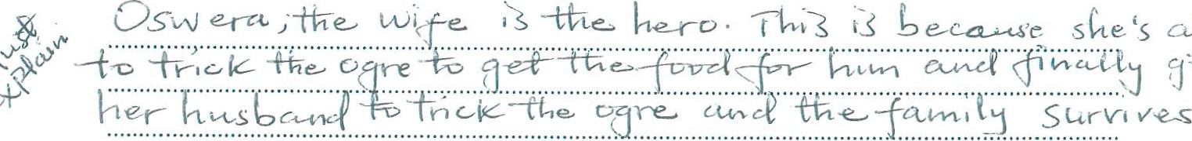
- Describe the place setting of this story. (2mks)
environ
me-at)

- Compare Obunde and the ogre as they are presented in this story. (2mks)
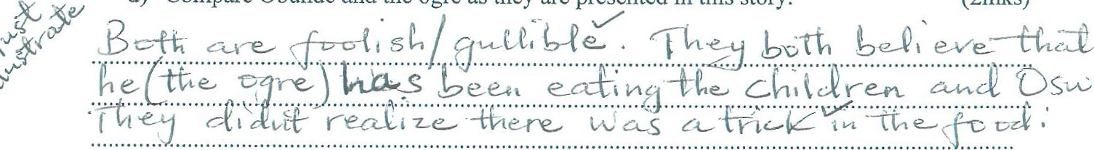
- What is the function of the song in this story? (2mks)
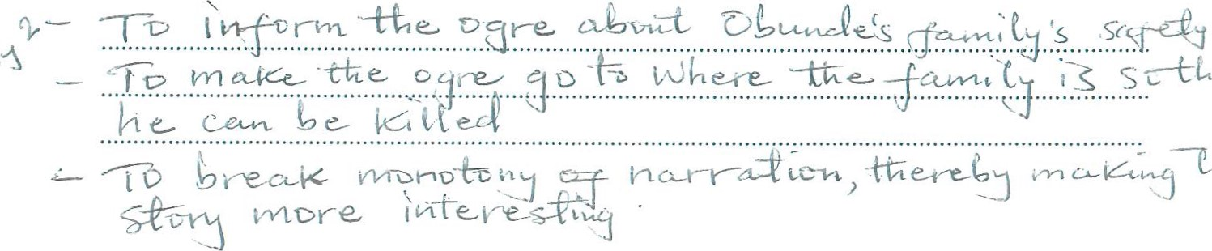
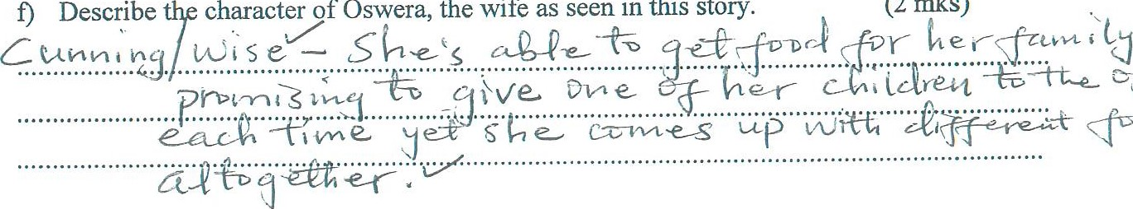
(2
mks)
seen
in
this
story.
the
wife
as
- Other than the song, identify and illustrate two other features that make this story an oral narrative. (4mks)
- State the moral lesson in the story. (Imk)
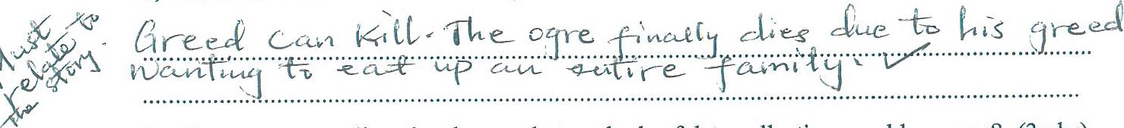
- If you were to collect the above, what methods of data collection would you use? (3mks)
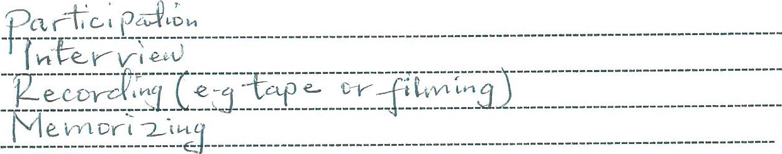
4. GRAMMAR ( 15 MARKS)
- Fill the blanks with the appropriateform of the words in brackets. (3 marks)
  - The manager was accused of ... I.'[fe (qf(J acquiring a piece of land. (regular)
  - He debunked the ..4?.C ^{C}' ^{jyü}.. .... that one must be intelligent to succeed. (argue)
  - We need to conduct some 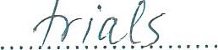.. before we install the equipment. (try)
- Use the correct pronoun in the blank spaces in the sentences below. (3 marks)
  - Ole Kaelo gave away 4 ..(J.... ... daughter to Oloisudori.
  - Father gave my brother and ,nu. .. a house in an apartment block.
  - That is the man 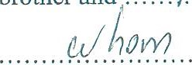. we saw on television yesterday.
- Rewrite thefollowing replacing the underlined words with a single word. (2 marks)
  - The road has to peter out into a dirt track.
K)L.L--KO—
  - The boy takes after his grandfather.
- Rewrite thefollowing sentences according to instructions after each. (5 marks)
  - There is no way you can solve your problem unless you are able to define its cause.
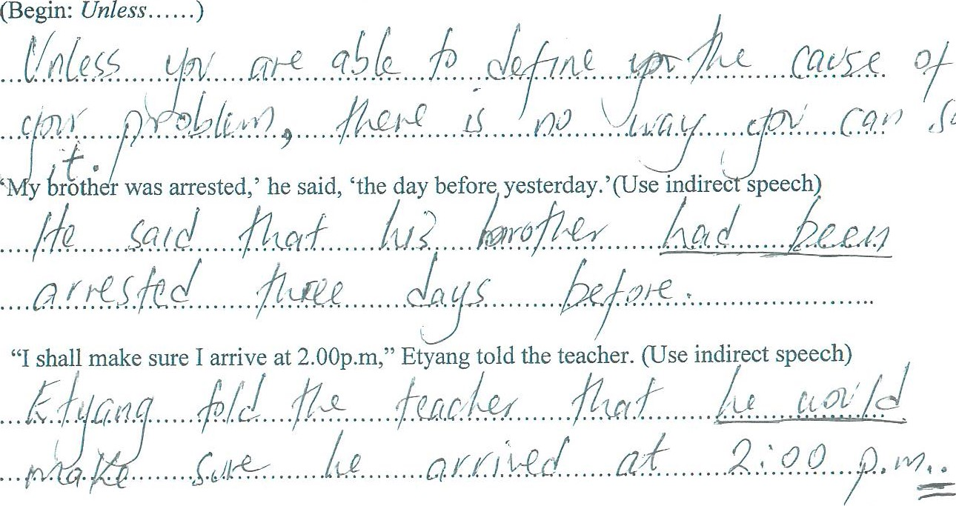
b.
(Begin:
Unless...
c.
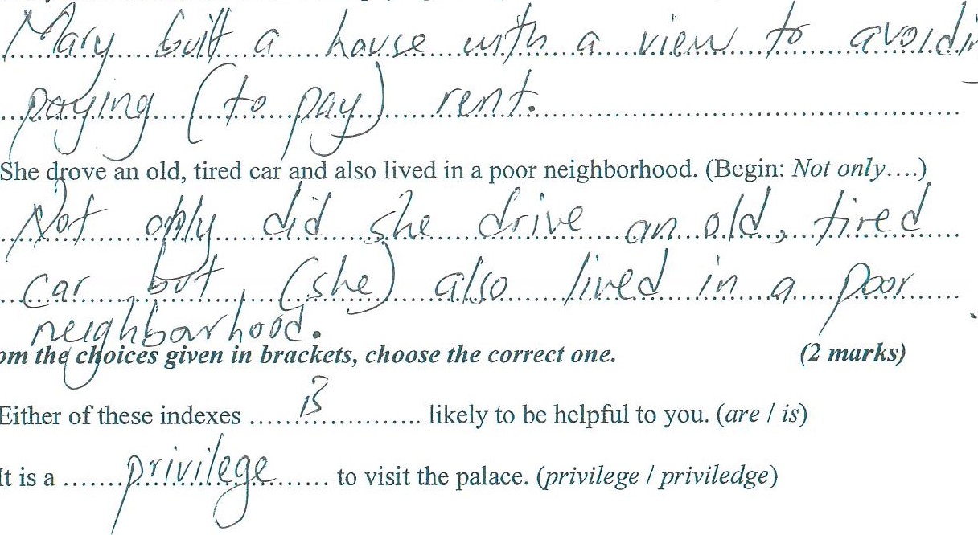
d. Mary built a house so as to avoid paying
rent.
(Use:
u'ith
a
view....
)
5.
From
a.
Either
e.
b. It is

