312/1
GEOGRAPHY P1
FORM 3
END OF TERM II EXAM (2021)
MARKING SCHEME

SECTION A
Answer all questions in this section
1)a) What are natural leaves? (2mks)
- They are river embarkments / raised river banks made of alluvial depositions on the sides of a river channel within the flood plain. (2mks)
b) List three conditions necessary for the formation of a delta (3mks)
- Large quantities of silt
- Low velocity of the river at the mouth
- Weak sea waves / weak tidal currents at the coast
- A shallow continental shelf annual the river mouth ( Any 3x 1 = 3mks)
2)a) What is a lake? (2mks)
- A large mass of water in a wide (2mk)
b) State any three ways through which lakes are formed (3mks)
- By erosion
- By earth movements
- By volcanicity / volcanic activity
- By human activity
- By mass movements of landslide ( Any 3 x 1 = 3mks)
3)a) What is climate? (2mks)
- Is the average weather condition of particular place for a long period of time
(2mks)

b) explain three effects of climate change on the physical environment (3mks)
- High rainfall results to flood that will uproot vegetation
- High temperature results to dying of vegetation
- Ice will melt leaving mountain tops bear
- Soil erosion lead to drying of vegetation ( Any 3 x 1 = 3mks)
4)a) name one active volcanoe in Kenya (1mk)
- Longonot
- Terleki
- Likaiyu
- Suswa
- Menengai
- Homa hills
( Any 3 x 1 = 3mks)
b) Describe how a geyser is formed? (4mks)
- Rainwater percolates down through cracks in the rocks
- The water gets into contact with hot igneous rocks and is heated and steam form
- Pressure builds up in the cracks.
- Steam and water is ejected explosively as geyser to the surface intermittently.
( 4 x 1 = 4mks)
5)a) Name the two types of deltas (2mks)
- Lacuistrive / inland delta
- Coastal deltas / marine (2 x 1 = 2mks)
b) Name the three parts of a wave (3mks)
- Wave length
- Crest
- Trough
( 3 x 1 = 3mks)
SECTION B
Answer questions 6, and any other two
6.Study the map of Taita hills (sheet 189/4) provided and answer the following questions
a)i) Give the four figure grid reference of the Mwatunge hilltop (2mks)
- 3214 (2mks)

ii) What was the magnetic variation of the map? (2mks)
- 0⁰ 30⁰
iii) What is the general direction of Mwatate Wundanyi C104 all weather road-bound surface (2mks)
- North (2mks)
b)i) name three physical features found along the Northing 22 from 330220 to 370220 (3mks)
- Rivers
- River valley
- Scarp slope / escarpment
- Gentle slope ( Any 3 x 1 = 3mks)
iii) Draw a rectangle 16cm by 12cm to represent the area enclosed by the Eastings 24 and 40 and Northings 20 and 30 (1mk)
- On the rectangle, mark and name the following:
- Mganga Hill (1mk)
- A rock outcrop (1mk)
- All weather road, bound surface (1mk)
- Ronge forest (1mk)

c) Citing evidence from the map, explain three factors that may have favoured the establishment of Taita Sisal Estates in the Southern parts of the area covered by the map (5mks)
- The area receives low / moderate rainfall as evidenced by the presence of the scrub vegetation. Low rainfall discourages growing of other crops
- The area is sparsely populated as evidenced by the settlements especially to the eastern side of the estate. This may have encouraged the establishment of the estate due to availability of land.
- The dense settlement near Mwatungo hill provide labour required in the sisal estate
- The road and railway line which pass close to the sisal estate provides transport to the sisal.
- The gently slopping land as evidenced by the widely spaced contours is ideal for mechanization. ( Any 5 x 1 = 5mks)
d) Describe the distribution of settlements in the area covered by the map (5mks)
- There is sparse settlement in the south east
- The sisal estate has no settlements
- Forested areas have few / no settlements
- There are four settlements along the rivers
- There are many settlements along the road / motorable tracks
- Escarpments / steep slopes / ridges have few or no settlements
- Gently sloping areas with scrub vegetation have few settlements
- There are clusters of settlements at stropping centres / markets
- There are many settlements in the mid-western part of th map than in the other parts. ( Any 5 x 1 = 5mks)
7)a) Identify two types of high level clouds (2mks)
- Cumulus 1MK
- Stratus 1MK
ii) Name two types of clouds that give rise to rainfall in the tropical regions (2mks)
- Cumulo-nimbus
- Cumulus
- Nimbostratus ( 2 x 1 = 2mks)
b)i) Give two factors that influence relative humidity (2mks)
- Distance from large water bodies / sea
- Altitude
- Vegetation / forests
- Latitude
- Temperatures ( Any 2 x 1 = 2mks)
ii) Outline the steps followed when measured humidity using a hygrometer (4mks)
- Read and record temperature of the web bub thermometer
- Read and record temperature of the dry bulb thermometer
- Calculate the difference in temperature readings of the wet and dry bulb
- Use the conversion scale to determine the humidity. ( 4 x 1 = 4mks)
c)i) Draw a diagram of the earth and on it label the North Pole and South Pole (3mks)
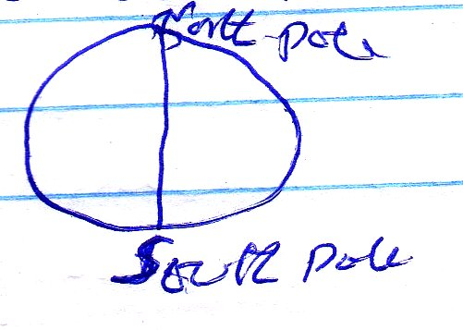
(Diagram – 1, Labelling – 2)

ii) Explain two reasons why the intensity of the insolation is higher at the equator than at the two poles (4mks)
- There is high concentration of heating at the equator than at the poles because the surface area at equator is smaller than at the poles
- The angle of the sun’s rays at the equator is higher than at the poles hence the variation in intensity (right angle / perpendicular at the equator)
- At the poles the sun’s rays travel over a long distance than at the equator thus losing the heat resulting to low intensity ( 2 x 2 = 4mks)
d)i) Draw a map of Africa, and on it label the following currents (3mks)
- Mozambique (1mk)
- Benguela (1mk)
- Guinea (1mk)
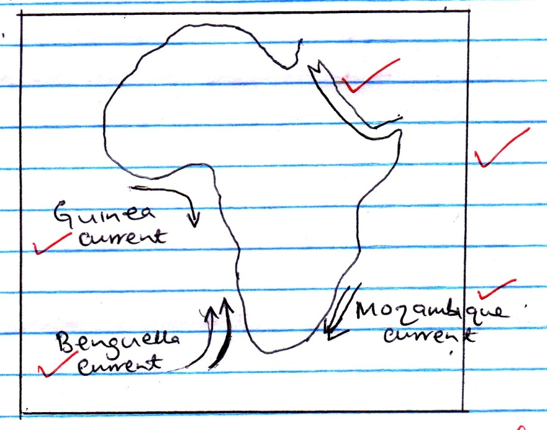

Title - 1
Frame – 1
Outline – 1
Correct labeling - 3

ii) State two effects of a warm ocean current on the adjacent coastlands (2mks)
- It warms up the adjacent land
- It increases the humidity of the adjacent land
- It may lead to rainfall on the adjacent land ( 2 x 1 = 2mks)
8)a)i) Name two features that result from horizontal earth movements (2mks)
- Faults
- Rift valleys
- Fold mts
- Escarpments
- Basins
- Tilt blocks ( Any 2 x 1 = 2mks)
ii) Give three causes of horizontal earth movements (3mks)
- Tensional forces
- Compressional forces
- Shear forces ( 3 x 1 = 3mks )
b)i) List any two large plates (2mks)
- Eurasian plate
- Australian plate
- Africa plate
- Antartic plate
- North American plate
- South American plate
- Pacific plate ( Any 2 x 1 = 2mks)
ii) What is subduction? (2mks)
- Refers to the passing of the edge on one plate beneath the edge of another (2mks)
c)i) Explain the formation of the fold mountains according to the plate tectonic theory (4mks)
- When an oceanic plate meets another or it meets a continentals plate the sediments under the sea are compressed to form fold mountains
- When two continental plates meet the continental layer is compressed to form fold mountains. ( 2 x 2 = 4 Mks)
ii) Name three fold mountains each from a separate continent (3mks)
- Himalayas - Asia
- Everest - Asia
- Audes - South America
- Alps - Europe
- Rockies - North America
- Atlas – Africa
- Appalachian - N. America ( 3 x 1 = 3mks)
d)i) A part from fold mountains, mention three resultant features due to folding (3mks)
- Escarpments
- Depressions
- Ridges and valleys
- Rolling plains
- Inter montane plateaus
- Inter montane basins ( Any 3 x 1 = 3mks)
ii) Explain three significance of folding to the physical environment (6mks)
- Folding can result in submerged coastal zones which are used as harboars
- Can lead to metamorphism of rocks changing their original state and making them more resistant to erosion.
- Depressions formed by folding turn into wet land important for water purification
- Folding leads to faulting and magma may escape through faults leading to vulcanicity and earthquakes. ( Any 3 x 2 = 6mks)
9)a)i) What is an arid area? (2mks)
- Refers to a land which is deficient of moisture leading to scanty or no vegetation (2mks)
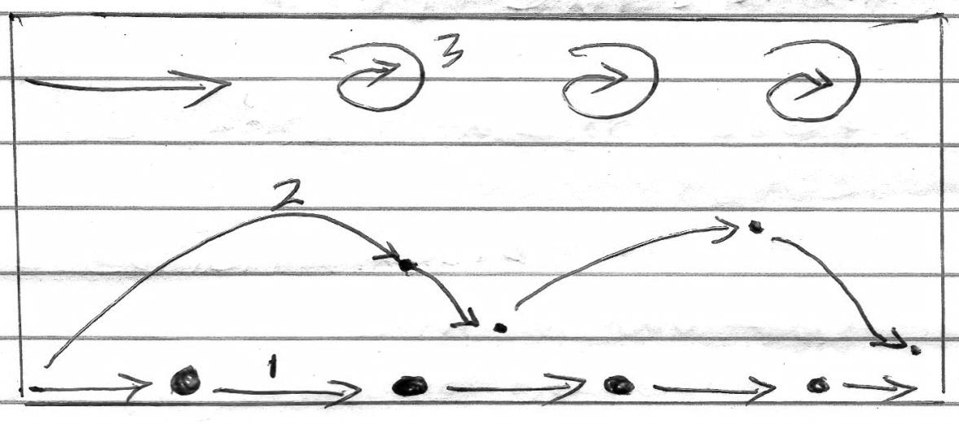
ii) The diagram below shows ways through which wind transport its load

Name the three ways labeled 1, 2 and 3 (3mks)
- 1 – Traction/ surface creep
- 2 – Saltatin
- 3 – Suspension ( 3 x 1 = 3mks)
b)i) Apart from Barchans, identify two types of sand dunes (2mks)
- Seif dunes
- Transverse dunes ( 2 x 1 = 2mks)
ii) Name five features of a Barchan (5mks)
- Cresent / moon shaped
- Smooth gentle windward slope
- Steep concave lee ward slope
- Horns / 2 curved edges
- Occurs individually or in groups ( 5 x 1 = 5mks)
c) Study the diagrams below and answer the questions that follow below:

i) Name the two desert erosive features labeled A and B above (2mks)
- A – Buttes 1mk
- B – Messas 1mk
ii) Name three county in Kenya where the names features in C (i) above can be found (3mks)
- Turkana
- Wajir
- Mandera ( 3 x 1 = 3mks)
iii) Explain any four negative significance of desert features to human activities (8mks)
- Some desert features prevent physical development e.g Sand dunes can burry roads
- Sound dunes can cover oasis and cause water shortage and discourage livestock farming
- Sand dune can destroy rich agricultural land
- High temperatures, shortage and discourage settlement ( 4 x 2 = 8mks)
10) i) Apart from weathering, name any two process that sculpture the Earth surface (2mks)
- Mass wasting
- Erosion ( 2 x 1 = 2mks)
ii) What is mechanical weathering? (2mks)
- Physical break of rocks without change in their chemical composition (2mks)
b)i) Explain the carbonation process of weathering (6mks)
- Rain water absorbs small quantities of carbon dioxide forming a weak carbonic acid
- The acid falls on limestone rocks reacting with calcite to form calcium bicarbonate
- Calcium carbonate is soluble and is removed from the rock in solution
( 3 x 1 = 3mks)
ii) Identify any three biological factors that influence weathering (3mks)
- Plant roots penetrate rocks resulting in cracks which provide passage of water which acts on rocks
- Bacteria facilitate rotting of organic matter producing organic acids which reacts with some minerals causing the rock to break up.
- Main accelerate the rate of weathering by exposing rocks buried deep below by digging, blasting and drilling ( 3 x 1 = 3mks)
c) You are planning to carry out a field study in a rocky landscape around the school
i) Name three relevant tools that you would require for the field study (3mks)
- Plastic bags
- Camera
- Maps
- Geological gummer etc ( Any 3 x 1 = 3mks)
ii) Identify three methods that you would use to collect data (3mks)
- Observing
- Administering a questionnaire
- Oral intervening
- Photographing (Any 3 x 1 = 3mks)
iii) Explain any three problems likely to be encountered during the field study (6mks)
- Unexpected change in weather e.g sudden rainfall
- Rugged terrain which may make some areas inaccessible
- Injuries caused by accident falls
- Fear of wild animals e.g snakes.
( Any 3 x 1 = 3mks)

312/1
GEOGRAPHY P1
FORM III
END OF TERM II EXAM (2019)

CONFIDENTIAL
Provide the Topographical map extract of Taita Hills 1:50,000 sheet 189/4

