231/1
Biology
Paper 1
Time: 2 hours

2021 TRIAL 3 OCT/N0VEMBER INTERNAL EXAMINATION

Kenya Certificate of Secondary Education (K.C.S.E.)

Name………………………………………………………. Adm No……………….
Stream……………………………………………………. Date ………………………….
Sign ..............................................................................

INSTRUCTIONS TO CANDIDATES
- Write your name, Admission number and name of your school in the spaces provided above
- Sign and write the date of examination in the spaces provided.
- Answer all the questions in the spaces provided.
- This paper consists of 8 printed pages.
- Candidates should check to ascertain that all pages are printed as indicated and that no questions are missing

FOR EXAMINERS USE ONLY
Question | Maximum score | Candidate’s score
1-26 | 80

- a) Name the causative agents of the following diseases in humans.
i) Typhoid. (1mk)
……………………………………………………………………………………………………….
……………………………………………………………………………………………………….
ii) Amoebic dysentery. (1mk)
……………………………………………………………………………………………………….
……………………………………………………………………………………………………….
- State the function of the following cell organelles.
i) Ribosome. (1mk)
……………………………………………………………………………………………………….
……………………………………………………………………………………………………….
ii) Lysosomes (1mk)
……………………………………………………………………………………………………….
……………………………………………………………………………………………………….
iii) Nucleolus. (1mk)
……………………………………………………………………………………………………….
……………………………………………………………………………………………………….
- a) Name one defect of the circulatory system in humans. (1mk)
……………………………………………………………………………………………………….
……………………………………………………………………………………………………….
b) State three functions of blood other than transport. (3mks)
……………………………………………………………………………………………………….
……………………………………………………………………………………………………….
……………………………………………………………………………………………………….
……………………………………………………………………………………………………….
- a) Distinguish between epigael and hypogeal germination in plants. (2mks)
……………………………………………………………………………………………………….
……………………………………………………………………………………………………….
b) Name the gland that secretes the following hormones. (2mks)
i) Ecdysone
……………………………………………………………………………………………………….
ii) Juvenile
……………………………………………………………………………………………………….
- a) Give two sex linked genes found on the Y-chromosome. (2mks)
……………………………………………………………………………………………………….
……………………………………………………………………………………………………….
b) Below is a nucleotide strand
A | A | G | T | C
i) Identify the type of nucleic acid. (1mk)
……………………………………………………………………………………………………….
……………………………………………………………………………………………………….
ii) Give a reason for your answer in (a) above. (1mk)
……………………………………………………………………………………………………….
……………………………………………………………………………………………………….
- a) Distinguish between homologous and analogous structures. (2mks)
……………………………………………………………………………………………………….
……………………………………………………………………………………………………….
b) Give one reason why organisms become resistant to drugs. (1mk)
……………………………………………………………………………………………………….
……………………………………………………………………………………………………….
- The following specimen was extracted from a newly discovered organism.
Orbit
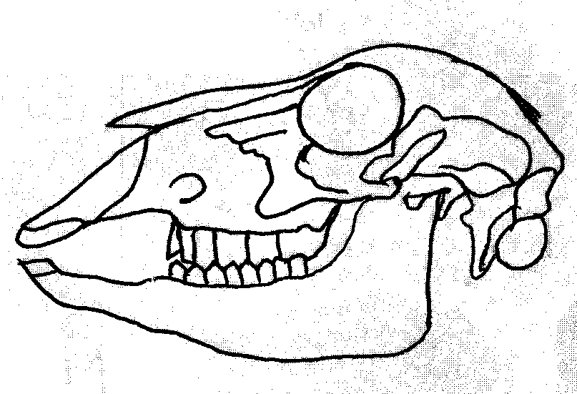

Q
M
a) Name the tooth labeled M. (1mk)
……………………………………………………………………………………………………….
……………………………………………………………………………………………………….
b) Name the part labeled Q and state its role. (2mks)
Name………………………………………………..…………………….
Role
……………………………………………………………………………………………………….
……………………………………………………………………………………………………….
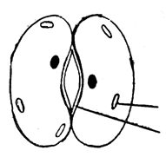
- The diagram below represents a cell organelle

Y
X

a) Name the part labeled Y. (1mk)
……………………………………………………………………………………………………….
……………………………………………………………………………………………………….
b) State the function of the part labeled X. (1mk)
……………………………………………………………………………………………………….
……………………………………………………………………………………………………….
c) Explain how dark stage of photosynthesis is dependent on the light stage. (2mks)
……………………………………………………………………………………………………….
……………………………………………………………………………………………………….
- a) Name two gaseous exchange surfaces in plants. (2mks)
……………………………………………………………………………………………………….
……………………………………………………………………………………………………….
b) What is the importance counter current flow system in fish? (2mks)
……………………………………………………………………………………………………….
……………………………………………………………………………………………………….
- Form three students wanted to estimate the population in 5km² grass field near a school compound. They captured 36 grass hoppers and marked them before returning them to the field. After a few days they made another catch of grasshoppers. They collected 45 grasshoppers out of which only 4 had marks.
a) Name the method of population estimation the students used. (1mk)
……………………………………………………………………………………………………….
……………………………………………………………………………………………………….
b) State two assumptions that were made by the students during the study. (2mks)
……………………………………………………………………………………………………….
……………………………………………………………………………………………………….
c) From the data, calculate the population size of grasshopper. (2mks)
……………………………………………………………………………………………………….

- State the functions of the following parts. (2mks)
- a) Endometrium
……………………………………………………………………………………………………….
……………………………………………………………………………………………………….
b) Epididymis
……………………………………………………………………………………………………….
……………………………………………………………………………………………………….
ii) What mechanism facilities the movement of the ovum towards uterus. (1mk)
……………………………………………………………………………………………………….
……………………………………………………………………………………………………….
- The diagram below represents the flow of energy in a food chain.
Sun Grass Antelope Leopard Bacteria P
a) Suggest a reason why the energy labeled P does not enter food chain (1mk)
……………………………………………………………………………………………………….
……………………………………………………………………………………………………….
b) State one way in which energy is lost from the food chain. (1mk)
……………………………………………………………………………………………………….
……………………………………………………………………………………………………….
- The diagram below represents the cross section of a part of a certain plant.
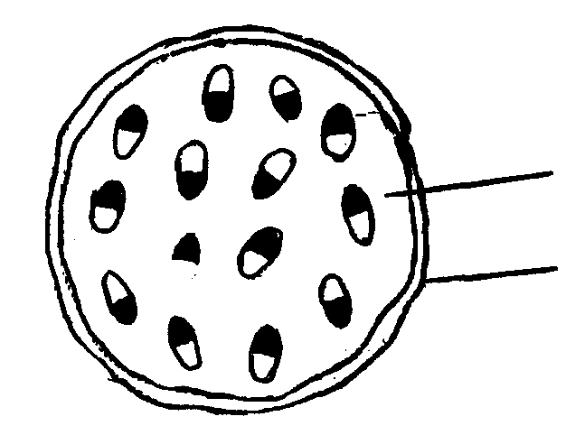
A
B

a) Name the class of the plant from which the section was taken. (1mk)
……………………………………………………………………………………………………….
……………………………………………………………………………………………………….
b) Give a reason for your answer in a) above. (1mk)
……………………………………………………………………………………………………….
……………………………………………………………………………………………………….
c) Name the parts labeled A and B. (2mks)
……………………………………………………………………………………………………….
……………………………………………………………………………………………………….

- State two reasons why the study of biology is important. (2mks)
……………………………………………………………………………………………………….
……………………………………………………………………………………………………….
- State the economic importance of the following plants excretory procedures. (3mks)
a) Caffeine
……………………………………………………………………………………………………….
……………………………………………………………………………………………………….
b) Quinine
……………………………………………………………………………………………………….
……………………………………………………………………………………………………….
c) Colchicine
……………………………………………………………………………………………………….
……………………………………………………………………………………………………….
- Define the following terms
a) Irritability (1mk)
……………………………………………………………………………………………………….
……………………………………………………………………………………………………….
b) Stimulus (1mk)
……………………………………………………………………………………………………….
……………………………………………………………………………………………………….
- A process that occurs in plants is replaced by the equation below
C₆H₁₂O₆ 2C₂H₅OH+ CO₂ + Energy
a) Name the process. (1mk)
……………………………………………………………………………………………………….
……………………………………………………………………………………………………….
b) State the importance of the process named in a) above. (2mks)
……………………………………………………………………………………………………….
……………………………………………………………………………………………………….
- a) What is Binomial Nomenclature? (1mk)
……………………………………………………………………………………………………….
……………………………………………………………………………………………………….

b) State two rules that are followed when printing scientific names. (2mks)
……………………………………………………………………………………………………….
……………………………………………………………………………………………………….
- Name three strengthening tissues in dicolyledonous plants. (3mks)
……………………………………………………………………………………………………….
……………………………………………………………………………………………………….
- Name the site for gaseous exchange in insects. (1mk)
……………………………………………………………………………………………………….
……………………………………………………………………………………………………….
- a) What is alternation of generations (2mks)
……………………………………………………………………………………………………….
……………………………………………………………………………………………………….
b) Explain why leaves of Peridophytes are referred to as Fronds. (1mk)
……………………………………………………………………………………………………….
……………………………………………………………………………………………………….
- State four adaptations of red blood cells to its functions. (4mks)
……………………………………………………………………………………………………….
……………………………………………………………………………………………………….
……………………………………………………………………………………………………….
……………………………………………………………………………………………………….
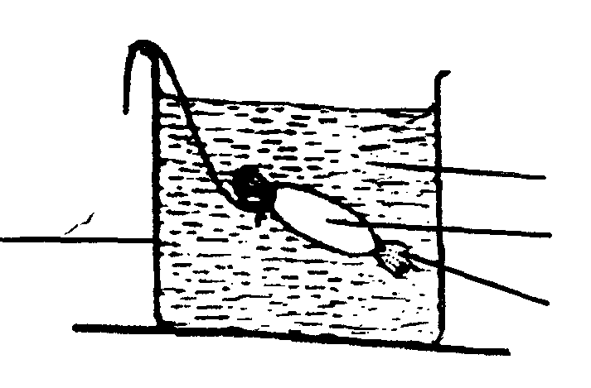
- The experiment illustrated below was set up to investigate a certain physiological process
String
Beaker
Starch solution
Iodine solution
Visking tubing solution

a) Name the physiological process that was being investigated. (1mk)
……………………………………………………………………………………………………….
……………………………………………………………………………………………………….
b) State the observations that were made after at the end of the experiment
(i) Inside the Visking tubing (1mk)
……………………………………………………………………………………………………….
……………………………………………………………………………………………………….
(ii) Outside the Visking tubing (1mk)
……………………………………………………………………………………………………….
……………………………………………………………………………………………………….

c) Account for the observations in b) above. (2mks)
……………………………………………………………………………………………………….
……………………………………………………………………………………………………….
- State the differences between the following structures in wind and insect pollinated flowers. (3mks)
(i) Anther
(ii) Pollen grains
(iii) Stigma
Wind Pollinated | Insect Pollinated flower

- A student placed a drop of pond water in a cavity slide and observed it under the microscope. The student observed many fast moving organisms, one of which is represented in the diagram below.
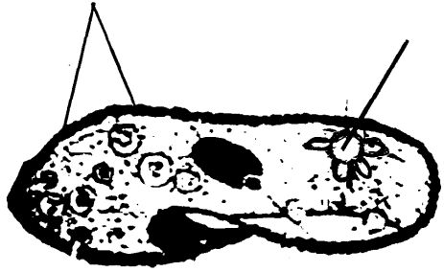
N
p

a) Name the kingdom to which the organism belongs. (1mk)
……………………………………………………………………………………………………….
……………………………………………………………………………………………………….
b) Name the structures labeled P and N (2mks)
P………………………………………………………..
N………………………………………………………...
- A person was found to pass out large volumes of dilute urine frequently. Name the;
a) Disease the person was suffering from (1mk)
……………………………………………………………………………………………………….
……………………………………………………………………………………………………….
b) Hormone that was deficient (1mk)
……………………………………………………………………………………………………….
……………………………………………………………………………………………………….

