BIOLOGY
PAPER 2
MARKING SCHEME
- (a) W – Sebaceous gland;
X – Erector pili muscles; (2mks)

(b) Y – Produces melanin which protects the body against U.V light/determines the skin colour;
Z – Secrets sweat which evaporates to bring about cooling or
Sweat also removes excretory products/excess salts/water (2mks)

(c) Vasoconstriction; hence less blood flows to the skin surface; reducing heat loss; no sweating; heat produced thought metabolisms/shivering; is retained in the body;
6 marks max 4 mks

- (a) (i) X^{R} X^{r} and X^{r} Y; (1mk)
Both must be present
(ii) Phenotype; Red eyed female White eyed male

Genotype X^{R} X^{r} x X^{r} y;

Gametes X^{R} X^{r} X^{r} Y ;

Fusion
;

F1 generation X^{R}X^{r} X^{R}Y X^{r}X^{r} X^{r}Y ; (4mks)

(iii) Crossing over;
- Mutations; (1mk)
Any one – 1mk
(iv) Down’s syndrome; klinefelters syndrome; turners syndrome; (2 mks) first 2 – 2mks

- (a) Aquatic; (1mk)

(b) (i) Phytoplankton’s; (1mk)
(ii) Hawks; (1mk)

(c) (i) Phytoplankton’s zooplanktons frogs snakes hawks
Reject if arrow is not indicated
(ii) Snakes would decrease (due to less food)
Zooplanktons would increases (due to less predator) 3mks

(d) Oil clogs fish gills;
- Oil cuts off dissolved oxygen in water leading to suffocation
Any one 1 mark
(e) Domestic effluents;
Sewage;
Silting;
Industrial effluents;
Agrochemicals;
Any one 1 mark

- (a) To find out whether energy/heat is released in anaerobic respiration/fermentation; 1mk
To investigate the gas produced during fermentation/anaerobic respiration; (1mk)

(b) (i) (Significant) rise in temperature; colour of bicarbonate indicator turns yellow; 2mks (ii) Yeast will respire aerobically releasing energy/and carbon (iv) oxide gas that turn indicator
yellow; 1mk
(iii) Expel/drive out oxygen; 1mk

- (a) Osmosis; (1mk)

(b) – Sugar solution is hypertonic to the cell sap of pawpaw;
- These cells lose water to sugar solution by osmosis;
- These cells thus become more concentrated/hypertonic to the water in the beaker;
- The cells then gain water by osmosis from the beaker;
- Causing a rise in level of the sugar solution; (max 4mks)

(c) (i) The sugar solution level will not rise/remain the same/no change;(1mk)
(ii) Boiling kills cells; making them osmotically inactive; (2mks)

(c) Use glucose solution without yeast cells/killed yeast cells; (1mk)
- a) Graph
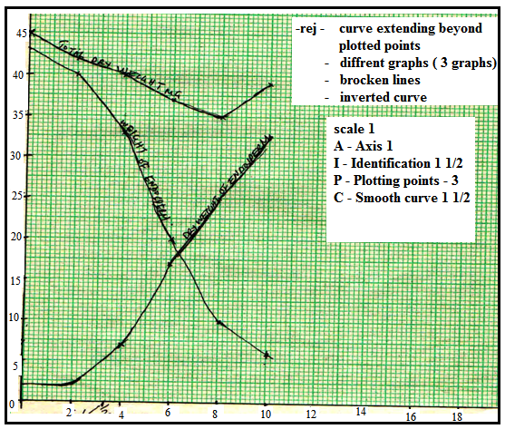

b) Total dry weight 38.5mg; acc ±0.5
c)
- Hydrolysis of starch into simple sugars/glucose which are translocated to the embryo;
Oxidation/respiration of( simple sugars) to the embryo;
CO2/energy/heat; acc water vapor
- New cells/tissues materials are synthesized (from proteins);bring about growth of embryo
- The rate of respiration is faster than that of synthesis of materials for growth;
- First leaf carried out photosynthesis; (leading to growth
d)

- Presence of absissic acid; (ABA)
- Presence of germination inhibitors;
- Embryo not fully developed/immature embryo;

- Absence of hormones/enzymes that stimulate germination;
Acc inactivity of hormones/enzymes inhibitors;
- Impermeable seed coat;
Acc for germination hormones such as cytokines, gibberellins;
- Unsuitable temperatures/lack of suitable/unfavorable temperatures; absence of light; lack of O₂ Rej lack of air
Lack of water
e)
- Dense cytoplasm; thin cell walls
- Absence of vacuoles (cell sap);

- (a) Fertilization is the fusion of the male and female nuclei in the embryo sac; this is preceded by the process of pollination which involves transfer of pollen grains from the anther to the stigma;
Stigma secrets sticky substance; which causes adherence of pollen grains; and stimulates germination of pollen tube; pollen tube grows down the style deriving nutrients from the style tissues; the tube nucleus follows behind; generative nucleus divides mitotically to form two male nuclei; in the ovule the pollen tube penetrates the embryo sac and the tube nucleus disintegrates; one of the male nuclei gets in and fuses with the egg cell nucleus; to form a diploid zygote; the other male nuclei fuses with polar nucleus; to form a triploid primary endosperm nucleus; hence double fertilization in flowering plants;

(b) Corolla/stamens/style wither/dry and fall off;
Calyx persists;
Ovule develops into a seed;
Zygote forms an embryo;
Primary endosperm tissues develops into an endosperm;
Ovary forms a fruit;

- (a) External intercostals muscles contract; internal intercostals muscle relax, this movement pulls the Rib cage move outwards; and upwards; Diaphragm muscles contract,which causes the Diaphragm to flatten; volume in thoraci cavity increases; pressure reduces.
Atmospheric air enters the lungs; inflate (correct sequence to be followed)
(b) Guard cells have chloroplast which photosynthesis in the presence of light, to form sugar, the osmotic pressure of guard cell increases; water move from neighbouring cells into guard cells being thicker than outer walls. Causes the outer wall to stretch more resulting guard cells budging outwards.

