Kenya Certificate of Secondary Education (K.C.S.E)
232/3
PHYSICS
PAPER 3
MARKING SCHEME

QUESTION ONE
Part A
b) d = 20.0 $±$ 1 cm1
d = 0.02 $±$ 0.01m 1
d)
BD= Xcm | AC = Y (cm) | $\frac{1}{y}$ (cm⁻¹)
30  25  20  15  10 | 16.0  17.5  20.0  25.5  28.0 | 0.0626  0.0571  0.0500  0.0392  0.0357
 | 4 marks for values within the range. Each value $±$ 1 cm | 2 marks for correct calculation
(6 marks)
f) i)
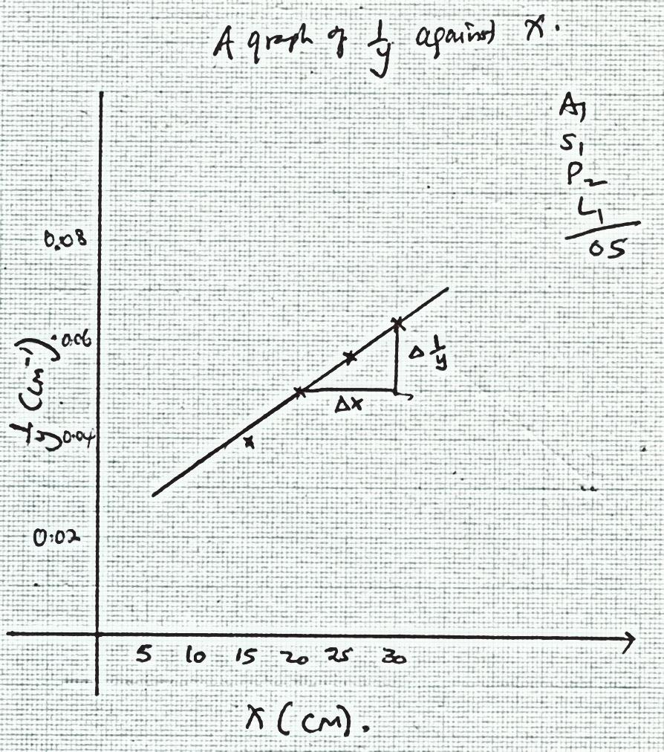

ii) Slope = $\frac{\frac{1}{y}}{x}$
= $\frac{\left(0.63-0.50\right){cm}^{-1}}{30-20 (cm)}$ 1
= $\frac{0.13}{10}$ 1
= 0.013cm⁻²1 (Answer to have the correct units)
iii) M = $\sqrt{\frac{1}{0.013}}$ 1
= 8.771cm1 (Answer with units)
iv) - M is approximately half of d1
- d is approximately the focal length of the lens1
QUESTION TWO
c) i) t = 4.51$±$ 2 seconds 1
ii) $\frac{4.51}{10}$ = 0.451Hz1
d)
Angle $θ^{0}$ | Time for 10 oscillation t(s) | Frequency f = $\frac{t}{10}$ | F₂(Hz²) | Cos $\frac{θ^{0}}{z}$
20⁰  40⁰  60⁰  80⁰  100⁰  120⁰ | 4.51  4.94  5.06  5.50  6.00  6.20 range $±$1 sec | 0.451  0.494  0.506  0.550  0.640  0.620 | 0.2034  0.2440  0.2560  0.3025  0.3600  0.3844 | 0.9848  0.9397  0.8660  0.7660  0.6428  0.5000
 | 3 mks | 1 mk for correct calculation | 1 mk for correct calculation | 2 mk(for correct calculation
e)
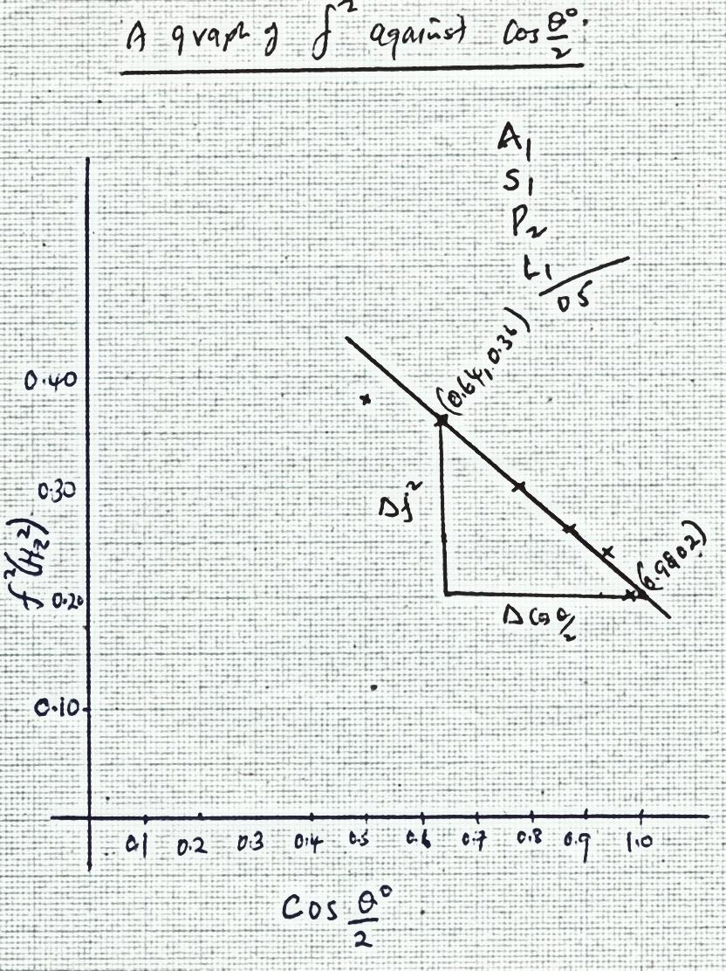

f) Slope = $\frac{f^{2}}{ Cos \frac{θ^{0}}{2}}$
= $\frac{\left(0.36-0.20\right){Hz}^{2}}{0.64-0.98}$
= $\frac{0.16}{- 0.34}$
= - 0.4706Hz² (Answer with units)
g) f² = $\frac{150k}{4πL}$ Cos $\frac{θ}{2}$
Slope = $\frac{150k}{4πL}$
L = $\frac{150 ×15}{4π^{2}}$ 1
= $\frac{2250}{39.478}$ 1
= 56.9941

