

1.(a) (i) Cracking√ 1

(ii) When the gas is burnt in air√ 1 it burns with a pale blue flame. √ 1

OR

Does not decolourize √ 1purple acidified potassium manganate (VII). √ 1

(iii) I. A. Ethane√ 1

II. B 1- Chloroethane√ 1

(iv)

H H

C C

H H n√ 1

(v) (i) Combustion√ 1

(ii) Dehydration√ 1

(vi) Conc. H2SO4√ 1

Temperature of 1700C. √ 1

(b) (i) Pent-2-ene√ 1

(ii) Prop-1-yne. √ 1

1. a) (i) Mass of Mg is 20.36-19.52=0.84g√ ½

Mass of MgO is 20.92-19.52=1.40g

Mass of oxygen is 20.92-20.36=0.56g√ ½

% mass of Mg in MgO is $\frac{0.84}{1.40}×100\%$

=60%√ ½

%mass of O2 in MgO is $\frac{0.56}{1.40}×100\%$

=40%√ ½

(ii)

|  |  |  |
| --- | --- | --- |
| Elements | Mg | O |
| %comp | 60 | 40 |
| R. A. M | 24 | 16 |
| Moles | 60 $÷24$ =2.5 | 40÷16  =2..5 |
| Mole ratio | 1√ 1 | 1√ 1 |

Empirical formula is thus MgO√ 1

b) (i) 2NaOH(aq) +H2SO4(aq) Na2SO4(aq) +2H2O(l) √ 1

(ii)

I. Moles of H2SO4 in 20cm3 is

=0.005moles√ 1

Mole ratio of base to acid is 2:1

Moles of NaOH is thus $\frac{2}{1}×0.005$

=0.01 moles of NaOH√ 1

II. Moles of NaOH in 1L is thus

$\frac{0.01×1000}{50}$ √ 1

=0.2moles√ 1

III. Mass of NaOH in 1L is

$0.2×40$ =8g

Mass of NaCl in the mixture is 8.8-8= 0.8g√ 1

% mass of NaCl is ${0.8}/{8.8}×100\%$

= 9.09%√ 1

1. a) (i) Bonds Broken are 4C-H= 4 x 413 = 1652

1C = C = 1 x 610 =610

1Br – Br = 1 x 193 = 193

**Total energy absorbed = 2455** **kJmol-1 √1**

Bonds formed are 4C-H= 4 x 413 = 1652

2C = Br = 2 x 280 =560

1C – C = 1 x 346 = 346

**Total energy given out = 2558 kJmol-1 √1**

ΔH = 2455 – 2558 = -103**kJmol-1 √1**

(ii) Addition reaction √1

b) (i) 4C (s) + 5H2 (s)  ΔH1 C4 H10(g)

ΔH3

ΔH2 √1

4CO2 (g) + 5H2O (g)

ΔHθf (C4H10) = ΔH3 - ΔH2

=4 (-393) + 5(-286) – (-2877) √1

= -3002 + 2877

= -125 kJmol-1 √1

(ii) ∆H +∆Hhyd

= 690 + -322 + - 364

= 690- 686

= + 4 kJ / mol

1. a) √ 1
2. Burrete √ 1
3. Pippete√ 1
4. Measuring cylinder

b)

* + 1. Due to incomplete combustion, it produces white hot carbon particles that emittes a lot of light √ 1
    2. It produces soot that makes apparatus dirty √ 1

It does not produce much heat √ 1

c)

1. Nitrogen √ 1and oxygen√ 1
2. It can be separated by physical means √ 1

Components of air are not chemically combined √ 1

1. Pass air through lime water (Ca(OH)2√)√ 1 the lime water forms white precipitate indicating presence of carbon(IV)oxide √ 1
2. (a) Alkali metals √ 1

(b) Electron arrangement 2.8.5 √1

position: group V period 3√1

(c) The atom of R is larger √ ½ // has a larger atomic radius than the ion √ ½ This is because the ion of R is formed when the atom loses the electrons in the outermost energy level √ ½ therefore, the ion has one less energy level than the atom.√ ½

(d) (i) P2W √ ½

(ii) TY4 √ ½

(e) S has a higher √ ½ melting point than Q √ ½

This is because e S has more valence electrons in its metallic structure hence a stronger metallic bond √ ½ than Q √ ½

(f) M √1

It has a completely filled outermost energy level √ ½ and therefore, does not need to react with other elements to gain stability √ ½

(g) S has a higher electrical conductivity than Q√ 1.

S does not corrode easily like Q. √ 1

(h)

1. (a) A – Ammonia √1

B – Calcium oxide √1

(b) CaO (s) + H2O (l)  Ca(OH)2 (aq) √1

(c ) Reaction is exothermic √1

(d) Filtration √1

(e) - Ammonia √1

- Carbon (IV) oxide √1

(f) (i) C (s) + 2H2SO4 (l)  CO2 (g) + 2H2O (l) + 2SO2 (g) √1

(ii) Oxidising property √1

(g) - Manufacture of glass√½

- Softening of hard water √½

- Making of soaps and detergents

- For making sodium hydrogen carbonate used in baking soda and fire extinguishers

(Any 2 correct answers each ½ mk )

1. (a) (i)

|  |  |  |
| --- | --- | --- |
| Substance | Carbon (IV) oxide | Carbon (II) oxide |
| K | Dilute hydrochloric acid √½ | Concentrated sulphuric (VI) acid √½ |
| L | Marble chips or calcium carbonate √½ | Sodium methanoate or ethanedioc acid (oxalic acid) √½ |

(ii)

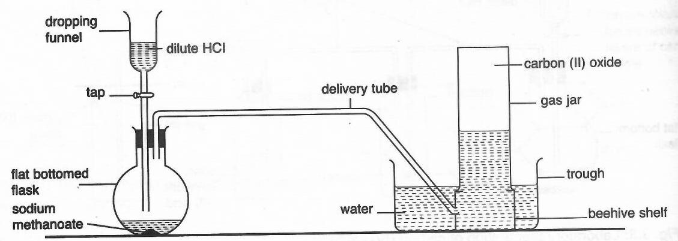

Complete diagram = 1 mark, Labelling = 1 mark

(iii) Carbon (IV) oxide reacts with lime water / calcium hydroxide solution√½ to yield

white precipitate while carbon (II) oxide does not. √½

Carbon (II) oxide burns √½with blue flame while carbon (IV) oxide does not burn. √½

(b) (i) CO2(g) + C(s) → 2CO(g) √1

(ii) Reducing agent in extraction of some metals from their oxides. √1

(c) The bulb lights in set up I or conducts electricity while set up II does not. √ √1

In graphite, three out of four valence electrons of carbon atom are bonded leaving one

delocalised√1 electron thus conducts electricity while in diamond, all the four valence

electrons are bonded and is without delocalised electrons. √1