(CZJISET)
MARKING SCHEME PAPER 3
PROCEDURE 1
1.[a]2 moles →1000cm³$\frac{25×1}{1000}$=0.05 moles
? 25cm³
0.05 moles-250cm³$\frac{0.05×1000}{250}$⁼0.2m
PROCEDURE II
Complete table 1
Decimal 1
Arithmetic 1
Accuracy 1=0.2
[a]$\frac{12.5+12.5+12.5}{3}$=12.5cm³
[b] 0.2 moles→1000cm³$\frac{0.2m×25}{1000}$=0005 moles
25cm³
[c]2NaoH _{[aq]}+H₂SO_{4[aq]}→NaSO_{4[aq]}+2H2O_{[l]}
[d]Mole ratio
A:C C=0.0025moles
1:2 A=$\frac{0.005}{2}$=0.0025 moles
[e]0.0025→answer a=$\frac{0.0025×1000}{answer a}$
1000
2. Table
Complete table 1
Decimal point 1
Trend 1
[a]Graph
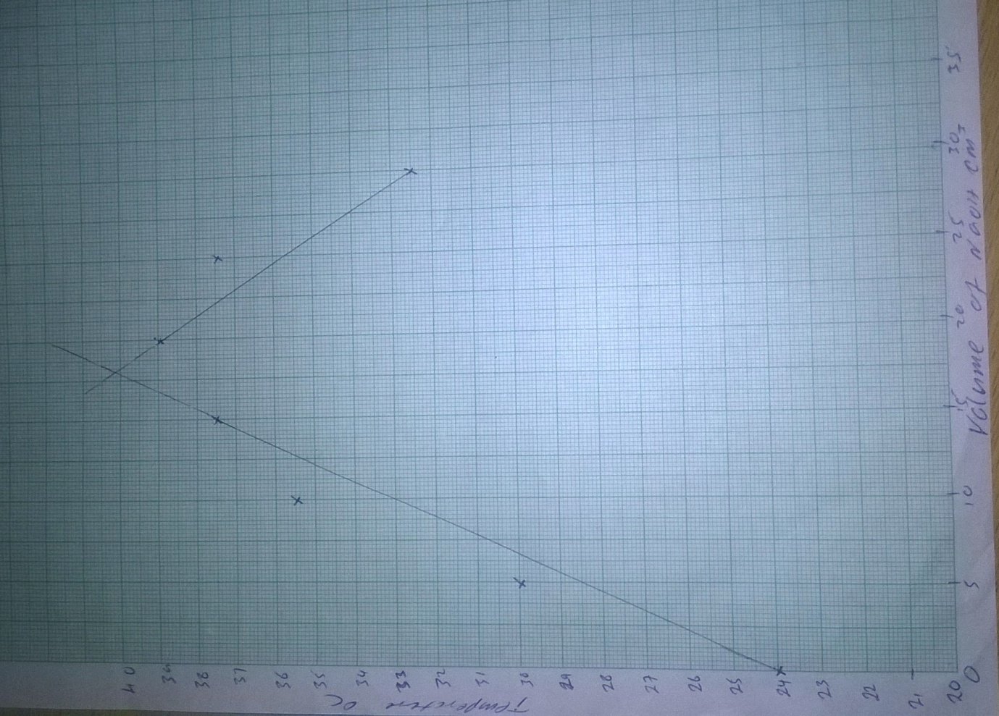
Axis -$\frac{1}{2}$Mk each
Scale-$\frac{1}{2}$Mk each
Plotting 1 mk
Curve 1 mk
[b][i]answer from the graph
[ii] Use MCDθ
Mass=50$×$1=50g.
From MCDθ→50g$×\frac{4.2}{g}$ J/g/$°$C $×$answer in b [i] above.
[iii]Theoretical value is higher than the obtained value
Heat lost to the surrounding[1mk]
Heat absorbed by the apparatus[1mk]

3.[a]
Observation | Inference
It dissolves into$[\frac{1}{2}$]a colourless solution$[\frac{1}{2}$mk] | Soluble salt[$\frac{1}{2}]$NoCu^{2+,}Fe²⁺ or Fe³⁺[$\frac{1}{ 2}mk$]

[b]
Observation | Inference
White precipitate soluble in excess [1mk] | Pb^{2+,}Zn^{2+,}Al³⁺ ions present[ 2mks] for the 3  1mk for 2  0 mk for less than 2

[c]
Observation | Inference
White precipitate insoluble in excess[1mk] | Pb^{2+,}Al³⁺ ions present[1mk]

[d]
Observation | Inference
No Yellow precipitate formed[1mk] | Pb ²⁺ ions absent/ Al³⁺ present[1mk]

[e]
Observation | Inference
White precipitate [1mk] | SO₄²⁻ ions[1mk]
Don’t dissolve on adding nitric acid

