AGRICULTURE PP2 MARKING SCHEME 2021

SECTION A
- Apiculture - keeping of bees.

- BROWN EAR TICK - East Coast Fever, Corridor disease, Nairobi sheep disease.
- TSETSEFLY - Trypanosomiasis/ Nagana

- Intermediate host for liverfluke Fasciola spp.
Fresh water snail/Lymneaspp

- Breeds of rabbits
- Chinchilla
- Carlifonia white
- Newzealand white
- Earlop
- Martensable
- Flemish Giant

- Functions of a crop in a digestive system of chicken.
- Mixes and softens food with water
- Temporary storage of water

- Ways of restraining cattle.
- Use of rope/halters/casting
- Use of lead stick and bull ring
- Use of crush
- Use of head yoke
- Use of isolation yard/ pen
- Casting.

- Livestock diseases caused by virus.
- Gumboro/infectious Bursa disease
- Fowl pox
- New castle disease
- African Swine fever
- Foot and mouth disease
- Rinderpest/cattle plague
- Lumpy skin disease
- Bird flu
- Mareki disease
- Mad cow disease

- Types of selection practiced by livestock farmers.
- Mass selection
- Progeny testing
- Contemporary comparison.

- Ways of preventing predation in a fish pond.
- Fencing with mesh wire
- Placing sieve at inlet

- Functions of feed additives in livestock production.
- Prevent diseases
- Promote growth of milk secretion
- Increase efficiency of feeds

- Types of calf pens
- Movable
- Permanent

- Advantages of embryo transplant.
- Stimulate milk production.
- Highly productive female can spread over and benefit many farmers
- Easier to transport than whole animals
- Embryos can be stored for a long period.
- Possible to implant embryo from high quality female.

- Roles of testis in male reproductive system.
- Production of spermatozoa
- Secretion of male sex hormone

- MOTHERING ABILITY- ability of the dam/mother to take care of offspring
until weaning.
PROLIFICACY-ability of female to give birth to many offsprings at the same time

- Ways in which feeding contributes to disease control.
- Prevents deficiency diseases
- Improves animal’s ability to resist diseases.
- Contains herbal medicine against diseases

- Functional differences between rumen and abomasum
Rumen
Temporary storage
Biological digestion
Abomasum
True stomach
Secrets digestive enzymes

- Four practices carried out in the crush ½ x 4 (2 mks)

- Dehorning
- Hoof trimming
- Vacinnation / injection
- A.I.
- Pregnancy diagnosis
- Spraying
- Castration
- Identification

- Three dual purpose cattle breeds ½ x 3 = 1½mks

  - Sahiwal
  - Red poll
  - Simmental

- Three terms used to describe the following: -
(i) Mature male pig : boar
(ii) Sterilised birds : Capon
(iii) Mature female goat : Doe / nanny ½ x 3 = 1½mks

- Four reasons for identifying farm animals ¼ x 4 = 2mks

- Facilitate selection and breeding
- Facilitate feeding
- Facilitate record keeping
- Facilitate culling
- Facilitate disease control and treatment.

- Four factors that determine the quality of honey ½ x 4 = 2 mks

- Type of plant from which nector was obtained
- Maturity stage of honey at harvesting time
- Method of harvesting
- Method of processing

- Four categories of livestock diseases ½ x 4 = 2 mks

- Bacterial
- Viral
- Protozoan
- Nutritional

- Three tools used for plumbing ½ x 3 = 1½mks

- Pipe wrench
- Pipe cutter
- Stock and die
- Hacksaw
- Adjustable spanner
- Screw drivers
- Sash clamp
- Tape measure
- Combination square

- Four maintenance practices carried out on an ox-drawn plough ¼ x 4 = 2 mks

- Lubricate land wheel bearing / moving parts
- Replace worn out share
- Sharpen blunt share
- Tight loose bolts and nuts
- Clean after use
- Proper storage / in a shed
- Before long storage paint / coat with old engine oil / any other anti-rust substance to prevent rusting.

- Four sources of farm power which are environmental friendly ¼ x 4 = 2 mks

- Solar power
- Wind power
- Water power
- Human power
- Animal power
- Electricity
- Biogas

- Four functions of the lubricating system in a tractor ¼ x 4 = 2 mks

- Reduce friction / increase efficiency
- Prevent rusting
- Prevents tear and wear
- Cleaning agent
- Reduce heat

- State two conditions under which a farmer would prefer to use an ox-cart instead of a tractor-drawn trailer ½ x 2 = 2 mks

- In case of inadequate capital
- Small load to carry
- Too steep an area to use a tractor.

- State four qualities considered when selecting a heifer for dairy purposes ½ x 4 = 2mks

- Body conformation / Triangular shaped / wedge shape
- From high milk yielding family
- Well adapted to the environment
- Free from physical defects
- Healthy / free from disease
- Docile / easy to handle

- Give one role of a damp proof course in the foundation of a farm building 1 x 1 = 1 mk
- Prevents moisture from rising up the wall
- Prevents termites from climbing up the wall.

SECTION B

a) 1: Eggs hatch and larvae emerge
4: Nymphs climb onto a 2nd host and feed
5: Engorged nymphs drop down to lay eggs
7: Engorged female drops to lay eggs 4 x½ = 2 mks

b) Tick keeps on dropping off the animals at every stage of development , so it is
not affected by acaricides when the animal is sprayed / dipped 1x½ = 1 mk

c) Most common sites where ticks are found
- Ears
- Base of the horns
- Around the eyes
- Tail switch

d) Examples a three host
- Brown ear tick
- Boot tick
- East African boot tick

(i) Wool shearing (½ mk)
(ii) Shearing should be done on clean floor free of grease

Care should be taken not to cut skin, testicles, udder, vulva and penis (2 x 1 = 2mks)
(iii) Once in a year (½mk)

- Below in an activity carried out in poultry production. Study it carefully then answer the questions that follow.
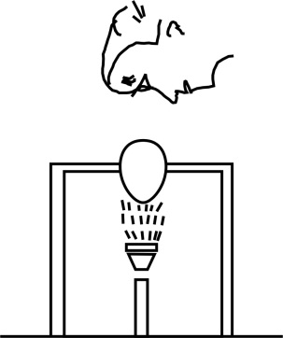

- Identify the practice being carried out : egg candling (1 mk)

- Three defects that can be detected by this practice (1 x 3 = 3 mks)
- Size of air space
- Fertility
- Very porous shell
- Blood spot
- Meat spot
- Double yolk
- Broken shell
- Hair cracks

c) Two disadvantages of artificial incubation. (1 x 2 = 2 mks)
- High initial capital / expesive to buy incubator
- Labour demanding
- Requires high skills
- High risk of damaging all eggs.

- Use the above diagram of a calf pen to answer the questions that follow.
a) How high should the calf pen be raised from the ground: 50cm (1mk)
b) Give any two reasons why calves are housed singly 1 x 2 = 2mks
- Avoid calves licking each other / formation of hair balls.
- Avoid spread of diseases / parasites
c) Why should the calf pen be near the milking parlour? 1 x 2 = 2mks
- Avoid contamination of milk
- Calf takes milk at mother’s body temperature
- Minimize problem of scouring
- Study the diagram below of a diesel fuel system then aswer the questions that follow
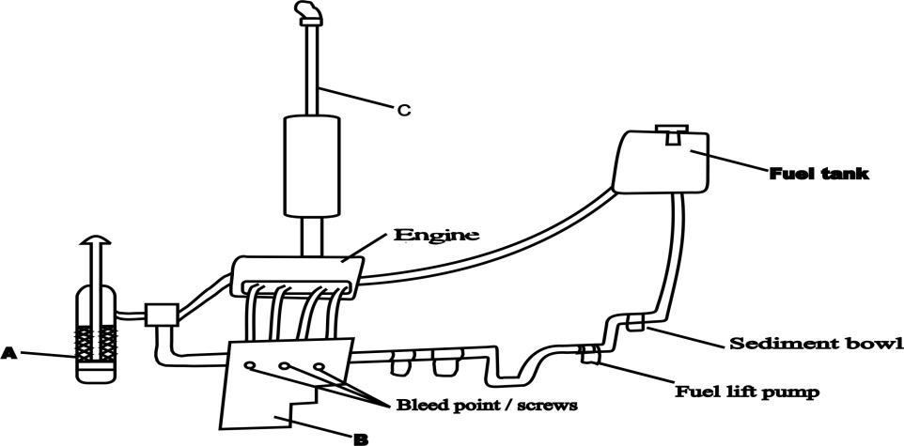
a) Identify the parts labelled (3 mks)
A - Air cleaner (1 mk) B - Injector pump (1 mk) C - Exhaust pipe (1 mk)

b) Three maintenance practices carried out on the system 1 x 3 = (3 mks)

- Replace / clean oil filters as recommended
- Remove and clean sediment bowl regularly
- Replace worn out injectors
- Bleeding should be done in case air is entrapped in the system.
- Replace dirt from air cleaner / clean air cleaner element by blowing with air (dry type)

SECTION C

- Five signs of heat in a cow 1 x 5 = (5 mks)

- Restlessness
- Mounting on others / stands still when mounted
- Slight increase in body temperature
- Drop in milk production in lactating cows
- Reddish and swollen vulva
- Clear / slimmy mucus from vulva
- Bellowing / mooing frequently
- Frequent urination

b) Five causes of stress in poultry and describe their control (10mks)

- Sudden change in routine practices
- Sudden change of feed
- Presence of predators / strangers in the house
- Attack by external parasites and diseases
- Sudden loud noise
- Abrupt change in weather
- Poor handling of birds during routine practices
- Inadequate feed and water
- Overcrowding

Control

- Change of routine practices should be gradual
- Change in feed should be done gradually.
- Seal the house against predators.
- Control parasite and disease attack promptly.
- Locate the poultry house in an appropriate place free from noise.
- Insulate the house against weather elements.
- Handle the birds properly
- Provide adequate feed and water to birds.
- Ensure proper floor space
[Five causes and their control 1 x 10 = 10 marks]

c) Using pearson’s square compute a ration with 20% DCP from oats which contains
10% DCP and simsim seedcake containing 60% DCP. ½ x 10 = (5mks)

Oats 10%
40 parts of oats
20
Simsim 60%

10 parts of simsim
50 parts
Oats - = 80 kgs of oats
Simsim - = 20 kgs of simsim

- a) Daily maintenance practices that should be carried out on a farm tractor 1 x 8 = 8 mks

- Check oil level / level of oil in the sump using dip stick
- Check level of fuel in the tank
- Check level of electrolyte in the battery and adjust accordingly.
- Check level of water in the radiator and top up.
- Grease moving parts
- Check fan belt tension and adjust accordingly.
- Check tyre pressure and adjust accordingly
- Tighten loose bolts and nuts
- Open and remove dirt from sediment bowls

b) Outline twelve general symptoms of endoparasite attack in livestock. 1 x 12 = 12 mks

- Emaciation
- Decline in production
- Staring / rough coat
- Oedematous swelling under the jaw.
- Diarrhoea
- Pot-belly
- Persistent cough
- Anorexia / loss of appepite
- Eggs / parasite in faeces
- Depraved appetite / abnormal appetite
- Blockage / obstruction of internal organs
- Anaemia

- a) State four advantages of using a sub soiler in seedbed preparation (4mks)
- Used in breaking hard pan
- Facilitate aeration
- Facilitate water infiltration
- Help in pulling deep rooted weeds
- They loosen up the the soil through the vibration they make

b) Give five advantages of artificial insemination in cattle management (5mks)
- Controls breeding diseases /parasites
- Controls breeding
- Its quicker method of obtaining a proven bull
- It is easy and cheap to transport semen to far areas
- Semen from a superior bull can be used to serve many cows
- Farmers who cannot afford to buy a superior bull can access the service at a low cost
- Bulls that cannot serve naturally due to physically injuries/defects can be utilized
- Prevents injuries to cows by heavy bulls

(c) State five function of water in animal’s body (5mks)

- Acts as solvent for chemical Substances
- Its a medium of transport of nutrients in the animals body
- Help in excretion of waste product from animals body
- Regulates temperature through sweating and evaporation
- Maintaining solute –solvent balance in body fluids (osmoregulation)
- Make cells turgid ;maintaining the shape of the body cells
- Used in bio chemical reactions in the body e.g digestion of food
- It’s a component of body fluids
- Describe control measures for tape worm in livestock (6mks
- Use of prophylactic drugs
- Keep animal houses clean and disinfected
- Practice rotational grazing and rest pastures to starve larvae to death
- Keep feeding and watering equipment clean
- Use of latrine by farm workers/proper disposal of human exceta
- Proper meat inspection
- Proper cooking of meat

