443/2 AGRICULTURE

PAPER 2
(THEORY)
DURATION:: 2HRS

2021 TRIAL 3 OCT/N0VEMBER INTERNAL EXAMINATION

Kenya Certificate of Secondary Education (K.C.S.E.)

Name………………………………………………………. Adm No……………….
Stream……………………………………………………. Date ………………………….
Sign ..............................................................................

Instructions to candidates
a) Write your name and index in the spaces provided above
b) Sign and write the date of examination in the spaces provided above
c) This paper consists of three sections A, B and C.
d) Answer all the questions in sections A and B.
e) Answer any two questions in section C
f) All answers should be written in the spaces provided in the question paper.

For Examiner’s Use Only
Section | Question | Maximum Score | Candidates Score
A | 1 – 29 | 40
B | 30 - 35 | 30
C | 36 - 38 | 20
Total Score |  | 90

- What is apiculture? (1 mark)
...............................................................................................................................................................................................................................................................................................................................................
- Name one livestock disease that is transmitted by the following parasites.
- Brown ear tick (½ mark)
........................................................................................................................................................................(b) Tsetsefly (½ mark)
........................................................................................................................................................................
- State the intermediate host for liver fluke Fasciola spp. (½ mark)
........................................................................................................................................................................
- State four breeds of rabbits. (2 marks)
................................................................................................................................................................................................................................................................................................................................................................................................................................................................................................................................................................................................................................................................................................
- State two functions of a crop in a digestive system of chicken. (1 mark)
................................................................................................................................................................................................................................................................................................................................................
- State three ways of restraining cattle (1½ marks)
........................................................................................................................................................................................................................................................................................................................................................................................................................................................................................................................
- State two livestock diseases caused by virus. (1 mark)
................................................................................................................................................................................................................................................................................................................................................
- State two types of selection practiced by livestock farmers (1 mark)
................................................................................................................................................................................................................................................................................................................................................
- State three ways of preventing predation in a fish pond (1mark)
........................................................................................................................................................................................................................................................................................................................................................................................................................................................................................................................

- State four functions of feed additives in livestock production. (2 marks)
................................................................................................................................................................................................................................................................................................................................................................................................................................................................................................................................................................................................................................................................................................
- State two types of calf pens. (1 mark)
................................................................................................................................................................................................................................................................................................................................................
- State advantages of embryo transplant. (2 marks).
................................................................................................................................................................................................................................................................................................................................................
- State two roles of testis in male reproductive system. (1 mark)
................................................................................................................................................................................................................................................................................................................................................
- Differentiate between mothering ability and prolificacy (2 marks)
................................................................................................................................................................................................................................................................................................................................................................................................................................................................................................................................................................................................................................................................................................
- State three ways in which feeding contributes to disease control. (1½ marks)
........................................................................................................................................................................................................................................................................................................................................................................................................................................................................................................................
- State two functional differences between rumen and abomasums. (2marks)
................................................................................................................................................................................................................................................................................................................................................
- Name four practices carried out in the crush (2 mks)
........................................................................................................................................................
........................................................................................................................................................
........................................................................................................................................................
........................................................................................................................................................

- Give three dual purpose cattle breeds (1½ mks)
........................................................................................................................................................
........................................................................................................................................................
........................................................................................................................................................
- Give three terms used to describe the following: - (1½ mks)
(i) Mature male pig ........................................................................................................................
(ii) Sterilised birds ........................................................................................................................
(iii) Mature female goat ................................................................................................................
- State four reasons for identifying farm animals (2mks)
...............................................................................................................................................................................................................................................................................................................................................
.......................................................................................................................................................................
.......................................................................................................................................................................
- State two factors that determine the quality of honey (1mk)
...............................................................................................................................................................................................................................................................................................................................................
- Give four categories of livestock diseases (2 mks)
...............................................................................................................................................................................................................................................................................................................................................
...............................................................................................................................................................................................................................................................................................................................................
- Name three tools used for plumbing (1½ mks)
................................................................................................................................................................................................................................................................................................................................................ ........................................................................................................................................................................
- State two maintenance practices carried out on an ox-drawn plough ( 1 mk)
...............................................................................................................................................................................................................................................................................................................................................
- List two sources of farm’s power which are environmental friendly (1 mk)
...............................................................................................................................................................................................................................................................................................................................................

- State four functions of the lubricating system in a tractor (2mks)
................................................................................................................................................................................................................................................................................................................................................................................................................................................................................................................................................................................................................................ ...............................................................
- State two conditions under which a farmer would prefer to use an ox-cart instead of a tractor-drawn trailer (1mks)
...............................................................................................................................................................................................................................................................................................................................................
- State four qualities considered when selecting a heifer for dairy purposes (1mks)
...............................................................................................................................................................................................................................................................................................................................................
...............................................................................................................................................................................................................................................................................................................................................
- Give one role of a damp proof course in the foundation of a farm building (1mk)
........................................................................................................................................................................

SECTION B (30MKS)
- The illustrations below represents the stages of development of a three –host tick. Study it carefully and then answer the questions that follow:
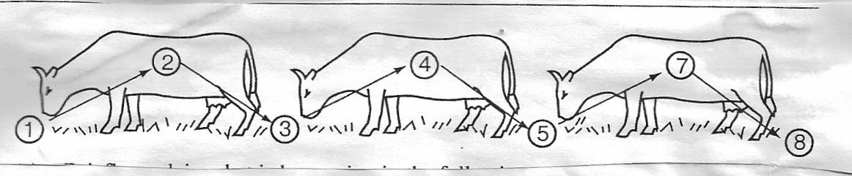

(a) Briefly explain what is happening in the following stages (4 marks)
1…………………………………………………..…………………………………………………............................................................................................................................................................
4…………………………………………………..…………………………………………………............................................................................................................................................................
5…………………………………………………..………………….……………………………..
............................................................................................................................................................7…………………………………………………..…………………………………………………..........................................................................................................................................................
(b) Why do you think that tick control is difficult using acaricides? (1 mark)
…………………………………………………..……………………….………………………….............................................................................................................................................................

(c) Name the most common sites the tick can be found on the body of an animal. (2 marks)
…………………………………………………..……………………….………………………….............................................................................................................................................................
(d) Give two examples of a three host tick (1mark)
............................................................................................................................................................
............................................................................................................................................................
- The diagram below illustrates a certain practice carried out in sheep management. Study carefully and answer the questions that follow

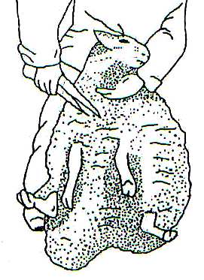

- Identify the practice illustrated above (1mark)
........................................................................................................................................................................................................................................................................................................................
- State two precautions a farmer should put into consideration when carrying out this practice. (2marks)
........................................................................................................................................................................................................................................................................................................................

- How often should the practice be carried out? (1mark)
........................................................................................................................................................................................................................................................................................................................
- Below in an activity carried out in poultry production. Study it carefully then answer the questions that follow.
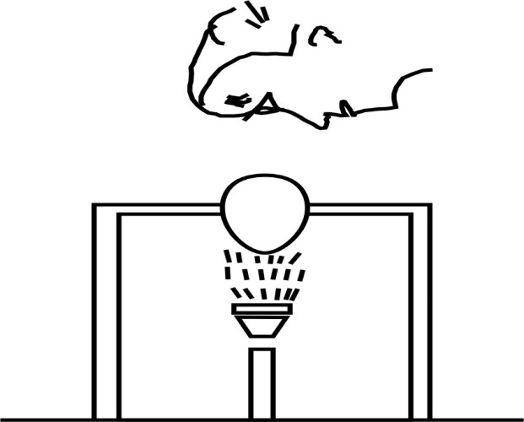

- Identify the practice being carried out...................................................................... (1 mk)
- State three defects that can be detected by this practice (3 mks)
............................................................................................................................................................... ...............................................................................................................................................................
...............................................................................................................................................................
- State two disadvantages of artificial incubation. (2 mks)
............................................................................................................................................................... ...............................................................................................................................................................

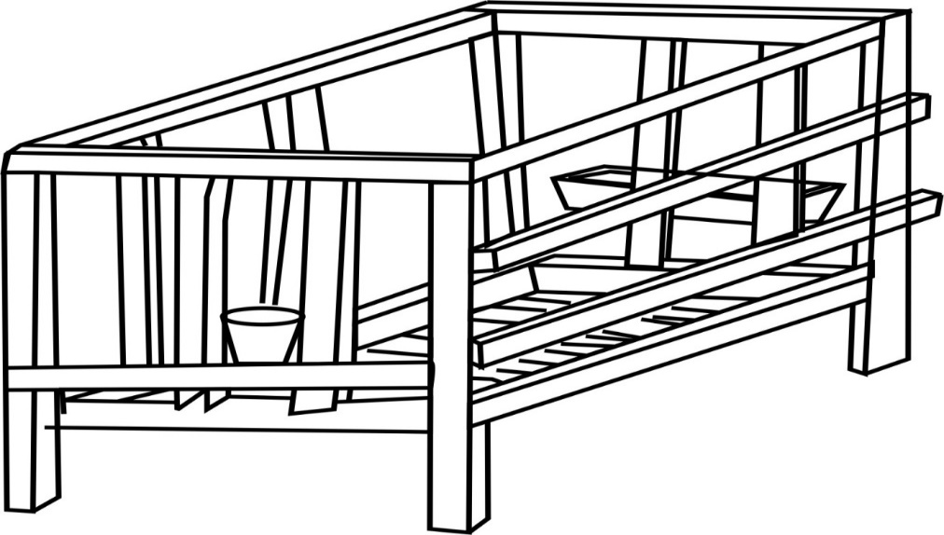
- Use the above diagram of a calf pen to answer the questions that follow.

a) How high should the calf pen be raised from the ground (1mk)
........................................................................................................................................................
b) Give any two reasons why calves are housed singly (2mks)
........................................................................................................................................................
........................................................................................................................................................
........................................................................................................................................................
........................................................................................................................................................
c) Why should the calf pen be near the milking parlour? (2mks)
........................................................................................................................................................
........................................................................................................................................................
........................................................................................................................................................
........................................................................................................................................................
- Study the diagram below of a diesel fuel system then answer the questions that follow.
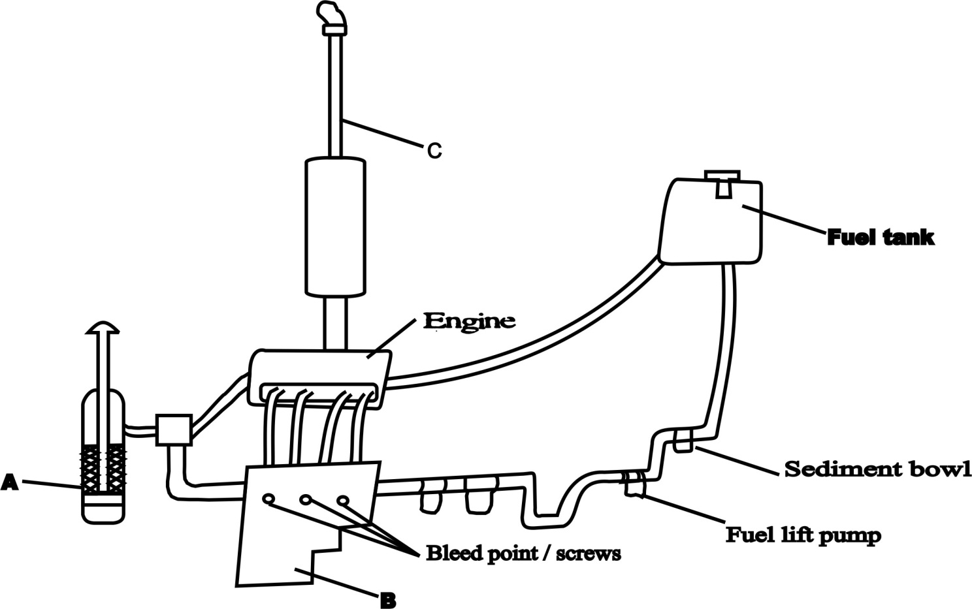

a) Identify the parts labelled (3 mks)
A.....................................................................................................................................................
B.....................................................................................................................................................
C.....................................................................................................................................................
b) State three maintenance practices carried out on the system (2mks)
........................................................................................................................................................
........................................................................................................................................................
........................................................................................................................................................
- Outline the procedure of proper milking technique (3 mks)
........................................................................................................................................................
........................................................................................................................................................
........................................................................................................................................................
........................................................................................................................................................
........................................................................................................................................................
........................................................................................................................................................
........................................................................................................................................................
........................................................................................................................................................

SECTION C (20MKS)

- a) Outline five signs of heat in a cow (5 mks)
........................................................................................................................................................
........................................................................................................................................................
........................................................................................................................................................
........................................................................................................................................................
........................................................................................................................................................
........................................................................................................................................................
........................................................................................................................................................
........................................................................................................................................................
........................................................................................................................................................
........................................................................................................................................................
........................................................................................................................................................

b) Outline five causes of stress in poultry and describe their control (10mks)
........................................................................................................................................................
........................................................................................................................................................
........................................................................................................................................................
........................................................................................................................................................
........................................................................................................................................................
........................................................................................................................................................
........................................................................................................................................................
........................................................................................................................................................
........................................................................................................................................................
........................................................................................................................................................
........................................................................................................................................................
........................................................................................................................................................
........................................................................................................................................................
........................................................................................................................................................
........................................................................................................................................................
........................................................................................................................................................
........................................................................................................................................................
........................................................................................................................................................
c) Using Pearson’s square compute a ration with 20% DCP from oats which contains 10% DCP
and simsim seedcake containing 60% DCP. (show your working) (5mks)

- a) Outline the daily maintenance practices that should be carried out on a farm tractor (8 mks)
........................................................................................................................................................................................................................................................................................................................................................................................................................................................................................................................................................................................................................................................................................................................................................................................................................................................................................................................................................................................................................................................................................................................................................................................................................................................................................................................................................................................................................................................................................................................................................................................................................................................................................................................................................................................................................................................................................................................................................................................................................................................................................................................................................................................................................................................................
b) Outline twelve general symptoms of endoparasite attack in livestock. (12 mks)
....................................................................................................................................................................
....................................................................................................................................................................
....................................................................................................................................................................
....................................................................................................................................................................
....................................................................................................................................................................
....................................................................................................................................................................
....................................................................................................................................................................
....................................................................................................................................................................
....................................................................................................................................................................
....................................................................................................................................................................
....................................................................................................................................................................
- a) State four advantages of using a sub soiler in seedbed preparation (4mks)
....................................................................................................................................................................
....................................................................................................................................................................
....................................................................................................................................................................
....................................................................................................................................................................

b) Give five advantages of artificial insemination in cattle management (5mks)
....................................................................................................................................................................
....................................................................................................................................................................
....................................................................................................................................................................
....................................................................................................................................................................
...................................................................................................................................................................
c) State five function of water in animal’s body (5mks)
....................................................................................................................................................................
....................................................................................................................................................................
....................................................................................................................................................................
....................................................................................................................................................................
..................................................................................................................................................................
d) Describe control measures for tape worm in livestock (6mks)
....................................................................................................................................................................
....................................................................................................................................................................
....................................................................................................................................................................
....................................................................................................................................................................
...................................................................................................................................................................
....................................................................................................................................................................
..................................................................................................................................................................
....................................................................................................................................................................
....................................................................................................................................................................
...................................................................................................................................................................

