MANGU HIGH SCHOOL

Name………………………………………….....………Index no……………………..
candidate’s signature …………………
Date…………………………….
443/2
AGRICULTURE
Paper 2
OCT/NOVEMBER
Time: 2hours
MANGU HIGH SCHOOL TRIAL 2 MOCK
Kenya Certificate of Secondary Education
443/2
Agriculture
Paper 2
2hours
INSTUCTIONS TO CANDIDATES
- Write your name and index number in the spaces provided
- This paper consists of three sections A,B and C.
- Answer all the questions in sections A and B and any other two in section C
- All answers must be written in the spaces provided in this booklet.
FOR EXAMINERS USE ONLY
SECTION | QUESTIONS | MAXIMUM SCORE | CANDIDATES SCORE
A | 1-19 | 30
B | 20-23 | 20
C | 24-26 | 40
 | TOTAL SCORE | 90

SECTION A ( 30 MARKS )
ANSWER ALL QUESTIONS IN THE SPACES PROVIDED
- List two cattle diseases caused by viruses. (1mark)
……………………………………………………………………………………………………………………………………………………………………………………………………………..
- State one use for each of the following tools
- Spoke shave ………………………………………………………………………………….
………………………………………………………………………………………………
- Plumb bob ………………………………………………………………………………….
………………………………………………………………………………………………
- List two distinguishing external characteristics of California breed of rabbit. (1mark)
………………………………………………………………………………………………..………………………………………………………………………………………………………….
- State four reasons for culling a breeding boar . (2marks)
………………………………………………………………………………………………..………………………………………………………………………………………………………….
- State any two disadvantages that may arise from inbreeding in livestock. (1mark)
………………………………………………………………………………………………..………………………………………………………………………………………………………….
- State two reasons for seasoning timber before use . (1mark)
………………………………………………………………………………………………..………………………………………………………………………………………………………….
- a) Differentiate between a roughage and a concentrate feed in animal nutrition. (1mark)
………………………………………………………………………………………………..……………………………………………………………………………………………………………………………………………………………………………………………………..………………………………………………………………………………………………………….
b)State four desirable qualities of a livestock ration. (2marks)
………………………………………………………………………………………………..……………………………………………………………………………………………………
- State three factors that may influence the amount of water intake by a farm animal .(1 ½ marks)
………………………………………………………………………………………………..………………………………………………………………………………………………………….
………………………………………………………………………………………………..………………………………………………………………………………………………………….
- State three advantages of keeping a herd of dairy cattle healthy. (1½ marks)
………………………………………………………………………………………………..………………………………………………………………………………………………………….………………………………………………………………………………………………..………………………………………………………………………………………………………….………………………………………………………………………………………………..………………………………………………………………………………………………………….
- Give three reasons for dehorning cattle. (1½ marks)
………………………………………………………………………………………………..………………………………………………………………………………………………………….………………………………………………………………………………………………..………………………………………………………………………………………………………….
- Give two methods of extracting honey from honey combs (1mark)
………………………………………………………………………………………………..………………………………………………………………………………………………………….
- a) Give four reasons for candling eggs in poultry production. (2marks)
………………………………………………………………………………………………………………………………………………………………………………………………………………………………………………………………………………………………………………………………
b) Give four maintenance practices that should be carried out on the mould board plough.(2marks)
………………………………………………………………………………………………..………………………………………………………………………………………………………….………………………………………………………………………………………………..………………………………………………………………………………………………………….………………………………………………………………………………………………..………………………………………………………………………………………………………….
- a) List four harmful effects of internal parasites in livestock. (2marks)
………………………………………………………………………………………………..………………………………………………………………………………………………………….………………………………………………………………………………………………..………………………………………………………………………………………………………….
(b) (i) Give two reasons for washing the udder with warm water before milking . (1mark)
…………………………………………………………………………………………..…………………………………………………………………………………………………………………………
(ii) Name three dairy goats kept in Kenya . (1½ marks)
………………………………………………………………………………………………..………………………………………………………………………………………………………….………………………………………………………………………………………………..………………………………………………………………………………………………………….
- Name two diseases that affect female animals only (1mark)
………………………………………………………………………………………………..………………………………………………………………………………………………………….
- What is the function of a spillway in a fish pond (½ mark)
………………………………………………………………………………………………..………………………………………………………………………………………………………….
- Name three types of lubrication systems used in tractors . (1½ marks)
………………………………………………………………………………………………..………………………………………………………………………………………………………….………………………………………………………………………………………………..………………………………………………………………………………………………………….

- Give the functions of the following parts of an ox-plough
- Land side …………………………………………………………………………… (½mark)
……………………………………………………………………………………………….
- Draft rod ……………………………………………………………………………( ½ mark)
……………………………………………………………………………………………….

- Give three structural requirements for a grain silo. (1½ marks)
………………………………………………………………………………………………..………………………………………………………………………………………………………….………………………………………………………………………………………………..………………………………………………………………………………………………………….
19 State three advantages of natural feeding in calf rearing. (1¹/₂ marks)
………………………………………………………………………………………………..………………………………………………………………………………………………………….………………………………………………………………………………………………..……………………………………………………………………………………………………….
SECTION B ( 20 MARKS )
Answer all the questions provided in this section in the spaces provided
- The diagram below shows the digestive system of cattle. Study it and answer the questions that follow.
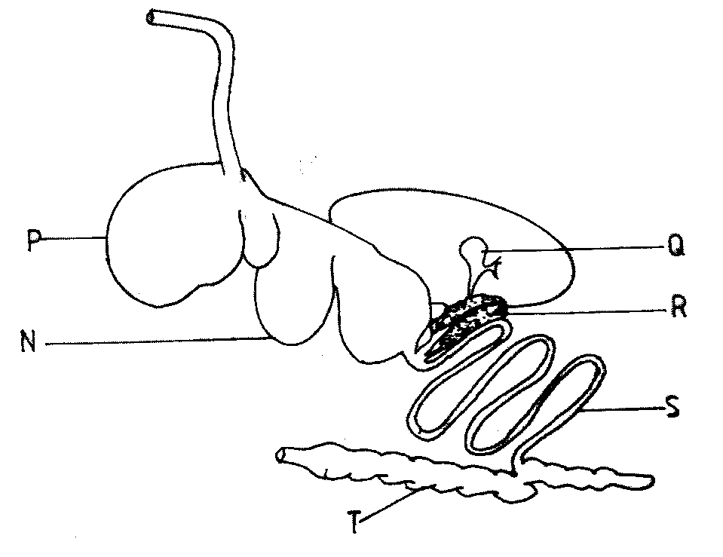

a). Name the parts labelled N, P and Q.

N .......................................................................................................................... (1 mark)

P .......................................................................................................................... (1 mark)

b). State one function for each of the parts labelled S and T.

S....................................................................................................................... (1 mark)

T ......................................................................................................................... (1 mark)

c). Give one enzyme produced by each of the parts labelled R and S.

R .......................................................................................................................... (¹/₂ marks)

S ................................................................................................................ (¹/₂ marks)

21. The illustration below shows a cross section of a cattle dip.
a) Name the parts labelled E and G.
E…………………………………………………………………… (1mark)
G…………………………………………………………………… (1mark)
b) State one use for each of the parts labelled E, F and H. (3marks)
E………………………………………………………….
F………………………………………………………….
H………………………………………………………….
22. The following diagrams show animals with deficiency symptoms of some minerals. Study the diagrams carefully and answer the questions that follow.
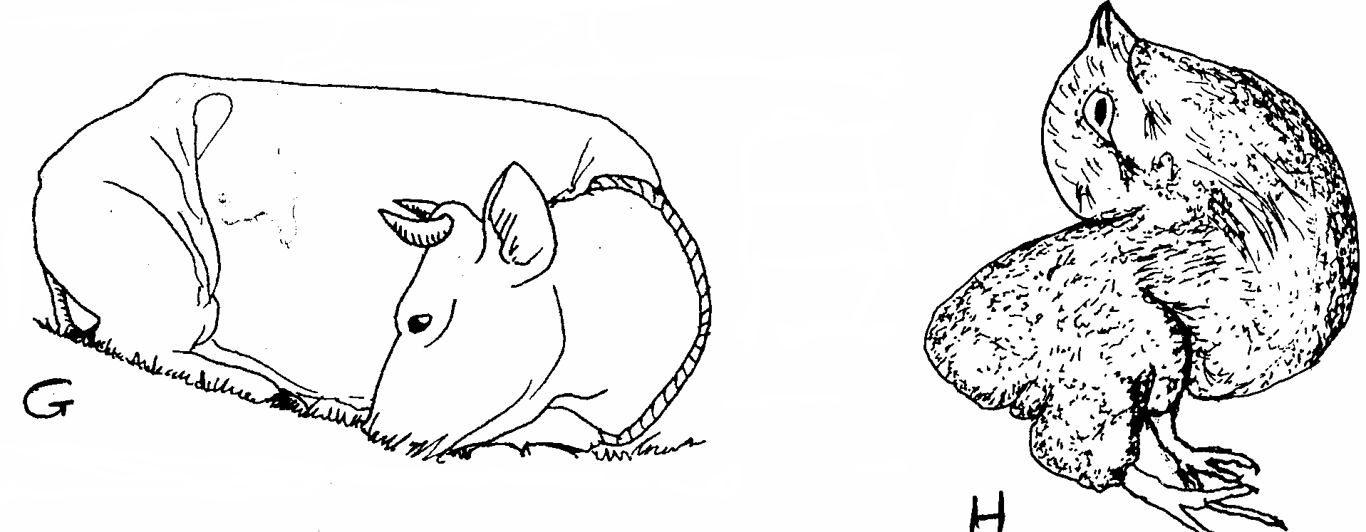

(a) State the nutrients lacking in the diet of each animal shown above.
Animal G …………………………………………………. (1mark)
Animal H……………………………………………………. (1mark)
(b) Name the disease whose symptoms are shown by the animal labeled G above. (1 mark)
…………………………………………………………………………………………………………

(c) Give two reasons why the disease named in (b) above should not be controlled by giving medicine through the mouth. (2marks)
…………………………………………………………………………………………………………
…………………………………………………………………………………………………………
23.The diagram below represents a foundation of a farm structure .Study it and answer questions that follow .
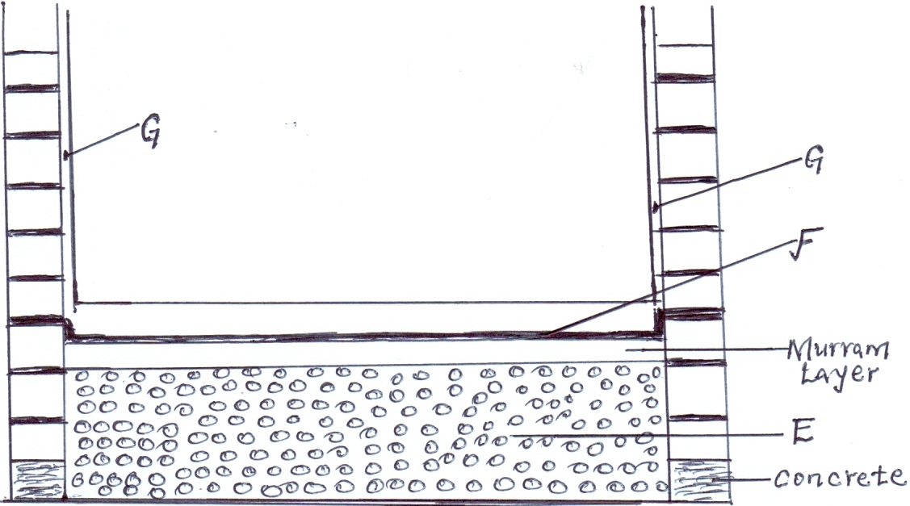
(a) Identify the parts labeled E and F .
E………………………………………………………………………………… (1mark)

F………………………………………………………………………………… (1mark)
(b)State two uses of part labeled F in a foundation structure . (2marks)
………………………………………………………………………………………………………………………………………………………………………………………………………………………………
(c) What ingredients are used to complete part G (1mark)
………………………………………………………………………………………………………………

SECTION C (40 MARKS )
Answer any two questions in this section in the spaces provided at the end of each question.
24. (a) Describe the uses of fences on the farm. (10 marks)

(b) Describe Newcastle disease under the following sub-headings

- causal organism; (1 mark)

(ii) signs of infection; (7 mark)

(iii) control measures. (2 marks)

25. a) Describe the rearing of lambs from lambing up to weaning time (10 marks)
b) Explain five causes of livestock diseases (5 marks)
c) State five differences between Ruminants and non Ruminants (5 marks)
26.a. State and explain five preventive measures of livestock diseases. (10 Marks)
b. Describe long term service carried out during tractor servicing. (6 Marks)
c. Outline four functions of the gearbox in a tractor. (4 Marks)

