Name……………………………………………………….. Index No…………………/…….
School……………………………………………………… Date………………………
Candidate’s Signature……………………
MANGU HIGH SCHOOL TRIAL 2 MOCK 2021

OCT/NOVEMBER
312/2
GEOGRAPHY
Paper 2
Time: 2 ¾ HOURS

Kenya Certificate of Secondary Education (K.C.S.E)

INSTRUCTIONS TO CANDIDATES

- This paper contains Two sections: A and B
- Answer ALL the question in section A.
- In section B answer question 6 and any other two questions from Section B
- Answers to be written in the answer booklet provided

This paper consists of 5 printed pages. Candidates should check the question paper to ensure that all pages are printed and no questions are missing.

SECTION A
INSTRUCTIONS: Answer all the questions in this section
1. (a) State three ways in which minerals occur (3 mks)
(b) Name any two types of underground mining (2 mks)
2. (a) What is a forest (1 mk)
(b) State any two characteristics of the tropical hardwood forests. (2 mks)
(c) State two main species of softwood trees mainly grown in Canada. (2 mks)
3. (a) State one major characteristics of non-renewable energy sources. (1mk)
(b) Name any two non-renewable energy sources. (2mks)
(c) State any two effects of charcoal burning in the environment. (2mks)
4. (a) What is a trading bloc. (2mks)
(b) State any three factors influencing trade. (3mks)
5. (a) Name any two pre- historic sites that are popular with tourists in Kenya. (2mks)
(b) State the three agencies set up by the three governments of East Africa countries to manage the game parks and take care of the wildlife. (3mks)

SECTION B
Answer question (6) compulsory and any other two questions.
6. The table below shows the population for the three district of Trans–Nzoia County.

DISTRICT | 2008 | 2009 | 2010 | 2011
TRANS-NZOIA WEST | 150 | 175 | 180 | 200  Note  Population in  ‘000’people
TRANS-NZOIA EAST | 25 | 30 | 25 | 28
KWANZA | 10 | 20 | 30 | 32

(a) (i) U sing the above information, construct a compound bar graph. Use a scale of 1cm Represent 25,000 people use the graph paper provided. (9mks)
(ii) Draw any two conclusions from the bar graph you have constructed (2mks)
(b) Explain three factors causing internal migration in Kenya. (6mks)

(c) (i) Explain three factors leading to slow population growth in some parts of East
Africa. (6mks)
(ii) State any two importance of a high population in a country. (2mks)

7. (a) (i) Name 2 major towns found in the oil palm growing areas in Nigeria. (2mks)
(ii) Explain four physical features favouring oil palm growing in Nigeria. (8mks)
(b) Describe the steps involved in the processing of oil palm from the time is harvested. (8mks)
(c) (i) State four problems facing oil palm farmers in Nigeria. (4mks)
(ii) List three uses of oil palm. (3mks)

8. (a) (i) What are pelagic fish (1mk)
(ii) Give two examples of pelagic fish (2mks)
(b) The map below shows fishing grounds in East Africa. Use it to answer the questions that Follows

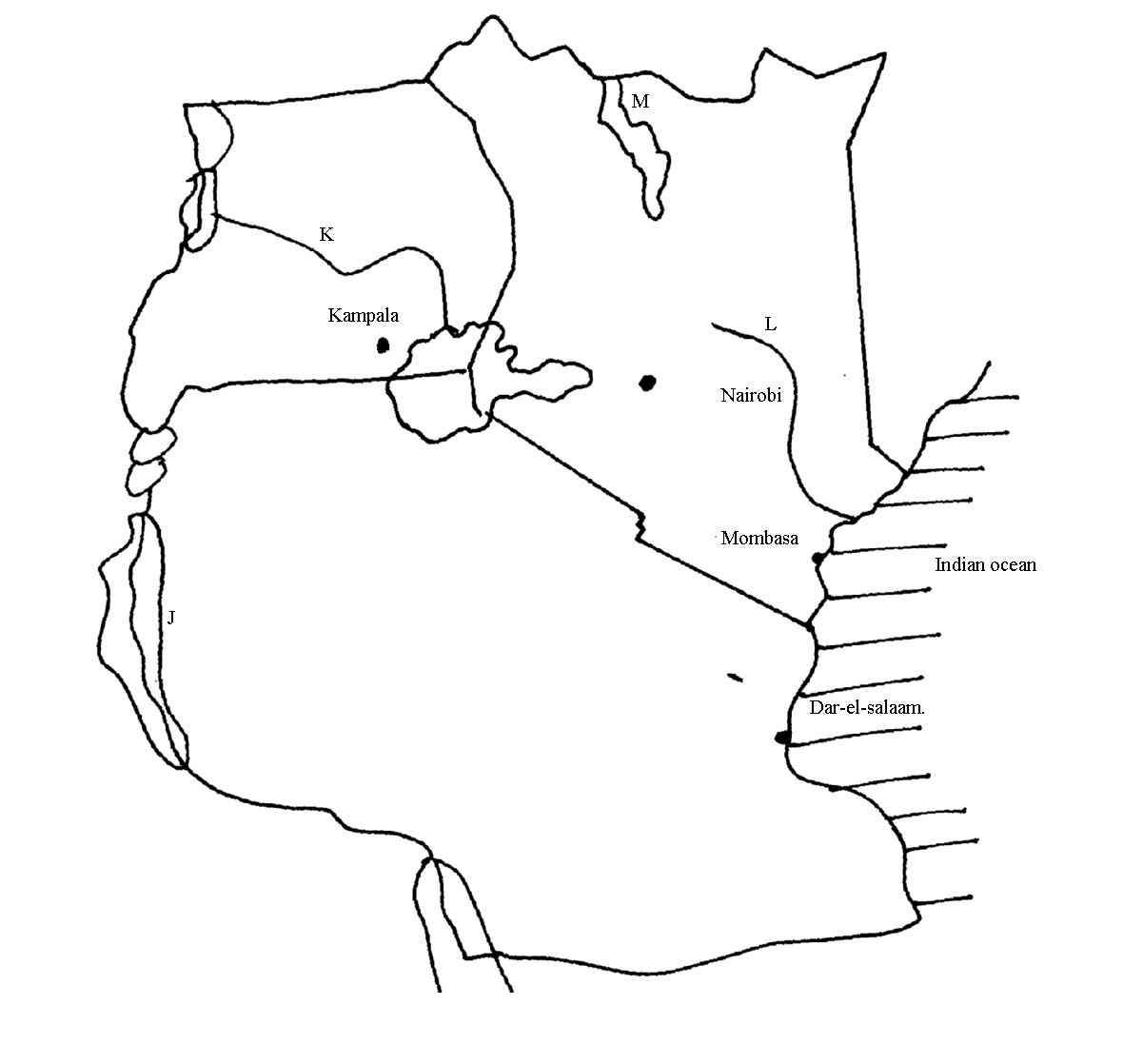

- Name the fishing grounds marked J, K, L and M. (4mks)
- Explain the solutions to any four problems facing Inland fishing in East Africa. (8mks)
(c) Explain three factors why the Namibian Coast fishing ground is not well developed like other major fishing grounds in the world. (6mks)
(d) Compare fishing in Kenya and Japan under the following sub- headings.
(i) Market. (2mks)
(ii) Nature of landscape. (2mks)

9. (a) (i) Define land Rehabilitation (2mks)
(ii) State four benefits of land Rehabilitation in Kenya (4mks)
(b) (i) Explain four factors that led to the successful establishment of Pekerra irrigation scheme (8mks)
(ii) State three problems facing Pekerra irrigation scheme (3mks)
- List four main crops grown in Pekerra irrigation scheme (4mks)
(c) State four advantages of irrigation farming to the economy of Kenya. (4mks)

10. . (a) i) Differentiate between market gardening and floriculture. 2mks
(ii) State four features of horticulture. 4mks
i) State three physical factors that favour development of horticulture in Kenya. 3mks

ii) Explain why horticulture is more developed in Netherlands than in Kenya. 8mks
c) State and explain four contributions of horticulture to the economy of Kenya. 8mks

