KAHUHO UHURU HIGH SCHOOL

Name…………………………………………………………………..……..Class…………….Adm no………….……

FORM 2 BIOLOGY
END YEAR EXAM 2016
TIME: 2 HOURS

INSTRUCTIONS
- Answer all questions in section A and B in the spaces provided, then follow instructions in section C.

SECTION A (30 MARKS)

- Name two major branches of Biology. (2marks)

……………………………………………………………………………………………………………………………………………………………………………………………………………………………………………………………………………………

- State the functions of the following apparatus. (2marks)
    - Bait trap
…………………………………………………………………………………………………………………………………………………………………………………………………………………………………………………………………………
    - Pooter
…………………………………………………………………………………………………………………………………………………………………………………………………………………………………………………………………………
- Study the diagram of the mammalian tooth below and answer the questions that follow.
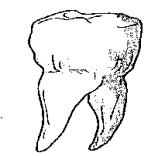

(a) Identify the tooth. (1mark)

………………………………………………………………
(b) Give a reason for your answer in (a) above. (1mark)
……………………………………………………………………………………………………………………………………………………………………………………………………………………………………………………………………………………
(c) State one adaptation of the tooth to its function. (1mark)
……………………………………………………………………………………………………………………………………………………………………………………………………………………………………………………………………………………
d) State two functions of bile juice in the digestion of food. (2marks)
……………………………………………………………………………………………………………………………………………………………………………………………………………………………………………………………………………………
…………………………………………………………………………………………………………………………………………
(b) How does substrate concentration affect the rate of enzyme action? (1mark)
……………………………………………………………………………………………………………………………………………………………………………………………………………………………………………………………………………………
- Name the features that increase the surface area of small intestines. (2marks)
………………………………………………………………………………………………………………………………………………………………………………………………………………………………………………………………………………………………
…………………………………………………………………………………………………………………………………………
- Describe what happens during the light stage of photosynthesis. (3marks)
………………………………………………………………………………………………………………………………………………………………………………………………………………………………………………………………………………………………………………………………………………………………………………………………………………………………………………………………………………………………………………………………………………………………………………………………
- (a) State two functions of the plasma membrane? (2marks)
…………………………………………………………………………………………………………………………………………………………………………………………………………………………………………………………………………
……………………………………………………………………………………………………………………………………
(b) Give the synthesis role of smooth endoplasmic reticulum. (1mark)
………………………………………………………………………………………………………………………………………………………………………………………………………………………………………………………………………………………………
- The diagram below represents a cell as seen under an electron microscope.
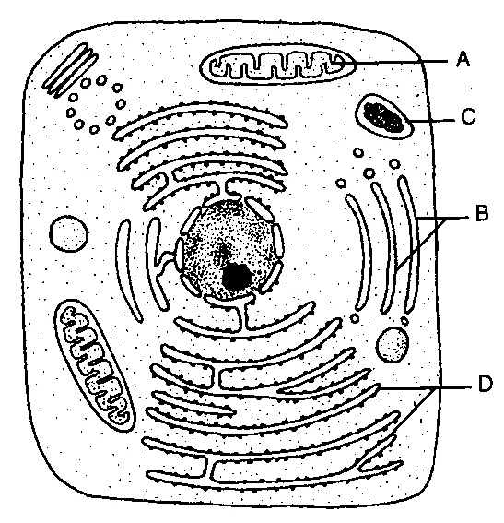

- Identify the parts labeled A and D. (2marks)

A………………………………………………………….
D………………………………………………………….
- State the function of the structures found on the part labeled D. (1marks)

…………………………………………………………………………………………………………………………………………………………………………………………………………………………………………………………………………
- Explain why a mature plant cell does not lose its shape even after losing water (1mark)

…………………………………………………………………………………………………………………………………………………………………………………………………………………………………………………………………………

- The graph below show the rate of an enzyme controlled reaction against temperature (OC)
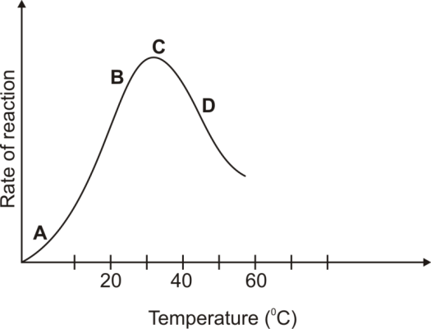

Explain the shape of the curve:
- Between A and B (2marks)
…………………………………………………………………………………………………………………………………………………………………………………………………………………………………………………………………………
- At Point C (2marks)
…………………………………………………………………………………………………………………………………………………………………………………………………………………………………………………………………………
- Between C and D (2marks)
…………………………………………………………………………………………………………………………………………………………………………………………………………………………………………………………………………
- Other than temperature, state two factors that affect the above reaction (2marks)

…………………………………………………………………………………………………………………………………………………………………………………………………………………………………………………………………………
- State one function of mucus along the alimentary canal (1mark)
…………………………………………………………………………………………………………………………………………………………………………………………………………………………………………………………………………

SECTION B (40 MARKS)
11. Other than carbon (IV) oxide, name other products of anaerobic respiration in plants (2marks) …………………………………………………………………………………………………………………………………………………………………………………………………………………………………………………………………………
……………………………………………………………………………………………………………………………………
12. (a) Name the fluid that is produced by sebaceous glands. (1mark)
…………………………………………………………………………………………………………………………………………………………………………………………………………………………………………………………………………
- State two functions of sweat on the human body. (2marks)
…………………………………………………………………………………………………………………………………………………………………………………………………………………………………………………………………………
……………………………………………………………………………………………………………………………………
13. Burning charcoal stove in a poorly ventilated room is likely to cause death of the inhabitants. Explain. (3marks)

…………………………………………………………………………………………………………………………………………………………………………………………………………………………………………………………………………
……………………………………………………………………………………………………………………………………
……………………………………………………………………………………………………………………………………
14. Why should respiratory surfaces be:
- Moist (1mark)
…………………………………………………………………………………………………………………………………………………………………………………………………………………………………………………………………………
- Highly vascularised (1mark)
…………………………………………………………………………………………………………………………………………………………………………………………………………………………………………………………………………
15. The diagram below shows a longitudinal section of mammalian skin.

a) Name the parts labelled F and G. (2marks)
…………………………………………………………………………………………………………………………………………………………………………………………………………………………………………………………………………
……………………………………………………………………………………………………………………………………
b) State one function of each of the parts labelled H and J (2marks)

…………………………………………………………………………………………………………………………………………………………………………………………………………………………………………………………………………
……………………………………………………………………………………………………………………………………
c) what is the function of melanin produced in the skin (1mark)
…………………………………………………………………………………………………………………………………………………………………………………………………………………………………………………………………………
- The diagram below shows the exchange of gases in alveolus.
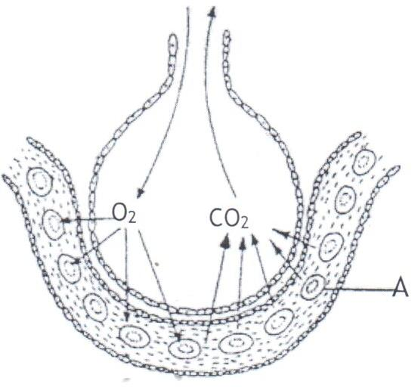

    - State how the alveoli are adapted to their function. (3marks)
…………………………………………………………………………………………………………………………………………………………………………………………………………………………………………………………………………
…………………………………………………………………………………………………………………………………………………………………………………………………………………………………………………………………………
    - Name the cell labelled A. (1mark)
…………………………………………………………………………………………………………………………………………………………………………………………………………………………………………………………………………
- A process that occurs in plants is represented by the equation below.

C₆H₁₂O₆ + 2C₂ H₅OH + 2CO₂ + Energy
(Glucose) (Ethanol) (Carbon VI oxide)

- Name the process (1mark)
…………………………………………………………………………………………………………………………………………………………………………………………………………………………………………………………………………
- State the economic importance of the process named in (a) above (2marks)
…………………………………………………………………………………………………………………………………………………………………………………………………………………………………………………………………………
…………………………………………………………………………………………………………………………………………………………………………………………………………………………………………………………………………
- The figure shown below represents a kidney nephron. Use it to answer the questions that follow.

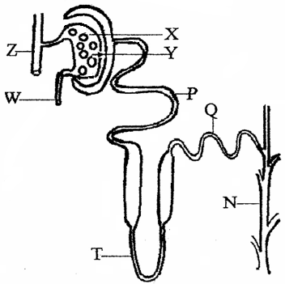

(a) (i) X is made up of a tuft of capillaries. How do they differ from other capillaries in the body? (1 mark)
…………………………………………………………………………………………………………………………………………………………………………………………………………………………………………………………………………
(ii) What structural difference exist between W and Z? (1 mark)
…………………………………………………………………………………………………………………………………………………………………………………………………………………………………………………………………………
(iii) State the significance of the difference stated in (a) (ii) above. (1 mark)
…………………………………………………………………………………………………………………………………………………………………………………………………………………………………………………………………………
(b) State three adaptations that enable P to perform its function. (3 marks)
…………………………………………………………………………………………………………………………………………………………………………………………………………………………………………………………………………
…………………………………………………………………………………………………………………………………………………………………………………………………………………………………………………………………………
(c) What is counter flow and in which part of the nephron does it occur. (2 marks)
…………………………………………………………………………………………………………………………………………………………………………………………………………………………………………………………………………
……………………………………………………………………………………………………………………………………
- The diagram below shows part of plant tissue.
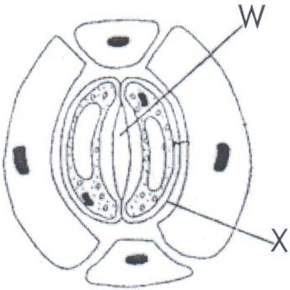

    - Name the cell labelled X and part labelled W. (2marks)
…………………………………………………………………………………………………………………………………………………………………………………………………………………………………………………………………………
    - State two adaptations of cell labelled X to its functions. (2marks)
…………………………………………………………………………………………………………………………………………………………………………………………………………………………………………………………………………
……………………………………………………………………………………………………………………………………
20. Give two reasons why animals have specialized organs for excretion as compared to plants. (2marks)

…………………………………………………………………………………………………………………………………………………………………………………………………………………………………………………………………………
……………………………………………………………………………………………………………………………………
21. Explain why the body temperature of a healthy human being must rise up to 39⁰C on a humid day. (2marks)
…………………………………………………………………………………………………………………………………………………………………………………………………………………………………………………………………………
……………………………………………………………………………………………………………………………………
22. State the hameostatic functions of the following hormone.
- Insulin (1mark)
…………………………………………………………………………………………………………………………………………………………………………………………………………………………………………………………………………
- Glucagon (1mark)
…………………………………………………………………………………………………………………………………………………………………………………………………………………………………………………………………………
SECTION C 30 MARKS
Answer question 23 and any other question after question 23 in the spaces provided
23. An investigation of haemolysis of human red blood cell was carried out .Red blood cells were placed in sodium chloride solution and percentage of haemolysed cell established.

Sodium chloride conce .g/cm³(%) | 0.33 | 0.36 | 0.38 | 0.39 | 0.42 | 0.44 | 0.48
Haemolysed red blood cells (%) | 100 | 91 | 82 | 69 | 30 | 15 | 0

a) (i) Using the data above, plot a graph of haemolysed red blood cell against salt concentration (6marks)
(ii) At what percentage of sodium chloride was the number of haemolysed cells equal to those that are not haemolysed.
(1mark)
…………………………………………………………………………………………………………………………………………………………………………………………………………………………………………………………………………
(iii) What is the percentage of cells haemolysed at salt concentration of 0.45 percent. (1 mark)
…………………………………………………………………………………………………………………………………………………………………………………………………………………………………………………………………………
b) Account for the result obtained at
i) 0.33% salt concentration (2marks)
…………………………………………………………………………………………………………………………………………………………………………………………………………………………………………………………………………
……………………………………………………………………………………………………………………………………
ii) 0.48% salt concentration (2marks)
…………………………………………………………………………………………………………………………………………………………………………………………………………………………………………………………………………
……………………………………………………………………………………………………………………………………
iii) Suppose the red blood cells were placed in 0.50%salt concentration .Explain what would happen (2marks)
…………………………………………………………………………………………………………………………………………………………………………………………………………………………………………………………………………
……………………………………………………………………………………………………………………………………

c) i) Distinguish between lymphocytes and phagocytes (2marks)
…………………………………………………………………………………………………………………………………………………………………………………………………………………………………………………………………………
……………………………………………………………………………………………………………………………………
ii) State two ways in which white blood cells defend the body against infections. (2 marks)
…………………………………………………………………………………………………………………………………………………………………………………………………………………………………………………………………………
……………………………………………………………………………………………………………………………………
d) State two adaption of red blood (2marks)
…………………………………………………………………………………………………………………………………………………………………………………………………………………………………………………………………………
……………………………………………………………………………………………………………………………………
- Describe the structure and functions of various organelles in a mature animal cell. (10marks)
- Describe Inhalation in man (10 marks)
…………………………………………………………………………………………………………………………………………………………………………………………………………………………………………………………………………
…………………………………………………………………………………………………………………………………………………………………………………………………………………………………………………………………………
…………………………………………………………………………………………………………………………………………………………………………………………………………………………………………………………………………
…………………………………………………………………………………………………………………………………………………………………………………………………………………………………………………………………………
…………………………………………………………………………………………………………………………………………………………………………………………………………………………………………………………………………
…………………………………………………………………………………………………………………………………………………………………………………………………………………………………………………………………………
…………………………………………………………………………………………………………………………………………………………………………………………………………………………………………………………………………
…………………………………………………………………………………………………………………………………………………………………………………………………………………………………………………………………………
…………………………………………………………………………………………………………………………………………………………………………………………………………………………………………………………………………
…………………………………………………………………………………………………………………………………………………………………………………………………………………………………………………………………………
…………………………………………………………………………………………………………………………………………………………………………………………………………………………………………………………………………
…………………………………………………………………………………………………………………………………………………………………………………………………………………………………………………………………………
…………………………………………………………………………………………………………………………………………………………………………………………………………………………………………………………………………
…………………………………………………………………………………………………………………………………………………………………………………………………………………………………………………………………………
…………………………………………………………………………………………………………………………………………………………………………………………………………………………………………………………………………
……………………………………………………………………………………………………………………………………

