NAME…………………………………………….class…………..adm………………Roll………

KAHUHO UHURU HIGH SCHOOL
MID TERM 3 2014
BIOLOGY FORM 2 EXAM

TOTAL MARKS: 50

Answer all questions in the spaces provided
- State two factors that affect the rates of breathing (2 marks)
……………………………………………………………………………………………………………………………………………………………………………………………………………………………………………………………………………………………………………………………………………..
- What are the causes of the following diseases (2marks)
- Tuberculosis
……………………………………………………………………………………………………………………………………………………………………………………………………………………………………………………………………………………………..………
- Pneumonia
……………………………………………………………………………………………………………………………………………………………………………………………………………………………………………………………………………………………………..
- Explain the importance of a counter current flow system in gaseous exchange in fish (3 marks)
…………………………………………………………………………………………………………………………………………………………………………………………………………………………………………………………………………………………………………………………………………………………………………………………………………………………………………………………..……
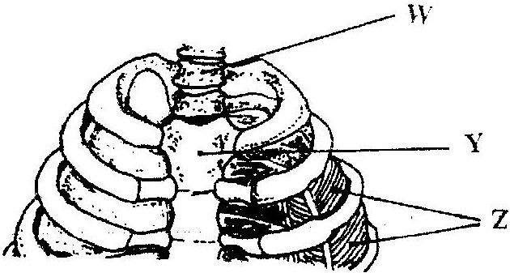
- The diagram below represents a part of the rib cage.

a) Name the parts labeled W, Y and Z. (3marks)
W ……………………………………………………
Y …………………………………………………….
Z ……………………………………………………..
b) How does the part labeled Z facilitates breathing in? (3marks)
………………………………………………………………………………………………………………………………………………………………………………………………………………………………………………………………………………………………………………………………………………
………………………………………………………………………………………………………………………………………………………………………………………………………………………………………………………………………………………………………………………………..……………
5) What characteristics do mammalian lungs and the gills of a bony fish have in common that enables them to exchange gases effectively (4 marks)
………………………………………………………………………………………………………………………………………………………………………………………………………………………………………………………………………………………………………………………………
……………………………………………………………………………………………………………………………………………………………………………………………………………………
6)List two structures used for gaseous exchange in land plants (2marks)
…………………………………………………………………………………………………………………………………………………………………………………………………………………………………………………………………………………………………………………………………………………………………………………………………………………………………………
7) Explain the photosynthetic theory of opening of the stomata (5 marks)
…………………………………………………………………………………………………………………………………………………………………………………………………………………………………………………………………………………………………………………………………………………………………………………………………………………………………………………………..……
…………………………………………………………………………………………………………………………………………………………………………………………………………………………..……
8) Below is a diagram of an organelle that is involved in respiration

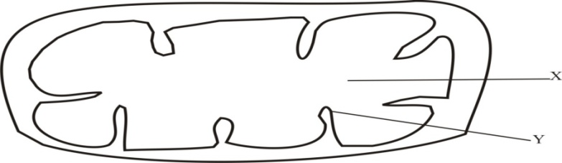
- Name the organelle …………………………………………………………… ( 1mark)

- Name the part labeled X………………………………………………………… (1 mark)

- What is the purpose of the part labeled Y (1 mark)
………………………………………………………………………………………………………

………………………………………………………………………………………………………
9. Define the term oxygen debt (2 marks)
………………………………………………………………………………………………………

……………………………………………………………………………………………………..

- The diagram below shows a set – up that was used to demonstrate fermentation
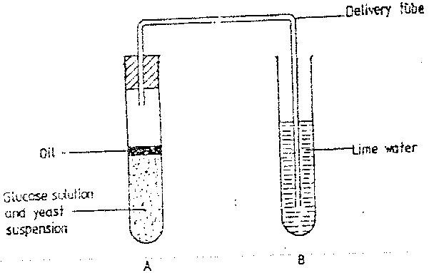

Glucose solution was boiled and oil added on top of it. The glucose solution was then allowed to cool before suspension.
  - Why was the glucose solution boiled before adding the yeast Suspension? (1mk)
………………………………………………………………………………………………………
……………………………………………………………………………………………………..
  - What was the importance of cooling the glucose solution before adding the yeast suspension? (1mk)
………………………………………………………………………………………………………
……………………………………………………………………………………………………..
  - What was the use of oil in the experiment? (1mk)
………………………………………………………………………………………………………
……………………………………………………………………………………………………..
  - What observation would be made in test tube B at the end of the experiment? ( 1 mk)
………………………………………………………………………………………………………
……………………………………………………………………………………………………..
  - Suggest a control for this experiment ( 1mk)
………………………………………………………………………………………………………
……………………………………………………………………………………………………..
- What is meant by the following terms as used in repiration (2marks)
- Respiratory quotient
………………………………………………………………………………………………………
……………………………………………………………………………………………………..
- Glycolysis
………………………………………………………………………………………………………
……………………………………………………………………………………………………..
- Distinguish between aerobic and anaerobic respiration (4 marks)
……………………………………………………………………………………………………..
………………………………………………………………………………………………………
……………………………………………………………………………………………………..
………………………………………………………………………………………………………
……………………………………………………………………………………………………..
………………………………………………………………………………………………………
……………………………………………………………………………………………………..
- Describe Inhalation and exhalation in human beings (10marks)

…………………………………………………………………………………………………………………………………………………………………………………………………………………………………………………………………………………………………………………………………………………………………………………………………………………………………………………………..……
…………………………………………………………………………………………………………………………………………………………………………………………………………………………………………………………………………………………………………………………………………………………………………………………………………………………………………………………..……
…………………………………………………………………………………………………………………………………………………………………………………………………………………………………………………………………………………………………………………………………………………………………………………………………………………………………………………………..……
…………………………………………………………………………………………………………………………………………………………………………………………………………………………………………………………………………………………………………………………………………………………………………………………………………………………………………………………..……
…………………………………………………………………………………………………………………………………………………………………………………………………………………………………………………………………………………………………………………………………………………………………………………………………………………………………………………………..……
…………………………………………………………………………………………………………………………………………………………………………………………………………………………………………………………………………………………………………………………………………………………………………………………………………………………………………………………..……
………………………………………………………………………………………………………………………………………………………………………………………………………………………………

