KAHUHO UHURU HIGH SCHOOL
NAME:…………………………………………………………..ADM NO:………………CLASS:………….

BIOLOGY
FORM 1 2012
TUNE UP EXAMINATION
TIME: 1HR

INSTRUCTIONS
Answer all questions in the spaces provided.

Questions (50 marks)

- State the functions of the following parts of a light microscope. (2marks)
- i) Diaphragm……………………………………………………………………………………....
ii) Objective lens…………………………………………………………………………………....

- In a test for complex sugars, state the reasons for:-
  - Adding dilute hydrochloric acid. (1 mark)

  - Adding sodium hydrogen carbonate. (1 mark)

- An experiment was carried out to investigate the rate of reaction shown below.

Sucrose fructose + glucose

For products fructose and glucose to be formed; substance K was to be added and the temperature maintained at 37⁰ C. When another substance L was added, the reaction slowed down and eventually stopped.

(a) Suggest the identify of substance K and L. (2 marks)
K
L
- Other than temperature state other ways by which the rate of reaction could be increased. (3 marks)

(c) Explain how substance L slowed down the reaction. (2 marks)

- State three factors which affect the rate of active transport. (3 marks)

Name the end products of the following stages in photosynthesis
    - Light stage (2 marks)

    - Dark stage (2 marks)

- State the function of lysosomes in a cell. (1 mark)

(b) State three differences between osmosis and diffusion. (3 marks)
Osmosis | Diffusion

- (a) A part from carbon hydrogen and oxygen list three other elements that make up proteins. (3 marks)

(b) State the building units of the following substrates. (2 marks)
  - Proteins

  - Carbohydrates

- During estimation of cell sizes using a light microscope, a student found out the diameter field of view to be 2.7mm and diameter of field of view had 9 cells. The magnification was x50.
Calculate the actual length of one cell in microns (3marks)

- How would you prove that, a species of weaver birds in Tanzania belongs to the same species with a similar looking weaver birds in Kenya? (2 marks)
…………………………………………………………………………………………………………….
…………………………………………………………………………………………………………….
…………………………………………………………………………………………………………….

- A student mashed a piece of ripe banana and made it into paste by adding water, placed the paste in a visking tubing and suspended it in a beaker containing iodine solution as shown below. The set- up was left for 40 minutes.

Ripe banana paste
Iodine solution
Visking tubing

- State the physiological process under investigation. (1 mark)
…………………………………………………………………………………………………………….
- Account for the result obtained in the table. (2 marks)
…………………………………………………………………………………………………………….
…………………………………………………………………………………………………………….
…………………………………………………………………………………………………………….
- Explain why a crocodile can survive on 4 kg meat for a week yet this may not be enough for man for one day. (2 marks)
…………………………………………………………………………………………………………….
…………………………………………………………………………………………………………….
…………………………………………………………………………………………………………….
In an experiment to investigate an aspect of digestion; two test tubes A and B were set up as shown in the diagram below.
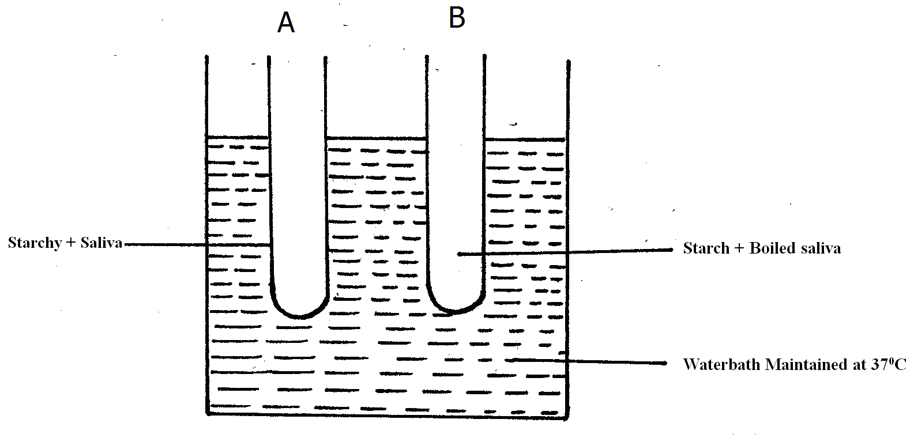

After 30 minutes the content of each test tube was tested for starch using iodine solution.
a) What results were expected in test tube A and B (2mks)
A………………………………………………………………………………………..
B………………………………………………………………………………………..
b) Account for the results you have given in (a) above in test tube A (2mks)
...........................................................................................................................................................
………………………………………………………………………………………………………
………………………………………………………………………………………………………
...........................................................................................................................................................
(a) State the two roles of leaves in plants. (2 marks) ...........................................................................................................................................................
………………………………………………………………………………………………………
………………………………………………………………………………………………………
...........................................................................................................................................................
(b) State the adaptations of leaves to the process of photosynthesis. (8 marks)
...........................................................................................................................................................
………………………………………………………………………………………………………
………………………………………………………………………………………………………
………………………………………………………………………………………………………
………………………………………………………………………………………………………
………………………………………………………………………………………………………
………………………………………………………………………………………………………
………………………………………………………………………………………………………
………………………………………………………………………………………………………
………………………………………………………………………………………………………
………………………………………………………………………………………………………
………………………………………………………………………………………………………
………………………………………………………………………………………………………
………………………………………………………………………………………………………
………………………………………………………………………………………………………
………………………………………………………………………………………………………
………………………………………………………………………………………………………

