NAME……………………………………………..…….. ADM NO…………..CLASS…….. ROLL NO……

KAHUHO UHURU HIGH SCHOOL
BIOLOGY DEPARTMENT
FORM II TUNE UP EXAM
TERM 3 2015
Time 1 Hr.30min.

Attempt all the questions in the space provide.

QUESTIONS (50 marks)

- List the use of the energy obtained from the process of respiration. (2mks)
……………………………………………………………………………………………………………………………………
……………………………………………………………………………………………………………………………………
……………………………………………………………………………………………………………………………………

- State three characteristic similar in plants and animals. (3mks)

………………………………………………………………………………………………………………………………………………
………………………………………………………………………………………………………………………………………………
………………………………………………………………………………………………………………………………………………
…………………………………………………………………………………………………………………………………………..….
4. What is meant by the term binomial nomenclature? (1mk)

………………………………………………………………………………………………………………………………………………
………………………………………………………………………………………………………………………………………………
5. Which organelle would be abundant in? (2mks)
Skeletal muscle cell

………………………………………………………………………………………………………………………………………………

Palisade cell

…………………………………………………………………………………………………………………………………………..….
6. The diagram below represents a cell.

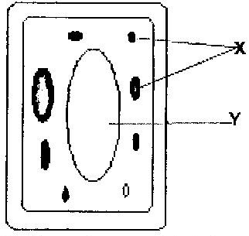

a) Name the parts labeled x and y (2mks)

X ………………………………..
Y ………………………………..
b) Suggest why the structures labeled x would be more on one side than the other side. (1mk)

………………………………………………………………………………………………………………………………………………
…………………………………………………………………………………………………………………………………………..….

7. Define the following (3mks)
i) Tissue

………………………………………………………………………………………………………………………………………………
………………………………………………………………………………………………………………………………………………
ii) Organ

………………………………………………………………………………………………………………………………………………
…………………………………………………………………………………………………………………………………………..….

iii) Organ system
………………………………………………………………………………………………………………………………………………
………………………………………………………………………………………………………………………………………………
8. The table below shows the concentration of some ions in pond water and in the cells sap of an aquatic plant growing in the pond.

Ions | Concentration in pond water (parts per million) | Concentration in cell sap (parts per million)
Sodium  Potassium  Calcium  Chloride | 50  2  1.5  180 | 30  150  1  200

a) Name the processes by which the following ions could have been taken up by this plant. (2mks)
i) Sodium ions

………………………………………………………………………………………………………………………………………………
………………………………………………………………………………………………………………………………………………
ii) Potassium ions

………………………………………………………………………………………………………………………………………………
………………………………………………………………………………………………………………………………………………

b) For each processes named in (a) (i) and (ii) above, state one condition necessary for the process to take place. (2mks)

………………………………………………………………………………………………………………………………………………
………………………………………………………………………………………………………………………………………………
………………………………………………………………………………………………………………………………………………

9. State the role of light in the process of photosynthesis. (2mks)

………………………………………………………………………………………………………………………………………………
………………………………………………………………………………………………………………………………………………
………………………………………………………………………………………………………………………………………………

10. Name one product of dark reaction in Photosynthesis (1mk)

………………………………………………………………………………………………………………………………………………
………………………………………………………………………………………………………………………………………………

9. In an investigation, the pancreatic duct of a mammal was blocked. It was found that the blood sugar regulation remained normal
while food digestion was impaired. Explain these observations. (3mks)

………………………………………………………………………………………………………………………………………………
………………………………………………………………………………………………………………………………………………
………………………………………………………………………………………………………………………………………………
…………………………………………………………………………………………………………………………………………..….

10. State any three contents of gastric juice (3mks)

………………………………………………………………………………………………………………………………………………
………………………………………………………………………………………………………………………………………………
………………………………………………………………………………………………………………………………………………
…………………………………………………………………………………………………………………………………………..….

11. Liver damage leads to impaired digestion of fats. Explain the statement. (3mks)

………………………………………………………………………………………………………………………………………………
………………………………………………………………………………………………………………………………………………
………………………………………………………………………………………………………………………………………………
…………………………………………………………………………………………………………………………………………..….

12. The diagram below represents the pathway of water from soil into the plant.
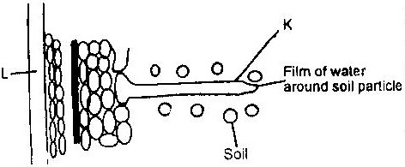

a) Name the structures labeled K and L
K…………………………………………………..

L………………………………………………….. (2mks)

b) Explain how water from the soil reaches the structure labeled L (5mks)

………………………………………………………………………………………………………………………………………………
………………………………………………………………………………………………………………………………………………
………………………………………………………………………………………………………………………………………………
…………………………………………………………………………………………………………………………………………..….
………………………………………………………………………………………………………………………………………………
………………………………………………………………………………………………………………………………………………
………………………………………………………………………………………………………………………………………………
…………………………………………………………………………………………………………………………………………..….
c) Name the process by which mineral salts enter into the plant. (1mk)

………………………………………………………………………………………………………………………………………………
………………………………………………………………………………………………………………………………………………

9. The chart below is a summary of the blood clotting mechanism in man.
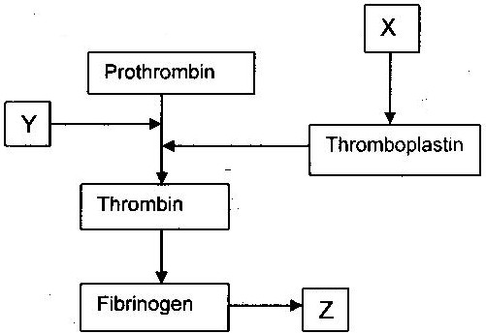

Name
- The blood cells represented by X (1mk)

……………………………………………………………………

- Metal ion represented by Y (1mk)

……………………………………………………………………

- The end product of the mechanism represented Z (1mk)

……………………………………………………………………

16. a) A patient whose blood group is A died shortly after receiving blood from a person of blood group B. Explain the possible cause of death of the patient. (2mks)
………………………………………………………………………………………………………………………………………………
………………………………………………………………………………………………………………………………………………
………………………………………………………………………………………………………………………………………………
…………………………………………………………………………………………………………………………………………..….
The diagram below represents some gaseous exchange structures in humans.

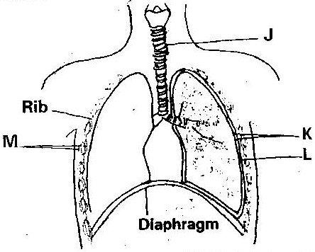

a)Name the structure labeled K, L and M (3mks)

………………………………………………………………………………………………………………………………………………
………………………………………………………………………………………………………………………………………………
………………………………………………………………………………………………………………………………………………
…………………………………………………………………………………………………………………………………………..….
b) How are the red blood cells adapted to their functions(3mks)
………………………………………………………………………………………………………………………………………………
………………………………………………………………………………………………………………………………………………
………………………………………………………………………………………………………………………………………………
…………………………………………………………………………………………………………………………………………..….
c) Name the process by which inhaled air moves from the structure labeled L into blood capillaries. (1mk)

…………………………………………………………………………………………………………………………………………..….

