Kuhs; biology
Mid-term exam; term 11 year 2011
Instructions; answer all questions in the spaces provided.
Totalmarks;50
Duration;1hr,30 minutes

- What are the functions of bile salts during the process of digestion? (2 marks)

- What is cell physiology? (1 mark)

- State two functions of mucus produced along the alimentary canal. (2 marks)

- Name the enzyme in red blood cells that speeds up conversion of carbon 1V oxide. (1 mark)

- Name the metallic ion needed to make the oxygen carrying compound in erythrocytes.(1 mark)

- Other than relative humidity, state four other environmental factors that affect water loss in plants.4MRKS

…………………………………………………………………………………………………………………………………………………………………………………………………………………………………………………………………………………………………………………………
- What is assimilation? (2mks)………………………………………………………………………………..
…………………………………………………………………………………………………………………………………………………………
8)The figure below is a diagram of an intestinal villus.
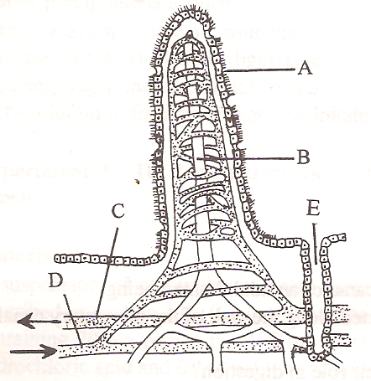

- Name the parts labeled A&B (2marks)
A…………………………………………………..
C…………………………………………………..
- What is the importance of intestinal villi (2mark)
……………………………………………………………………………………………………………………………………………………………………………………………………………………………………………………………………………………………………………………………………………………………………
- (i)Name any TWO pancreatic enzymes (2marks)
………………………………………………………………………………………………………………………………………………………………………………………………………………………………………………………………………………………………………………………………………………………………………………………………………………………………………………………………………………………………………………………………………
(ii)Give one function of any one of the enzymes named above (1mark)
…………………………………………………………………………………………………………………………………………………………………………… ……………………………………………………………………………………………………………………………………………………………………………
- The dental formula of a certain animal is as shown below. Work out the total number of teeth that the animal has.(2mks)

I $\frac{2}{1}$, C $\frac{0}{0}$ PM $\frac{3}{2}$ , M $\frac{3}{3}$ .

9). Why are people with blood group AB referred to as universal recipients? (2marks)

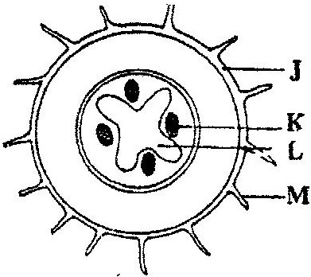
10) SStudy the illustration below and answer the questions that follow.

a). From which plant organ was the section obtained? (1 mk)

b). Give two reasons for your answer in (a) above. (2mks)

c). Name the parts labeled J,K and L. (3mks)
J

………………………………………………….
K

………………………….
L

………………………………………………….

D. State two functions of the part labeled M. (2mks)

11) A freshly obtained dandelion stem measuring 5 cm long was split lengthwise to obtain two similar pieces. The pieces were placed in solutions of different concentrations in Petri dishes for 20 minutes. The appearance after 20 minutes is as shown

- Account for the appearance of the pieces in solutions L₁ and L₂ ( 4 mks)

- State two significance of the biological process involved in the experiment ( 2 mks)

12)state six adaptations of leaves for photosynthesis.(12mks)……………………………………………………………………………………………………………………………………………………………………………………………………………………………………………………………………………………………………………………………………………………………………………………………………………………………………………………………………………………………………………………………………………………………………………………………………………………………………………………………………………………………………………………………………………………………………………………………………………………………………………………………………………………………………………………………………………………………………………………………………………………………………………………………………………………………………………………………………………………………………………………………………………………………………………………………………………………………………………………………………………………………………………………………………………………………………………………………………………………………………………………………………………………………………………………………………………………………………………………………………………………………………………………………………………………………………………………………………………………………

