NAME:……………………………………………………………… ADM NO: ……………
SCHOOL …………………………………………………………… DATE: ………………
BIOLOGY
FORM II
TIME: 2 ½ HOURS

MWAKICAN JOIT EXAMINATION
TERM 1
YEAR 2015
INSTRUCTIONS TO CANDIDATES
- Write your name and admission number in the spaces provided above.
- Answer ALL questions in the spaces provided.

- Explain the following terms:
- Taxonomy (1mk)

- Species (1mk)

- State the function of the following organelles
- Lysosomes (1mk)

- Golgi apparatus (1mk)

- What is the role of vascular bundles in plant? (3mks)

- Name the form in which carbohydrates are stored in
- Plant tissues
- Animal tissues
(2mks)
- State two differences in arrangement of vascular bundles in monocot and dicot stems (2mks)
Monocot Dicot

- The following experiment was set up to demonstrate a physiological process. Two tubes A and B made of sheep’s bladder were filled with different liquids and placed in a basin containing a liquid
Liquid
Basin
B
A

After 20 minutes, it was found that tube A felt hard and the liquid in it had increased. Tube B was soft and contained less liquid.
- Explain what took place in tubes A and B (4mks)
A

B

- Indentify the liquid hypertonic in the basin (1mk)
- What does the sheep’s bladder correspond to? (1mk)

- The diagram below show two conducting elements of the xylem tissue.
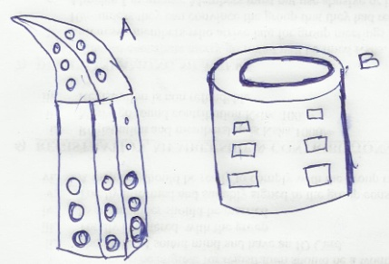

- Identify each of the A and B (2mks)

- State two structural adaptations that make xylem vessels suitable to their functions (2mks)

- A. Explain how the following reduce transpiration in xeropytes
- Sunken stomata
- Thick cutile

B. State two roles of transpiration ( 2mks)

- Study the dental formula below:
2
3
3
3
0
0
0
4
I ; C ; ; PM ; M

- Identify with reasons the mode of feeding of the animals whose dental formula is given above. (2mks)

- Calculate the total number of teeth in the mouth of the above (1mk)

- State the differences between plants and animals (3mks)
Plants Animals

- Name three photosynthetic cells in plants (2mks)

- The diagram below represents an experimental set up by students of Kiboko Secondary School
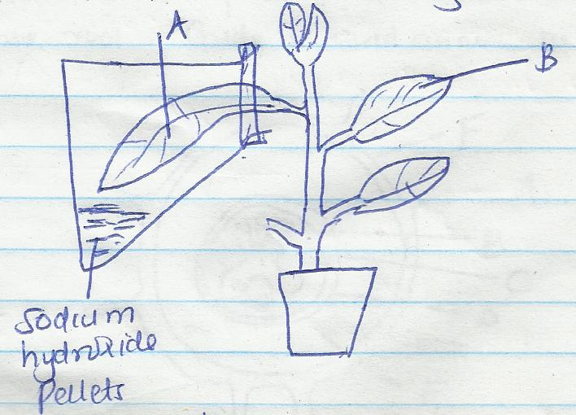

- Name the factor being investigated in the above set-up
(1mk)
- Why is it necessary to first keep the set-up in the dark for 48 hours? (1mk)

- What is the role of sodium hydroxide pellets in the experiment? (1mk)

- When testing for starch in a leaf, explain the reason for doing the following

- Dipping the leaf in boiling water (1mk)

- Boiling the leaf in methylated spirit? (1mk)

- State the expected results for leaves A and B after a starch test. (2mks)
A

B
- Explain the results in e) above (2mks)

- Name the elements present in carbohydrates (3mks)

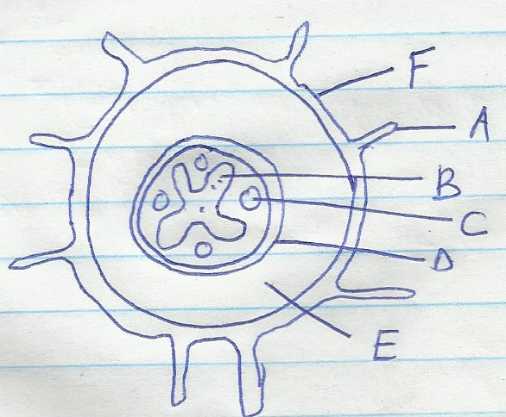
- The diagram below represents a transverse section of a dicotyledonous root. Study it and answer the questions that follow.

- Name parts labeled A to F (3MKS)
A C E
B D F

- Explain how the structure labeled A is adapted to its function (2mks)

- What are the structural adaptations of the structure labeled B to its function? (2mks)

- The graph below shows the effects of temperature on the rate of reaction of the enzymes salivary amylase
P
C
D
10 20 30 40 50 60
Temperature (ºc)
- Explain the role of enzymes in living cells (1mk)

- I) Account for the changes in the curve between C and D (2mks)

ii) What does dotted line represent? (1mk)

- Explain how the following factors affect the rate of enzyme activity
- Temperature (3mks)

- Substrate concentration (3mks)

- State three structural differences between arteries and veins
Arteries veins

- A) Give two reasons why clotting of blood is important (2mks)

B) Name one enzyme and one metal ion that are required in the blood clotting process (2mks)

C) Explain why excessive bleeding may lead to death of patient (3mks)

- A) Most of absorption of digested food in mammals takes place in the ileum. In what ways is it adapted for this function? (5mks)

B) Name two nutrients that are absorbed in mammalian gut without chemical digestion (2mks)

C) State and explain four factors that determine energy requirements in human beings (8mks)

- Distinguish between the following terms; (3mks)
- I) Systole and diastole

ii) Open and closed circulatory systems

iii) Single and circulation

- Briefly describe how a mammalian heart is adapted for its function (10mks).

