GATITU MIXED SECONDARY SCHOOL
BIOLOGY FORM 2 MID EXAM TERM 2 2014
- State any three functions of the mucus which is secreted along the wall of the alimentary canal. 3mks

- Explain why the digestion of starch stops immediately after food enters the stomach. 3mks

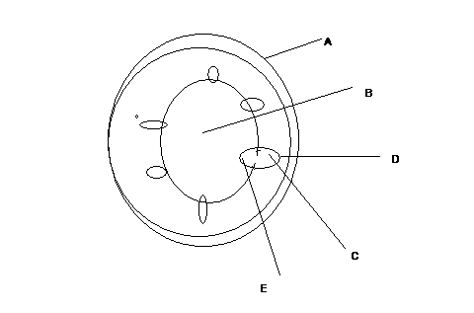
- Name the parts labeled A and B 2mks

- State the functions of parts labeled C, D and E. 4mks

- List three differences between the section shown above and that one that would be obtained from the root of the same plant. 3mks

- Name the:
- Material that strengthens xylem tissue. 1mk

- Tissue that is removed when the bark of a dicotyledonous plant is ringed. 1mk

- What is wilting? 1mk

- State how the following specialized cells are adapted to perform their functions. 4mks
- Nerve cell

- palisade cell

- Root hair cell

- Red blood cell

- Outline the differences between light and electric microscope. 3mks

- Name two mineral elements that are necessary in the synthesis of chlorophyll. 2mks

- State three functions of hydrochloric acid in the digestion in stomach. 3mks

- Give an example of a phylum where all members have: 2mks
- Open circulatory system

- Closed circulatory system

- What are the advantages of the closed circulatory system over the open circulatory system? 5mks

- Discuss the three theories of opening and closing of stomata. 9mks

- State the functions of the following parts of a 5mks
- microscope

- Diaphragm

- Objective lenses

- coarse adjustment knob

- Arm

