Gatitu Mixed Secondary School
Form 2 | Term 1 | 231 - Biology | 06-Jan-16 | Opener
1. Explain how drooping of leaves on a hot sunny day is advantageous to a plant. (2mks)

2. a) What is diffusion? (2mks)

b) How do the following factors affect the rate of diffusion?
i) Diffusion gradient (1mk)

ii) Surface area to volume ratio (1mk)

iii) Temperature (1mk)

c) Outline 3 roles of active transport in the human body (2mks)

3. State the importance of osmosis in plants (3mks)

4. An experiment was set up as shown in the diagram below.

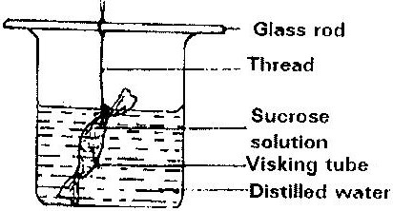

The set up was left for 30 minutes.
a) State the expected results. (1mk)

b) Explain your answer in (a) above. (3mks)

5. Explain why plant cells do not burst when immersed in distilled water. (2mks)

6. Distinguish between diffusion and osmosis. (2mks)

7. Define the following terms in relation to a cell
a) Isotonic solution
b) Hypotonic solution
c) Hypertonic solution (3mks)
8. Addition of large amounts of salt to soil in which plants are growing kills the plants. Explain (6mks)

9. Explain why
a) Red blood cells burst when placed in distilled water while plant cells remain intact. (2mks)

b) Fresh water protozoa like amoeba do not burst when placed in distilled water. (2mks)

10. State the role of light in the process of photosynthesis. (2mks)

Name one product of dark reaction in Photosynthesis (1mk)

11. Photosynthesis takes place in two stages. Name the part of the chloroplast where
i) Light stage occurs (2mks)
ii) Dark stage occurs (2mks)

