NAME ……………………………………………………………………ADM.NO…………
SIGN …………………………INDEX NO ………………… ……...STREAM……………
231/2
Biology Paper 2(Theory)
DECEMBER 2021
Time: 2 Hours
MOKASA II JOINT EVALUATION EXAMINATION
Kenya Certificate of Secondary Education
- Write your name, Index Number in the spaces provided above
- Write the date of examination in the space provided above
- Answer ALL the questions in section A in the spaces provided below each question in the question paper
- In section B, answer question 6(Compulsory) and either question 7 or 8
FOR EXAMINER’S USE ONLY
Section | Question | Maximum Score | Candidate’s Score
A | 1 | 08
 | 2 | 08
 | 3 | 08
 | 4 | 08
 | 5 | 08
B | 6 | 20
 | 7 or 8 | 20
 | TOTAL | 80

- The diagram below shows the traverse section of a young stem.
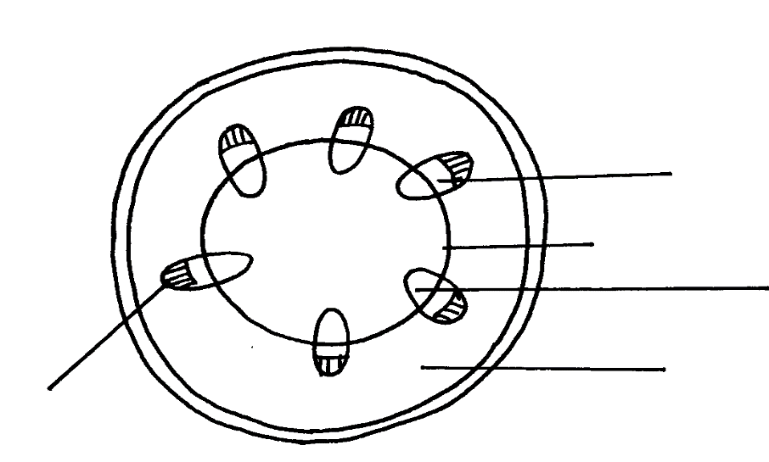
E
A
B
C
D

(a)(i) Name the class of the plant from which the section was obtained belong. ( 1 mark)
…………………………………………………………………………………………………
(ii) Give a reason for your answer in (a)(i) above (1 mark)
……………………………………………………………………………………………….
(b)What are the functions of the structures labelled A, B and E (3 marks)
A………………………………………………………………………………...
B…………………………………………………………………………………
E………………………………………………………………………………...
(c) What type of cells are fond in the parts labelled D (1 mark) …………………………………………………………………………………….
(d) Name the tissue labelled C (1 mark)
……………………………………………………………………………………….. (b) How is the part labelled C adapted to its functions? ( 1 mark)
……………………………………………………………………………………………..…………………………………………………………………………………………………………………………………………………………………………………………………………

2.(a)What is meant by the term non-disjunction (1marks)
……………………………………………………………………………………………………………………………………………………………………………………………………………………………………………………………………………………………………… (b) Differentiate between continuous and discontinues variations, giving examples of each (2 marks)
……………………………………………………………………………………………………………………………………………………………………………………………………
……………………………………………………………………………………………….
(c) A female with sickle cell trait marries a normal man. The allele for sickle cell is Hb^{S} and the normal allele is Hb^{A}. Using a Punnet square, determine the probability that their first born will have sickle cell trait. Show your working. (5 marks)
………………………………………………………………………………………………………………………………………………………………………………………………………………………………………………………………………………………………………………………………………………………………………………………………………………………………………………………………………………………………………………………………………………………………………………………………………………
……………………………………………………………………………………………….
………………………………………………………………………………………………..

3. The diagram below shows some of the processes that take place in the female reproductive
system.
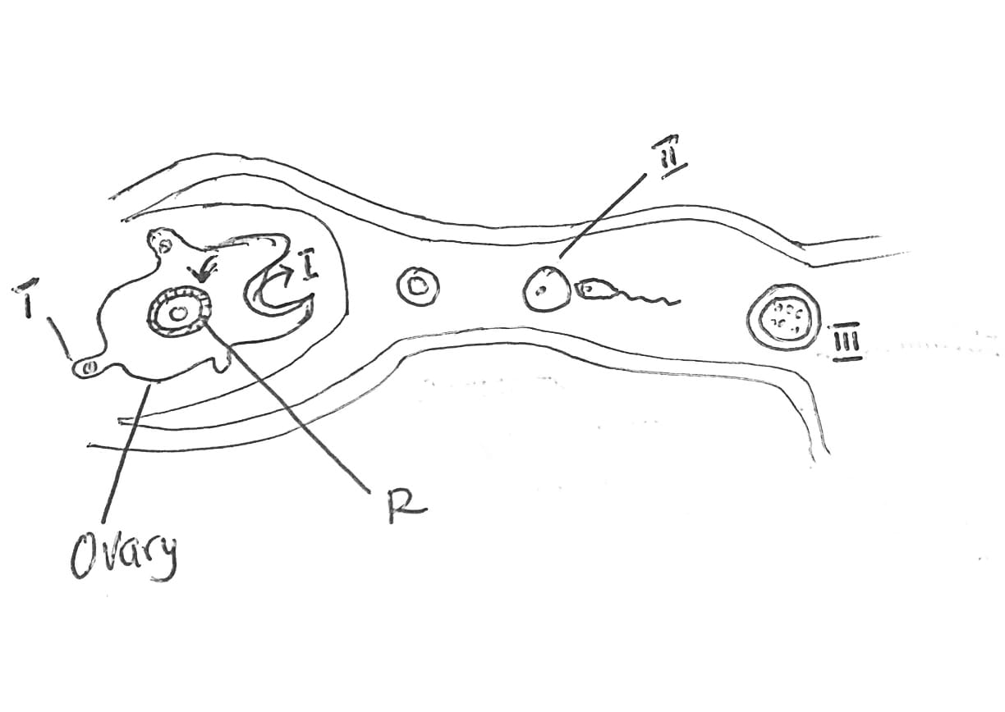
- Name the part process labeled I and state the hormone responsible for triggering the process. (2 marks)
……………………………………………………………………………………….
……………………………………………………………………………………….
- (i)Name the structures labeled R; (1 mark)
……………………………………………………………………………………...
(i) Identify the hormone responsible for the formation of the structures named in b (i) above; (1 marks)
…………………………………………………………………………………..
(d) (i) Identify the process labeled II (1 mark)
…………………………………………………………………………………………………
(ii) Explain what leads to the process named in d(i) above. (3 marks)
……………………………………………………………………………………………………………………………………………………………………………………………………
………………………………………………………………………………………………………………………………………………………………………………………………………………………………………………………………………………………………………

4. Study the diagram below which makes 4 revolutions per hour. A tomato seedling with a straight radicle and plumule was attached to the apparatus as shown below.
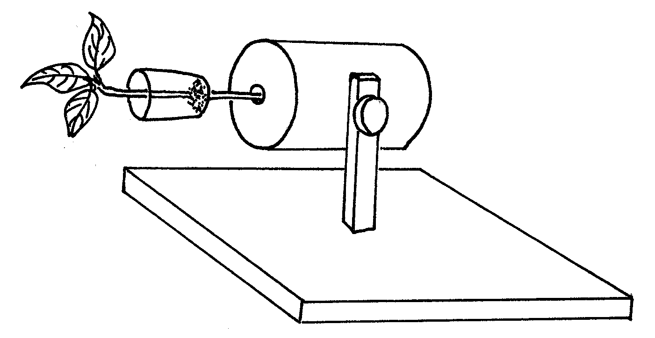
a) Give the name of the above apparatus (1mk)
………………………………………………………………………………………………
………………………………………………………………………………………………

b) i) Make a drawing of how the seedling above might have appeared after a fortnight.
(Draw the seedling alone with radicle and shoot) (2mks)

ii) Account for the observation in b) (i) above (2 marks)
..................................................................................................................................................
………………………………………………………………………………………………
..................................................................................................................................................
………………………………………………………………………………………………
c) What type of responses are being expected in this experiment? (2 marks)
..................................................................................................................................................
………………………………………………………………………………………………
..................................................................................................................................................
………………………………………………………………………………………………
d) Give one survival value of the response above (1 mark)
.........................................................................................................................................
5. The diagram below represents a food web in a terrestrial ecosystem.
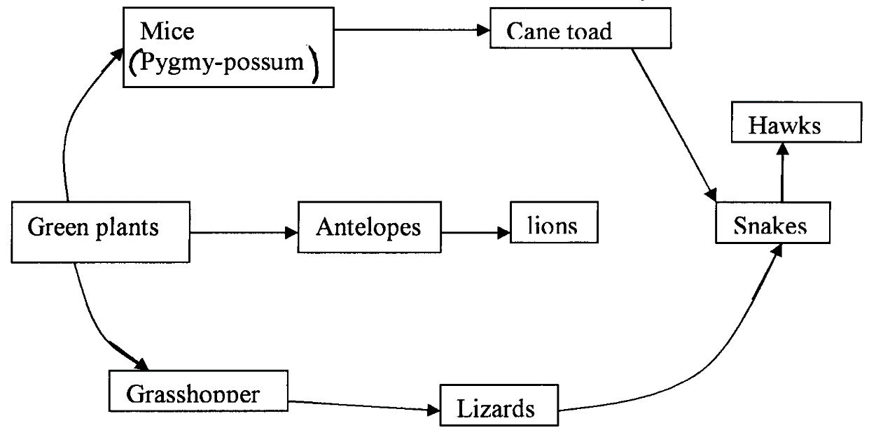
(a) Which organism has the highest number of preys (lmk)
…………………………………………………………………………………………
(b) Construct food chains with snakes as tertiary consumers (2mks)
………………………………………………………………………………………………………………………………………………………………………………………………………………………………………………………………………………

(c) State the trophic level occupied by hawks in the food chains constructed in b) above (1 mark)
……………………………………………………………………………………………………………………………………………………………………………………

(d) Describe how capture — recapture method that can be used in estimating the population of fishes in a lake. (4mks)
………………………………………………………………………………………………………………………………………………………………………………………………………………………………………………………………………………
………………………………………………………………………………………………………………………………………………………………………………………………………………………………………………………………………………

6.The length of a grasshopper femur and internode of a seedling were recorded in a period of 19 weeks. The results are recorded in the table below.
Week | 1 | 3 | 5 | 7 | 9 | 11 | 13 | 15 | 17 | 19
Average length of femur(mm) | 8.0 | 9.0 | 9.0 | 9.0 | 13.0 | 13.0 | 15.0 | 19.0 | 19.0 | 19.0
Average length of internode(mm) | 5.0 | 6.5 | 10.5 | 16.5 | 24.5 | 27.5 | 32.5 | 34.5 | 36.0 | 37.5

- Plot a graph of length of femur and internode against time on the same (7mk)

- (i)What was the average length of internode in the 8th week? (1mk)
…………………………………………………………………………………
(ii)Suggest how average length of internodes was obtained. (2mk)
…………………………………………………………………………………
…………………………………………………………………………………
- Name the type of growth curve shown by:
- Grasshopper (1mk)
…………………………………………………………………………………
- Seedling (1mk)
…………………………………………………………………………
- Account for the change in length for femur between:
- 3rd and 7th week. (2mk)
………………………………………………………………………………………………………………………………………………………………………………………………………………………………………………
- 16th and 20th week. (2mk)
………………………………………………………………………………………………………………………………………………………………………………………………………………………………………………

- (i)Which animal phylum exhibits the growth pattern of the femur? (1mk)
…………………………………………………………………………………………………………………………………………………………………..
- Name the hormone responsible for the growth pattern in grasshopper.(1mk)
……………………………………………………………………………………………………………………………………………………………………
- Work out the rate of growth of the seedling between week 7 and 10. (2mk)
…………………………………………………………………………………
…………………………………………………………………………………………………………………………………………………………………………………………………………………………………………………………………………………………………………………………………………

7. Describe the adaptation of the mammalian eye to its functions (20 marks)
8. (a) (i) Define the term natural selection (1 mark)
(ii) Explain how the distribution of the two types of moths were used as evidence of natural selection in action (5 marks)
(b) Describe evidences to support organic evolution (14 marks)
…………………………………………………………………………………………………………………………………………………………………………………………………………………………………………………………………………………………………………………………………………………………………………………………………………………………………………………………………………………………………………………………………………………………………………………………………………………………………………………………………………………………………………………………………………………………………………………………………………………………………………………………………………………………………………………………………………………………………………………………………………………………………………………………………………………………………………………………………………………………………………………………………………………………………………………………………………………………………………………………………………………………………………………………………………………………………………………………………………………………………………………………………………………………………………………………………………………………………………………………………………………………………………………………………………………………………………………………………………………………………………………………………………………………………………………………………………………………………………………………………………………………………………………………………………………………………………………………………………………………………………………………………………………………………………………………………………………………………………………………………………………………………………………………………………………………………………………………………………………………………………………………………………………………………………………………………………………………………………………………………………………………………………………………………………………………………………………………………………………………………………………………………………………………………………………………………………………………………………………………………………………………………………………………………………………………………………………………………………………………………………………………………………………………………………………………………………………………………………………………………………………………………………………………………………………………………………………………………………………………………………………………………………………………………………………………………………………………………………………………………………………………………………………………………………………………………………………………………………………………………………………………………………………………………………………………………………………………………………………………………………………………………………………………………………………………………………………………………………………………………………………………………………………………………………………………………………………………………………………………………………………………………………………………………………………………………………………………………………………………………………………………………………………………………………………………………………………………………………………………………………………………………………………………………………………………………………………………………………………………………………………………………………………………………………………………………………………………………………………………………………………………………………………………………………………………………………………………………………………………………………………………………………………………………………………………………………………………………………………………………………………………………………………………………………………………………………………………………………………………………………………………………………………………………………………………………………………………………………………………………………………………………………………………………………………………………………………………………………………………………………………………………………………………………………………………………………………………………………………………………………………………………………………………………………………………………………………………………………………………………………………………………………………………………………………………………………………………………………………………………………………………………………………………………………………………………………………………………………………………………………………………………………………………………………………………………………………………………………………………………………………………………………………………………………………………………………………………………………………………………………………………………………………………………………………………………………………………………………………………………………………………………………………………………………………………………………………………………………………………………………………………………………………………………………………………………………………………………………………………………………………………………………………………………………………………………………………………………………………………………………………………………………………………………………………………………………………………………………………………………………………………………………………………………………………………………………………………………………………………………………………………………………………………………………………………………………………………………………………………………………………………………………………………………………………………………………………………………………………………………………………………………………………………………………………………………………………………………………………………………………………………………………………………………………………………………………………………………………………………………………………………………………………………………………………………………………………………………………………………………………………………………………………………………………………………………………………………………………………………………………………………………………………………………………………………………………………………………………………………………………………………………………………………………………………………………………………………………………………………………………………………………………………………………………………………………………………………………………………………………………………………………………………………………………………………………………………………………………………………………………………………………………………………………………………………………………………………………………………………

