NAME.......................................................................ADM NO...............................
DATE............................. SIGN.....................................
231/3
Biology paper 3
(Practical)
1 ¾ HRS
December 2021.
MOKASA MOCK
Kenya Certificate of Secondary Education 2021
231/3
Biology paper 3
(Practical)
TIME: 1 ¾ HRS
December 2021.

INSTRUCTIONS TO CANDIDATES
- Write your name and index number in the spaces provided at the top of this page.
- Answer all the questions in the spaces provided.
For examiner’s use only

QUESTION | MAXIMUM SCORE | CANDIDATE’S SCORE
1. | 14
2. | 14
3. | 12
TOTAL | 40

1. You are provided with irish potato tuber labeled specimen K, use it to answer questions that follow.
Cut out two cubes whose sides measure 1cm from the irish potato provided
Label three test-tubes as, A, B and C and put them into the test-tube rack.
A ) Crush one cube to obtain a paste and add about 15 cm³ of distilled water to the paste to form a solution and then carry out the following procedure;
i) Use a measuring cylinder to pour 10 cm³ of potato extract solution into test-tube A.

ii) Use the measuring cylinder to transfer 5 cm³ of potato solution extract from test-tube A to test- tube B.

iii) Use the measuring cylinder to add 5 cm³ of distilled water to test-tube B. Place a stopper in test-tube B and shake it.

iv) Remove the stopper. Use the measuring cylinder to transfer 5 cm³ of the liquid in test- tube B to test-tube C.

v) Use the measuring cylinder to add 5 cm³ of distilled water to test-tube C. Place a stopper in test-tube C and shake it. Using a measuring cylinder reduce the volume of solution C to 5 cm³.
a) Table below shows the percentage concentration of the potato extract solution.

test-tube | percentage concentration of potato extract solution
A | 100.00
B
C

Complete the table above by calculating and writing in the percentage concentration of potato extract solutions in test-tube B and C. (2mks)

b ) Using a measuring cylinder pour 1 cm³ to each of hydrogen peroxide to the contents in test tube A to C and make the observations (3mks)

Test tube | Observations
A

B
C

( i) What was the aim of the investigation above (1mk)
…………………………………………………………………………………………………………………………………………………………………………………………………………

(ii) Write the word equation for the reactions taking place in the test tubes (1mk)
…………………………………………………………………………………………………………………………………………………………………………………………………………

(iii) What will be the expected observation if the irish potato was replaced with a piece of mammalian liver (1mk) ………………………………………………………………………………………………………………………………………………………………………………………………………………………………………………………………………………………………………………………
(iv) Explain your answer in c (iii) above (2mk)
………………………………………………………………………………………………………………………………………………………………………………………………………………………………………………………………………………………………………………………………………………………………………………………………………………………………………………………………………………………………………………………………………

(B) Crush the remaining cube to obtain the paste. Use the reagents provided to and carry out food test on the extract. (4mks)

TEST | PROCEDURE | OBSERVATIONS | CONCLUSION

2. You are provided with specimens labeled L and M. Study them then answer questions that follow:
a) Identify the specimens. (2mk)
L…………………….………………..
M...........................................................
b) Name the part of the body where each is found. (2mk)
L……………………………..…………….
M……………………………………………
c) State three adaptive characteristic features of the bone L. (3mks)
………………………………………………………………………………………………………………………………………………………………………………………………………………………………………………………………………………………………………………………………………………………………………………………………………………………………………………………………………………………………………………………………………………………………………………………………………………………………………………………………………………………………………………………………………………………

d) State two observable differences between bones L and M. (2mks)
Bone L | Bone M

e) Study the diagrams below and answer questions that follow.

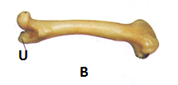C
I) Identify the bone labelled C in the diagram. (1mk)
…………………………………………………………………………………………….
II) Name the type of joint and bone formed at the proximal and distal end of bone B (4mks)
Proximal end;
(i) Bone …………………..………………….
(ii) Type of joint ……………………………..
Distal end;
(i) Bone(s)………………………………….
(ii) Type of joint ……………………………
3. The photo graphs labelled W, X, Y and Z show seedlings that were grown under different conditions. Examine them.
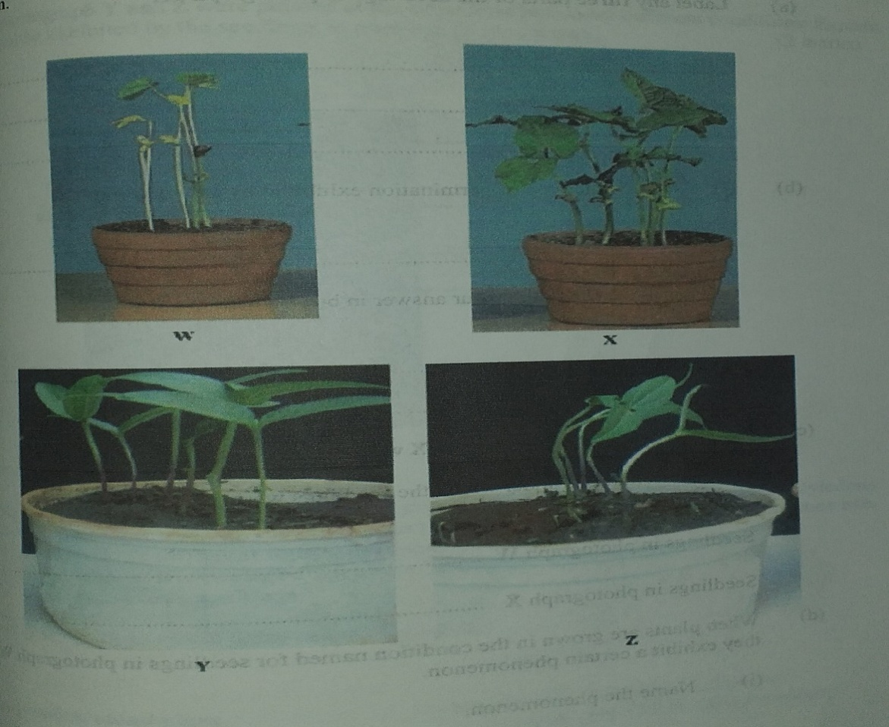

(a) Label any two parts of the seedlings in photograph W. (2 mks)
(b)(i)Name the type of germination exhibited by the seedlings. (1 mk)
………………………………………………………………………………………………………………………………………………………………………………………………………………
(ii) Give a reason for your answer in b(i) above. (1 mk)
………………………………………………………………………………………………………………………………………………………………………………………………………………………………………………………………………………………………………………………

(c)Seedlings in photographs W and X were planted at the same time. State the conditions under which the seedlings were grown. (2 mks)
(i) Seedlings in photograph W.
………………………………………………………………………………………………………………………………………………………………………………………………………………
(ii) Seedlings in photograph X.
………………………………………………………………………………………………………………………………………………………………………………………………………………
(d) When plants are grown in the condition named for seedlings in photograph W, they exhibit a certain phenomenon.
(i) Name the phenomenon. (1 mk)
………………………………………………………………………………………………………………………………………………………………………………………………………………

(ii) State the significance of the phenomenon named in d(i). (1 mk)
………………………………………………………………………………………………………………………………………………………………………………………………………………………………………………………………………………………………………………………

(e) Using observable features only, state two differences between the seedlings in photographs W and X. (2 mks)
W | X

(f) Seedlings in photographs Y and Z were planted at the same time but under different conditions. Explain how the response exhibited by seedlings in photograph Z occurred. (2 mks)

………………………………………………………………………………………………………………………………………………………………………………………………………………………………………………………………………………………………………………………………………………………………………………………………………………………………………………………………………………………………

