451/2 - COMPUTER STUDIES – Paper 2
(PRACTICAL)
DECEMBER 2021
TIME: 2½ HRS

MOKASA II EXAMINATION
Kenya certificate of secondary education
(K.C.S.E)

Name…………………………………………….………Adm. No……….…Class………………
Date: ……………………………………….……….Signature: ……………………………

INSTRUCTIONS TO CANDIDATES

- Type your name and admission number at the top right hand corner of each printout
- Sign and write the date of the examination below the name and index number on each printout
- Write your name and index number on the compact disks
- Write the name and version of the software used for each question attempted in the answer sheet
- Passwords should not be used while saving in the compact disks
- Answer all the questions
- All questions carry equal marks
- All answers must be saved in your compact disks
- Make a printout of the answers on the answer sheets provided
- Hand in all the printouts and the compact disks.

This paper consists of 4 printed pages. Candidates should check the question paper to ascertain that all the pages are printed as indicated and that no questions are missing.

- The table below shows list of students admitted to MOKASA School under different sponsors.

- Open a database program and create a database named SPONSORSHIP. (1 mark)
- (i) Create three tables named Students, Sponsor and Amount received by each student in the database file created in (a) using the following field properties. (10 marks)
Student_Table
Field name | Data types and properties
Sch-Code | Default value = 520
AdmNo | Text (Size = 4, Required = Yes )
Student Name | Text (Size = 12)
Date of Birth | Date and time (Size = 10)
AmountId | Text (Size = 4, Required = Yes )

Sponsor_Table
Field name | Data types and properties
SponsorID | Text (Size = 4, Required = Yes )
Sponsor Name | Text (Size = 16)

Amount_Table
Field name | Data types and properties
BankID | Text (Size = 4, Required = Yes )
BankName | Text (Size = 10)
Amount Per Student | Number (Size = 8, Decimal Place = 2)
Mode of payment | Text (Size = 12)
(ii) Create the relationship between the tables. (2 marks)
(iii) Enforce referential integrity between the tables. (1 mark)
(iv) Create the three forms StudentForm, SponsorForm and AmountForm. (3 marks)
(v) Enter the following data in their respective tables using the respective forms. (12 marks)
Table 1: Sponsor_Table
SponsorID | Sponsor Name
S1 | Myles
S2 | Bishop
S3 | Myles

Table 2: Student_Table
Sch-Code | AdmNo | SponsorID | StudName | BankID | DateOfBirth
520 | 444 | S1 | Lilian Mwende | 100 | 12/03/2000
520 | 443 | S3 | Oscar Juma | 200 | 23/01/1998
520 | 445 | S2 | Chebara Omondi | 100 | 11/07/2002
520 | 442 | S1 | Bianca Godana | 300 | 12/05/2005
520 | 410 | S3 | Anorld Schawz | 300 | 28/05/1999
520 | 413 | S2 | King kalala | 200 | 30/09/1998
520 | 449 | S1 | Marx Otaigo | 100 | 18/02/2005
520 | 411 | S3 | Biggie Smalls | 100 | 17/04/2001
520 | 412 | S2 | Brianna Kawaswa | 200 | 19/06/2004
520 | 415 | S2 | Muinde Jake | 100 | 22/03/2003

Table 3: Amount_Table
BankID | BankName | Amount Per Student | Mode of payment
100 | COOP | 550,000 | EFT
200 | KCB | 120,000 | M-banking
300 | Sidian | 420,000 | Cheque

(c) Create a query to display the fields:
- AdmNo, Sponsor name, age and Students whose first name start with letter “B” and whose payment Bank is “COOP” Save query as B-query. (4 marks)

- StdName, Sponsor name, Mode of payment and Amount per student. Calculate the total amount received. Save query as AMount-query. (3 marks)

- StudName, Sponsor name, mode of payment and number of students whose age is above 15 and less than 18 years. Save query as Age-query. (3 marks)

(d) Create a bar chart to display students and their respective amount received. Save chart as S-chart. (2 marks)
(e) Create a report to display the fields as it appears in the figure below. (5 marks)
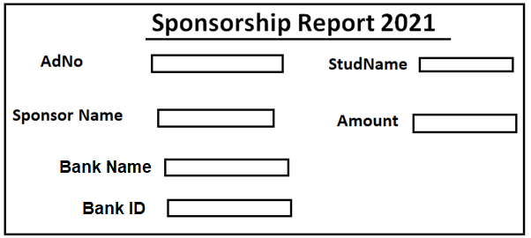

(f) Print the following: (4 marks)
- the Student, Sponsor table and Amount table
- the forms
- two queries
- The chart
- the report

- The figure bekow shows the design of a wedding card. You are required to use a desktop publishing software to design the card as it appears. Save as PRE_WEDDING
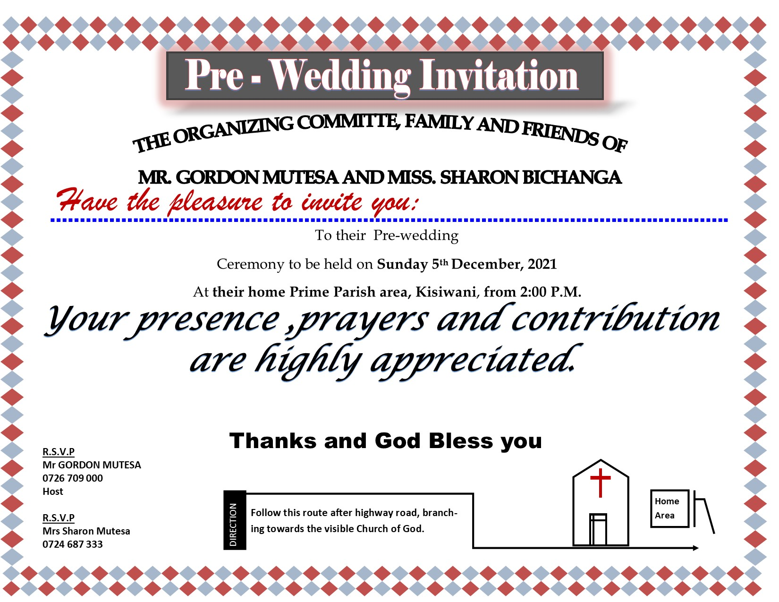
- Create the publication with the following page settings and layout: (4 marks)
- Paper size : A4
- Landscape orientation
- Margins: 1.2cm all round
- Enter the text and other objects and perform formarting to appear like the design above. (34 marks)
- After completing the design, create a copy of the publication and save it As NEW_CARD and apply the following formatting operations:
- Set the text information starting with “To their pre-wedding…..” to te following font settings:
- Font ype: Arial narrow (½ mark)
- Size: 15pts (1 mark)
- Line spacing: 1.2sp (1 mark)
- Indent: Flush left (½ mark)
- Automatically insert a calender and position to fit slightly above the church. Mark the pre-wedding date with a red color. (3 marks)
- Apply these measurements to the rectangular object containing the heading title “Pre-Wedding Invitation” to 1.67cm height and 15.62 cm width. Add a glow effect (Accent 2. 18pt glow) to the rectangular object. (3 marks)
- Put a gradient effect on the text object containing Thanks and God Bless you“. (1 mark)
- Print both publications (2 marks)

