SUKELEMO JOINT MOCK EXAMINATION
Kenya Certificate of Secondary Education-Mock

ART AND DESIGN
442/1 Paper 1

NOV. 2021 - 1 ½ hours
_________________________________________

SECTION A (20 marks)
Answer all the questions in this section in the spaces provided.

- What is a picture plane in art? (1mark)

- The flat two-dimensional surface on which we draw or project an image in perspective.

- Identify the technique use to render the art work below (1mark)

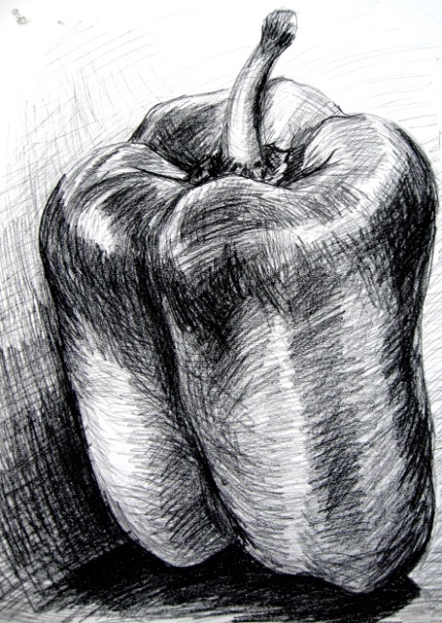

- Cross hatching

- What is environmental design? (1mark)
- An area of design that deals with the shaping of the physical environment. E.g Architecture, interior design, landscape architecture

- Below is a still-life composition. Study it carefully and answer the question that follows.
Identify two outstanding elements in the composition above (2marks)

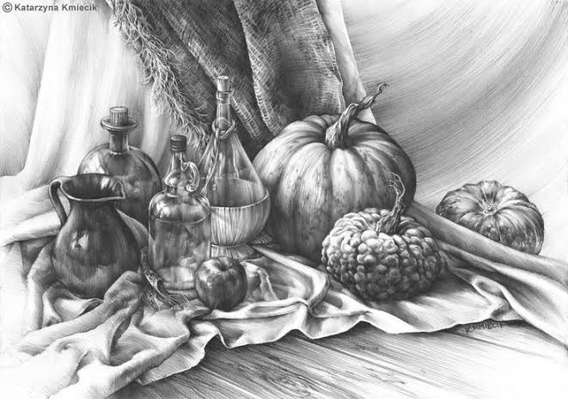
- Texture
- Shape
- Explain the difference between simulated texture and invented texture (2marks)

- Simulated texture is imitated/copied from existing objects
- Invented texture is created by the artist through the use of patterns etc.

- Identify and explain the colour scheme illustrated below: (2marks)

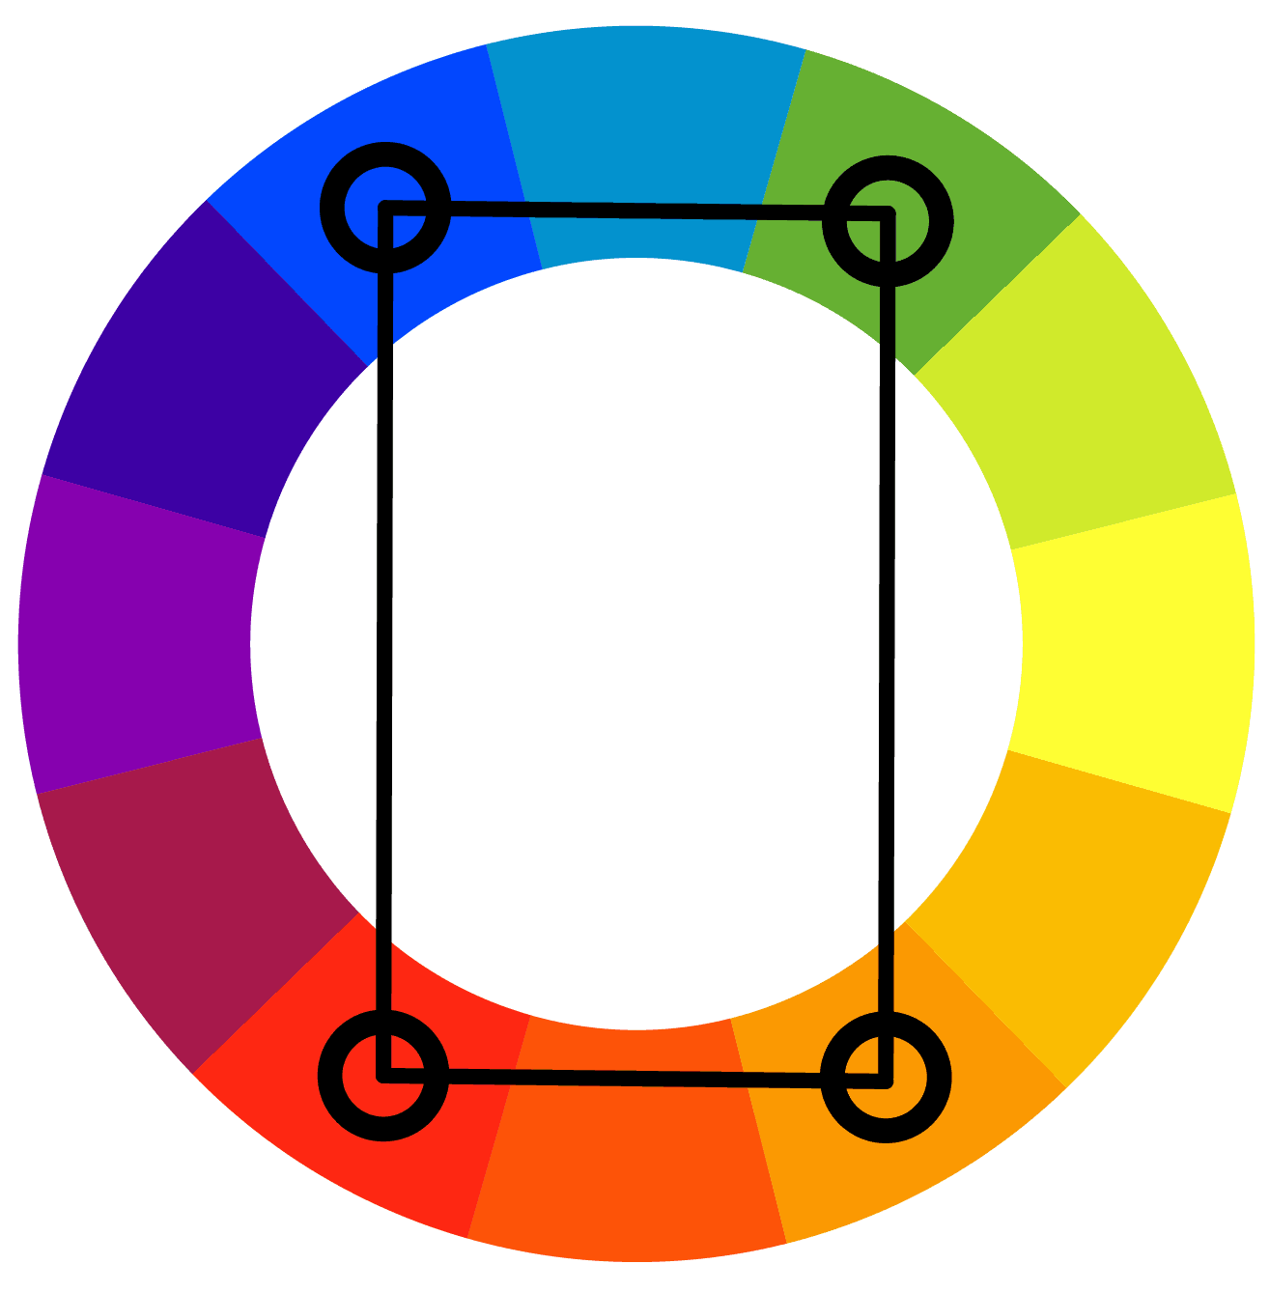

- Tetradic colors : two sets of complementary pairs of colors found opposite each other on the color wheel

- Identify and explain the type of balance shown in the illustration below: (2marks)

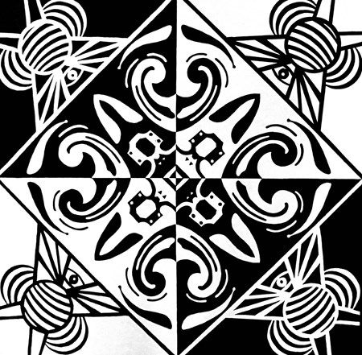

- Asymmetrical balance: Elements on either halves of the composition are not similar

- Below is a type of perspective drawing

- Identify the type of perspective portrayed in the composition below (1mark)

- Three-point linear perspective

- State and explain the eye view portrayed in the composition above (1mark)

  - Bird’s eye view

- Explain the difference between contour and gesture drawing (2marks)

- Explain two techniques of book making (2marks)

- Hinge method
- Hard spine method
- Folding

- Identify the parts labeled A, B and C in the composition rendered below: (3marks)

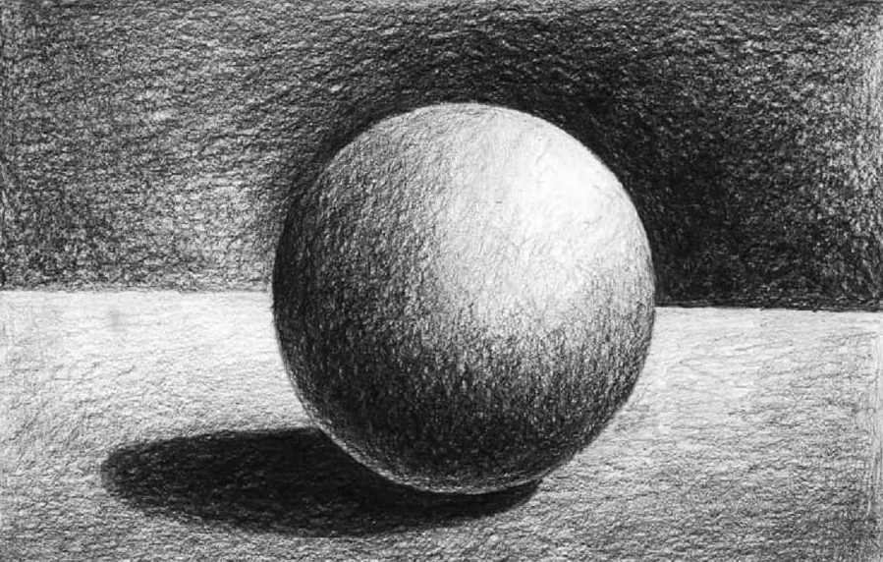
C
B
A

- A – Highlight
- B – Core shadow
- C- Cast shadow

SECTION B (25 marks)
Answer all the questions in this section in the spaces provided.

- a) Identify two elements of an emblem (2marks)

- Shape (Pictorial image)
- Colour

- Explain three key stages in layout process of design (3marks)
- Thumbnails
- Roughs
- Comprehensives

- a) Explain the term sizing as applied to weaving (1mark)

- Application of a protective coat on yarns
- Highlight four reasons for sizing yarn during the process of weaving (4marks)

- To reduce abrasion
- To strengthen yarns
- To prevent breakage of yarns
- To reduce hairiness

- Study the painting below and answer the questions that follow:

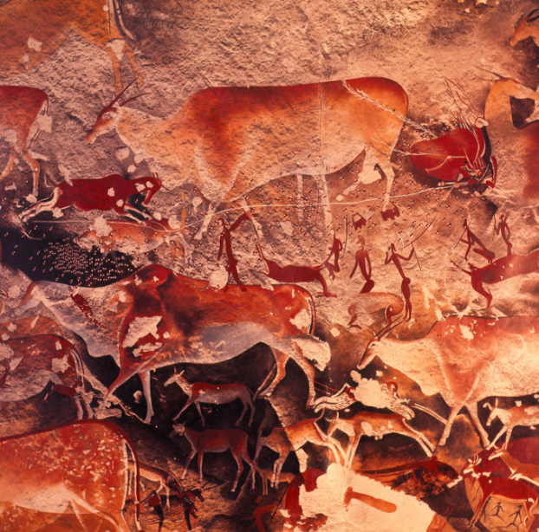

- Identify the type of painting (1mark)
- Rock/ cave painting

- State four characteristics of the painting above (4marks)

- Consisted of hunting scenes/ human and animal forms
- Sketch figures
- Done using natural earth colours
- Superimposed paintings- i.e new paintings were done over old paintings

- In the space provided below, create a composite pattern using the image below (4marks)

Z

- Complete the table below (6 marks)

Symbol | Identity/ Type | Function
 | Road sign | No waiting
 | Disability sign | Braille
 | Environmental sign | Do not dispose in ordinary bin

SECTION C (15 marks)
Answer any one question in the spaces provided after question 9.

- a) Identify three causes of pinholes on a printing screen (3marks)
- Dust/dirt on the screen
- Poor handling of the screen
- Poor application of the blocking medium ( e.g wax)

- You have been provided with two colours of printing ink. Discuss the process of creating a three colour
print using the block out method in screen printing. (12 marks)
- Draw/ Sketch design
- Gather tools & materials
- Trace design on screen
- Apply blocking medium on the screen accordingly
- Prepare printing surface
- Register the design
- Lay screen on printing surface
- Apply ink of first colour and pull with the squeegee
- Allow ink to dry
- Clean the screen to remove remains of first colour
- Place the screen partially covering the first print (overprinting)
- Apply second colour and pull with squeegee
- Leave to dry
- Press with hot iron to finish

- a) Explain the term Engobe as applied to pottery (1mark)

- Application of white or colored slip to pottery for decoration or to improve the surface texture

b) Describe three techniques of wedging clay (6marks)

- Spiral wedging-
- Rams head

c) Using Illustrations discuss four techniques of hand building in pottery (8marks)
- Pinch
- Slab
- Coil
- Scoop
- Pellets
- Ball

- a) Identify three types of reliefs in sculpture making (3marks)
- Bas relief
- Inverse/intaglio relief
- Raised relief
b) Discuss the process of creating a sculpture in the round using plaster of Paris (12marks)

- Sketch the design
- Gather tools & materials
- Prepare an armature
- Mix plaster with water
- Apply the paste on armature
- Continue apply until the whole structure is covered
- Add details
- Refine details
- Allow to dry
- Smoothen by sanding
- Apply colour to finish (optional)

