NAME …………………….. CLASS…….ADM NO………………
DATE…………………………… CANDIDATES SIGN………..
231/2
BIOLOGY
PAPER 2
(THEORY)
DECEMBER 2021
Time: 2 HOURS

SUKELLEMO JOINT MOCK EXAMINATION
Kenya Certificate of Secondary Education
Instructions to candidates
- Write your name and admission number in the spaces provided.
- Answer ALL the questions in section A in the spaces provided.
- In section B answer question 6 (compulsory) and either question 7 or 8 in the spaces provided after question 8.

For Examiners use only
SECTION | QUESTIONS | MAXIMUM SCORE | CANDIADTES SCORE
A | 1  2  3  4  5 | 8  8  8  8  8
B | 6  7  8 | 20  20  20
TOTAL SCORE

SECTION A (40 marks)
Answer all the questions in this section in the spaces provided.

- Below is a diagram showing part of human digestive system.

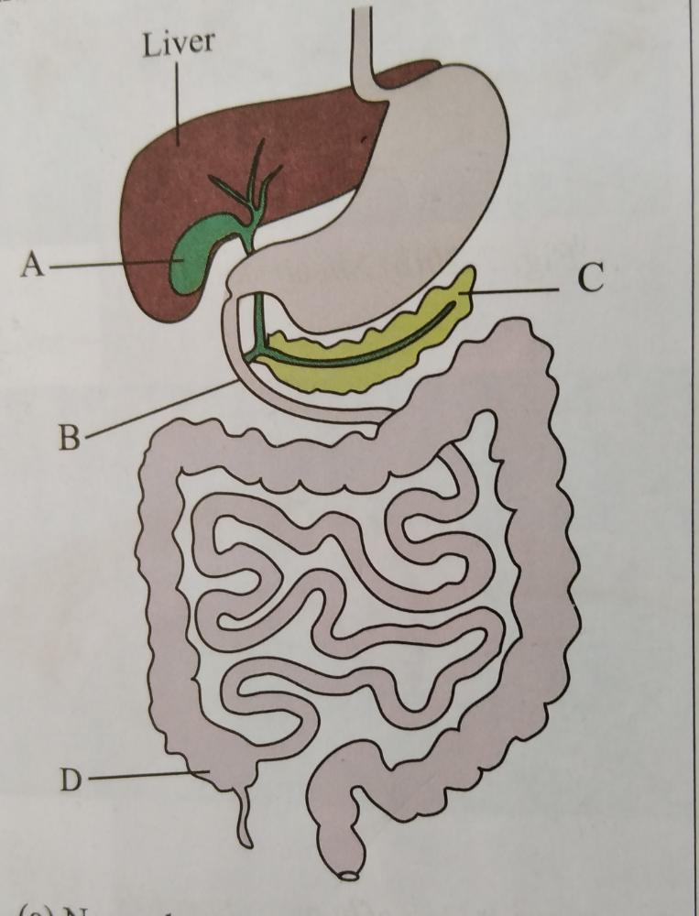

- Name the parts labelled B and C. (2mks)
B………………………………………………………………………………………………………
C………………………………………………………………………………………………………
- (i)Name the substance produced by the part labelled A. (1mk)

(ii) State the function of the substance named in (b)(i) above. (1mk)
………………………………………………………………………………………………………………………………………………………………………………………………………………………………………………………………………………………………………………………………
- What is the functional relationship between the part labelled A and the liver. (1mk)
……………………………………………………………………………………………………………………………………………………………………………………………………………………
- The part labelled D is poorly developed in humans. Name the group of mammals in which it is well developed and describe its role. (3mks).
…………………………………………………………………………………………………………………………………………………………………………………………………………………………………………………………………………………………………………………………………………………………………………………………………………………………………………
- Study the diagram of the mammalian ear and answer the question that follow.
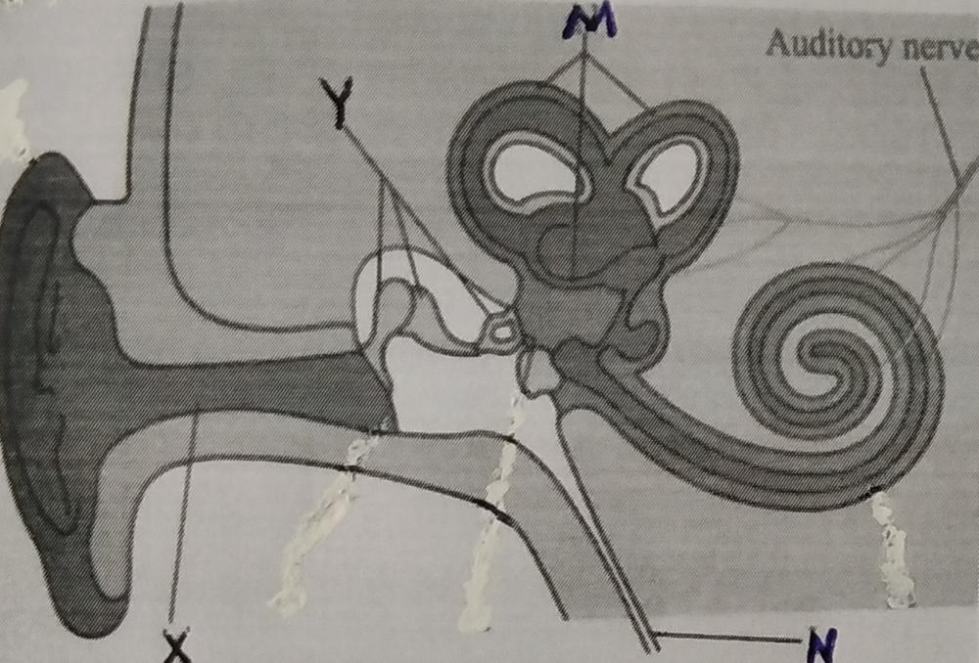

- Name the parts labelled X, Y and N. (3mks)
X………………………………………………………………………………………………
Y………………………………………………………………………………………………
N………………………………………………………………………………………………

- State how the parts labelled Y are adapted to their functions. (2mks)
………………………………………………………………………………………………………………………………………………………………………………………………………………………………………………………………………………………………………………
……………………………………………………………………………………………………
- (i) Besides hearing, state one other function of the ear. (1mk)
…………………………………………………………………………………………………….
(ii) Which of the labelled parts is responsible for the function you have stated in c(i) above. (1mk)
……………………………………………………………………………………………………………………………………………………………………………………………………………………

- What would happen if the auditory nerve is completely nerve is completely damaged? (1mk)
……………………………………………………………………………………………………………………………………………………………………………………………………………………………………………………………………………………………………………………………………………………..
- In human beings, the allele for a curved thumb (T) is dominant over the allele for a straight thumb (t).
- State the possible genotypes of individuals who have curved thumbs. (2mks)
……………………………………………………………………………………………………………………………………………………………………………………………………………………………………………………………………………………………………………………………………………………….
- Work out the genotypic and phenotypic ratio of a cross between a heterozygous male and a female with a straight thumb. (5mks)

- What is mutation? (1mk)
……………………………………………………………………………………………………………………………………………………………………………………………………………………………………………………………………………………………………………….

- The diagram below shows part of a longitudinal section of a young root.

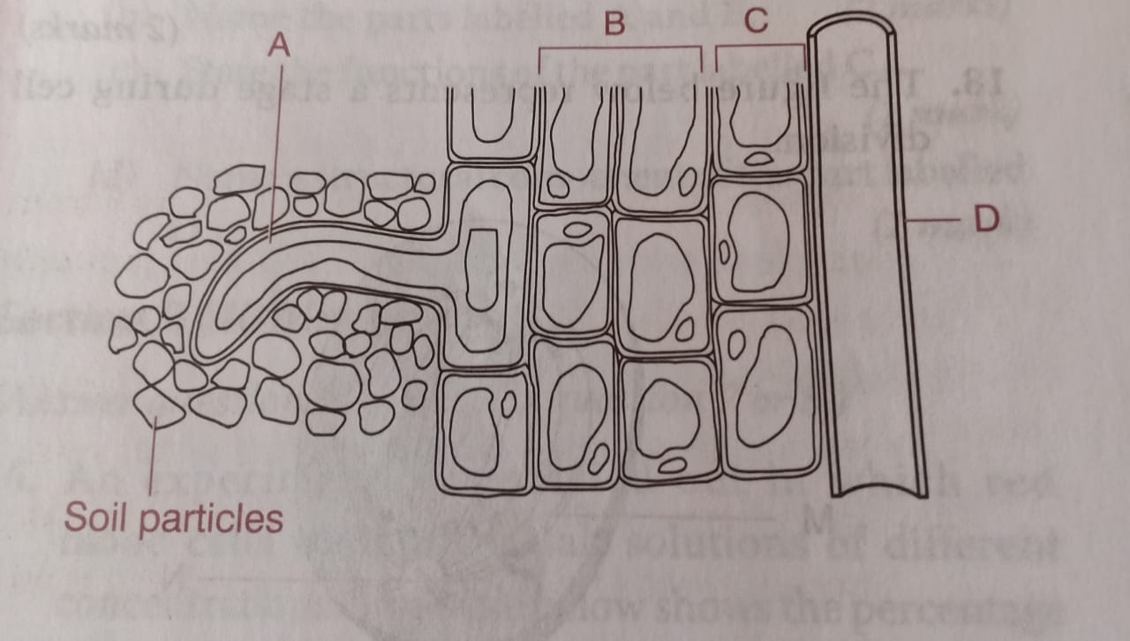

- Name the parts labeled: (2mks)
B ……………………………
C…………………………….

- State the significance of cell A. (1mk)
………………………………………………………………………………………………………………………………………………………………………………………………………………………………………………………………………………………………………………
- Explain how water from the soil reaches tissue D. (4mks)
…………………………………………………………………………………………………………………………………………………………………………………………………………………………………………………….…………………………………………………………………………………………………………………………………………………………………………………………………………………………………………………………………………………………………………………………………………………………………………………………………………………………………………………………………………………………………………………………………………………………………………………………………………………………………………………………………………………………………………………………………………
- State one adaptation of part D to its function. (1mk)
…………………………………………………………………………………………………………………………………………………………………………………………………………………………………….

- A student obtained a piece of petiole of pumpkin leaf and split it lengthwise into two halves. She placed one of the split in solution A and the other one in solution B. After 30 minutes she observed that the split in solution A was firm, rigid and curved outwards while the one in solution B was soft, flabby and curved inwards.
  - Account for the observations made for the split in A and B.
A (3mks)
…………………………………………………………………………………………………………………………………………………………………………………………………………………………………………………………………………………………………………………………………………………………………………………………………………………………………………………………………………………………………………….………………………………………………………………………………………………….………………………………………………………………………………………………………………………………………………………………………………………………………………….

B (3mks)
……………………………………………………………………………………………………………………………………………………………………………………………………………………………………………………………………………………………………………………………………………………………………………………………………………………………………………………………………………………………………………………………………………………………………………………………………………………………………………………………………………………………………………………………………………………………………………………………………………………………………………………………………………………………………………………………………………………
(b) State two roles of the process that was being investigated in this experiment. (2mks)
…………………………………………………………………………………………………………………………………………………………………………………………………………………………………………………………………………………………………………………………………………………………………………………………………………………………………………………………………………

SECTION B (40 marks)
Answer question 6 (compulsory) and either question 7 or 8 in the spaces provided after question 8.
- The data provided below represent the growth of a pollen tube of a certain plant species over a given time.
Time in minutes | 0 | 30 | 60 | 90 | 120 | 150 | 180
Growth in millimetres | 0 | 1.8 | 2.8 | 6.2 | 9.0 | 10.2 | 10.4

Draw a graph of growth of pollen tube against time. (6mks)

- (i) At what intervals was the growth of the pollen tube measured. (1mk)
…………………………………………………………………………………………
(ii) At what time was the length of the pollen tube 7.8mm? (1mk)
………………………………………………………………………………………….
(c) With reasons describe growth pattern of the pollen tube between:
(i) 0 to 120 minutes (1mk)
…………………………………………………………………………………………………………………………………………………………………………………………………………………….
Reason (1mks)
………………………………………………………………………………………………………………………………………………………………………………………………………………………………………………………………………………………………………………………………
- 120 to 180 minutes (1mk)
…………………………………………………………………………………………………………………………………………………………………… ……………………….
Reason (1mks)
……………………………………………………………………………………….
…………………………………………………………………………………………
…………………………………………………………………………………………
(d) Apart from nutrients, state two factors that affect the growth of pollen tube. (2mks

- State two functions of the pollen tube. (2mks)
…………………………………………………………………………………………………………………………………………………………………………………………………………………………………………………………………………………………………………………….……………………………………………………………………………………………………………………………………………………………………………………………………………………………….
- Describe what happens when the pollen tube enters the embryo sac. (4mks)
…………………………………………………………………………………………………………………………………………………………………………………………………………………………………………………………………………………………………………………………………………………………………………………………………………………………………………………………………………………………………………………………………………………………………………………………………………………….………………………………………………………………………………………………………………

7. (a) Define the following terms: (3mks)
- Excretion
- Egestion
- Secretion
(b) Describe how urea is formed in the human body. (7mks)
(c) Explain the various methods of excretion in plants giving examples of waste product in each case.
(10mks)
8. (a) Why is locomotion important to animals? (4mks)
(b) Explain how a finned fish is adapted to swimming. (16mks)
…………………………………………………………………………………………………………………………………………………………………………………………………………………………………………………………………………………………………………………….……………………………………………………………………………………………………………………………………………………………………………………………………………………………………………………………………………………………………………………….……………………………………………………………………………………………………………………………………………………………………………………………………………………………………………………………………………………………………………………………………………………………………………………………………………………………………………………………………………………………………………………………………………………………………………………………………………………………………………………………………………………………………………….…………………………………………………………………………………………………………………………………………………………………………………………………………………………………………………………………………………………………………………….…………………………………………………………………………………………………………………………………………………………………………………………………………………………………………………………………………………………………………………………………………………………………………………………………………………………………………………………………………………………………………………………………………………………………………………………………………………………………………………………………………………………………………….……………………………………………………………………………………………………………………………………………………………………………………………………………………………………………………………………………………………………………………….…………………………………………………………………………………………………………………………………………………………………………………………………………………………………………………………………………………………………………………………………………………………………………………………………………………………………………………………………………………………………………………………………………………………………………………………………………………………………………………………………………………………………………………………………………………………………………………………………………………………………………………………………………………………………………………………………………………………………………………………………………………………………………………………………………………………………………………………………………….…………………………………………………………………………………………………………………………………………………………………………………………………………………………………………………………………………………………………………………….……………………………………………………………………………………………………………………………………………………………………………………………………………………………………………………………………………………………………………………….……………………………………………………………………………………………………………………………………………………………………………………………………………………………………………………………………………………………………………………………………………………………………………………………………………………………………………………………………………………………………………………………………………………………………………………………………………………………………………………………………………………………………………….…………………………………………………………………………………………………………………………………………………………………………………………………………………………………………………………………………………………………………………….…………………………………………………………………………………………………………………………………………………………………………………………………………………………………………………………………………………………………………………………………………………………………………………………………………………………………………………………………………………………………………………………………………………………………………………………………………………………………………………………………………………………………………….……………………………………………………………………………………………………………………………………………………………………………………………………………………………………………………………………………………………………………………….…………………………………………………………………………………………………………………………………………………………………………………………………………………………………………………………………………………………………………………………………………………………………………………………………………………………………………………………………………………………………………………………………………………………………………………………………………………………………………………………………………………………………………………………………………………………………………………………………………………………………………………………………………………………………………………………………………………………………………………………………………………………………………………………………………………………………………………………………………….…………………………………………………………………………………………………………………………………………………………………………………………………………………………………………………………………………………………………………………….……………………………………………………………………………………………………………………………………………………………………………………………………………………………………………………………………………………………………………………….………………………………………………………………………………………………………………………………………………………………………………………………………………………………………………………………………………………………………………………………………………………………………………………………………………………………………………………………………………………………………………………………………………………………………………………………………

