NAME……………………………………………………..INDEX NO…………………………………
CANDIDATE’SSIGNATURE…………………………………..
231/3
BIOLOGY
Paper 3
(PRACTICAL)
November 2021
Time: 1³/₄Hours

SUKELLEMO JOINT EVALUATION TEST– 2021
Kenya Certificate of Secondary Education
(K.C.S.E)

231/3
BIOLOGY
Paper 3
(PRACTICAL)
November 2021
Time: 1³/₄Hours

INSTRUCTIONS TO THE CANDIDATES

- Sign and write your Name and Index Number in the spaces provided above.
- Answer all the questions in the spaces provided.
- You are required to spend the first 15 minutes of the1 ¾ hours allowed for this paper reading the whole paper carefully before commencing your work
- Additional pages must NOT be inserted.
- Candidates may be penalized for recording irrelevant and incorrect spelling especially of technical terms.
For Examiner’s Use Only

QUESTION | MAXIMUM SCORE | CANDIDATE’S SCORE
1 | 13
2 | 12
3 | 15
TOTAL | 40

This paper consists of 5 printed pages. Candidates should check to ascertain that all pages are printed as indicated and that no questions are missing.
1. You are provided with specimen labeled M-soaked millet. Grind them using pestle and mortar, add some water to get fine solution. Label four clean test tubes: A, B, C, and D. Put about 4ml of the solution into each of the four test tubes.
a) To solution in test tube A, add some few drops of iodine. Shake the solution to mix well. Pour some little solution onto a white tile.
(i) Record your observation. (1mk)
……………………………………………………………………………………………………………..
(ii) Account for your observations in a) (i) above (1mk)
……………………………………………………………………………………………………………..
b) Into solution in test tube B, add about 2ml of Benedict’s solution. Place it in a boiling water bath.
(i) After about 3 minutes, record your observation (1mk)
…………………………………………………………………………………….………………………..
(ii) What is your conclusion from observation in b) i) above? (1mk)
………………………………………………………………………………………………………………
- For the remaining test tubes:-
c) To test tube C, add about 3ml of solution labeled K. To test tube D, add about 3ml of solution K and about
2ml of solution labeled L. Place both test tubes C and D in a water bath. Maintain the water bath at 37 ⁰ C
Allow it to stand in the water bath for 30 minutes. After 30 minutes, remove the test tubes. Add about 2ml
of Benedicts solution to each test tube and shake well. Place the two test tubes in a boiling water bath.
After about 5 minutes record your observations in the table below (4mks)

Test tube | Observation | Conclusion
C

D

d) Account for your observations in the test tubes C and D. (2mks)
………………………………………………………………………………………………………………
………………………………………………………………………………………………………………
………………………………………………………………………………………………………………
e) i) Why was set up placed at 37⁰C? (1mk)
………………………………………………………………………………………………………………
(ii) Suggest identity of solutions K and L (2mks)
K………………………………………………… L…………………………………………………

2. You are provided with specimen D1 and D2 which are organs of two different plants. Examine them
carefully and answer the questions that follow.
(a) Name the type of fruit of each specimen
(i) Type of fruit D1 (1mk)
……………………………………………………………………………………………………………….
(ii) Type of fruit D2 (1mk)
……………………………………………………………………………………………………………….
(b) Draw and label the unopened fruit D2. (3mks)

(c) Carefully open specimen D2 and remove one seed. State two differences and two similarities between
specimens D1 and D2.
Differences (2mks)

D 1 | D2

Similarities (2mks)

………………………………………………………………………………………………………………
………………………………………………………………………………………………………………
(d) Classify D1 upto the division (2mks)
Kingdom……………………………………………………………..
Division………………………………………………………………
(e) State the method of dispersal of specimen D2 (1mk)

………………………………………………………………………………………………………………

3. The photographs below are of the same mammalian vertebra showing two views of the same bone.
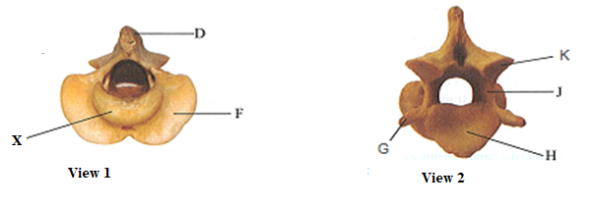
Examinethem carefully.

(a) (i) Identify the vertebra…………………………………………………………….. (1mk)

(ii) Name part X………………………………………………………………………….. (1mk)
(iii) State the function of part X (1mk)

………………………………...………………………………………………………………………….……

…………………………...…………………………………………………………….………………………
(b)State the functional difference between a tendon and a ligament (1mk)
…………………………………..…………………………………………………………………………………

…………………………………..……………………….…………………………………………………………
(c)Which of the labeled part(s) are used for articulation with an adjacent vertebra? (2mks)
…………………………………………………………………………………………………………………
(d) State a common role of the parts labeled H and J. (1mk)
……………………………………………………………………………………………………………………
(e) Which of the labeled part(s) is (are) used for muscle attachment? (2mks)
…………………………………………..……….………………………………………………………….

(f) The diagram below represents two mature parasitic worms, labelled A and B, of the species
Schistosoma mansoni that causes bilharzia

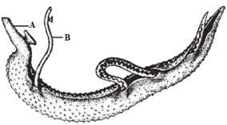

i) With a reason, identify the male and the female worm in the diagram above. (3mks)
ii) Male ………………………………………Female…………………………………
Reason………………………………………………………………………………………………………...

…………………………………………………………………………………………………………………

iii) Name two hosts, primary and intermediate, for theseparasiticworms. (2mks)
Primary host…………………………………………………………
Intermediate host…………………………………………………………………………..

iv) State two ways of controlling the spread of bilharzia. (2mks)
……….……………………………………………………………………………………………………………
……………………………………………………………………………………………………………………..

