SUKELLEMO JOINT MOCK
Kenya Certificate of Secondary Education
231/1- BIOLOGY –PAPER 1
(Theory)
Nov. 2021-2 hours
Name................................................................Adm number.....................

Candidates Signature........................................Date..................................

Instructions to candidates
(a)Write your name and admission number in the spaces provides above.
(b)Sign and write the date of examination in the spaces provided above.
(c) This section has a total number of 28 questions
(d)Answer all the questions in the space provided.
(e)This paper consist 10 printed pages
(f)Candidates should check the question paper to ascertain that all pages are printed as indicated and no questions are missing
(g)Candidates should answer all the questions in English.

FOR EXAMINERS USE ONLY
1 | 2 | 3 | 4 | 5 | 6 | 7 | 8 | 9 | 10 | 11 | 12 | 13 | 14

15 | 16 | 17 | 18 | 19 | 20 | 21 | 22 | 23 | 24 | 25 | 26 | 27 | 28

STUDENTS SCORE: TOTAL MARKS: 80 MARKS
1. Define the following terms:
(a)Phylogeny (1mark)
.........................................................................................................................
.........................................................................................................................
(b)Ontogeny (1mark)
.........................................................................................................................
.........................................................................................................................
2. Differentiate between a test cross and a back cross (2marks)
.........................................................................................................................
.........................................................................................................................
.........................................................................................................................
3. State two roles of Golgi apparatus. (2marks)
.........................................................................................................................
.........................................................................................................................

4. The diagram below represents a living organism. Study it and answer the questions that follows.
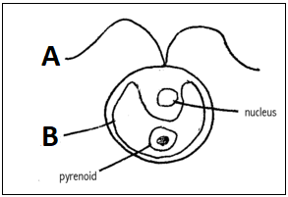

- (i)State the kingdom in which the organism belongs
(1mark)
.........................................................................................................................

(ii) Give a reason for your answer. (1mark)
..........................................................................................................................
..........................................................................................................................
(b) What is the role of structure labeled B (1mark)
.........................................................................................................................
.........................................................................................................................
5. State the role of each of the following in the mammalian respiratory system:
(a) Surfactant fluid (1mark)
.....................................................................................................
(b) Epiglottis. (1 mark)
.....................................................................................................
6. Why is it necessary for blood from the gut to pass through the liver before joining general circulation? (2 marks)
.....................................................................................................
.....................................................................................................

7. The diagram below represents a type of response in an organism use it to answer the question that follows:
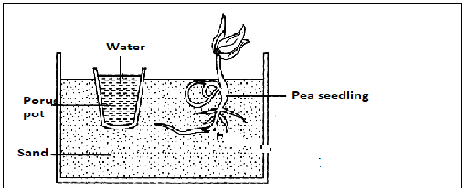
(a)State the type of response represented above (1mark)
.....................................................................................................
(b)What is the importance of the response to plants. (1mark)
.....................................................................................................
....................................................................................................
8. Identical twins were separated after birth and were then raised in different environments. One in Kenya and the other in U.S.A. They rejoined after 18 years and they looked slightly different.
(i)Name the type of variation the twins exhibited (1mark)
……………………………………………………………………………………………............

(ii)Give two observable differences likely to be noted between the twins (2marks)
……………………………………………………………………………………………………..………………………………………………………………………………………………………………………………………………………………….....................................................

9. The diagram below indicates a type of response in a given animal
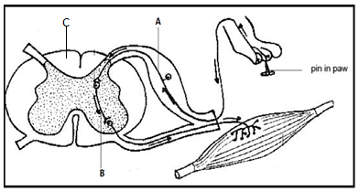
(a)Name the part labelled
A ...........................................................................................................(1mark)
(b) In the space provided below give the letter(s) that represents the part of the reflex arc that consists mainly of axons of sensory and motor neurons. (1mark)
..........................................................................................................................
(c) State the role of part labeled B. (1mark)
....................................................................................................................................................................................................................................................
10. Explain why a pregnant woman excretes less urea compared to a woman who is non- pregnant. (2marks)
.. ........................................................................................................................
.. ........................................................................................................................

1 11. The diagram below indicates an eye defect use it to answer the question that follows:
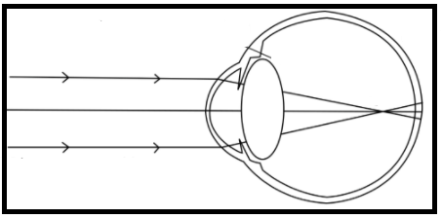
(a)Name the eye defect using the diagram given above (1mark)
.........................................................................................................................
(b)Draw a diagram that indicates how the defect can be collected (2marks)

12. What is the significance of the following processes during meiosis I?
(a) Shortening of the spindle fibres during Anaphase I (1mark)

.........................................................................................................................
(b)Chiasma formation (1mark)

.........................................................................................................................

13. The figure below shows an apparatus at the start of an experiment to investigate the digestion of an emulsion of fat droplets in water by enzyme A
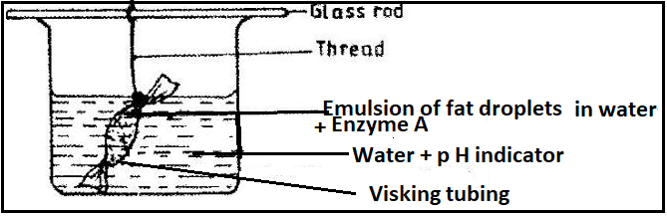
When the pH of the solution is 7 the colour of the pH indicator is green, blue when the pH is above 7 and red when below 7. The apparatus is kept at 40 degrees Celsius for 20 minutes during which time the indicator changes from green to red.
(a)Describe how the products of fat digestion enter a person’s transport system
(2marks)
.........................................................................................................................
.........................................................................................................................
(b)State the identity of enzyme A (1mark)
.........................................................................................................................
(c)Describe the process that led to the change in p H (2marks)
.........................................................................................................................
.........................................................................................................................
14. (a) Distinguish between parthenocarpy and parthogenesis. (2marks)
..........................................................................................................................
..........................................................................................................................
..........................................................................................................................

(b) State the role of juvenile hormone in insect metamorphosis. (1mark)
.........................................................................................................................

15. Explain how industrial melanism can be used to provide evidence for evolution (4marks)
..........................................................................................................................
..........................................................................................................................
..........................................................................................................................
..........................................................................................................................
..........................................................................................................................
..........................................................................................................................
..........................................................................................................................
16. What is the causative agent of the following conditions?
(a)Amoebic dysentery (1mark)
..........................................................................................................................
(b)Candidiasis (1mark)
..........................................................................................................................

17. The diagram below shows a section through the human ovary. Study it and answer the questions that Follows:
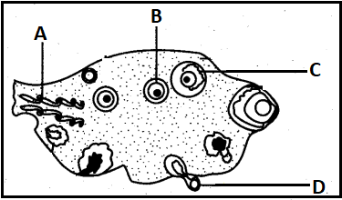
(a)Name the parts labelled A and B
A...........................................................................................................(1mark)
B...........................................................................................................(1mark)
C..........................................................................................................(1mark)
(b)Explain how the part labelled D is adapted to its function (2marks)
...................................................................................................................
...................................................................................................................
...................................................................................................................
18. Most of carbon (IV) oxide is transports from tissues to lungs within red blood cells and not blood plasma explain? (2marks)
...................................................................................................................
...................................................................................................................
...................................................................................................................
19. What is the significance of the counter current flow system in the loop of Henle? (2marks)
...................................................................................................................
...................................................................................................................
...................................................................................................................
20. The diagram below shows parts of the human skeleton. Study it and answer the questions that follow.
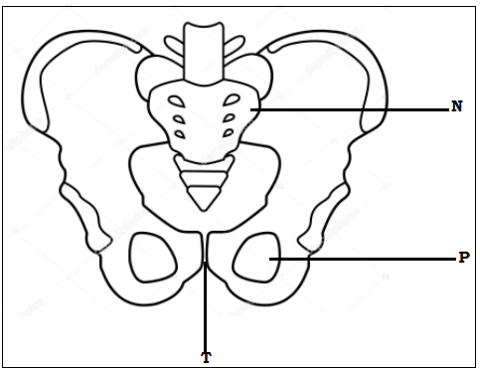
- Name the part labeled N and P (2marks)
N……………………………………………………………………………………………

P……………………………………………………………………………………………
- State the role the part marked T. (1mark)
……………………………………………………………………………………………

…………………………………………………………………………………………....

- In a mammal bone is usually made of many small fused bones. How many such bones constitute structure N of this mammal (1mark)
..............................................................................................................................

21. Examine the drawings of organisms shown below. Using features that are clearly visible, construct dichotomous key that can be used to distinguish them (4marks)
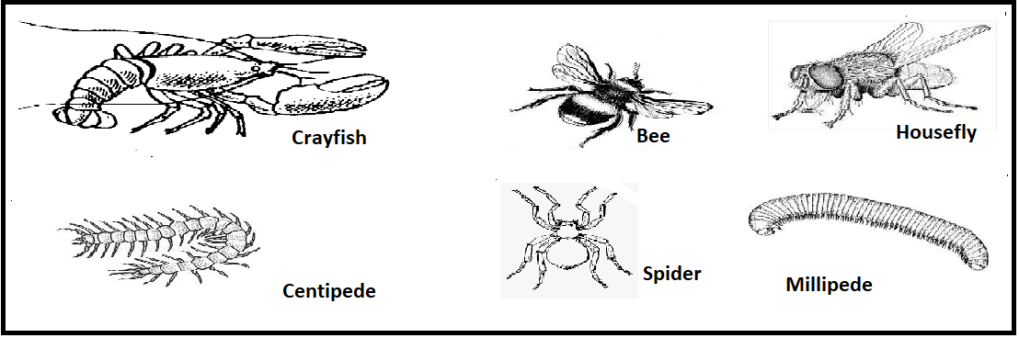
...................................................................................................................
...................................................................................................................
...................................................................................................................
...................................................................................................................
...................................................................................................................
22. Explain any two processes by through which plants excrete waste products from their bodies (2marks)
...................................................................................................................
...................................................................................................................
...................................................................................................................
23. G A C A G U A C represents the base sequence of a segment of nucleic acid.
(a)Which nucleic acid does the above segment represent? (1mark)
...................................................................................................................
(b)Give a reason for your answer in (a) above (1mark)
...................................................................................................................

(c)Write down the complementary base sequence of the strand (1mark)
...................................................................................................................
24. State two differences between Krebs cycle and Glycolysis. (2marks)

....................................................................................................................
....................................................................................................................
.....................................................................................................................
.....................................................................................................................
25. The images shown below were taken from a given experiment whose objective was to determine germination using given seed that was subjected into various suitable conditions. Use the images given below to answer the questions that follows:
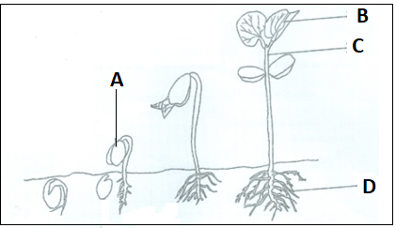
(a)Name the parts labelled C (1mark)
...................................................................................................................
(b)What is the function of the part labelled D (1mark)
...................................................................................................................
(c)Name the type of germination above (1mark)
...................................................................................................................

(d)Explain how the part labelled A is carried above the soil level (2marks)
...................................................................................................................
...................................................................................................................
...................................................................................................................
26. An elephant weighing 2000Kg requires 3000kJ per gram body weight while a rat weighing 100g requires 5000kJ per gram body weight. Explain
(2marks)
...................................................................................................................
...................................................................................................................
...................................................................................................................
27. Explain the fate of excess glucose in humans (2marks)
...................................................................................................................
...................................................................................................................
...................................................................................................................
28. The figure below shows the change in the population of herbivores after new animals were introduced into a new isolated habitat with abundant vegetation and no natural enemies.
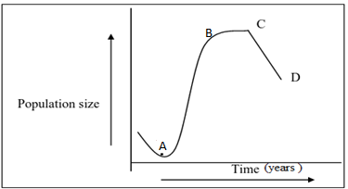
- Account for the change in population between point A and B (2marks)
………………………………………………………………………………………………………………………………………………………………………………………………………………………………………………………………………………………
- Explain one factor that maybe responsible for the change in population between point C and D. (2marks)
……………………………………………………………………………………………………………………………………………………………………………………………………………………………………………………………………………………………………………………………………………………………………………………
- What term is used to describe the change in population between point C and D. (1mark)
……………………………………………………………………………………………..

