Candidate Name___________________________ Index Number _______________________
451/2
Computer Studies – Practical
December 2021
Time 2 ½ hours
Kenya Certificate of Secondary Education
Sukellemo Joint Evaluation Mock
Instruction to the candidates
- Write your name and index number on the CD/Removable disk provided
- Answer all the questions
- Passwords must not be used while saving any file
- All files generated must be transferred to the removable storage disk provided
- Hand in the printouts and the removable storage disk provided at the end of the exam

Question 1
- Use a suitable DTP software to create a new publication named Delivery note1 (1 mark)
- Set the page layout to A4 portrait (1 marks)
- Create the delivery note as it appears on Figure 1 (41 marks)
- Fill in the heart symbol in dark blue (1 mark)
- The logo is in orange color (1 mark)
- Table border color is light blue (1 mark)
- Use font size 11 Bell MT font type (1 mark)
- Fit two copies on a new blank page. Save it as Delivery note 2 (2 marks)
- Print delivery note 1 and delivery note 2 (2 marks)
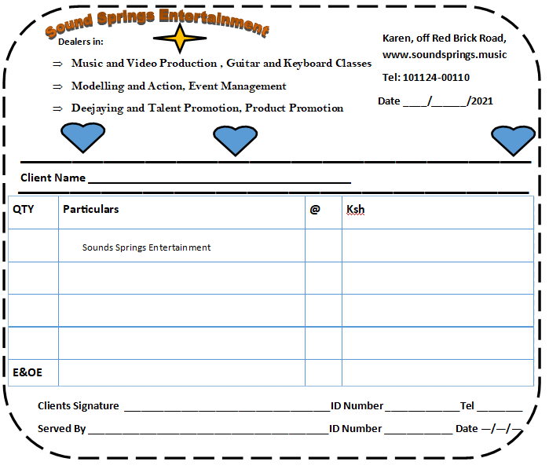
Figure 1

Question 2
Study the following data carefully and use it to answer the questions that follow.
Suppliers Table
Supplier Id | Supplier Name | Supplier Location | Supplier Contact
S1 | Timeline | CBD | 012101210
S2 | Super | Thika | 142145452
S3 | Mjengo | Dargoretti | 145213452
S4 | Hardline | CBD | 451454214
S5 | Effort | Westlands | 471200124
S6 | Mountain | Karen | 415422540

Products Table
Product Code | Product Name | Supplier ID | Unit price (sh)
P1 | Cement | S1 | 550
P2 | Sand | S2 | 12500
P3 | Ballast | S1 | 15000
P4 | Nails | S4 | 150
P5 | Pipes | S1 | 80
P6 | Iron sheets | S6 | 750
P7 | Putty | S5 | 450
P8 | Wheelbarrow | S2 | 4500
P9 | Metallic beams | S2 | 980
P10 | Binding Wires | S3 | 350
P11 | Sand Paper | S1 | 150
P12 | Paint | S3 | 6500
P13 | Sockets | S6 | 450
P14 | Screws | S5 | 20

Customers table
Customer Code | Customer Name
C1 | Kenya High
C2 | Moi Girls
C3 | Tripple S
C4 | Lenana School
C5 | Light School

Sales table
Transaction Code | Date of purchase | Customer Code | Product code | Number bought
T1 | 1/29/2021 | C3 | P8 | 5
 | 1/29/2021 |  | P9 | 12
 | 1/29/2021 |  | P10 | 21
T2 | 2/3/2021 | C5 | P2 | 5
 | 2/3/2021 |  | P3 | 8
 | 2/3/2021 |  | P4 | 7
 | 2/3/2021 |  | P2 | 9
T3 | 2/15/2021 | C1 | P1 | 10
T4 | 1/17/2021 | C3 | P2 | 2
T5 | 1/31/2021 | C2 | P2 | 1
 | 1/31/2021 |  | P1 | 1
T6 | 3/14/2021 | C5 | P5 | 4
T7 | 3/14/2021 | C4 | P4 | 2
 | 3/14/2021 |  | P5 | 8
 | 3/14/2021 |  | P6 | 7

- Create a database and name it sales (1 marks)
- By choosing appropriate data types and primary keys, crate table to hold data for products, suppliers, customer and sales (8 marks)
- Establish relationships amongst the tables (2 marks)
- Validate the following fields as shown: (3 marks)
Field | Validation
Unit price | Greater than 10
Number bought | Greater than 1
Date of purchase | Less or equal to 01/04/ 2021
- Create data entry forms for each table. On each form place a command button for
Create: (12 marks)
- Create new record
- Save record
- Delete record
- Close form
NB: The forms should be named
- Customer Form
- Supplier Form
- Sales Form
- Product Form
- Using the forms, enter the data shown above in the table (8 marks)
- Create a query named Customer_L to extract customer name and product code for customers whose name start in letter “L” (2 marks)
- All products were supplied on 01/01/2021. Create a query called Stock_days to show product code, product name and the number of days the between date of stock purchase and sale of stock (3 marks)
- Create a query called product_sales to show; Supplier name, product name, unit price and number bought and the total amount of sales from each product. (4 marks)
- Based on query named product_sales create a report named Sales_Report with the following.
(5 marks)
Group it on product name
Show the total units sold
Total sales
- Print the three queries and the report (3 marks)

