GEOGRAPHY PAPER 1 MARKING SCHEME
SECTION A
ANSWER ALL QUESTIONS IN THIS SECTION
1ai. What is a galaxy? (2m)
A galaxy is a group/cluster of stars within the universe. (2X1=2m)
ii. Geomorphology is a branch of Physical Geography that deals with landforms. (1m)
b. How does Geography encourage time management? (2m)
During fieldwork studies students draw up work schedules that trains them in management of time. (2X1=2m)

2a.The diagram below shows a volcanic feature. Study it and answer the questions that follow. 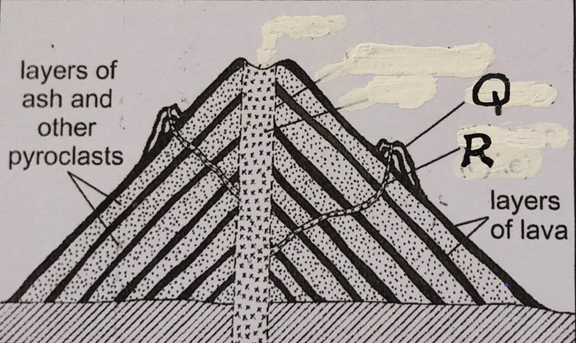
i. Identify and name the feature. (1m)
Composite /Strato/Stratified/Complex volcano (1X1=1m)
ii. Name the parts marked Q and R. (2m)
L- Dyke (1X1=1m)
M- Conelet (1X1=1m)
b. Differentiate between a laccolith and a sill. (2m)
A laccolith is a shallow mushroom shaped intrusion of magma/igneous rock inside the earth’s crust while /whereas a sill is a horizontal intrusion of magma/igneous rock along the bedding plane in between the rock strata. (2X1=m)

3a. what does the term ‘mixed stand of trees’ mean when describing characteristics of vegetation. (2m)
- The forests consist of mixed species of trees
b. State three examples of temperate grasslands and where they are found. (3m)
- The pampas of Argentina
-The prairies of North America
-The Steppes of Eurasia
-The downs of New Zealand and Australia
-The veldt of South Africa (1X3=3m)
4a. Differentiate between steam fog and orographic fog. (2m)
-Steam fog is formed when cold air passes over a warm fresh water body; as warm water is cooled it appears to be steaming from above while /whereas orographic fog forms when warm moist air is forced up a mountain and is cooled to dew point to form tiny water droplets. (2X1=)
b. Identify and name three types of cold climate. (3m)
-Cold/Cool temperate continental/Interior/Siberian
Cold/Cool temperate Eastern margin/Laurentian/Cool temperate coast
-Cold/Cool temperate Western margin/British type/European type
-Tundra/Polar/Ice cap/Very cold climate (1X3=3m)
5a. identify and name two types of chemical weathering. (2m)
- Solution
-Carbonation
- Hydration
- Oxidation
-Hydrolysis
b. State three significance of weathering. (3m)
- Weathering leads to breakdown of rock mass into smaller fragments leadig to formation of soil.
- Weathering weakens rocks making it easier for exploitation by quarrying or mining
- Some weathered rocks like granitic tors are fascinating and act as tourist attraction earning the country foreign exchange
- Weathering produces natural resources like clay which is used in making bricks.
SECTION B
ANSWER QUESTION 6 AND ANY OTHER TWO QUESTIONS FROM THIS SECTION
- Give the magnetic declination of the map . (1mk)
2° 21’
- Identify one human feature in grid square 3533. (1mk)
-settlements
- Give six-grid reference of the chief’s house near Funyula market (2mks)
256313 /257314
- Give the height of Burenda Hill.(2mks)
1460 meters
- Find the direction and bearing of Bujumba School from Odiado market. (3mks)
b) Describe the relief of the area covered by the map. (4mks)
- presence of hills such as Burende ndanyi Odiado
- Aridge that is Samia ridge on the southern part of the area covered by the map
- The northern part of the area covered by the map is plain shown by the presence of widely spaced contours.
- The highest height in the area covered by the map is 1560 meters the odiado hill.
- The lowest height is 1120 meters on north western part of the area covered by the map
c) Reduce by half the area enclosed by easting 27 and 34 and northing 30 and 38. (3mks)
On it mark and name
- Riverine trees (1mk)
- Air photo principal point(1mk)
- all weather road bound surface C526(1mk)

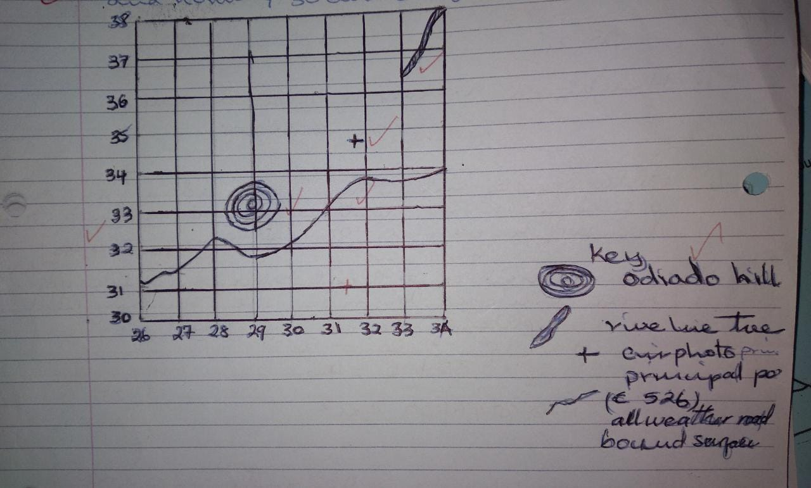

d) Citing evidence from the map, explain three factors influencing trade in the area covered by the map. (6mks)
- Means of transport evidenced by all weather roads loose surface and all weather roads bound surface which makes movements of good easy
- Dense settlements shown by very many dots which are well distributed in the southern part of the area covered by the map providing market for the goods
- Presence of goods such as cotton that is grown in the area shown by cotton stores.
2mks each if evidence, factor and is explained,
no mark if the tree are not given

Q7. a) i) What is a limb in a fold? (2mks)
Rock layers on both sides of the axis that slope in opposite directions (2mk)
ii) Explain how Fold Mountains are formed according to convectional theory (3mks)
- when convectional currents in the mantle move horizontally they cause a frictional pull on the crustal rocks
- when continental coasts are pulled towards each other due to those currents
- the sediments between the coats are squeezed to form fold mountains
b) i) Differentiate between orogeny and orogenesis(2mks)
Orogeny refers to the fold mountain building period while/ whereas oregenesis refers to the process of fold mountain formation
ii) State three factors influencing folding of sedimentary rocks. (3mks)
- Intensity/ strength of compressional force influences the folding of sedimentary rocks. The greater the intensity the more the sedimentary rocks fold.
- Nature/ elasticity of crustal rocks
- Movement equal or unequal strength/ type of earth movement
- The amount of temperature within the rocks
c) i) Use the world map provided and answer the questions that follow.
Name mountain ranges marked U, V, W, X, Y and Z (6mks)
U- Himalayas
V- Ural
W- Akwapim Hills
X- Andes
Y- Appalachians
Z- Rockies

ii) Draw a well labeled diagram of anticlinorium and synclinorium (3mks)

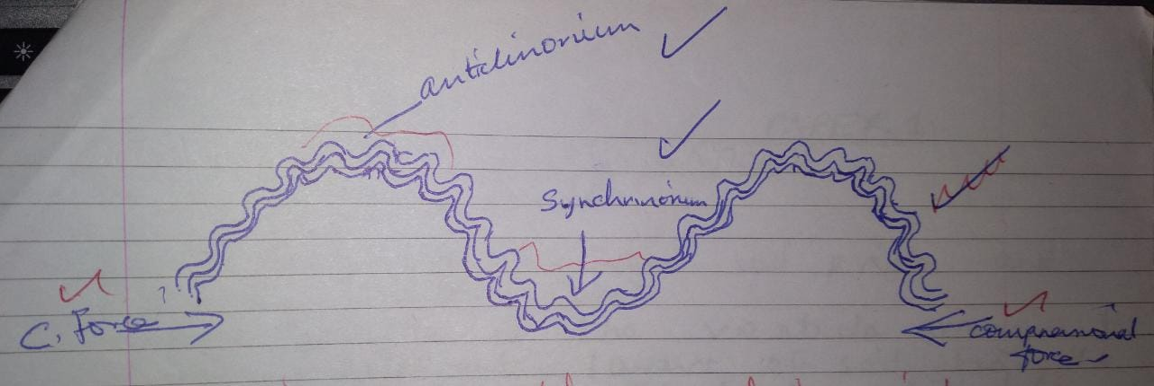

d) Explain three ways in which fold mountains influence climate in a region. (6mks)
- Fold mountains receive heavy rainfall on the windward slope while leeward slopes receive very little rainfall
- In the northern hemisphere the south facing slopes of fold mountains experience higher temperatures compared to the north facing slopes. In the southern hemisphere the north facing slopes have higher temperature than the south facing slopes.
- Temperature inversion occurs in the lowland valleys therefore they are cooler than the higher slopes of fold mountains
- Some fold mountains have very high attitude resulting in very low temperatures and are permanently covered with snow eg. The alp
- 2mks if well explained max 6

Q8ai. Define endogenic processes. (2m)
- These are internal land forming processes. (2X1=2m)
ii. State three causes of earth movements. (3m)
- Movement of magma within the earth’s crust occurs through a line of weakness and invades the rocks. The magma occupies space and displaces the rocks which move vertically or horizontally.
- Gravitative pressure; when large quantities of magma escape from the mantle large voids/cavities are left behind. The force of gravity acts on the rocks above the cavities pulling them inwards to fill up the voids causing earth movements.
- Convectional currents in the mantle move in a circular manner exerting a frictional drag on the crustal rocks above, this causes horizontal movement.
- Isostatic adjustment occurs when the state of balance between sial and sima is distorted by erosion from the continents and deposition in the sea bed. This adjustment causes movements.
(1X3=3m)
bi. Apart from the jigsaw fit of continents name three evidence that support the continental drift theory. (3m)
- Distribution of ancient climate/ancient glacial deposits/Paleoclimate
-Location of coalfields/Climatology
- Crustal separation of the red sea/
- Geological structure
-Paleontological evidences
- Mid-Atlantic Ridge
- Paleomagnetic studies
- Sea floor spreading
(1X3=3m)

ii. According to the plate tectonics theory explain what happens along the compressional boundary. (6m)
- When a continental plate and another continental plate move towards each other, they collide or crush against each other resulting in destruction of materials at the edges to form Fold Mountains.
- When an oceanic plate meets a continental plate, the dense oceanic plate sinks beneath the continental plate in a movement called subduction to form an ocean trench
- The sediments on the ocean floor in the region of subduction may be compressed to form Fold Mountains.
(2X3=6m)
c. Below is a diagram showing a plate boundary. Study it and answer the questions that follow.
i. identify and name the type of boundary. (1m)
- Conservative /Transform fault/Transcurrent boundary (1X1=1m)
ii. Give an example of such a boundary. (1m)
- San Andreas fault (1X1=1m)
iii. State three negative effects of movement along the boundary on the human environment. (3m)
- The movement triggers earthquakes that cause the destruction of life and property
- The vertical and lateral displacement of rocks damages transport and communication lines, gas and water pipes, oil pipes.
- Parts of the sea floor can be raised or lowered leading to mass flooding of coastal regions
- When earthquakes occur on the sea floor, huge destructive sea waves called Tsunamis cause severe flooding to coastal regions.
(1X3=3m)

d. Explain three positive significance of plate tectonics. (6m)
- Plate tectonics is associated with the formation of Fold Mountains that receive high rainfall leading to the development of forests that are exploited to earn revenue.
- Plate tectonics leads to plate convergence which causes metamorphism resulting to the formation of precious minerals exploited to earn revenue.
- Plate tectonics is associated with volcanic activities; this may lead to the formation of hot water springs and geysers. This is harnessed for geothermal energy/may have medicinal value (spas)
- Plate tectonics is associated with the formation of features eg fold mountains/rift valley which attract tourists and earn foreign exchange
- Plate tectonics associated with volcanic activity results in volcanic rocks that are weathered to form fertile volcanic soils that support agriculture.
(2X3=6m)

Q9ai. Define the term coast. (1m)
- A coast is a strip of land which borders the sea under the direct influence of the waves. (1X1m)
ii. The diagram below shows some relief features of the ocean floor, study it carefully and use it to answer the questions that follow
ii. Identify the features labelled H, I and J. (3m)
H - Continental slope
I - Oceanic Island
J - Oceanic deep
b. Name three processes by which waves erode. (3m)
- Corrasion
- Hydraulic action
- Solution
- Attrition

c. With aid of well labelled diagrams, explain how an Atoll is formed. (5m)
d. The diagram below represents a coastal landscape. Identify the features marked K, L M. (3m) 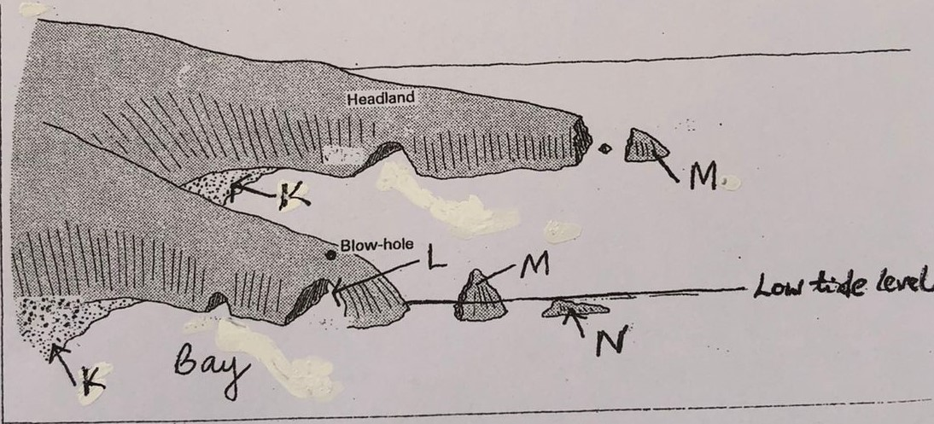
K - Beach
L - Arch/window
M - Stack
e. Form 4 students form a school carried out a field study on coastal features found along the coast of Kenya
i. Name three features as a result of coastal emergence that they are likely to have studied. (3m)
- Raised cliffs
- Raised wave-cut platform
- Raised beaches
- Emerged lowland coasts/coastal plain
ii. State three methods the students used to record their data. (3m)
- Taking photos of the coastal features
- Taking notes of the coastal features
- Drawing sketches of the coastal features
- Drawing a map of the location of the coastal features.
(1X3=3m)
iii. Describe two ways in which features resulting from coastal submergence are of significance to Kenya. (4m)
- Rias formed as a result of costal submergence provide deep natural harbor’s for shipping and sheltered bays for ports eg at kilindini harbor
- They form lowland coast providing room for the development of urban centers eg Mombasa
10. a i) Name 3 types of glaziers. (3 marks)
- Cirque glacier.
- Piedmont glacier.
- Continental glazier
- Valley glazier.
- State 3 factors influencing ice movements (3 marks)
- Gradient of the land.-Ice moves faster on steeper slopes than gentle slopes.
- Season- ice moves faster during summer than winter due to thawing.
- Friction- center part of glacier moves fastest as the sides and bottom parts are slowed by resistance.
- Thickness and weight of glacier- thick and heavy mass of ice exerts more pressure reading to slight ice melt at the base causing faster movement.
(1mk each mark 3)
b i)Explain 2 processes of glacial erosion. (4 marks)
- Abrasion-Rock debris embedded in glacier is used as a grinding/scouring tool.
- Plucking/Sapping-Ice at the base and sides, the glazier freezes in cracks and crevices of rocks. It is then pulled out as a grinding tool.
- Nivation- Alternate freezing and thawing action of glaciers which leads to rocks rotting and disintegration.
(2mks each max 4)
ii) A well labelled diagram of a crag and Tail. (3 marks)
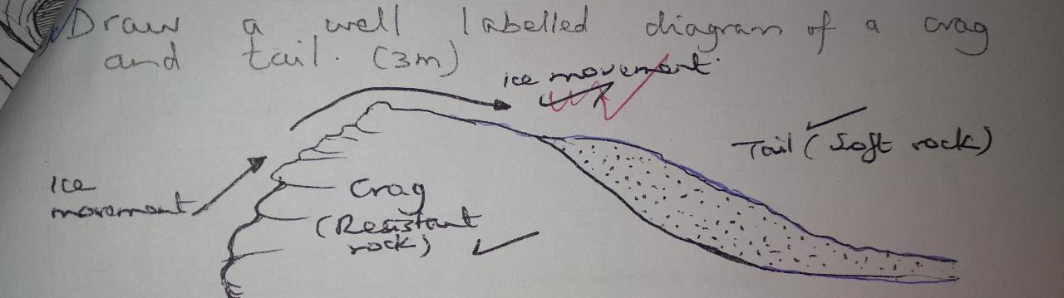
c ) With the aid of awell labelled diagram explain the process involved in the formation
of a corrie lake. (5 marks)
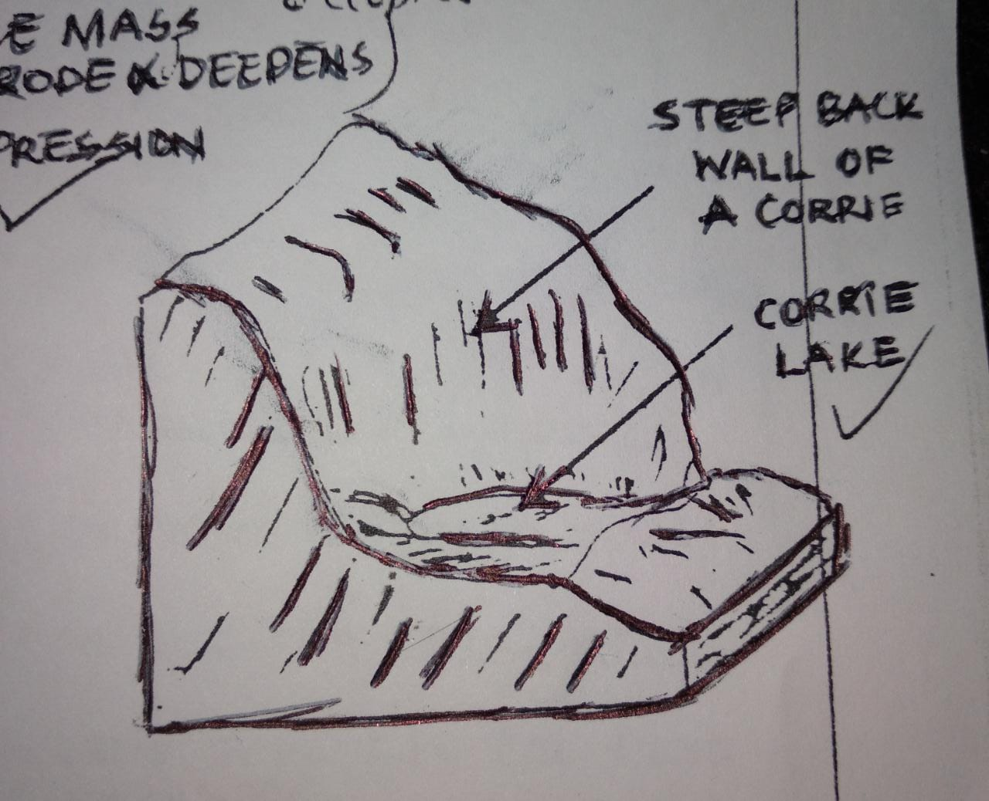
- Presence of pre-existing depression on mountain sides.
- Snow accumulates in the depression .
- The snow gets compacted into ice forming a cirque glacier.
- Frost action/alternating freeze thaw action enlarges the hollow.
- Scouring/abrasion action at the bottom of the glacier deepens the hollow.
- Plucking process steepens the backwall.
- Eventually, a deep arm-chair shaped depression known as a corrie is formed.
- When the corrie fills up with melt water/rain it forms a corrie lake
(4mk exp 1mk diagram)
d ) Students from a secondary school went out for a field study in a glaciated region in Kenya.
- Give two reasons why they would need a route map 2mks. A route map will help in;
- Identifying the direction they would take.
- Identifying the features they are likely to encounter.
- Estimating the distances they would cover.
- Estimating the time they are likely to take.
- Planning the schedule of activities.

- State 3 methods of collecting data.
- Observation.
- Taking photographs.
- Content analysis.

- Write 2 problems the students are likely to encounter;
- Altitude.
- Sickness
- Frost bite.
- Frog/mist obscures vision.
- Rugged relief/steep slopes difficult to climb.

