NAME____________________________________ CLASS____________ HOUSE____________________
312/1
GEOGRAPHY
PAPER 1
NOVEMBER 2021
TIME 2³/₄ HOURS
MOCK JOINT EVALUATION TEST
Kenya Certificate of Secondary Education (K.C.S.E)
Geography
Paper 1
INSTRUCTIONS TO CANDIDATES
- Write your name, admission number and your class in the spaces provided above
- This paper consists of two sections: A and B
- Answer all the questions in section A
- Answer question 6 and any two questions from section B
- All answer must be written in the foolscaps provided
FOR EXAMNER’S USE ONLY
QUESTION | SECTION A | 6 | 7 | 8 | 9 | 10 | TOTAL
MARKS

SECTION A
ANSWER ALL QUESTIONS IN THIS SECTION
1ai. What is a galaxy? (2m)
ii. ___________________________ is a branch of Physical Geography that deals with landforms. (1m)
b. How does Geography encourage time management? (2m)
2a.The diagram below shows a volcanic feature. Study it and answer the questions that follow. 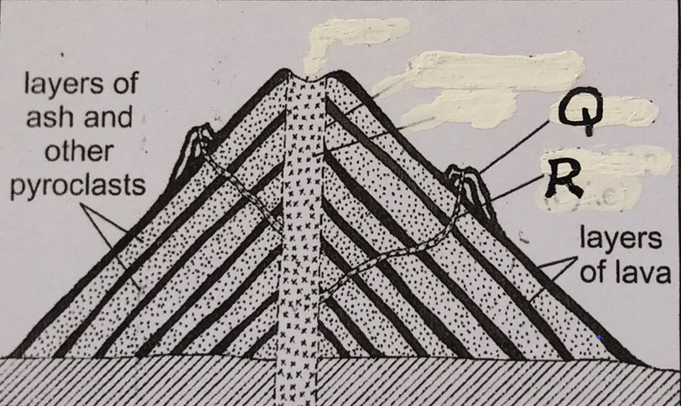
i. Identify and name the feature. (1m)
ii. Name the parts marked Q and R. (2m)
b. Differentiate between a laccolith and a sill. (2m)
3a. what does the term ‘mixed stand of trees’ mean when describing characteristics of vegetation. (2m)
b. State three examples of temperate grasslands and where they are found. (3m)
4a. Differentiate between steam fog and orographic fog. (2m)
b. Identify and name three types of cold climate. (3m)
5a. identify and name two types of chemical weathering. (2m)
b. State three significances of weathering. (3m)

SECTION B
ANSWER QUESTION 6 AND ANY OTHER TWO QUESTIONS FROM THIS SECTION
6. Study the map Busia sheet 101/1 1:50000 provided and answer the questions that follow.
i) Give the magnetic declination of the map . (1mk)
ii) Identify one human feature in grid square 3533. (1mk)
iii) Give six-grid reference of the chief’s house near Funyula market (2mks)
iv) Give the height of Busenda Hill.(2mks)
v) Find the direction and bearing of Bujuimba School from Odiado market. (3mks)
b) Describe the relief of the area covered by the map. (4mks)
c) Reduce by half the area enclosed by easting 27 and 34 and northing 30 and 38. (3mks)
On it mark and name
- Riverine trees (1mk)
- Air photo principal point(1mk)
- all weather road bound surface C526(1mk)
d) Citing evidence from the map, explain three factors influencing trade in the area covered by the map. (6mks)
Q7. a) i) What is a limb in a fold? (2mks)
ii) Explain how Fold Mountains are formed according to convectional theory (3mks)
b) i) Differentiate between orogeny and orogenesis (2mks)
ii) State three factors influencing folding of sedimentary rocks. (3mks)

c) i) Use the world map provided and answer the questions that follow.
Name mountain ranges marked U, V, W, X, Y and Z (6mks)
ii) Draw a well labeled diagram of anticlinorium and synclinorium (3mks)
d) Explain three ways in which fold mountains influence climate in a region. (6mks)
Q8ai. Define endogenic processes. (2m)
ii. State three causes of earth movements. (3m)
bi. Apart from the jigsaw fit of continents name three evidence that support the continental drift theory. (3m)
ii. According to the plate tectonics theory explain what happens along the compressional boundary. (6m)

c. Below is a diagram showing a plate boundary. Study it and answer the questions that follow.
i. identify and name the type of boundary. (1m)
ii. Give an example of such a boundary. (1m)
iii. State three negative effects of movement along the boundary on the human environment. (3m)
d. Explain three positive significance of plate tectonics. (6m)

Q9ai. Define the term coast. (1m)
ii. The diagram below shows some relief features of the ocean floor, study it carefully and use it to answer the questions that follow
ii. Identify the features labelled H, I and J. (3m)
b. Name three processes by which coasts erode. (3m)
c. With aid of well labelled diagrams, explain how an Atoll is formed. (5m)

d. The diagram below represents a coastal landscape. Identify the features marked K, L M. (3m) 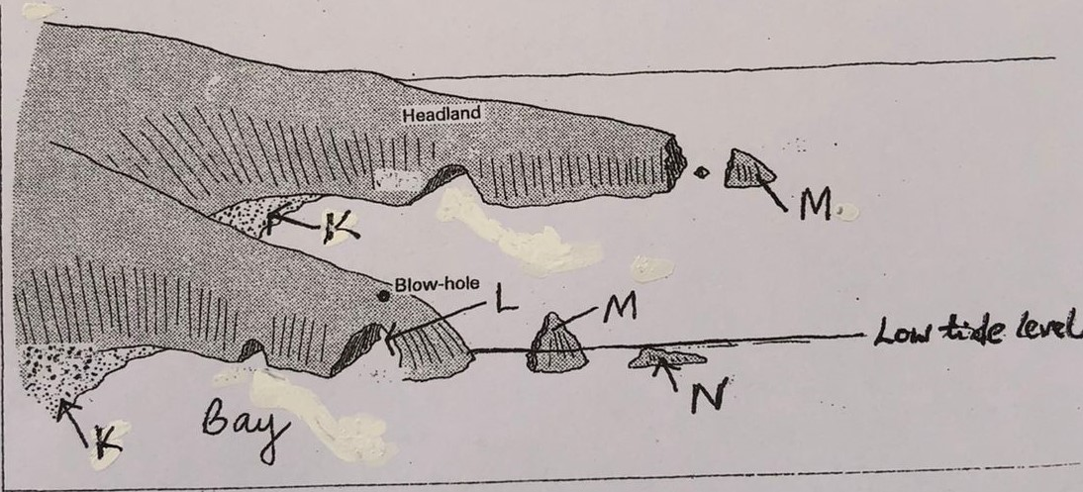
e. Form 4 students form a school carried out a field study on coastal features found along the coast of Kenya
i. Name three features as a result of coastal emergence that they are likely to have studied. (3m)
ii. State three methods the students used to record their data. (3m)
iii. Describe two ways in which features resulting from coastal submergence are of significance to Kenya. (4m)
10. a) i) Name three types of glacier. (3mks)
ii) State three factors influencing ice movement. (3mks)
b) Explain two processes of glacial erosion. (4mks)
ii) Draw a well labeled diagram of a crag and tail. (3mks)
c) With aid of a well labeled diagram, explain the processes involved in formation of a corrie lake. (5mks)
d) Students from a school went out for a field study on glaciation on Mt. Kenya.
i) Give two reasons why they would need a route map. (2mks)
ii) State three methods they are likely to use to collect data during the field study. (3mks)
ii) What two problems are the students are likely to encounter during the study. (2mks)

