JOINT MOCK EXAMINATION
MARK SCHEME
312/2
GEOGRAPHY
Paper 2
Nov./Dec. 2021
2¾ hours
SECTION A
Answer all the questions in this section.
1. (a) (i) Define Geography. (2 mark)
It is the study of the interrelationship between physical and human phenomena in
relation to the earth surface. 2 mks
(ii) Name the two branches of Geography (2 marks)
- Physical Geography
- Human Geography
- Practical Geography 2 x 1 = 2 marks
(b) State two reasons why it is important to study Geography. (2 marks)
- It provides knowledge about the immediate and the wider environment/it makes us to
- understand the earth on which we live.
- It creates awareness about the country and the rest of the world / promotes international
- understanding.
- It promotes awareness on the sustainable use of resources.
- It promotes development of skills and critical thinking.
- It prepares one for career opportunities. 2 x 1 = 2 marks

2. (a) Name two breeds of dairy cattle reared in Kenya. (2 marks)
- Guernsey
- Jersey
- Friesian
- Ayrshire
- Zebu swiss brown 2x1 = 2 marks
(b) State two factors which favour dairy farming in Denmark. (2 marks)
- well-developed co-operative movement
- Availability of market for dairy produce
- Availability of extension services
- Suitable climate/moderate temperature
- Handy fodder/ pasture
- Advanced technology/specialization
- Mechanization 2x 1 = 2 marks
3. (a) State two physical factors which influence the location of settlements. (2 marks)
- Availability of water supply/ good drainage
- Availability of land/space
- Nature of relief
- Suitability of climate/good rainfall
- Absence of pest and diseases/health environment fertile soils 2 x 1 = 2 marks
4. The diagram below shows shaft mining.
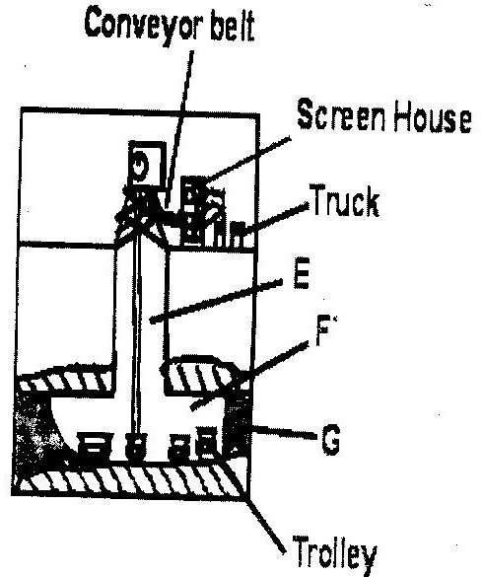

(i) Name the parts marked E, F and G. (3marks)
E- main shaft/vertical shaft
F- Tunnel/horizontal shaft/Gallery
G- Mineral ore 3 x 1 = 3 marks
(ii) State two problems associated with shaft mining. (2marks)
- Sometimes, mines get flooded with sub/terrain water.
- There are occasional emission of poisonous gases in the mines.
- The dust produced causes respiratory diseases
- Sometimes tunnels collapse causing deaths of miners. 2 x1 = 2 marks
(b) State two factors which influence the occurrence of minerals. (2 marks)
- Rate of evaporation
- vulcanicity
- metamorphism 2 x1 = 2 marks
5. (a) (i) Define the term eco-tourism. (2 marks)

- Tourism combined with conservation of the environment
- It is tourism directed towards exotic, often threatened, natural environments, intended to support conservation efforts and observe wildlife
- It is a form of tourism involving visiting fragile, pristine and relatively undisturbed natural areas, intended as a low impact and often small scale alternative to standard commercial(mass) tourism 2 marks

(ii) Name two tourist attraction found in the Rift valley province of Kenya. (2 marks)

- The varied relief features.
- Wild animals
- Birds / flamingos
- Hot springs / Geysers / Fumaroles /Geothermal
- Vegetation
- People culture
- Pre- historic sites /Historical sites e.g. Kapenguria
- Mining sites
- Sports tourism e.g. fishing 2x1= 2 marks

(b) Give two reasons why domestic tourism is being encouraged in Kenya. (2 marks)

- To make use of tourist facilities during the low tourist seasons
- In order for Kenyans to be exposed to move about their own country
- To facilitate interaction / cultural exchange among different communities and thus enhance national unity/ patriotism
- To expose people locally to produces articrafts
- To expose Kenyans to a wider variety of recreational facilities
- To create employment/ income to government or individuals

SECTION B
Answer questions 6 and any other two questions in this section.
6. Study the table below that shows crop production in Kenya between 1978 and 1982 and
answer question (a).
CROP/YEAR | 1978 | 1979 | 1980 | 1981 | 1982
Coffee | 1000 | 990 | 870 | 850 | 840
Tea | 750 | 700 | 650 | 700 | 600
Pyrethrum | 300 | 250 | 350 | 400 | 450
Cotton | 500 | 450 | 550 | 600 | 350
Crop production in 000’ kilograms

(a) (i) Using a vertical scale of 1 cm represent 500, 000 kilograms, draw a multiple line
graph to represent the data above. (8 marks)

CROP/YEAR | 1978 | 1979 | 1980 | 1981 | 1982
Coffee | 1000 | 990 | 870 | 850 | 840
Tea | 750 | 700 | 650 | 700 | 600
Cotton | 500 | 450 | 550 | 600 | 350
Pyrethrum | 300 | 250 | 350 | 400 | 450
Others | 550 | 300 | 300 | 350 | 300
Total | 3 100 000

Scale: 15 cm _______________3 100 000 Kgs
1 cm ______________ (1 x 3 100 000)/15 = 206 666.7 kgs

Coffee - (1000 000/3 100 000)x 15 = 4.839 4.8 cm
Tea – (750 000/3 100 000) x 15 = 3.629 3.6 cm
Pyrethrum- (500 000/3 100 000) x 15 = 2.419 cm 2.4 cm
Cotton - (300 000/3 100 000) x15 = 1.452 cm 1.5 cm
Others - (550 000/3 100 000) x 15 = 2.661 2.7 cm 2½ marks

A DIVIDED BAR REPRESENTING CROP PRODUCTION IN KENYA BETWEEN 1978

KEY
Coffee
Tea
Pyrethrum
Cotton
Others
Title--------------------- 1 mark
Key --------------------- 1 mark
Short line scale ------- 1 mark
Each segment--------- ½ mark 2½ marks
NB The bar/ rectangle must be 15 cm long by 2 cm (or less) wide to score.
(ii) Calculate the percentage decrease in tea production between 1978 and 1979.
(2 marks)
750,000 – 700,000 = 50,000 Kg
(50,000 ÷ 750,000) ×100% = 6.67% calculation -1 mark
Ans – 1 mark

(b) (i) Name two research stations that produce maize in Kenya. (2 marks)
- The National Research Station at Kitale
- Embu Research Station
- The Coast Agricultural Research Station – Mtwapa
- The Katumani Research Station in Makueni 2 x 1 = 2 marks
(ii) Name two common pests that attack maize in Kenya. (2 marks)
- Stalk borers
- Army worms
- Aphids
- Birds 2 x 1 = 2 mks
(c) Describe how the following conditions influence the growing of maize.
(i) Topography (3 marks)
- Gently sloping or undulating plains and plateaus favour maize growing
- The soil here is well drained and well aerated
- Gentle slopes also favour mechanization
- Steep slopes discourage mechanization and soil is not well developed 3 x 1 = 3 marks
(ii) Soils (3 marks)
- Deep and rich soil with abundant amount of nitrogen content support maize growing
- The soil should be well drained as the crop cannot tolerate waterlogging 3 x 1 = 3 marks
(d) Describe the processing of maize in Kenya. (5 marks)
- Maize is first weighed and put on trays
- Any undesirable grains and broken cobs are removed
- It is then sieved to remove any tiny impurities such as soil or rock particles
- The maize is then passed through a milling machine which grinds it into flour according to the desired grade
- It is stored in cool and dry store 5 x 1 = 5 marks
7. (a) (i) What is Agroforestry? (1 mark)
- Agro forestry is a land use system, which enables the production of trees, crops and livestock
- on a given unit of land either in spartial arrangement or/over time to maximize productivity and sustainability of the land. 1 mk

(ii) Give four reasons why afforestation is being encouraged in Kenya. (4 marks)
- To ensure continuous supply of wood fuel/timber/herbal/medicine/raw material for paper making.
- To protect the soil from erosion.
- To protect the water catchment areas/create microclimates/maintain hydrological cycle.
- To create scenic beauty.
- To expand the habitat for wildlife/conservation of wildlife.
- To create employment opportunities.
- To reduce importation of forest products/save foreign exchange. 4 x 1 = 4 mks
(b) (i) List two factors that determine the distribution of forests in Kenya. (2 marks)
- Climate / rainfall / temperature
- Aspect
- Altitude / Relief
- Soils / edaphic factors
- Animals
- Government policy
- Human Activities 2x1 = 2 mark
(b) Give three economic uses of mangrove forests.
- Provide poles for construction / furniture making
- Source of fuel

- For aqua – culture

- For export / earn foreign exchange / income

- The bark / fruits are a source of tannin 3 x 1 = 3 marks

(ii) Give two economic uses of mangrove forests. (2 marks)
- Provide poles for construction / furniture making
- Source of fuel
- For aqua – culture
- For export / earn foreign exchange / income
- The bark / fruits are a source of tannin 2 x 1 = 2mks
(c) (i) Compare forestry in Canada and Kenya under the following sub – headings.
Tree harvesting. (2 marks)
- In Canada, harvesting is done through clear cutting while in Kenya it is selective logging.
- In Canada logging is done in winter while in Kenya cutting takes place throughout the year.
- In both countries, commercial logging is mechanized. 2 mks
Transportation of logs. (2 marks)
- In Canada, logs are transported using melt water/rivers while in Kenya transportation is by road. 2 mks
N.B. Comparisons must be complete.
(d) Explain three problems that affect forestry in Canada. (6 marks)
- Accidental fires which consume large tracts of the forests reduce the area under the forests.
- The cold climate leads to trees taking too long to mature which delays harvesting time.
- Rugged landscape especially in the mountainous areas hinder smooth exploitation of the forests.
- Northern parts are inaccessible in winter due to very cold climate conditions.
- Overexploitation in some areas have created a shortage in some of the true species while taking a long time to mature. 3 x 2 = 6 mks
(e) You are supposed to carry out a field study on Agroforestry in the area around your
school.
(i) State three reasons why it would be necessary to visit the area before the day of
the study. (3 marks)

- To familiarize in order to design the appropriate research method
- To prepare the working schedule
- To be able to formulate the appropriate objectives and hypothesis
- To be able to identify relevant equipment for data collection
- To identify suitable areas for study to meet the people who will provide information during the study
- To seek permission from the owners of the land/ authorities 3 x 1 = 3 mks

(ii) Give three significance of agroforestry you are likely to identify during the study.
(3 marks)
- Some of the trees may be used as fodder for farm animals
- Some of the trees may be used for providing fruits/ roots/ vegetables/ food e.g. fruit
- Trees control soil erosion
- Use for ornamental/ Beauty/ aesthetics
- Trees provide shade for the crops
- Leaves from trees decompose into humus contribute nutrients to crops
3 x 1 = 3 mks
8. (a) (i) A part from draining swamps, state two other methods used in reclaiming land in
Kenya. (2 marks)
- irrigation
- tsetsefly control
- afforestation
- flood control 2 x 1 = 2 mks
(ii) State three benefits that resulted from reclamation of the Yala swamp. (3 marks)
- Floods were controlled
- Pests waterborne diseases were controlled
- There was an increase in the land for agriculture/ more land was made available for agriculture.
- Better farming methods were introduced
- There was increase in the employment opportunities. 3 x 1 = 3 mks

(b) (i) Draw a map of Kenya; (2 marks)
(ii) On the map drawn, locate the following;
Perkerra irrigation scheme (1 mark)
Mwea Tebere irrigation scheme (1 mark)
River Tana (1 mark)

A MAP OF KENYA SHOWING THE MAIN IRRIGATION SCHEMES

(c) Describe the stages in the reclamation of land from the sea in the Netherlands
(7 marks)
- Protective dykes/ sea walls are constructed enclosing the part of the sea to be reclaimed
- Ring canals are constructed
- Pumping stations are installed to pump out sea water from the area enclosed by the dyke
- Water is pumped out of the area enclosed by the dyke
- Reeds are sown to help out the soil
- Drainage ditches and more pumping stations are made on the land being reclaimed
- Drainage pipes are laid below the soil
- The area is divided into regular portions using inner dykes and ring canals
- Soils treated with chemical to lower salinity
- The drained land is flushed with fresh water to remove salt from the soil
- Pumping out water from the polders is a continuous process to prevent water from accumulating. 7 x 1 = 7 mks

NB: Sequence must be followed
(d) Explain four benefits of land reclamation in the Netherlands. (8 marks)
- Reclamation creates more land for agriculture / settlement
- Reclaimed land has improved agricultural output hence more food
- More raw materials for industries
- Land reclamation has resulted in improved fresh water/ supply for domestic and industrial use/ irrigation
- Construction of dykes/ walls around the polders has helped control floods/ sea invasion
- Construction of dykes and canals has improved road transport network
- Reclamation has created sceneries that have become tourists attractions
- Improved social amenities
- Reclamation and associated activities have created more employment opportunities and improved the standard of living of citizens . 4 x 2 = 8 mks

9. The map below shows some major fishing grounds in the world. Use it to answer question (a)
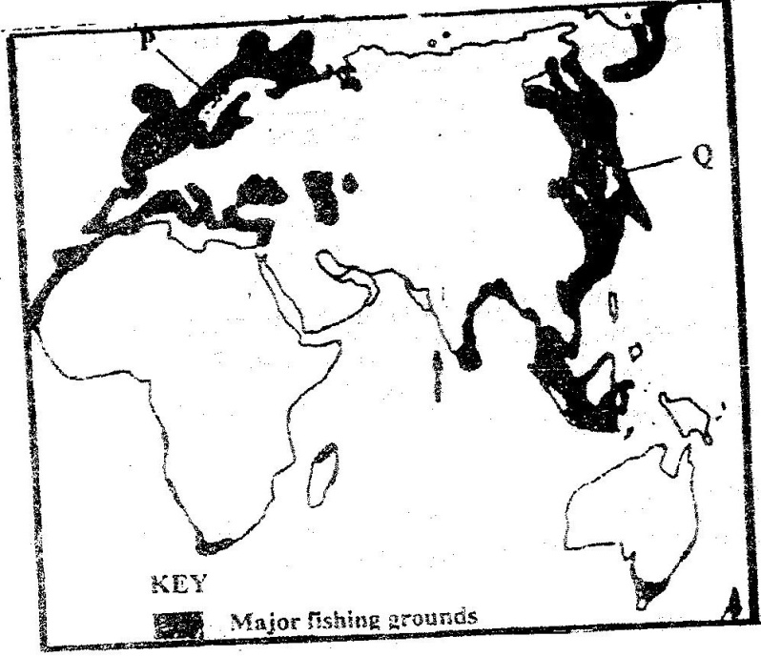

(a) (i) Name the countries marked P and Q. (2 marks)

P- Norway Q- Japan

(ii) Name one types of fish caught along the west coast of country Q. (1 mark)

- Cod
- Alaska Pollack
- Tuna
- Mackerel
- Bonito 1 x 1 = 1 mark

(iii) Name two methods of fishing used in the shaded areas. (2 marks)

- Trawling
- Purse-seining
- Drifting /gill net
- Lining /Line /hook and line/longline 2 x 1 = 2 marks

(iv) Explain three conditions that favour fishing in the shaded coastal waters. (6 marks)
- The area has cool waters which have abundant supply of planktons which is the main food for fish
- The areas have shallow continental shelves which allow light to penetrate to the sea below encouraging the growth of micro- organisms used as food by fish
- The areas experience convergence of warm Kuro Siwo and cold Oya Shio currents which result in upwelling of ocean waters thus bringing minerals for fish and plankton from the sea bed to the surface
- Most of the coast are indented/ have numerous sheltered bays which provide secure breeding grounds for fish.
- The shelters bays provide suitable sites for building fishing ports/ fish landing sites
- The rugged mountainous landscape in this area limits agricultural activities thus people turn to fishing as an alternative economic activity/ cold climate also limit agriculture
- Cold climate of the temperate latitudes provides natural preservation of fish
- large population in the country and the neighbouring countries, provides both internal and external markets for the fishing industry.

(b) Explain four ways in which marine fisheries in Kenya can be conserved. (8 marks)

- To increase the fish number/ restock over fished areas by breeding fingerlings in fish farms and then release them into the sea/induced fish regeneration.
- Standardizing the size of fish nets used in fishing to ensure that only the mature fish are caught.
- Restricting disposal of untreated waste into the sea to ensure that the water remains clean for survival of fish.
- Enforcing the international conventions in order to protect the endangered fish species
- Licensing fishermen to control their numbers and ensure that there is no ever-fishing
- Restricting fishing to specific seasons to allow for breeding and maturing of fish/ ensuring natural regeneration of fish.. 4 x 2 = 8 marks

(c) Explain three problems experienced by fishermen while fishing in Lake Victoria.
(6 marks)

- The occurrence of strong wind lead to high waves causing accidental drowning/destruction of fishing vessels and nets
- Most fishermen have poor fishing equipments/ motorboat engines which are inefficient. This leads to a low catch and delayed landing.
- Fishermen lack appropriate storage/preservation facilities leading to low catch
- Presence of floating vegetation/water hyacinth entangles and tears the fishing nets, which is a loss to the fishermen. / hinders movement of fishing boats.
- Parts of the lake shores are swampy/marshy which makes the landing of the catch difficult
- Insecurity / theft of fish and fishing equipment discourages the fisherman.

10. (a) Explain what is meant by overpopulation? (1mark)
It is suited where the number of people living in a country or region exceed the available
resources. 1 mark
(b) How does Kenya’s population differ from that of Sweden? (4marks)
- The population has lower life expectancy than that of Sweden has an ageing
population..
- Most people live in urban centers

- Kenya has a high population birth rate while in Sweden it is low

- Kenya has high population death rate than Sweden.

- Kenya’s fertility rate is higher than that of Sweden. (Any 4x 1= 4mrks)

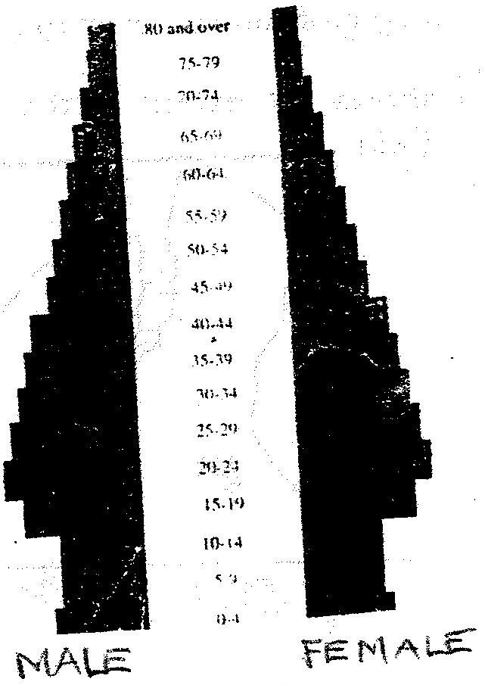
(c) The population pyramid below represents the population structure of a country.

Describe the characteristics of the population represented by the pyramid

- The number of male and female population is almost equal at all levels
- From 0- 14 years, the population is low
- From 14 -44 the population is high
- The ageing population is low
- The population has high life expectancy
- The dependency ration is low
- The population has a low birthrate
- The population has a low death rates 4 x 1 = 4 marks

(d) Explain four factors that influence population distribution in Kenya. (4 marks)
- Most people live in the central highlands and lake Victoria basins because these areas
have suitable climate for human settlement and for agricultural production. Areas with
fertile soil such as the central Highlands have dense population because the soil
support agricultural production/ areas with poor soil have sparse population e.g most
parts of Nyika plateau.
- Gently sloping and flats lands facilitate settlement and transportation while rugged
slopes/steep landscapes have sparse population or nil higher and steeper slopes of
Mt. Kenya a nd Elgon.
- Transport and communication facilities have encouraged settlements. There are
many market centres along the Kenya roads and centres such as Nairobi and Thika,
which are, accommodate large population.
- Development of industries is a major factor influencing population distribution in
Kenya. There are many people in the industrial centers such as Nairobi, Nakuru,
Mombasa and Eldoret.
- Disease and pest discourages or discourages settlement in given areas. In Kenya, the
government discourages population settlement schemes such as Mwea.
Any 4 x 2 = 8marks)
- Rainfall amount and distribution
- Soil fertility
- Colonial administration
- Government policy
- Vegetation
- Transport and communication network/social amenities
- Pests and diseases
- Development of industries
- Availability of water
- Drainage
- Temperature
- Relief
NB: Explanation should be attached
(e) (i) A part from rural – rural migration, list three other types of migrations in Kenya.
Rural-urban urban-Urban
Urban-Rural International
(ii) Explain four causes of rural – rural migration in Kenya. (8 marks)
- Population pressure which leads to landlessness in areas such as central province
lead to migration of people to settlement schemes and to less populated rural areas in
search of land.
- Insecurity in areas such as North-Eastern and Northern Kenya which have frequent
attacks from bandits and cattle rustler shapes made some people to migrate to more
secure areas.

- Establishment of large plantation near Thika town and rice irrigation schemes in
Mwea and Ahero attract people from neighboring areas as they search for
employment /mining/Lumbering/fishing.
- Natural catastrophes such as floods in Kano plains and lower Tana Valley cause
people to move to more secure higher grounds.
- Pastoral communities such as the Maasai, Samburu and Boran migrate from one
rural area to another in search of pasture and water for their livestock.
- Drought and famine sometimes cause people to migrate in search of food e.g some
people who live in semi-arid areas of Kenya temporarily migrate to those districts
where they can get food during the time of droughts)

