NAME ……………………………………………………………. INDEX NO………………………
SCHOOL ………………………………. CANDIATES SIGNATURE ___________

232/2
PHYSICS
PAPER 2
(THEORY)
TIME: 2 HOURS
Kenya Certificate of Secondary Education (K.C.S.E.)
SUKELLEMO JOINT EXAMINATION
TERM 2 2021
232/2
Physics
Paper 2

INSTRUCTIONS TO CANDIDATES
- Write your name and index number in the spaces provided
- This paper consist of two section A and B
- Answer all questions in section A and B in the spaces provided
- All working must be clearly shown in the spaces provided in this booklet.
- Non- Programmable silent electronic calculators and KNEC mathematical tables may be used
SECTION | QUESTION | MAXIMUM SCORE | CANDITATES SCORE
A | 1-13 | 25
B | 14 | 12
 | 15 | 11
 | 16 | 11
 | 17 | 09
 | 18 | 12
TOTAL SCORE |  | 80

This paper consists of 12 printed pages. Candidates should check to ascertain that all pages are printed as indicated and that no questions is missing

SECTION A (25 MARKS)

1. The figure 1 below shows a ray of light incident on a mirror. Determine the angle of reflection when the mirror is rotated 10⁰ anticlockwise (2marks)

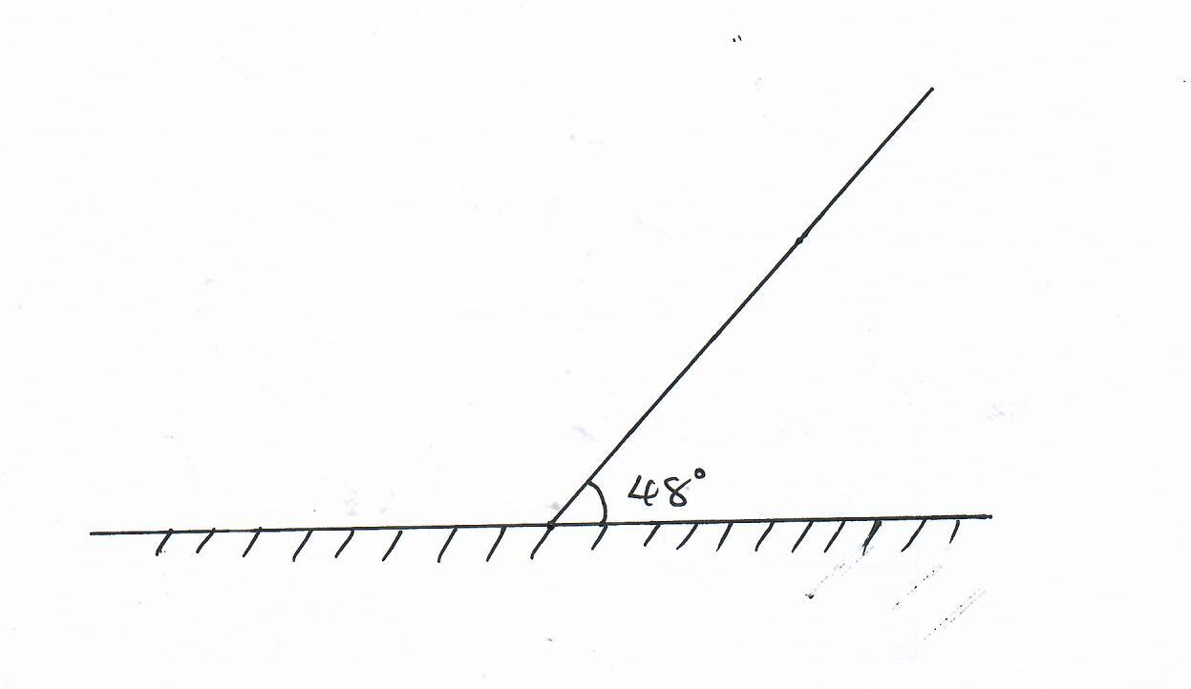
2. a) Explain why the E.M.F of a dry cell drops if a large current is drawn for a short time. (1mark)
……………………………………………………………………………………………………
……………………………………………………………………………………………………
b) Give one advantage of using dry cells over an accumulator (1mark)
……………………………………………………………………………………………………
……………………………………………………………………………………………………
3. A student set up the apparatus shown below in figure 2 to magnetize an iron bar
State one mistake in the set up and explain how it affects the experiment (2marks)
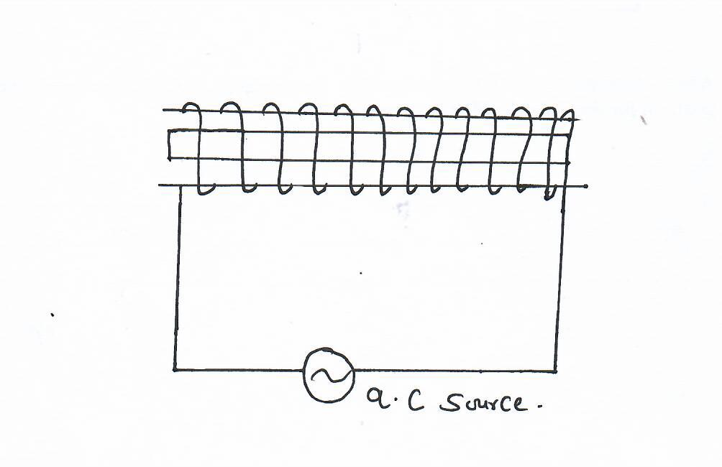……………………………………………………………………………………………………
……………………………………………………………………………………………………
……………………………………………………………………………………………………

4. Name one radiation of the electromagnetic spectrum which has the highest wavelength than the visible light (1mark)
……………………………………………………………………………………………………
5. State two uses of optical fibre (2marks)
……………………………………………………………………………………………………
……………………………………………………………………………………………………
……………………………………………………………………………………………………

6. The activity of a radio activity source is initially 450 counts per second. After 72 hours, it reduces to 100 counts per second. If the background count is 50 counts per second, determine the half-life of the substance (3marks)
……………………………………………………………………………………………………
……………………………………………………………………………………………………
……………………………………………………………………………………………………

7. Give two ways of decreasing the capacitance of parallel plate capacitor (2marks)
……………………………………………………………………………………………………
……………………………………………………………………………………………………
……………………………………………………………………………………………………
8. Draw a ray diagram to show how a ray of light may be totally internally reflected two times in an isosceles right-angled prism (assume that the critical angle of glass is 42⁰) (2marks)
……………………………………………………………………………………………………
……………………………………………………………………………………………………
……………………………………………………………………………………………………

9. Define kilowatt- hour (1mark)
……………………………………………………………………………………………………
……………………………………………………………………………………………………

10. State two advantages of using circuit breakers in the consumer unit than using fuse wire (2marks)
……………………………………………………………………………………………………
…………………………………………………………………………………………………

11. A student observes her face in a concave mirror of focal length 100cm. If the mirror is 80cm away. State two characteristics of the image observed (2marks)
……………………………………………………………………………………………………
……………………………………………………………………………………………………
……………………………………………………………………………………………………
12. A charged metal sphere is connected to an uncharged electroscope as shown in figure 3 below. State and explain the observations made (2marks)
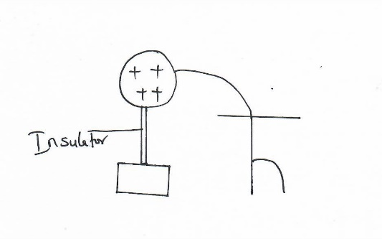……………………………………………………………………………………………………
……………………………………………………………………………………………………
……………………………………………………………………………………………………
13. Explain what happens to the depletion layer of a p-n junction diode when the diode is forward biased (2marks)
……………………………………………………………………………………………………
……………………………………………………………………………………………………
……………………………………………………………………………………………………

SECTION B (55 MARKS)

14. a) State one application of photoelectric effect (1mark)
……………………………………………………………………………………………………
……………………………………………………………………………………………………
b) The figure 4 below shows an arrangement used to investigate photoelectric effect
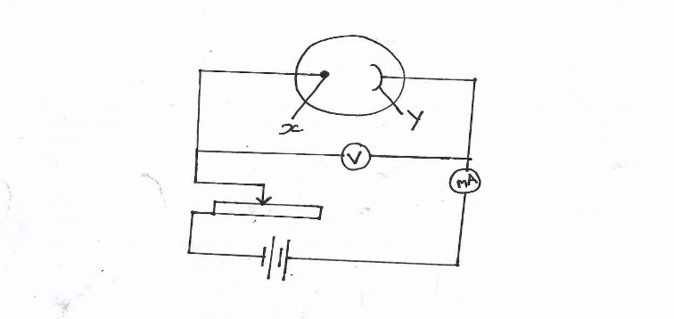
i) Name the parts labelled X and Y (2marks)
……………………………………………………………………………………………………
……………………………………………………………………………………………………

ii) State two measurable quantities in this set up (2marks)
……………………………………………………………………………………………………
……………………………………………………………………………………………………

iii) State and explain how the intensity of light affects the photo current (2marks)
……………………………………………………………………………………………………
……………………………………………………………………………………………………
……………………………………………………………………………………………………
……………………………………………………………………………………………………

c) The circuit shown in figure 5 below is used to investigate how current changes with voltage for component A
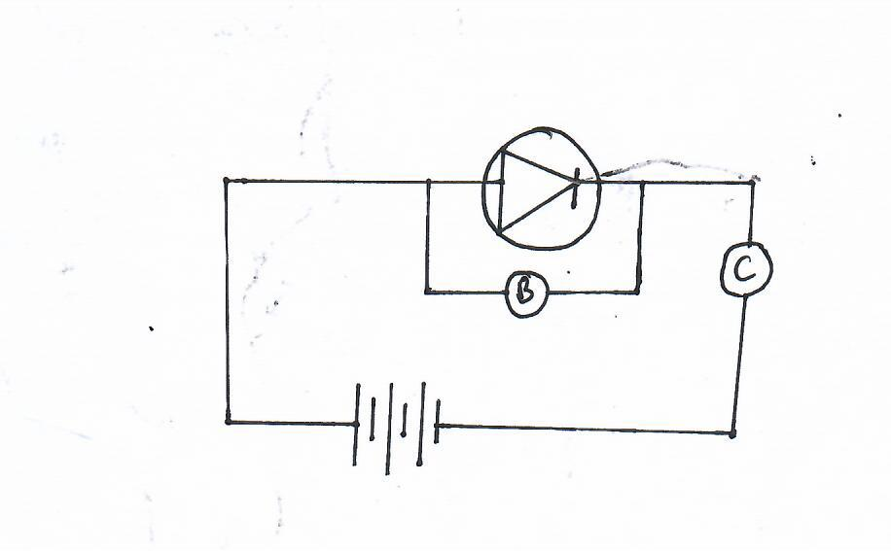
A text here

i) Name the components (3marks)
A
B
C
ii) Sketch a graph of current (I) against voltage (V) to establish the characteristic of component A (2marks)

15. a) A student set up a mass attached to a spring such that when it oscillates it taps on the water surface in a wide shallow tank as in figure 6 below.
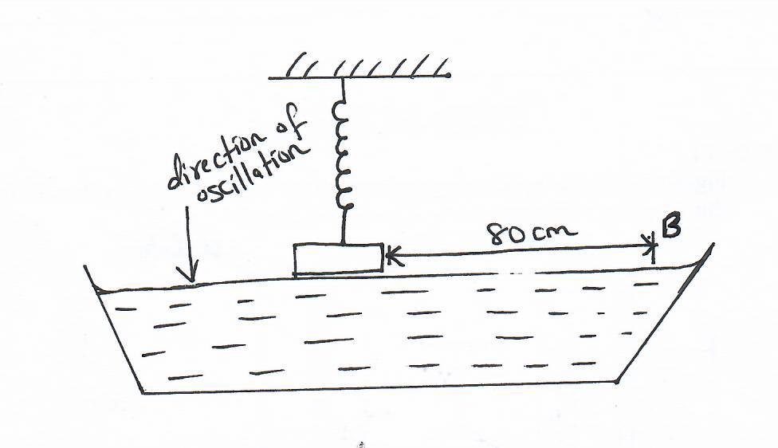
The student measures time for 20 oscillations and found that it takes 36 seconds.
Determine;
i) The periodic time of the mass (2marks)
……………………………………………………………………………………………………
……………………………………………………………………………………………………
ii) The frequency of the waves produced on the water surface (2marks)
……………………………………………………………………………………………………
……………………………………………………………………………………………………
iii) The speed of the waves if the students counted four ripples between the mass and end B of the tank
(3marks)
……………………………………………………………………………………………………
……………………………………………………………………………………………………
……………………………………………………………………………………………………
……………………………………………………………………………………………………
b) An echo sounder of a ship received the reflected waves from a sea bed after 0.20 seconds
i) Determine the depth of the sea bed if the velocity of sound in the water is 1450 m/s (2marks)
……………………………………………………………………………………………………
……………………………………………………………………………………………………
ii) When the ship above passes over a sunken reef, the echo sounder receives an echo after 0.16seconds. Determine the height of the sunken reef. (2marks)
……………………………………………………………………………………………………
……………………………………………………………………………………………………

- (a) Define the refractive index of a substance (1mark)
..........................................................................................................................................................................................................................................................................................................................
(b) In an experiment to determine the refractive index of a liquid the liquid was poured into a measuring cylinder. A pin was placed at the bottom of the cylinder and another pin was used to locate the apparent position of the first pin. The real depth and the apparent depth were measured for various volumes of the liquid. A graph shown below was obtained.

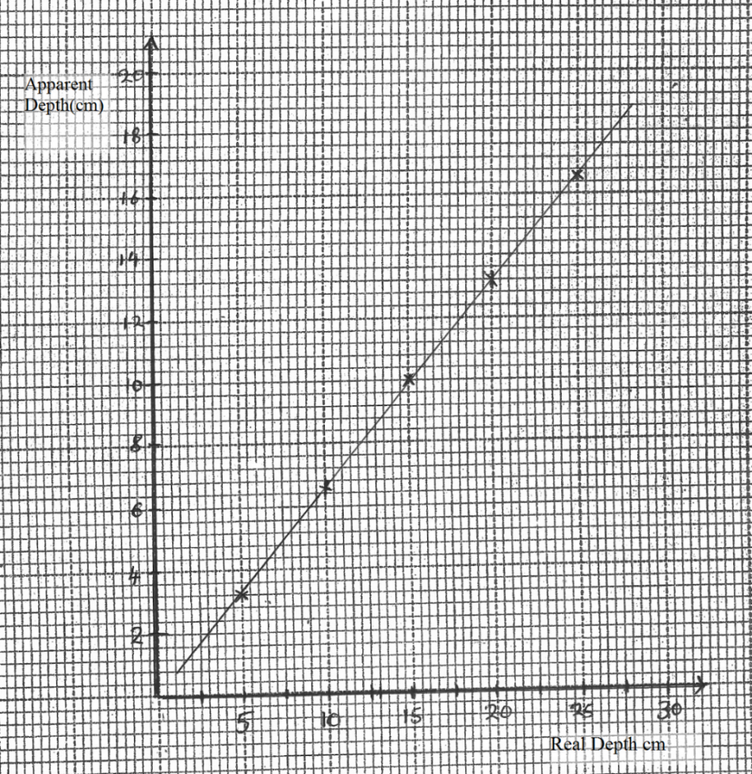

From the graph determine the refractive index of the liquid (3marks)
……………………………………………………………………………………………………
……………………………………………………………………………………………………
……………………………………………………………………………………………………

c) A vertical object is placed 20cm in front of a convex lens of a focal length 5cm. Determine
i) The image distance (3marks)
……………………………………………………………………………………………………
……………………………………………………………………………………………………
……………………………………………………………………………………………………
ii) State two characteristics of the image (2marks)
……………………………………………………………………………………………………
……………………………………………………………………………………………………
…………………………………………………………………………………………………
d) Give one similarity and one difference between human eye and a camera (2marks)
……………………………………………………………………………………………………
……………………………………………………………………………………………………
……………………………………………………………………………………………………
17a) Distinguish between hard and soft x-rays. (1 mark)
………………………………………………………………………………………………………….……………………………………………………………………………………………………………………
b) Figure 12 below shows an x-ray tube
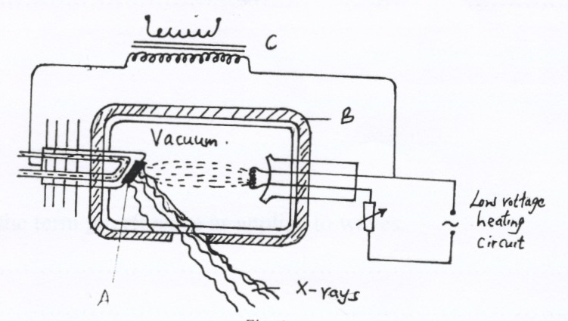
C

B
Vacuum

Low voltage
circuit

X-rays
A

i) Name the elements used in making the parts labeled A and B. (2marks)
A…………………………………………………………………….
B ……………………………………………………………………
ii) Explain the use of the part labeled C. (2marks) ………………………………………………………………………………………………………….…………………………………………………………………………………………………………………….

( c) Figure 14 shows a waveform displayed on the cathode ray oscilloscope screen when an alternating voltage is applied to the y- input. The time- base is set at 1ms/cm and the y- gain at 10v/cm
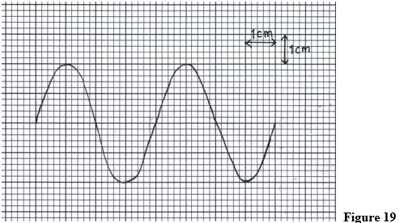
Calculate
i) The amplitude of the ac input voltage. (2 marks)
………………………………………………………………………………………………………………………………………………………………………………………………………………………………………………………………………………………………………………………………………………
ii) The frequency of the ac input voltage signal. (2 marks)
……………………………………………………………………………………………………………………………………………………………………………………………………………………………………………………………………………………………………………………………………………

18. a) Explain the meaning of the term battery (1mark)
………………………………………………………………………………………………………………
………………………………………………………………………………………………………………
b) It was noted that for the circuit diagram below, when S was opened the voltmeter gave a reading of 12V but when it is closed, the voltmeter reading drops to 10V.
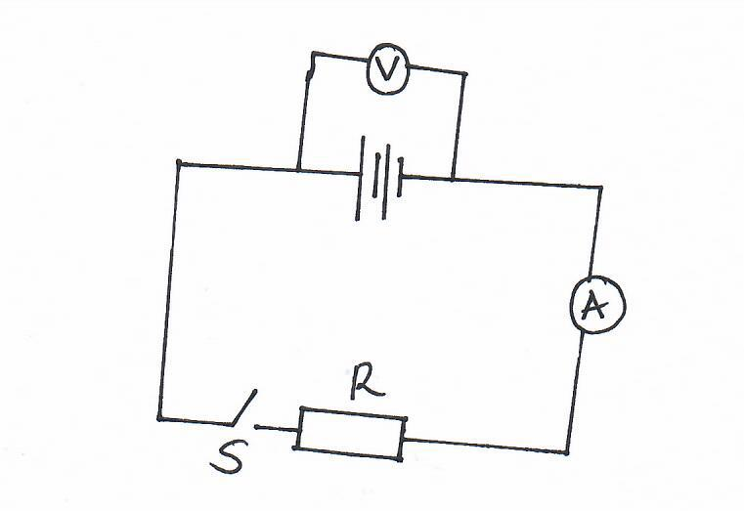
i) Give an explanation for the difference on the voltmeter reading when S is open and when it is closed
(2marks)
………………………………………………………………………………………………………………
………………………………………………………………………………………………………………
ii) If the ammeter gave a reading of 0.8A when S is closed, determine the value of R (3marks)
………………………………………………………………………………………………………………
………………………………………………………………………………………………………………
……………………………………………………………………………………………………….............
iii) What is the internal resistance of the accumulator (2marks)
………………………………………………………………………………………………………………
………………………………………………………………………………………………………………
……………………………………………………………………………………………………………

c) Calculate the cost of using the following appliances in one month of 30 days, if the company rates is Ksh. 10.50 per unit (4marks)
A 200W water heater for 2hours per day
A 75W bulb for 10 hours per day
A 1500W electric iron for 1hour per day
………………………………………………………………………………………………………………
………………………………………………………………………………………………………………
………………………………………………………………………………………………………………
………………………………………………………………………………………………………………
………………………………………………………………………………………………………………

THIS IS THE LAST PRINTED PAGE

