GATITU MIXED SECONDARY SCHOOL
AGRICULTURE FORM 1 MID TERM EXAM TERM 2 2015
1. Differentiate between the following terms as used in Agriculture:- 2mks
(a) Oleculture and floriculture

(b) Apiculture and aquaculture

2. State three reasons why organic farming is encouraged in farming 3mks

3. State two ways in which agriculture contributes to industrial development 2mks

4. State four ways by which wind affects the growth of crops 4mks

5. State one physical characteristic used in classifying soil 1mk

6. Outline four advantages of organic farming 4mks

7. List three environmental factors that affect crop distribution in Kenya 3mks

8. What are the three aspects of light that are important to a farmer? 3mks

9. The diagrams below show an experiment carried out by a form 1 class. Study them carefully and
answer questions that follow: 3mks
E
D
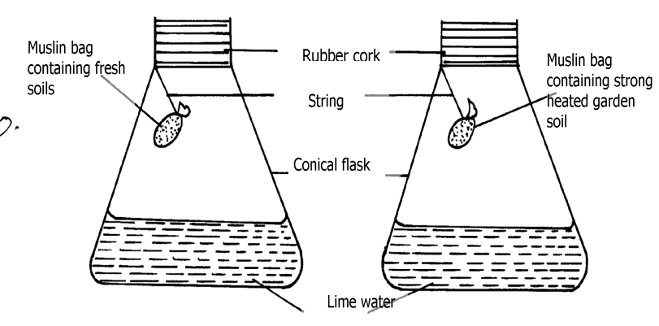

- What was the aim of the experiment?

(b) What was the observation that form 1 students made at the end of the experiment in
flasks D and E?

- Give the reason for the observation made in flask D

10. Mention four ways of modifying soil temperature in crop production 4mks

11. What is the use of a garden fork? 1mk

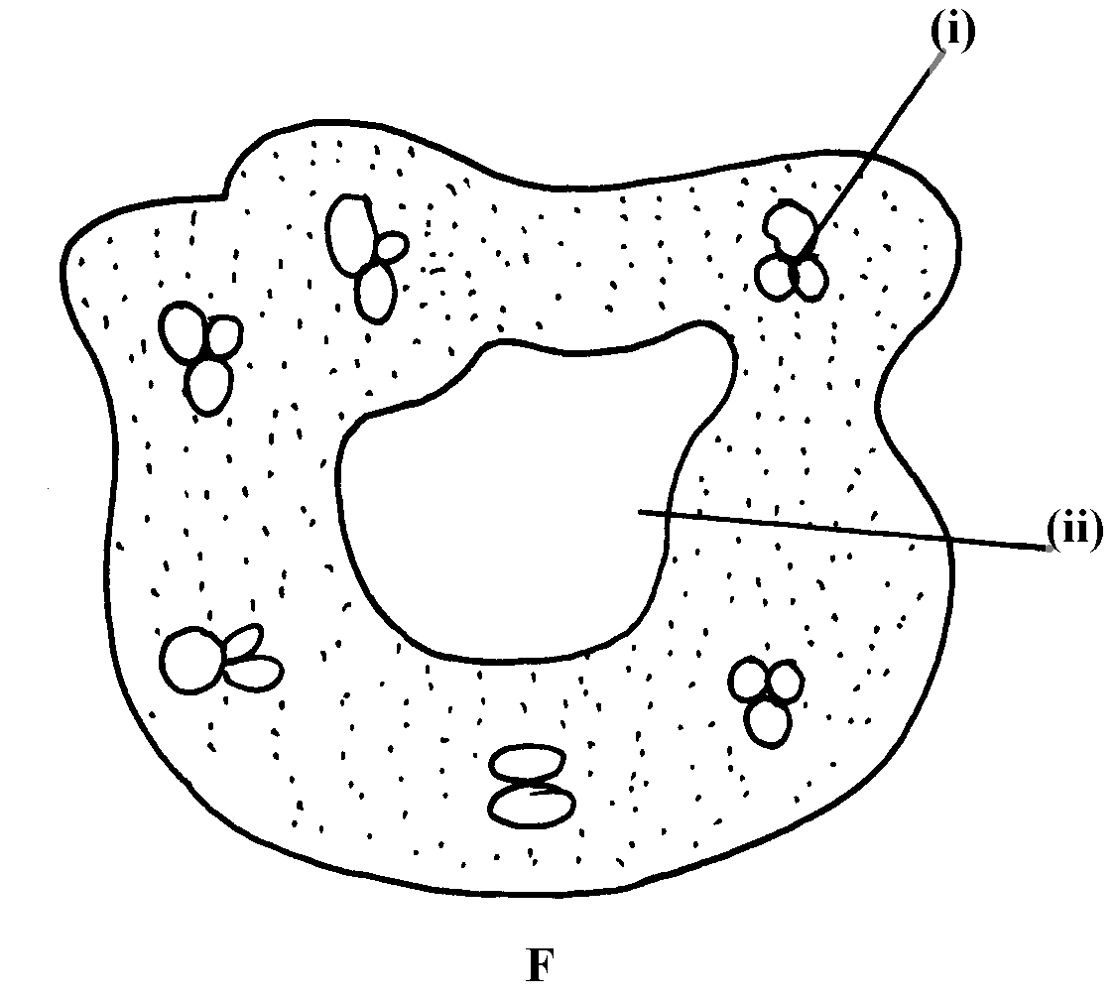
12. The diagram labeled E and F below illustrates some type of soil structure. Study the diagrams carefully and answer the questions that follow:

- Identify the types of soil structure illustrated in diagrams E and F

- Identify the parts labeled (i) and (ii) in diagram F

- Outline the influence of physical characteristics of soil on its properties

13. State three physical characteristics of soil 3mks

14. Study the diagram below and answer the questions that follow 4mks
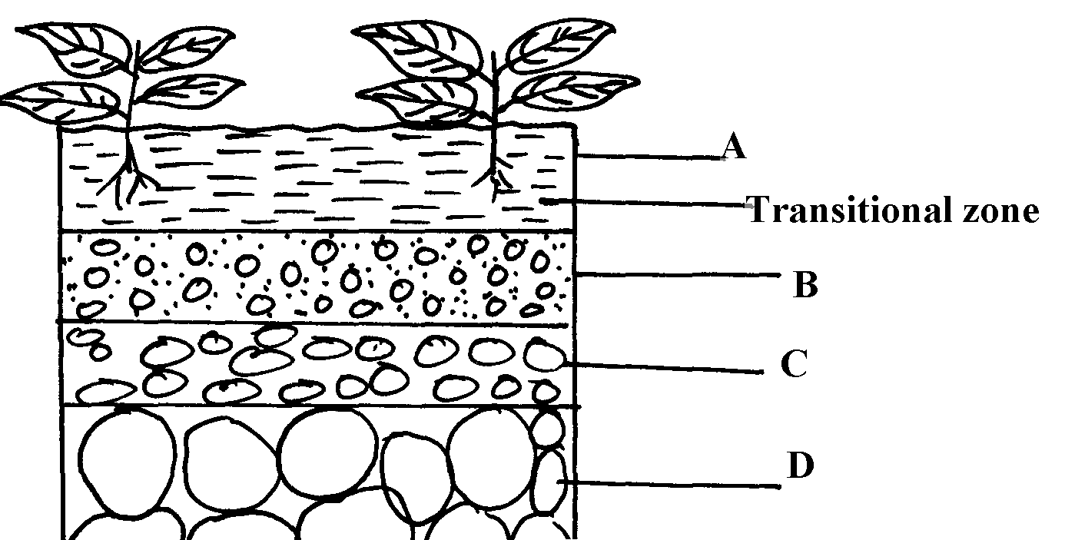

- State merits of horizon A

- State distinct features of horizon B

- What does the term transition zone refer to in soil profile

- Name horizon C and state its importance

15. Give four factors that influence soil formation 4mks

16. Name any three agents of biological weathering 3mks

17. Name five categories of farm tools and equipment: 5mks

