MUKINDURI MIXED SECONDARY SCHOOL
FORM ONE 2017
BIOLOGY
NAME……………………………………. ADM NO…….

Q1.Define osmosis.(2mks)

Q2.Give the name of the kingdom to which each of the following organisms belong:
(i)Amoeba (1mk)

(ii) Dog (1mk)

(iii)Zeamays (1mk)

Q3.Give the functions of the following parts of a light microscope (3mks)
(a)Condenser

(b)Diaphragm

(c)Objective lens

Q4.How is the rate of diffusion affected by the following factors:
(a)Temperature

(b)Concentration

(c)Surface area to volume ratio
Q5 The diagram below shows a certain cell organelle.
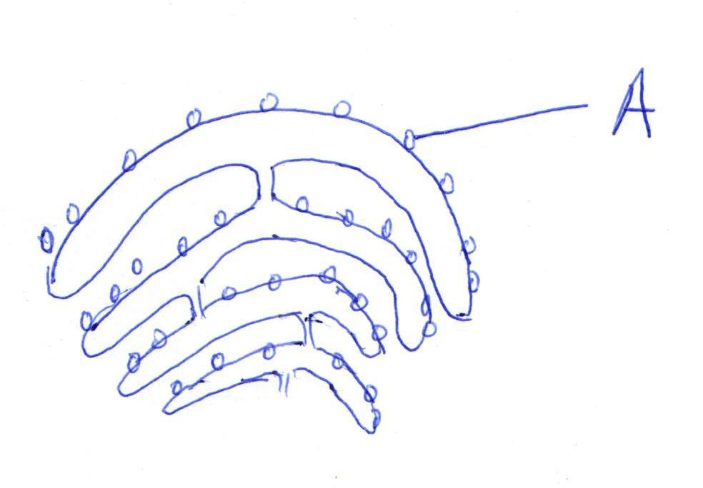
- Name the organelle

- Label structure A and identify the function
.
(2 mks)
Q6.Kamau observed eight leaf epidermal cells across the field of view of a light microscope. If the field of view was 4mm in diameter, estimate the average size of the cell in micrometre(1mm = 1000µm)(3mks

Q7.State four importance of classification. (4mks

Q8.The following experiment was set up to demonstrate a physiological process. Two tubes A and B made of visking tube were filled with different liquids and placed in a basin
containingdistilled water.

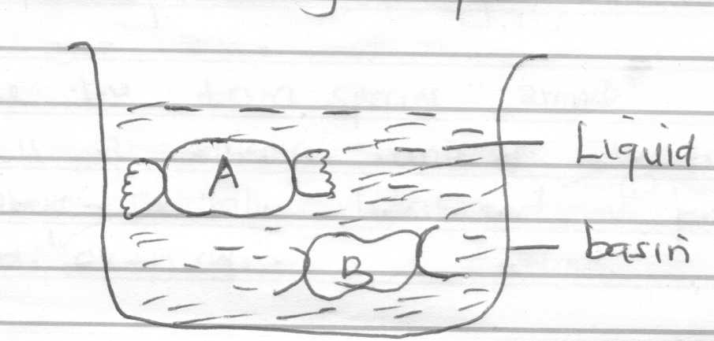
After 20 minutes, it was found that tube A felt hard and liquid in it had increased. Tube B was soft and contained less liquid.

- Identify the process being investigated. (1 mk)

- Explain what took place in tube A and B. (2 mks)

- Identify the liquid hypertonic distilled water in the beaker. (1mk

- What does the visking tubing correspond to in a living organism (1mk

- State four importances of the process being investigated to living organisms(4mks

Q9. Define the term species (2mks

Q10.State two adaptations of mitochondrion to its function.(2mks)

Q11 a) Canis familiaris is the scientific name for a dog.
b) Name the particular taxonomic units represented by the two words (2mks)
i.Canis……………………………………………………………………………………………………………………………………………………………………………………………
ii.Familiaris………………………………………………………………………………………………………………………………………………………………………………………
Q12. State two precautions to be observed during collection and observation in biology test(2mks)

Q12.State 1 characteristics of nuclear membrane(1mk)

Q13.State one function of root hair (1mk)

Q14. a) Name the branch of science that deals with the study of living things (1mk

b) Name the branch of Biology that deals with the study of ;( 2mks
- Plants
- Animals
Q15.a) Distinguish between taxonomy and taxon
(2mks
b) State the seven classification units starting from the smallest unit (7mks

c) What is the name given to the system of assigning two scientific names to an organism?(1mk)

d) A scientist discovered a new organism and decided to assign it a scientific name. What rules should be put in consideration while assigning the name? (4mks)
Q16. Name five kingdoms used in classifying organisms and give an example in each (5mk

Q17. The diagram below represents a cell organelle. Study it and answer the questions that follow
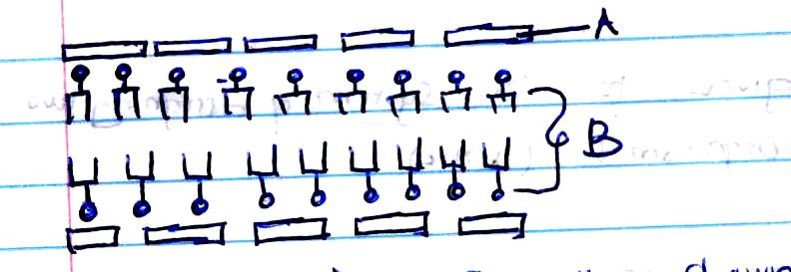

- Name the organelle shown above (1mk

- State two functions of the organelle (2mks

c) Name the parts labeled (2mks
A
B
- State two properties of the organelle you have named (2mks)

e) State two differences between a light and electron microscope. (2mks)

