NAME:…………………………………………………………… Adm .No………………..
SCHOOL:………………………………………………….……DATE……..…………………………….

SIGNATURE…………………………

BUSINESS STUDIES
FORM 1
THIRD TRIAL 2017
2 hours

Kenya Certificate of Secondary Education,

BUSINESS STUDIES
FORM 1

INSTRUCTIONS TO CANDIDATES

Answer all questions in the spaces provided in the question paper

Questions | 1 | 2 | 3 | 4 | 5 | 6 | 7 | 8 | 9 | 10 | 11 | 12 | 13 | 14 | 15
Marks

Questions | 16 | 17 | 18 | 19 | 20 | 21 | 22 | 23 | 24 | 25
Marks

1. Define the following terms as used in business studies. (4mks)
a) Production……………………………………………………………………………………………………………………………………………………………………………………………………………………….....

b) Distribution………………………………………………………………………………………………………………………………………………………………………………………………………………………..

c) Consumption………………………………………………………………………………………………………………………………………………………………………………………………………………………..

d) Business……………………………………………………………………………………………………………………………………………………………………………………………………………………….....

2. Outline four reasons as to why business studies is offered to secondary students. (4mks)
a) ……………………………………………………………………………………………………………………………………………………………………………………………………………………….....
b)
……………………………………………………………………………………………………………………………………………………………………………………………………………………….....
c)
……………………………………………………………………………………………………………………………………………………………………………………………………………………….....
d)
………………………………………………………………………………………………………………………………………………………………………………………………………………………...................
3. Outline four ways by which an entrepreneur can improve internal operations of a business. (4mks)
a) ………………………………………………………………………………………………………………………………………………………………………………………………………………………...................

b)
………………………………………………………………………………………………………………………………………………………………………………………………………………………...................

c)
………………………………………………………………………………………………………………………………………………………………………………………………………………………...................

d)
………………………………………………………………………………………………………………………………………………………………………………………………………………………...................

4. State four types of business activities. (4mks)
a)
………………………………………………………………………………………………………………………………………………………………………………………………………………………...................

b)
………………………………………………………………………………………………………………………………………………………………………………………………………………………...................

c)
………………………………………………………………………………………………………………………………………………………………………………………………………………………...................

5. Mention four types of utility. (4mks)
a)
………………………………………………………………………………………………………………………………………………………………………………………………………………………...................

b)
………………………………………………………………………………………………………………………………………………………………………………………………………………………...................

c)
………………………………………………………………………………………………………………………………………………………………………………………………………………………...................

d)
………………………………………………………………………………………………………………………………………………………………………………………………………………………...................

6. Outline four types of business resources. (4mks)
a)
………………………………………………………………………………………………………………………………………………………………………………………………………………………...................

b)
………………………………………………………………………………………………………………………………………………………………………………………………………………………...................

c)
………………………………………………………………………………………………………………………………………………………………………………………………………………………...................

d)
………………………………………………………………………………………………………………………………………………………………………………………………………………………...................

7. State whether each of the following activities would satisfy basic or secondary needs. (4mks)

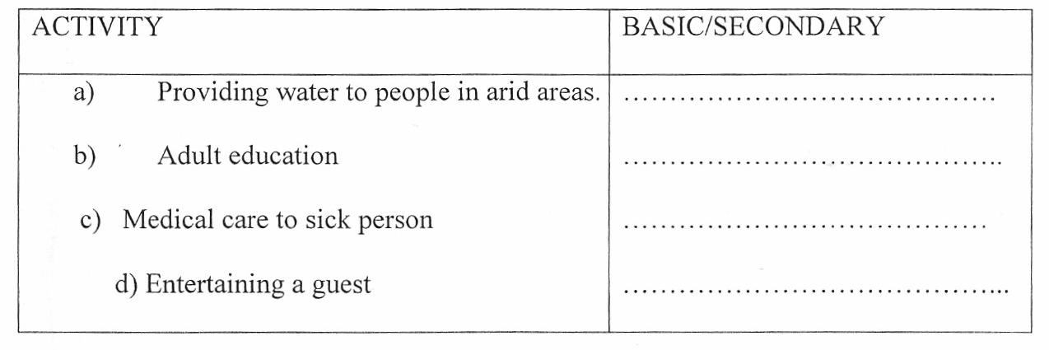

8. Give four components business studies. (4mks)
a)
………………………………………………………………………………………………………………………………………………………………………………………………………………………...................

b)
………………………………………………………………………………………………………………………………………………………………………………………………………………………...................

c)
………………………………………………………………………………………………………………………………………………………………………………………………………………………...................

d)
………………………………………………………………………………………………………………………………………………………………………………………………………………………...................

9. Outline four importance of business to a society. (4mks)
a)
………………………………………………………………………………………………………………………………………………………………………………………………………………………...................
b)
………………………………………………………………………………………………………………………………………………………………………………………………………………………...................
c)
………………………………………………………………………………………………………………………………………………………………………………………………………………………...................
d)
………………………………………………………………………………………………………………………………………………………………………………………………………………………...................

10. Highlight four advantages of division of labour and specialization (4mks)
a) ………………………………………………………………………………………………………………………………………………………………………………………………………………………...................
b) ………………………………………………………………………………………………………………………………………………………………………………………………………………………...................
c) ……………………………………………………………………………………………………………………………………………………………………………………………………………………...................

d)………………………………………………………………………………………………………………………………………………………………………………………………………………………..................

11. Outline four ways by which a well laid business structure can lead to business success. (4mks)
a)
………………………………………………………………………………………………………………………………………………………………………………………………………………………...................
b) ………………………………………………………………………………………………………………………………………………………………………………………………………………………...................
c) ………………………………………………………………………………………………………………………………………………………………………………………………………………………...................
d) ………………………………………………………………………………………………………………………………………………………………………………………………………………………...................
12. Highlight four benefits of indirect production to a society. (4mks)
a)
………………………………………………………………………………………………………………………………………………………………………………………………………………………...................
b)
………………………………………………………………………………………………………………………………………………………………………………………………………………………...................
c)
………………………………………………………………………………………………………………………………………………………………………………………………………………………...................
d)
………………………………………………………………………………………………………………………………………………………………………………………………………………………...................
13. Highlight four factors that make up the external business environment. (4mks)
a)
………………………………………………………………………………………………………………………………………………………………………………………………………………………...................
b)
………………………………………………………………………………………………………………………………………………………………………………………………………………………...................

c)
………………………………………………………………………………………………………………………………………………………………………………………………………………………...................
d)
………………………………………………………………………………………………………………………………………………………………………………………………………………………...................

14. Define the following terms. (4mks)
a) Scarcity
………………………………………………………………………………………………………………………………………………………………………………………………………………………...................

b) Choice
………………………………………………………………………………………………………………………………………………………………………………………………………………………...................

c) Scale of preference.
………………………………………………………………………………………………………………………………………………………………………………………………………………………...................

d) Opportunity cost
………………………………………………………………………………………………………………………………………………………………………………………………………………………...................

15. State four characteristics of human wants. (4mks)
a)
………………………………………………………………………………………………………………………………………………………………………………………………………………………...................

b)
………………………………………………………………………………………………………………………………………………………………………………………………………………………...................

c)
………………………………………………………………………………………………………………………………………………………………………………………………………………………...................

d)
………………………………………………………………………………………………………………………………………………………………………………………………………………………...................

16. Outline four characteristics of land as a factor of production. (4mks)
a)
………………………………………………………………………………………………………………………………………………………………………………………………………………………...................

b)
………………………………………………………………………………………………………………………………………………………………………………………………………………………...................
c)
………………………………………………………………………………………………………………………………………………………………………………………………………………………...................

Give four differences between goods and services (4mks)
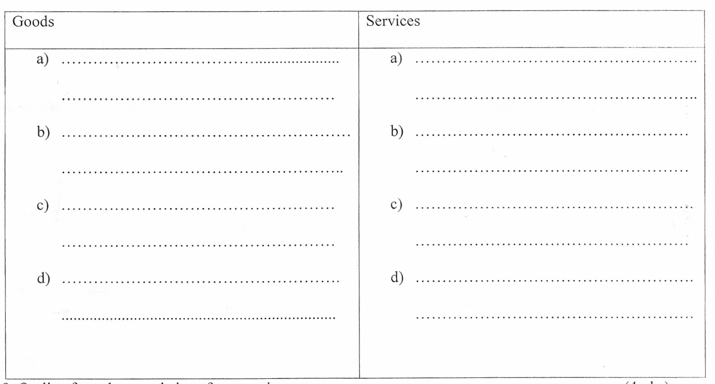

18. Outline four characteristics of economic resource. (4mks)
a)
………………………………………………………………………………………………………………………………………………………………………………………………………………………...................

b)
………………………………………………………………………………………………………………………………………………………………………………………………………………………...................

c)
………………………………………………………………………………………………………………………………………………………………………………………………………………………...................
d)

19. Give the difference between: (4mks)
a) Consumer goods and producer goods
………………………………………………………………………………………………………………………………………………………………………………………………………………………...................

b) Material and non-material goods.
………………………………………………………………………………………………………………………………………………………………………………………………………………………...................

20. Outline four reasons why Kenya should exploit the oil discovered in Northern Kenya. (4rnks)
a)
………………………………………………………………………………………………………………………………………………………………………………………………………………………...................

b)
………………………………………………………………………………………………………………………………………………………………………………………………………………………...................

c)
………………………………………………………………………………………………………………………………………………………………………………………………………………………...................

d)

21. Give four characteristics of subsistence farming in Kenya. (4mks)
a)
………………………………………………………………………………………………………………………………………………………………………………………………………………………...................

b)
………………………………………………………………………………………………………………………………………………………………………………………………………………………...................

c)
………………………………………………………………………………………………………………………………………………………………………………………………………………………...................

d)
………………………………………………………………………………………………………………………………………………………………………………………………………………………...................

22. List four occupations found in the secondary level of production. (4mks)
a)
………………………………………………………………………………………………………………………………………………………………………………………………………………………...................

b)
………………………………………………………………………………………………………………………………………………………………………………………………………………………...................

c)
………………………………………………………………………………………………………………………………………………………………………………………………………………………...................

d)
………………………………………………………………………………………………………………………………………………………………………………………………………………………...................

23. Classify each of the following goods as either producer or consumer. (4mks)

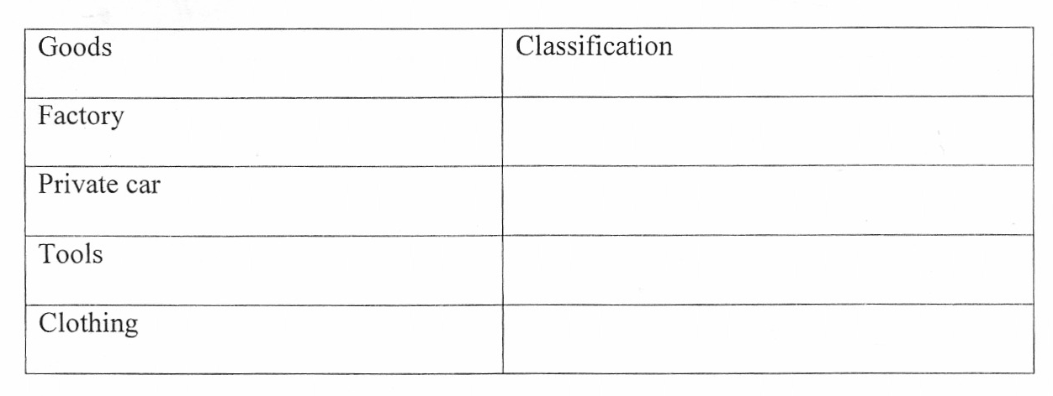

Name four commercial services which are useful to the manufacturer. (4mks)
a)
………………………………………………………………………………………………………………………………………………………………………………………………………………………...................

b)
………………………………………………………………………………………………………………………………………………………………………………………………………………………...................

c)
………………………………………………………………………………………………………………………………………………………………………………………………………………………...................

d)
………………………………………………………………………………………………………………………………………………………………………………………………………………………...................

25. Classify the following as either Renewable or Non Renewable resources. (4mks)
