GATITU MIXED SECONDARY SCHOOL
CHEMISTRY FORM 1 MID TERM EXAM TERM 2 2015
- Define chemistry. 1mk

- Define matter and state the three states of matter. 4mks

- State any five differences between luminous and non –luminous. 4mks

- Define the following terms: 4mks
- Solution

- Solvent

- Solute

- Suspension

- The diagram below shows a heating curve of a pure substance. Study it and answer the questions that follows:

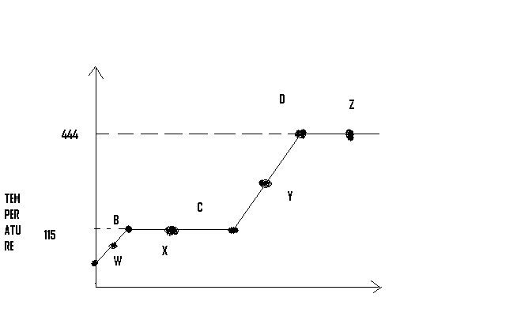

- What physical changes are taking place at point X and Z? 1mk

- What are the physical states of the substance at point W, X, and Y? 3mks

- Using the simple kinetic theory of matters explain what happens to the substance between points A and C. 3mks

- What happens to temperature between points B and C? 2mks

- Give the effect of impurities on melting point of pure substance. 1mk

- Name the elements present in the following compounds 2mks
- Sodium chloride

- Sodium carbonate

- Calcium sulphite

- Sodium hydride

- Differentiate using characteristics of each change between permanent changes and non- permanent change. 4mks

- Define the following terms. 4mks
- Elements

- Compound

- Atoms

- Molecule

- Complete the following word equation 5mks
- Iron + sulphur →

- --------------------- → sulphur (iv) oxide

- Iodine → ---------------------------------

- Carbon + -------------- → carbon (iv) oxide

- Zinc +oxygen → ------------------------------

- Write chemical symbols for the following elements. 4mks
- Carbon

- Silver

- Sodium

- Mercury

- Copper

- Iron

- Calcium

- Magnesium

- State the function of the following apparatus. 5mks
- Desiccators

- Crucible

- Separating funnel

- Thistle funnel

- Pipe clay triangle

- Give the function of each an every part of the Bunsen burner as follows. 5mks
- Chimney

- Colar

- Air hole

- Base

- Gas inlet

- The figure below shows a wooden splint burnt using non- luminous flame. 3mks

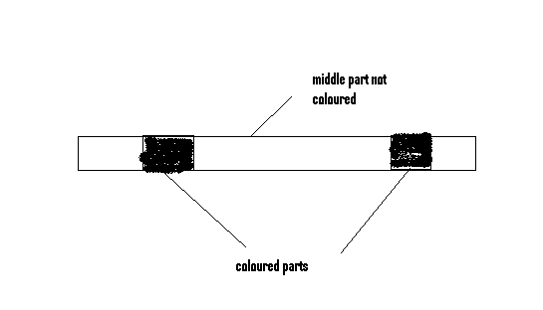
Explain why the middle part is not charred

- Name a solvent that is used in a paper chromatography

- Why is water not a suitable solvent in paper chromatography?

- Complete the table below. 5mks

Indicator | Colour in basic solution | Colour in acidic solution
Blue litmus
Phenolphthalein
Bromothymol blue
Methyl orange
Red litmus

- How can you separate a mixture of salt and sand in the lab. 5mks

- Define the following terms. 5mks
- Strong acid

- Weak base

- Strong base

- Alkalinity

- Spots of pure pigments A and B, and a mixture Z were placed on a filter paper and allowed to dry. The paper was then dipped in a solvent. The results obtained were as on the paper chromatogram. 5mks

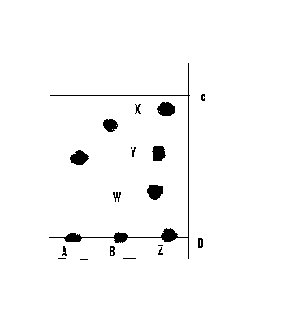

- Which is the base line

- Which of the pure pigments was a component of Z? explain

