Name: …………………………………………………………… ADM No. ……………………………
School: …………………………………………………………. Sign. …………....................................
Date: ………………………………............................................

233
CHEMISTRY
FORM I
THIRD TRIAL
Time: 2 hours

233
CHEMISTRY
FORM I

INSTRUCTIONS TO CANDIDATES
Write your name in spaces provided above
Answer ALL questions in the spaces provided.
All workings must be clearly shown where necessary.
1. (i) Define Chemistry. (1 mark)
............................................................................................................................................................................................................................................................................................................................................................

(ii) Give three importance of studying Chemistry. (3 marks)
.............................................................................................................................................................................. ............................................................................................................................................................................................................................................................................................................................................................
2. The diagram below shows the apparatus commonly used in a laboratory.
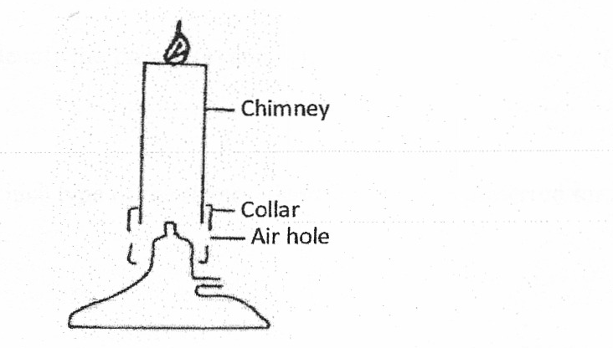

(i) Name the apparatus. (1 mark)
............................................................................................................................................................................................................................................................................................................................................................
(ii) State the function of the parts labeled in the above apparatus.
a) Chimney. (1 mark)
............................................................................................................................................................................................................................................................................................................................................................

b) Collar (1 mark)
............................................................................................................................................................................................................................................................................................................................................................

c) Air hole. (1 mark)
............................................................................................................................................................................................................................................................................................................................................................

(iii)What is a flame? (l mark)
............................................................................................................................................................................................................................................................................................................................................................

(iv) The following diagrams represent the two types of flames produced by a bunsen burner.
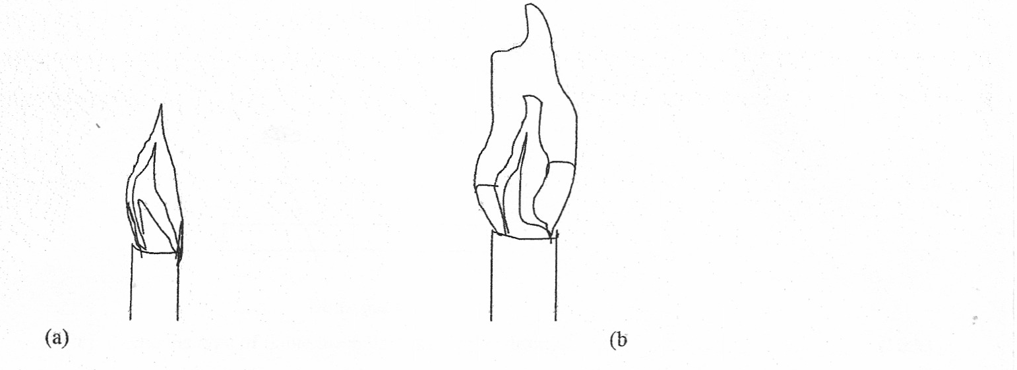
a) Identify the flames (a) and (b) (2 marks)
a) .......................................................................................................................................................................

b) .......................................................................................................................................................................

b) Which type of the flames identified above is preferred for heating?
Give a reason for your answer. (2 marks)
............................................................................................................................................................................................................................................................................................................................................................
c) Give four differences between the flames (a) and (b) above. (4 marks)
....................................................................................................................................................................... ....................................................................................................................................................................... ....................................................................................................................................................................... .......................................................................................................................................................................
d) (i). Give two reasons why flames (a) and (b) in 4(ñ) above differ. (2 marks)
....................................................................................................................................................................... .......................................................................................................................................................................
(v) A wooden splint was slipped through a region of a particular flame of the Bunsen burner in the laboratory. The split was burnt as shown in the diagram

a) Name the type of flame the splint was slipped through. (1 mark)
....................................................................................................................................................................... .......................................................................................................................................................................
b) Explain why the splint was burnt the way it is shown in the diagram. (2 marks)
....................................................................................................................................................................... .......................................................................................................................................................................

(vi) After use, the non-luminous flame should be put off or adjusted to luminous flame. Explain. (2 marks)
....................................................................................................................................................................... .......................................................................................................................................................................

(v) Putting off flames is one of the laboratory safety rules. State THREE other rules. (3 marks)
....................................................................................................................................................................... .......................................................................................................................................................................

3. a) What is a drug? (1 mark)
....................................................................................................................................................................... .......................................................................................................................................................................

b) Name two commonly legal abused drugs (2 marks)
....................................................................................................................................................................... .......................................................................................................................................................................

4. Describe briefly how a mixture of sand and sodium chloride can be separated (3 marks)
....................................................................................................................................................................... ....................................................................................................................................................................... .......................................................................................................................................................................

5 a) State three differences between temporary and permanent changes (2 marks)
....................................................................................................................................................................... .......................................................................................................................................................................

b) Classify each of the following changes as either temporary or permanent (4 marks)
(i) Striking a match to burn.
.......................................................................................................................................................................
(ii) Diluting ethanol with water.
.......................................................................................................................................................................

(iii) Burning a piece of paper.
.......................................................................................................................................................................
Heat
Zinc oxide Zinc oxide
Cold
(White) (Yellow)

6. (i) Define the terns.
a) Element. (1 mark)
....................................................................................................................................................................... .......................................................................................................................................................................

b) Compound. (1 mark)
....................................................................................................................................................................... .......................................................................................................................................................................

(ii) State two differences between a compound and a mixture. (2 marks)
....................................................................................................................................................................... .......................................................................................................................................................................

(iii) In the table below classify the following substances by ticking (√ ) the correct identity. (4 marks)

Substance | Element | Compound | Molecule
Zinc
Hydrogen gas
Zinc oxide
Water

(iv) Identify the elements present in the following compounds.
a) Lead oxide (1 mark)
....................................................................................................................................................................... .......................................................................................................................................................................
b) Magnesium nitrate (1¹/₂ marks)
....................................................................................................................................................................... .......................................................................................................................................................................

c) Calcium sulphate (1¹/₂ marks)
....................................................................................................................................................................... .......................................................................................................................................................................
(v) Write down the chemical symbol of the following elements. (2 marks)

Element | Chemical symbol
Sodium
Hydrogen
Chloride
Zinc

7. Study the table below which shows the p{ values of solutions A, B, C, U and E. Use it to answer the questions that follow.

Solution | A | B | C | D | E
PH | 13.0 | 7.0 | 9.0 | 6.5 | 2.0

i) Which solution is the most acidic? (1 mark)
....................................................................................................................................................................... .......................................................................................................................................................................

Substance | Element | Compound | Molecule
Zinc
Hydrogen gas
Zinc oxide
Water

ii) Which solution is a neutral? (1 mark)
....................................................................................................................................................................... .......................................................................................................................................................................

iii) Identify the solution that is most likely to be:
(a) Rain water ...........................................................................................................
(b) Antacids tablet ...........................................................................................................
(c) Sodium hydroxide ........................................................................................................... (3 marks)

8. (a) What is an acid-base indicator? (1 marks)
....................................................................................................................................................................... .......................................................................................................................................................................

(b) Fill in the table below to show the colours of the following indicators. (3 marks)

Indicator | Colour in acid | Colour in alkali
Litmus
Phenolphthalein
Methyl orange

(c) Consider the following general reaction.
Acid + Base Salt + Water

(i) Name the type of reactions shown above. (1 mark)
....................................................................................................................................................................... .......................................................................................................................................................................

(ii)Name one example of each of the following. (2 marks)
Acid:
.......................................................................................................................................................................

Base:
.......................................................................................................................................................................

9. The diagram below shows a chromatogram of pure dyes W, X and Y. It also contains that of an impure substance K.
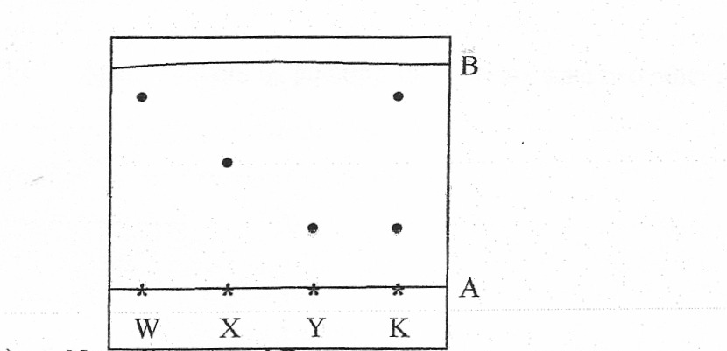

(a) Name lines A and B
A ............................................................................................

B ............................................................................................

(b) Identify which. Pure dyes substance K contain. (1 mark)
....................................................................................................................................................................... .......................................................................................................................................................................

(e) Which two properties of the component of the mixture facilitate separation? (2 marks)
....................................................................................................................................................................... .......................................................................................................................................................................

(d) Normally line A is drawn using a pencil and not ink. Explain why the pencil is preferred to ink.(1 mark)
.......................................................................................................................................................................

(e) State one application of chromatography. (1 mark)
....................................................................................................................................................................... .......................................................................................................................................................................

10. Give two reasons why laboratory apparatus are made of glass. (2 marks)
....................................................................................................................................................................... .......................................................................................................................................................................

(a) State the conditions necessary for rusting to take place. (2 marks)
....................................................................................................................................................................... .......................................................................................................................................................................

(b) Apart from oiling, painting and greasing state two other methods of preventing rusting. (2 marks)
....................................................................................................................................................................... .......................................................................................................................................................................

11. The follow set-up was used. by some students to study some properties of air.

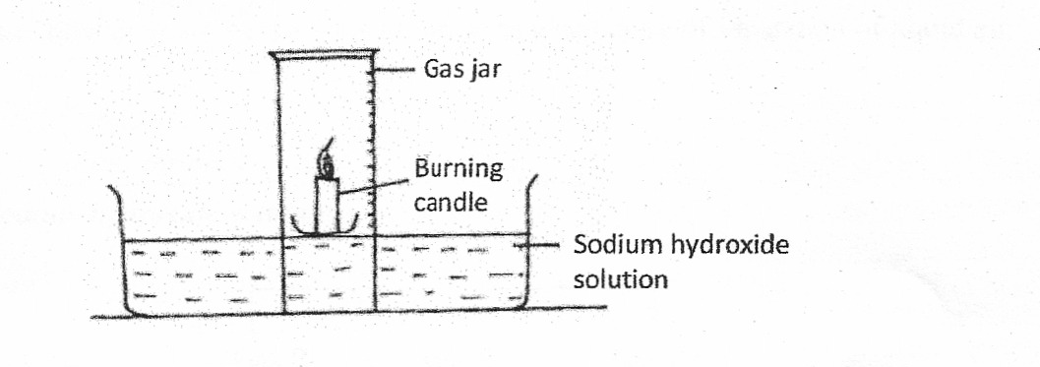

(a) State two observations made after a few minutes. (2 marks)
....................................................................................................................................................................... .......................................................................................................................................................................

(b) Name the gas that occupies the largest volume after the experiment (1 mark)
....................................................................................................................................................................... .......................................................................................................................................................................

(c) Tile percentage of air used w as calculated to be 19.375% while the approximate percentage of oxygen is 21%. State one source of error. (1 mark)
....................................................................................................................................................................... .......................................................................................................................................................................

(d) Why is sodium hydroxide solution preferred to water in this experiment? (1 mark)
....................................................................................................................................................................... .......................................................................................................................................................................

(e) Why is it advisable to allow the apparatus to cool before the final volume is taken? (1 mark)
....................................................................................................................................................................... .......................................................................................................................................................................

12. (a) Define the term reactivity series (1 mark)
....................................................................................................................................................................... .......................................................................................................................................................................

(b) Arrange the following metals in order of their reactivity starting with the most reactive Cu, Mg, Zn, K, Na, and Fe

13 Study the flow diagram below which represents a summary of separation of liquid air.
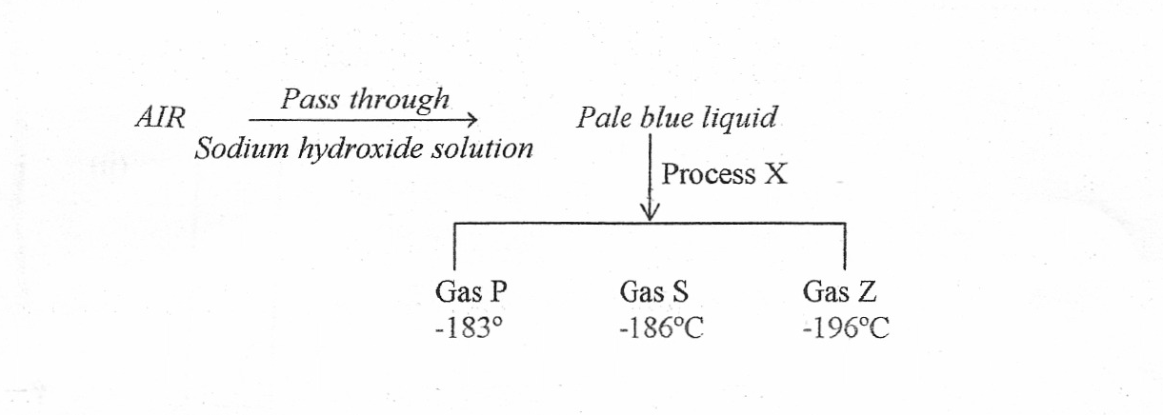
(a) (i) Identify the gases.
P ..................................................................................
S ..................................................................................
Z .................................................................................. (3 marks)

(ii) Name process X. (1 mark)
.......................................................................................................................................................................

(iii) What is the role of sodium hydroxide solution in the above flow diagram? (1 mark)
....................................................................................................................................................................... .......................................................................................................................................................................

(b) Name:
(i) A compound that is normally present in aft. (1 mark)
.......................................................................................................................................................................

(ii) An element that is normally present in air
.......................................................................................................................................................................

14. The following are laboratory apparatus used in Chemistry. Name them and give their uses. (1 mark)
....................................................................................................................................................................... .......................................................................................................................................................................
15. The diagram below illustrates one of the methods of gas collection in the laboratory.

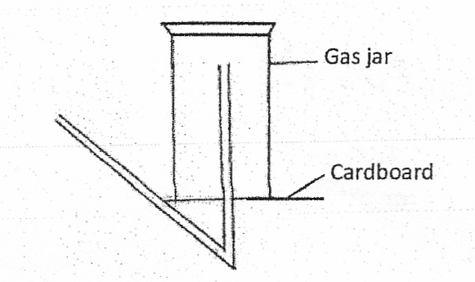

- Name the method ( ½ mark)
.......................................................................................................................................................................

- Name one gas that can be collected using this method. Explain your answer. (1 ½ mks)
....................................................................................................................................................................... .......................................................................................................................................................................

