TOP EVALUATION EXAMINATION - 2016
Kenya Certificate of Education
Chemistry Combined Paper
FORM 1
JULY/AUGUST

MARKING SCHEME

- (a) What is a mixture? (1 mark)
Combination of two or more substances that can be separated by physical means.
(b) Name the method of separation you would use in separating: (3 marks)
- Beans from maize beans mixture.
Sorting/picking
- Water from sand.
Decantation
- Cream from milk.
Skimming
(c) State four areas in which the knowledge of chemistry is used. (4 marks)
- In washing/cleaning with soap.
- Understanding chemicals oflife.
- Baking requires understanding of chemistry.
- Medicine.
- Fractional distillation of crude oli.
- Manufacture of synthetic substances.
- Diagnosis/test for abnormal body functions.
- (a) Define the following terms as used in chemistry. (5 marks)
- Drug
Natural or manmade substance that when taken changes the body function.
- Medicine
Natural or manmade substance that when taken alters/changes the abnormal body functioning to normal.
- Prescription
Medical instruction to a patient/sick on the correct type of medicine to take and period between pne intake and the other.
- Dosage
Correct quantity of drug required to alter the abnormal body function back to normal.
- Over the Counter drug
Drug that needs minimal prescription and available without prescription from a pharmacist or doctor.
(b) Name three illegal drugs that are normall abused. (3 marks)
- Tobacco
- Miraa
- Alcohol
- Sleeping pills
- (a) State three reasons why most chemistry laboratory apparatus are made of glass. (3 marks)
- Glass is transparent.
- Comparatively cheaper.
- Easier to wash after use.
- Unreactive to many chemicals.
(b) Name each of the apparatus below and state what it is used for. (8 marks)
(i) 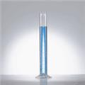

Measuring cylinder. Measure volume of liquid/solutions.

(ii)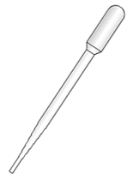
Pipette. Measure and transfer small very accurate volumes of a liquid/solution.
(iii)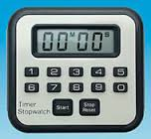
Stop watch. Measure time

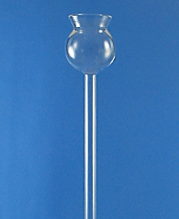
Thistle funnel.Direct liquid solution into stoppered container.
- Draw a Bunsen burner and label all its parts. (3 marks)

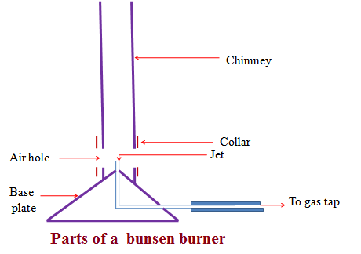
(b) Outline the procedure for lighting a Bunsen burner. (4 marks)
- Adjust the collar to ensure the air holes are closed.
- Connect the burner to the gas tap using a rubber tubing. Ensure the rubber tubing has no side leaks.
- Turn on the gas tap.
- Ignite the top of the chimney using a lighted match stick/gas lighter/wooden splint.
.
(c) State three characteristic differences between luminous and non-luminous flame (3 marks)
Luminous flame | Non-luminous flame
1. Produced when the air holes are fully/completely closed. | 1. Produced when the air holes are fully/completely open.
2. when the air holes are fully/ completely closed there is incomplete burning/ combustion of the laboratory gas | 2.when the air holes are fully/ completely open there is complete burning/ combustion of the laboratory gas
3. Incomplete burning/ combustion of the laboratory gas produces fine unburnt carbon particles which make the flame sooty/smoky | 3. complete burning/ combustion of the laboratory gas does not produce carbon particles.
4. Some carbon particles become white hot and emit light.This flame is thus bright yellow in colour producing light | 4. Is mainly blue in colour and is hotter than luminous flame.
5. Is larger, quiet and wavy/easily swayed by wind | 5.Is smaller, noisy and steady
Luminous flame has three main regions | Non-luminous flame has four main regions

- Study the setup below of an experiment and then answer questions that follow.
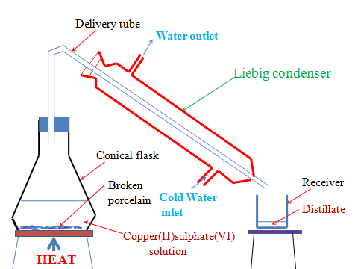
- State the purpose of the experiment. (1 mark)
To obtain copper(II)sulphate (VI) crystals and water from copper (II) sulphate(VI) solution.
- Give a reason for each of the following.
- the solution is heated. (1 mark)
To vapourize /evaporate the solvent/one component which is condensed at a different part of the apparatus.
- Using pieces of broken porcelain (2 marks)
- Prevent bumping of the solution during boiling.
- Ensure smooth and even boiling.

- Liebig condenser has a cold water inlet near the receiver and cold water out let. (1 mark)
To ensure efficient cooling
- Other than b(ii) above, what else can be used. (2 marks)
Porous pot/glass/sand

- Name the method of separation illustrated by the setup. (1 mark)
Simple fractional distillation
- The procedure below was followed when using commercial indicators to determine acidic and basic/alkaline and neutral solutions
Procedure
- Place 5cm3 of the solutions in the table below.
- Add three drops of litmus solution to each solution.
- Repeat with phenolphthalein indicator, methyl orange, and bromothymol blue.
- Complete the table by showing the colour change. (6 marks)
Substance/  solution | Indicator Used
 | Litmus | Phenolphthalein | Methyl orange | Bromothymol  blue
wood ash | Blue | Pink
soap solution |  | Pink |  | Blue
ammonia solution | Blue |  | Yellow
sodium hydroxide |  |  | Yellow | Blue
hydrochloric acid

Substance/  solution | Indicator Used
 | Litmus | Phenolphthalein | Methyl orange | Bromothymol  blue
wood ash | Blue | Pink | Yellow | Blue
soap solution | Blue | Pink | Yellow | Blue
ammonia solution | Blue | Pink | Yellow | Blue
sodium hydroxide | Blue | Pink | Yellow | Blue
hydrochloric acid | Red | Colourless | Red | Orange
Each ½ mark
- Ferdinand placed 5cm3 of dilute hydrochloric acid in a small test tube. He then added 1cm length of polished magnesium ribbon. He stoppered the test tube using a thump. After this, he lit a wooden splint and Placed it on top of the stoppered test tube. He then released the thump stopper.
- Write down two observations he made. (2 marks)
- effervescence/bubbles produced/fizzing.
- colourless gas produced.
- gas produced extinguishes a burning wooden splint with an explosion/pop sound.
- Why wouldn’t Ferdinand use copper in stead of magnesium ribbon? (2 marks)
Copper is not reactive enough to displace/remove the hydrogen from dilute acids.
- Write a word equation for the reaction that happens. (2 marks)
Magnesium +Hydrochloric acid->Magnesium chloride + Hydrogen

- Sodium carbonate is reacted with an acid A to produce chloride B, gas C and water.
- Name: (3 marks)
- Acid A
Dilute hydrochloric acid
- Chloride B
Sodium chloride
- Gas C
Carbon(IV)oxide
- State the observations made in the experiment when:
- Test tube holding the mixture is directed into lime water. (2 marks)
gas produced forms a white precipitate with lime water
effervescence/bubbles produced/fizzing in all cases.
- Write word equation of the reaction in above. (2 marks)
Sodium carbonate +Hydrochloric acid -> Sodium chloride + Carbon(IV)Oxide+ Water
- Write word and chemical equations for the reactions if the following would have been used in stead of sodium carbonate(acid remains the same). (6 marks)
- Copper carbonate
Copper carbonate +Hydrochloric acid -> Copper(II) chloride + Carbon(IV)Oxide+ Water
CuCO₃(s) + 2HCl (aq) -> CuCl₂ (aq) + H₂O(g) + CO₂ (g)
- Potassium hydrogen carbonate
Potassium hydrogen carbonate +Hydrochloric acid -> Potassium chloride + Carbon(IV)Oxide+ Water
KHCO₃(s) + HCl (aq)-> KCl (aq) + H₂O(g) + CO₂ (g)

- Sodium hydrogen carbonate
Sodium hydrogen carbonate +Hydrochloric acid -> Sodium chloride + Carbon(IV)Oxide+ Water
NaHCO₃(s) + HCl (aq) -> NaCl (aq) + H₂O(g) + CO₂ (g
- State three physical properties of acids. (3 marks)
- Acids have a characteristic sour taste
- Most acids are colourless liquids
- Mineral acids are odourless.
- All acids have pH less than 7
- All acids turn blue litmus paper red,methyl orange red and phenolphthalein colourless.
- All acids dissolve in water to form an acidic solution.

- (a) Giving the approximate their percentage composition by volume, identify two main gases present in the atmosphere/air. (2 marks)

Gas | Approximate % composition by volume
Nitrogen | 78.0
Oxygen | 21.0

b) the set up apparatus below was used to find out the composition of air that support combustion.

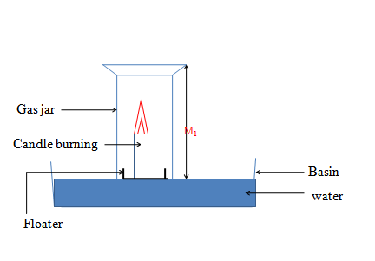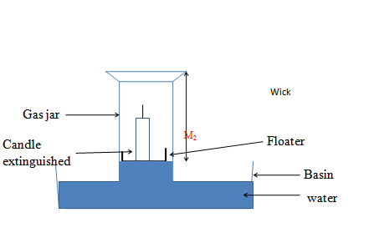

(i) What happens to the candle after a while? (1 mark)
Candle continues to burn then extinguished/goes off
Level of water in the gas jar rises after igniting the candle

(i)
I. the active part of the air. (2 marks)

Length of empty gas jar = M₁= 20cm
Length of gas jar without water before igniting candle = M₂= 15 cm
Length of gas jar with water after igniting candle = M₃ = 12 cm
Length of gas jar without water after igniting candle = M2 - M₃ = 15 -12 = 3 cm

M₂ - M₃ x 100% => 15- 12 x 100% = 20%
M₂ 15cm

II. The inactive part of the air. (2 marks)
100% -20% = 80%

